JENKINS CI/CD
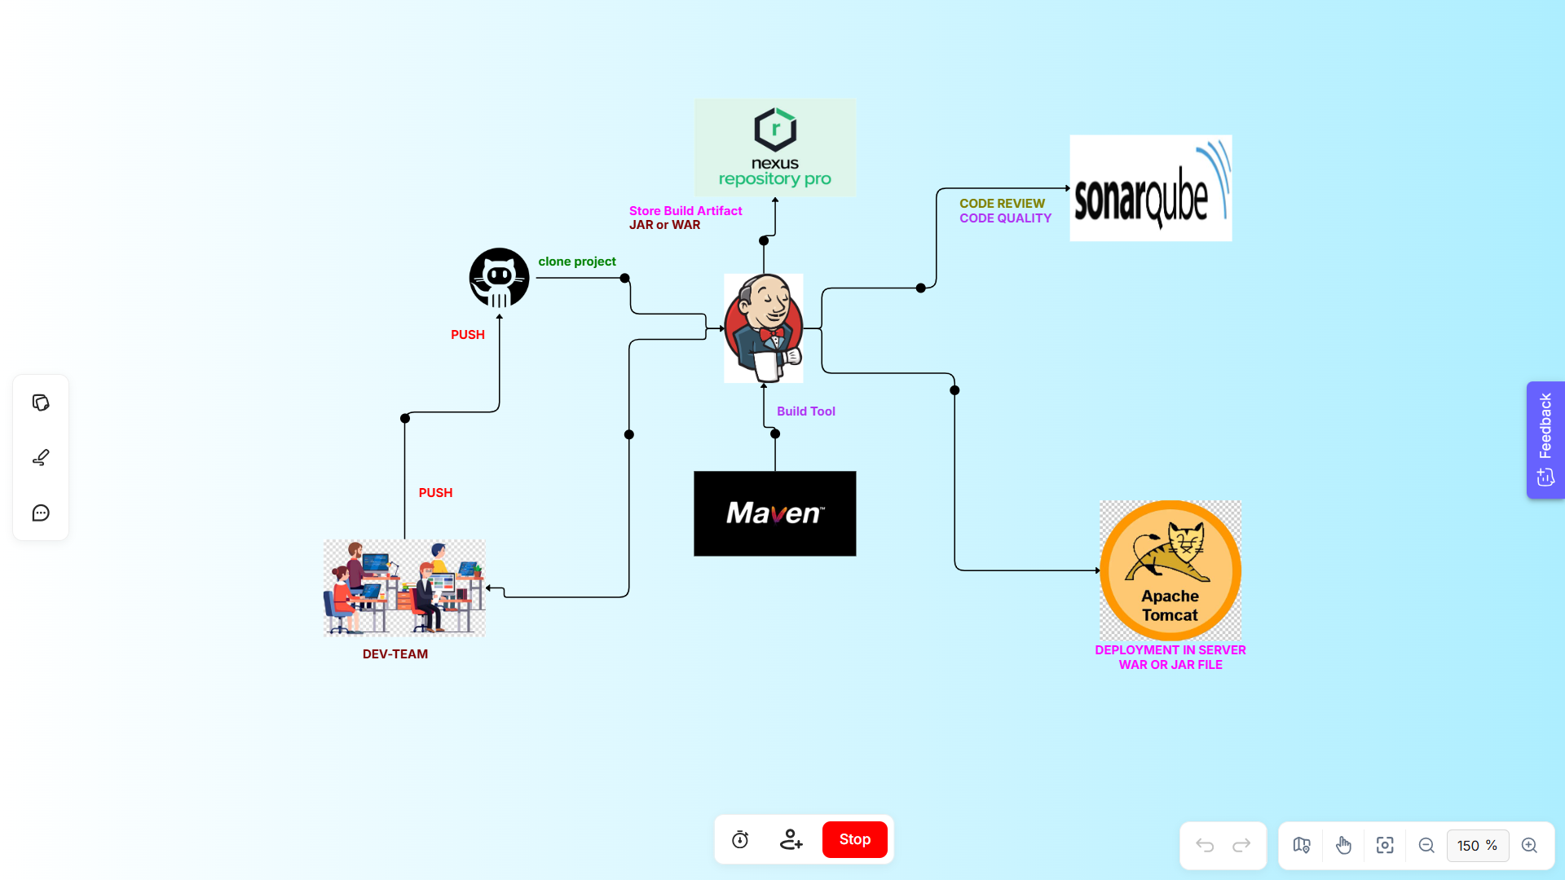

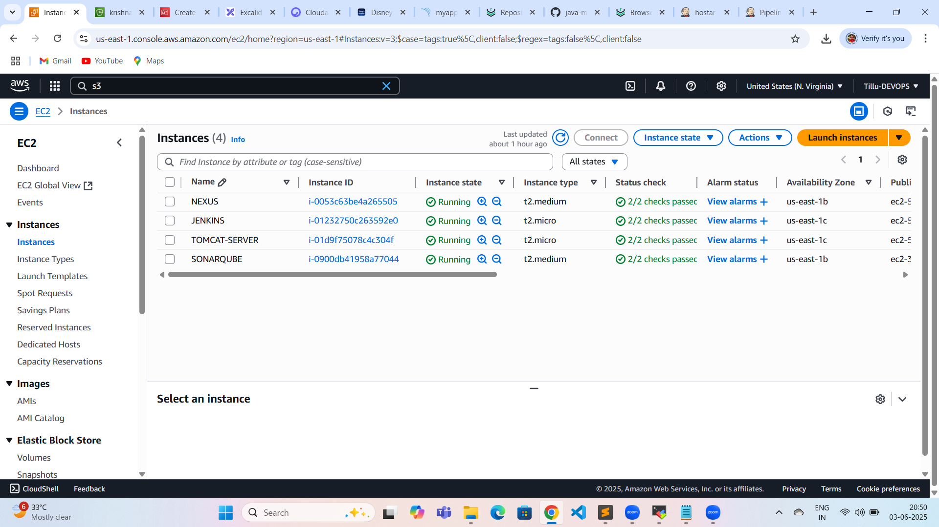

Jenkins installation
-------------------------
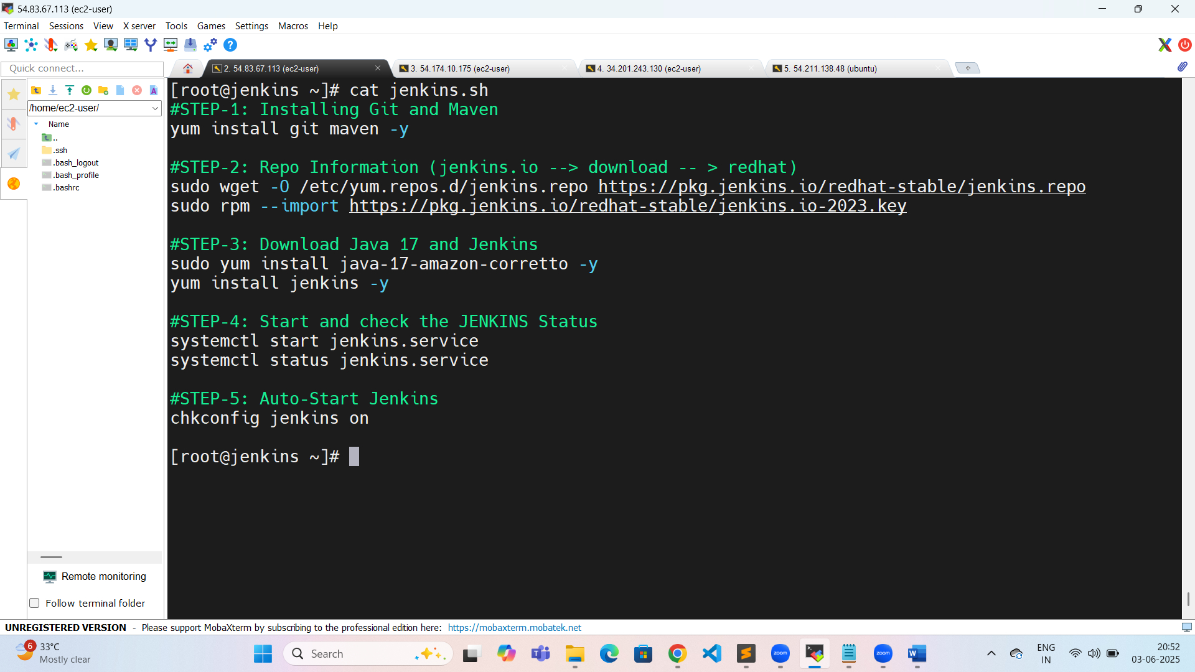
[root@jenkins ~]# cat jenkins.sh
#STEP-1: Installing Git and Maven
yum install git maven -y

#STEP-2: Repo Information (jenkins.io --> download -- > redhat)
sudo wget -O /etc/yum.repos.d/jenkins.repo https://pkg.jenkins.io/redhat-stable/jenkins.repo
sudo rpm --import https://pkg.jenkins.io/redhat-stable/jenkins.io-2023.key

#STEP-3: Download Java 17 and Jenkins
sudo yum install java-17-amazon-corretto -y
yum install jenkins -y

#STEP-4: Start and check the JENKINS Status
systemctl start jenkins.service
systemctl status jenkins.service

#STEP-5: Auto-Start Jenkins
chkconfig jenkins on
[root@jenkins ~]#
Sonar installation:
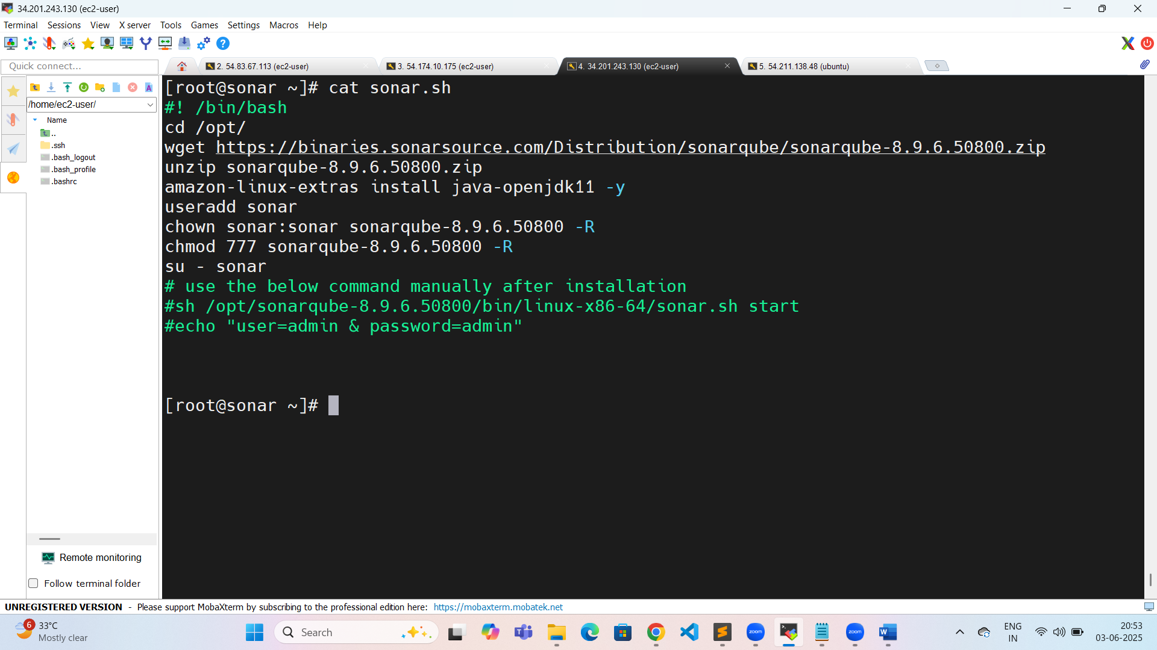
[root@sonar ~]# cat sonar.sh
#! /bin/bash
cd /opt/
wget https://binaries.sonarsource.com/Distribution/sonarqube/sonarqube-8.9.6.50800.zip
unzip sonarqube-8.9.6.50800.zip
amazon-linux-extras install java-openjdk11 -y
useradd sonar
chown sonar:sonar sonarqube-8.9.6.50800 -R
chmod 777 sonarqube-8.9.6.50800 -R
su - sonar
# use the below command manually after installation
#sh /opt/sonarqube-8.9.6.50800/bin/linux-x86-64/sonar.sh start
#echo "user=admin & password=admin"
[root@sonar ~]#
Tomcat installation:
[root@tomcat ~]# history
1 sudo yum install java-17-amazon-corretto -y
2 wget https://dlcdn.apache.org/tomcat/tomcat-9/v9.0.105/bin/apache-tomcat-9.0.105.tar.gz
3 ll
4 tar -zxvf apache-tomcat-9.0.105.tar.gz
5 cd apache-tomcat-9.0.105/
6 ll
7 cd webapps/
8 ls
9 cd manager/
10 ls
11 cd META-INF/
12 ls
13 vim context.xml
14 cd ../../..
15 ls
16 cd conf/
17 ls
18 vim tomcat-users.xml
19 cd ..
20 cd bin/
21 ls
22 ./startup.sh
23 cd
24 history
[root@tomcat ~]#
Nexus installation:
ubuntu@ip-172-31-87-227:/opt/nexus$ history
1 sudo apt update
2 sudo apt install openjdk-17-jdk openjdk-17-jre -y
3 cd /opt/
4 wget https://download.sonatype.com/nexus/3/nexus-3.76.1-01-unix.tar.gz
5 sudo wget https://download.sonatype.com/nexus/3/nexus-3.76.1-01-unix.tar.gz
6 sudo tar -zxvf nexus-3.76.1-01-unix.tar.gz
7 ll
8 sudo mv /opt/nexus-3.76.1-01 /opt/nexus
9 ll
10 sudo adduser nexus
11 sudo visudo
12 sudo chown -R nexus:nexus /opt/nexus
13 ll
14 sudo chown -R nexus:nexus /opt/sonatype-work/
15 ll
16 cd nexus/
17 sudo vim /opt/nexus/bin/nexus.rc
18 sudo ln -s /opt/nexus/bin/nexus /etc/init.d/nexus
19 su - nexus
20 ll
21 history
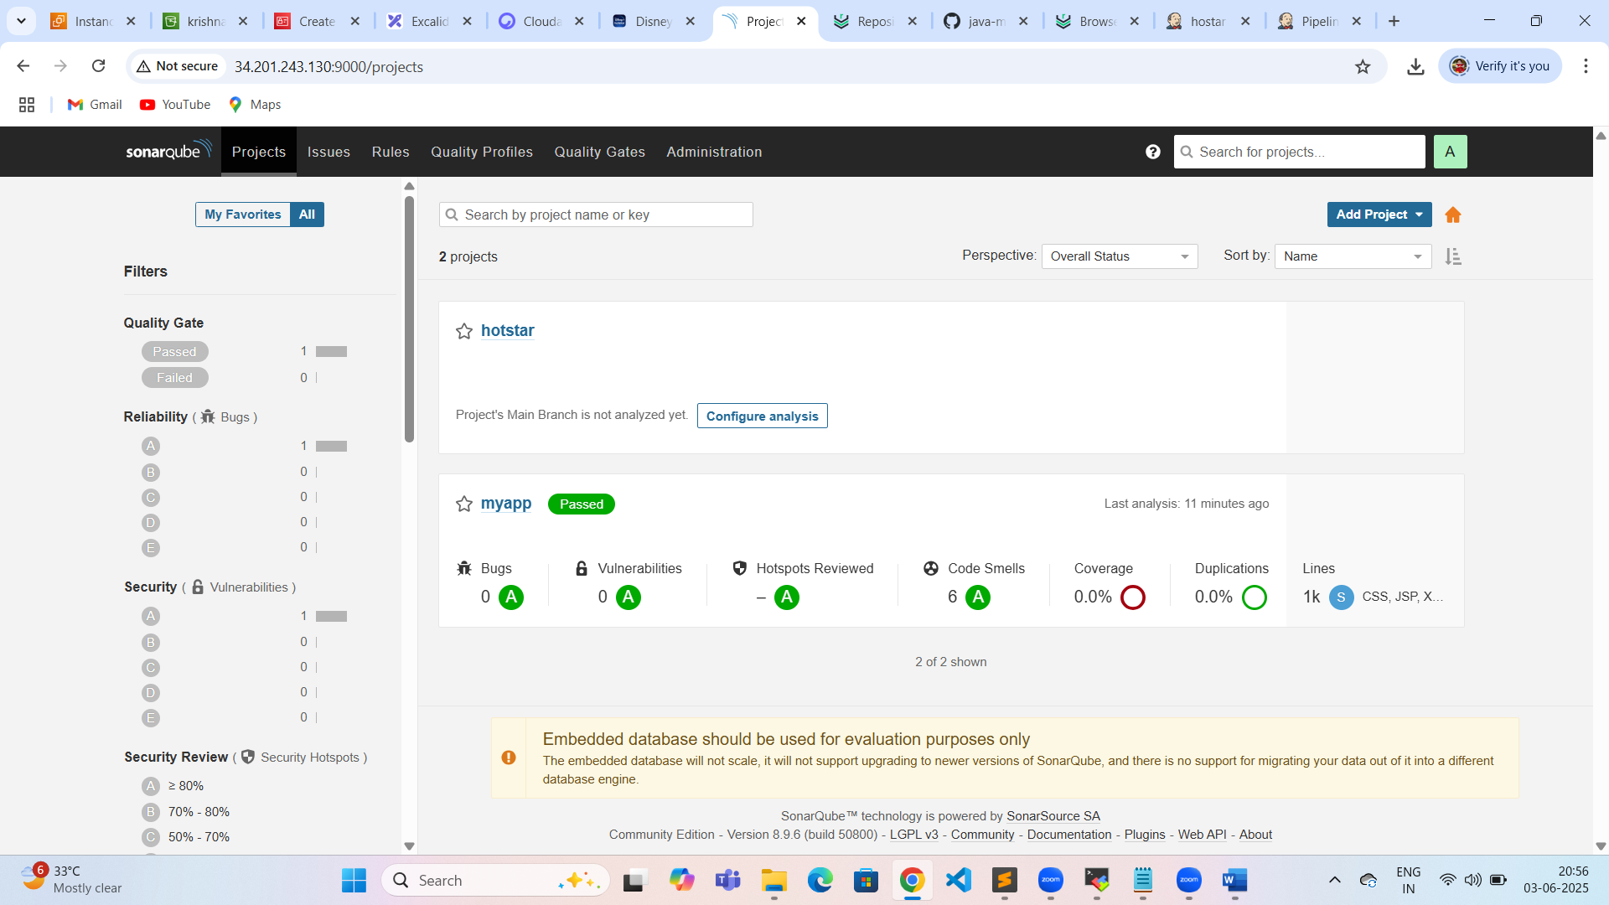
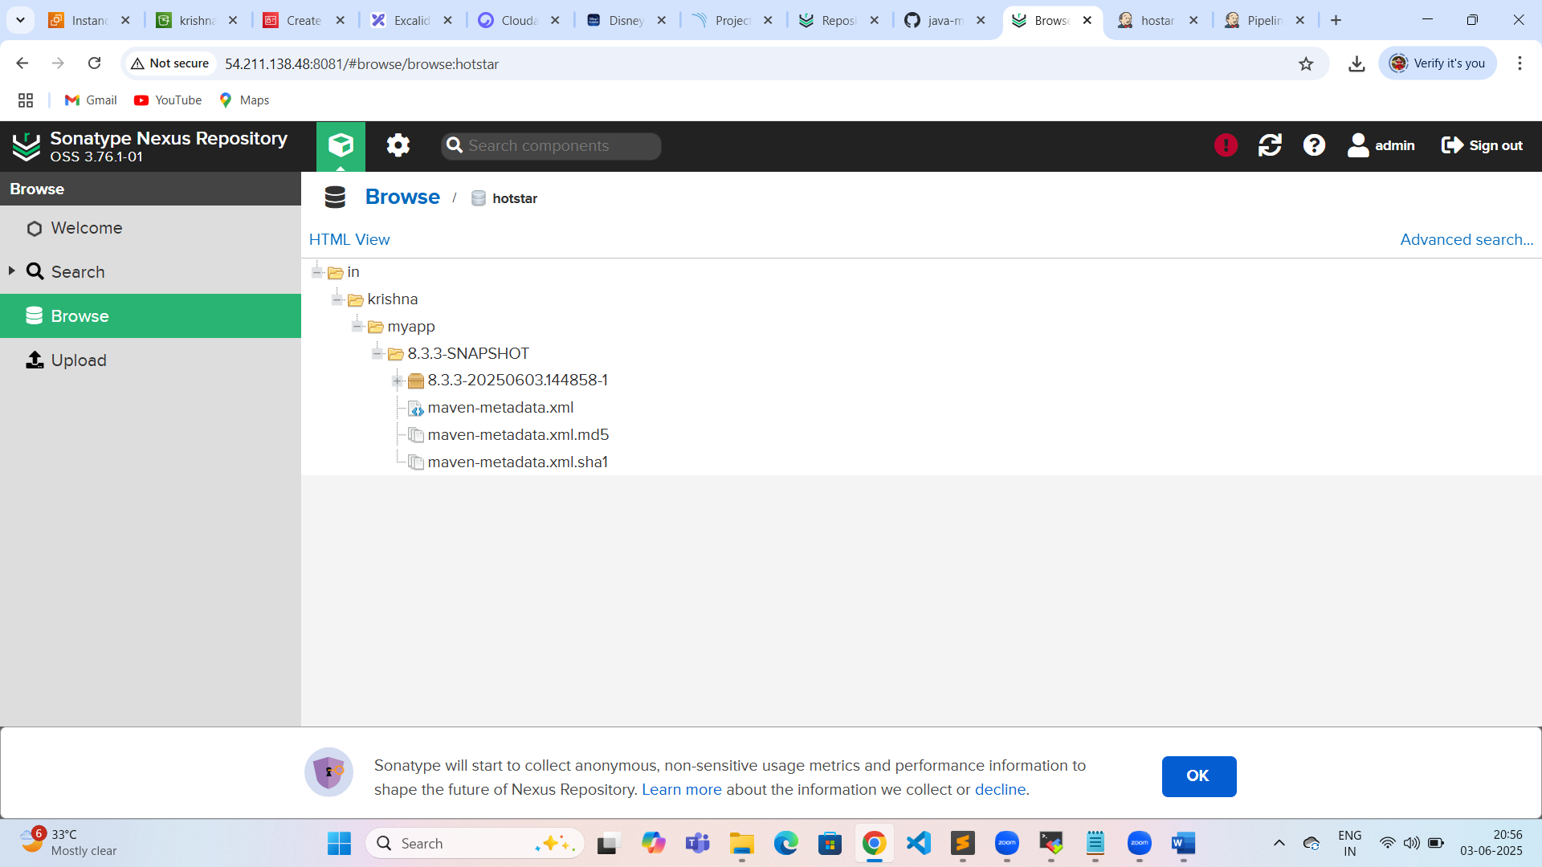
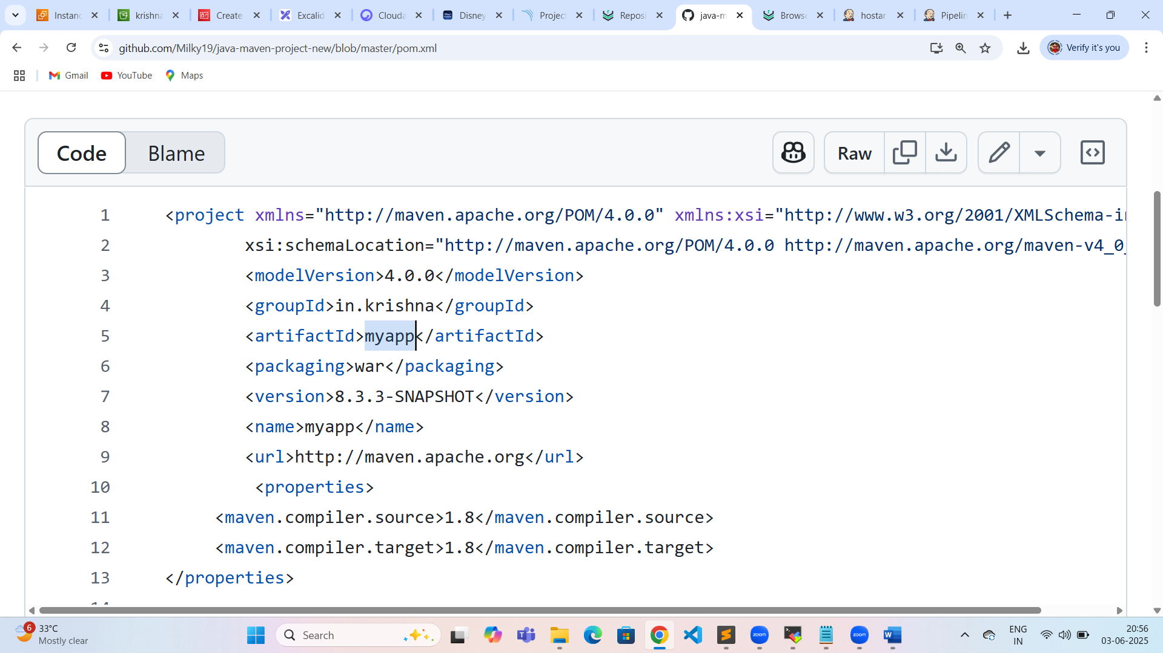
Pipeline code:
pipeline {
agent any
stages{
stage('checkout'){
steps{
git 'https://github.com/Milky19/java-maven-project-new.git'
}
}
stage("Compile-Project"){
steps{
sh 'mvn compile'
}
}
stage("Test-project"){
steps{
sh 'mvn test'
}
}
stage('sonarqube-scanning'){
steps{
withSonarQubeEnv('SonarQube') {
sh 'mvn org.sonarsource.scanner.maven:sonar-maven-plugin:3.7.0.1746:sonar'
}
}
}
stage("Generate Artifact"){
steps{
sh 'mvn clean package'
}
}
stage("Uploading-artifactory"){
steps{
nexusArtifactUploader artifacts: [[artifactId: 'myapp', classifier: '', file: 'target/myapp.war', type: '.war']], credentialsId: 'nexus', groupId: 'in.krishna', nexusUrl: '54.211.138.48:8081', nexusVersion: 'nexus3', protocol: 'http', repository: 'hotstar', version: '8.3.3-SNAPSHOT'
}
}
stage('deploying artifact'){
steps{
deploy adapters: [tomcat9(alternativeDeploymentContext: '', credentialsId: 'mytomcat', path: '', url: 'http://54.174.10.175:8080')], contextPath: 'myapp', war: '**/*.war'
}
}
}
}

Plugins:
- Deploy to container
- Nexus artifact uploader
- Sonarqube scanner
- Sonarqube server
- Pipeline stage view

