Intelligent CRM
First pre defense package
  - Development of an Intelligent CRM Platform with Automated Customer Interaction Analysis
Software Engineering · SE-2426
Astana IT University
Checkpoint: 24 October 2026
Prepared: 19 October 2026; tracker/status updated: 23 October 2026
Team member | Responsibility
Yeshimkul Beybit | Frontend and visualisation
Shaikenov Danial | Backend and integrations
Saken Akhmediyar | AI/NLP, evaluation and QA

Supervisor: Arailym Orazova
This package proposes a text-first CRM and a reproducible evaluation. It includes a runnable interaction prototype and analysis/design materials. The source documents distinguish published evidence, proposed design choices and measurements that have not yet been made.
Readiness: User discovery and supervisor feedback are not collected. YouTrack is configured with 14 assigned issues. Actual student contribution and peer-review evidence remain open. The package is a preparation candidate, not a claim of complete checkpoint compliance.
Repository: https://github.com/dinfy07/intelligent-crm-platform
Preparation branch: codex/CRM-13-pre-defense-package (AI-assisted review candidate; students commit their own meaningful revisions)

Contents and readiness
1 Project proposal
2 Relevance evidence and discovery
3 Critical literature review
4 Existing system comparison
5 Technology comparison
6 Initial requirements
7 Architecture and diagrams
8 UX prototype
9 Verification and evaluation plan
10 Project management and risks
11 Supervisor feedback
12 Source register

Evidence checklist
Component | Current state
Proposal | Prepared candidate
Relevance evidence | OPEN
Literature review | Prepared candidate
Existing systems | Prepared candidate
Technology comparison | Prepared candidate
Requirements | Prepared candidate
Architecture | Prepared candidate
UX prototype | Runnable prototype
Verification plan | Prepared candidate
Management | PARTIAL: tracker and 14 assigned issues; real reviews still open
Supervisor feedback | OPEN

1 Project proposal

Project identity
Development of an Intelligent CRM Platform with Automated Customer Interaction Analysis
Astana IT University. Software Engineering. Group SE-2426. Supervisor: Arailym Orazova. Stage: first pre-defense candidate prepared on 19 October 2026 for the 24 October checkpoint.
Team member | Accountable contribution
Yeshimkul Beybit | Frontend and visualisation
Shaikenov Danial | Backend and integrations
Saken Akhmediyar | AI/NLP, evaluation and QA

Problem statement
A staff member who needs to understand a customer's previous interaction must locate the record, read the text, identify the issue and verify the next step. We propose to investigate whether an integrated, source-linked analysis workflow can reduce this effort while preserving factual accuracy. The frequency, severity and preferred workflow of this problem remain hypotheses because the team has not yet interviewed users or agreed requirements with a client.

Target users and boundaries
The initial user hypothesis is a small sales or customer-support team operating within one organisation. An analyst handles assigned customers. A manager reviews the team's interaction history and analyses. An administrator manages accounts and access settings. A specific organisation, purchase intention and willingness to adopt the platform have not been established.

Aim
Develop and evaluate a CRM prototype that manages customer interactions and produces reviewable topic labels and short summaries with links to their source turns.

Objectives
1. Validate the workflow through 3–5 discussions with user representatives or a substantive client agreement.
2. Define traceable functional and non-functional requirements with acceptance criteria.
3. Implement customer records, text interaction import, access control and analysis job tracking.
4. Compare a deterministic extractive baseline with a pretrained analysis method on a held-out set.
5. Provide a user interface for inspection, correction and approval of analysis results.
6. Evaluate factuality, topic tagging, key-fact coverage, task time and operational behaviour.

Scope
Mandatory MVP: one organisation; analyst, manager and admin roles; customer cards; manual entry and JSON import of text interactions; source-linked topic tagging and summaries; explicit analysis states; human review; filtered search; JSON export; versioned runs and audit events. English-language evaluation is the initial controlled scope. Russian and Kazakh support requires separate labelled evaluation before any quality claim.
Optional after mandatory criteria: CSV adapter, richer analytics and a second language. Out of scope: telephone recording, automatic speech recognition, real-time call assistance, automatic messages to customers, payment processing, a full enterprise sales suite, training a large language model from scratch and production-scale availability guarantees.

Engineering contribution and expected outcomes
The engineering work combines an object-level permission model, validated imports, asynchronous job lifecycle, source and model versioning, an analysis adapter, human review and a coherent UI. Expected deliverables are a reproducible prototype, documented API and data model, automated checks, an annotated evaluation set with provenance, experiment scripts and an honest limitations report. No experiment results or commercial superiority are claimed at this stage.

Proposed research questions
RQ1: How do the extractive baseline and a pretrained summarisation method differ in factuality, key-fact coverage and topic macro-F1 on the same held-out interactions? RQ2: Does the reviewed analysis workflow reduce median completion time for defined history-review tasks compared with reading the original interaction, without increasing task errors? RQ3: Which error types, input lengths and topic classes cause failures?
The design draws on dialogue evaluation and factuality research [L03, L04, L06, L08, L09]. Any benefit remains to be measured. See the source register for publication URLs.

2 Relevance evidence and discovery

Evidence status
Confirmed from the team's current statement: there is no real client agreement, no completed user discussion and no supervisor feedback record yet. Published dialogue research and existing CRM documentation establish technical context, but they do not establish local demand for this specific product [L03, L06, L08, S01–S06].

Hypotheses to test
H1: Representatives repeatedly reconstruct customer context from scattered text records. H2: They value source-linked summaries and review controls enough to use them in an existing workflow. H3: Topic labels help locate unresolved issues. H4: Their organisation can lawfully provide de-identified examples and define who may access them. H5: English-first text input is sufficient for a demonstrable initial scope. Interview evidence may contradict this.

Recruitment and sample
Recruit 3–5 representatives from the target workflow, ideally at least two customer-facing employees and one manager. Do not count the three project developers as target users solely because they built the prototype. A single actual client may instead provide substantive agreement on users, scope, data access and acceptance criteria, as permitted by the supplied rubric.

Discussion guide for 20–25 minutes
1. Describe the last time you reviewed a customer's previous conversation. What triggered the task?
2. Show the steps, tools and handovers without exposing personal or confidential data.
3. What facts do you need before deciding the next action? What happens when one is missing?
4. How often does this task occur? If possible, observe a timed example rather than relying only on estimates.
5. What languages and interaction formats actually occur? Which records are too sensitive to share?
6. Show the prototype. Ask the participant to find an unresolved issue and check a summary against the original.
7. What is incorrect, unnecessary or missing? What would make the proposed workflow unsuitable?
8. Ask what an acceptable result would look like and which mistakes are unacceptable.
9. May the team keep de-identified notes? May an anonymised quote be included? These are separate permissions.

Record and synthesis
Use participant codes U01–U05. Record date, role, workflow, observed steps, supporting notes, permission scope, contradictory findings and candidate requirement IDs. Separate exact quotations from interpretation. Do not insert invented names, quotes, durations or percentages.
After each discussion, classify a statement as observed, reported, inferred or proposed. Retain conflicting views. Summarise findings by workflow and link a requirement only when the supporting note exists. With 3–5 convenience participants, report qualitative patterns and avoid population prevalence claims.

Evidence completion gate
Before the checkpoint, attach 3–5 substantive de-identified records or a real client agreement. Update the requirements and prototype in response to findings. Preserve the previous design and a change log. Until this occurs, component 2 remains open.

3 Critical literature review

Selection and evidence quality
We selected ten scientific works relevant to dialogue summarisation, topic tagging and factual evaluation. Eight date from 2022–2025. DialogSum and QMSum from 2021 are retained for foundational dataset and source-span ideas. Nine entries are peer-reviewed publications. GPT-Calls is explicitly treated as a preprint. Product documentation is analysed separately. This is a focused engineering review, not a systematic or exhaustive literature search.
Queries covered dialogue summarisation, factual consistency, fine-grained evaluation and sales-call topic tagging. Primary publication pages, PDFs and official product documentation were checked on 19 October 2026. Inclusion required a concrete design or evaluation consequence. No benchmark score is transferred to the proposed CRM.

L01 Chen et al. 2021
DialogSum: A Real-Life Scenario Dialogue Summarization Dataset. Findings of ACL. Peer reviewed; foundational.
Source: https://aclanthology.org/2021.findings-acl.449/
Approach and contribution: Labelled dialogue summaries and benchmark experiments expose discourse and coreference challenges.
Limit and transfer risk: English everyday dialogues differ from customer records and local business vocabulary.
Consequence for this project: Use public dialogues for a smoke benchmark, then evaluate a separate domain set.

L02 Zhong et al. 2021
QMSum: A New Benchmark for Query-based Multi-domain Meeting Summarization. NAACL. Peer reviewed; foundational.
Source: https://aclanthology.org/2021.naacl-main.472/
Approach and contribution: Locate-then-summarise connects requested information to relevant dialogue spans.
Limit and transfer risk: Long meetings and query-focused summaries do not directly represent short CRM interactions.
Consequence for this project: Retain source turn identifiers for every extracted fact and inspect evidence during review.

L03 Gao and Wan 2022
DialSummEval: Revisiting Summarization Evaluation for Dialogues. NAACL. Peer reviewed.
Source: https://aclanthology.org/2022.naacl-main.418/
Approach and contribution: Compares automatic metrics against human judgements on coherence, consistency, fluency and relevance.
Limit and transfer risk: Findings depend on the studied datasets and model outputs; one metric cannot establish business utility.
Consequence for this project: Combine human factuality and key-fact coverage with timing measurements, rather than relying on ROUGE alone.

L04 Wang et al. 2022
Analyzing and Evaluating Faithfulness in Dialogue Summarization. EMNLP. Peer reviewed.
Source: https://aclanthology.org/2022.emnlp-main.325/
Approach and contribution: Analyses factual errors and proposes FacEval with transformed multiple-choice questions.
Limit and transfer risk: The paper notes that rule-based transformations cover only designed error types.
Consequence for this project: Add speaker swaps, negation changes and unsupported commitments to the error test set.

L05 Laban et al. 2022
SummaC: Re-Visiting NLI-based Models for Inconsistency Detection in Summarization. TACL. Peer reviewed.
Source: https://aclanthology.org/2022.tacl-1.10/
Approach and contribution: Segments source and summary into smaller units and aggregates entailment signals.
Limit and transfer risk: An NLI score on summarisation benchmarks does not certify a CRM statement as true.
Consequence for this project: Consider consistency scoring as a secondary experiment, with human adjudication for the main outcome.

L06 Zhu et al. 2023
Annotating and Detecting Fine-grained Factual Errors for Dialogue Summarization. ACL. Peer reviewed.
Source: https://aclanthology.org/2023.acl-long.377/
Approach and contribution: DIASUMFACT supplies fine-grained factual error annotations and compares error detectors.
Limit and transfer risk: The authors report limitations in practical error detection and evaluate their method on that dataset.
Consequence for this project: Use an explicit error taxonomy and retain reviewer decisions rather than automatically approving analyses.

L07 Malkiel et al. 2023
GPT-Calls: Enhancing Call Segmentation and Tagging by Generating Synthetic Conversations via Large Language Models. arXiv preprint. Preprint; lower evidence weight.
Source: https://arxiv.org/abs/2306.07941
Approach and contribution: Uses topic anchors and synthetic conversations to support call segmentation and tagging.
Limit and transfer risk: Production and domain-specific evidence cannot be reproduced from our small prototype; synthetic data are not user validation.
Consequence for this project: Compare topic tagging against a keyword baseline. Label synthetic fixtures separately from field evidence.

L08 She et al. 2024
Exploring the Factual Consistency in Dialogue Comprehension of Large Language Models. NAACL. Peer reviewed.
Source: https://aclanthology.org/2024.naacl-long.338/
Approach and contribution: Evaluates dialogue summaries and factual question answering, including participant attribution errors.
Limit and transfer risk: Results concern the evaluated model versions and data; published error rates are not predictions for this project.
Consequence for this project: Test attribution, dates and next steps on held-out interactions. Record model and prompt versions.

L09 Song et al. 2024
FineSurE: Fine-grained Summarization Evaluation using LLMs. ACL. Peer reviewed.
Source: https://aclanthology.org/2024.acl-long.51/
Approach and contribution: Evaluates faithfulness, completeness and conciseness through fact checks and key-fact alignment.
Limit and transfer risk: The main benchmark is news, and LLM judging introduces domain and evaluator dependence.
Consequence for this project: Adopt key-fact coverage as a human rubric. Treat an automated judge as secondary and never as sole ground truth.

L10 Zhu et al. 2025
Factual Dialogue Summarization via Learning from Large Language Models. COLING. Peer reviewed.
Source: https://aclanthology.org/2025.coling-main.302/
Approach and contribution: Distils generated positive and negative examples to improve smaller dialogue summarisation models.
Limit and transfer risk: Training requires data and compute; benchmark improvements do not prove multilingual CRM readiness.
Consequence for this project: Keep fine-tuning outside the mandatory MVP. Compare a pretrained model with the extractive baseline first.

Synthesis and design consequences
Dataset studies [L01, L02] inform source format and evidence links, but their domains do not establish CRM validity. Evaluation studies [L03, L09] support multiple quality dimensions. Factual-error studies [L04, L06, L08] motivate human inspection and targeted failure cases. Consistency scoring [L05] can support an experiment but cannot replace adjudication. Topic tagging [L07] motivates a separate tagging baseline. Distillation research [L10] informs future work; training remains outside the mandatory scope.

Research gap and alternative explanations
The supported project question is whether an auditable, limited CRM workflow works for the recruited users under documented conditions. We have not established a new summarisation algorithm or a market gap. A configured existing CRM, improved note templates or a standalone summariser may solve the same problem more cheaply. Interviews and the workflow comparison must test these alternatives.

Structured analysis matrix
ID | Year | Evidence type | Project use
L01 | 2021 | Peer reviewed; foundational | Dataset and input design
L02 | 2021 | Peer reviewed; foundational | Evidence-linked UX
L03 | 2022 | Peer reviewed | Evaluation dimensions
L04 | 2022 | Peer reviewed | Adversarial test cases
L05 | 2022 | Peer reviewed | Optional consistency checker
L06 | 2023 | Peer reviewed | Review labels and error audit
L07 | 2023 | Preprint; lower evidence weight | Topic taxonomy and baselines
L08 | 2024 | Peer reviewed | Factuality and reproducibility
L09 | 2024 | Peer reviewed | Annotation rubric
L10 | 2025 | Peer reviewed | Model scope and feasibility

4 Existing system comparison

Method and limits
Four relevant CRM conversation-analysis systems are compared against the same eight criteria. Findings describe official documentation as checked on 19 October 2026, not hands-on tests. A missing claim means not verified in the cited material, never proof that a feature is absent. Feature availability depends on edition, configuration, region and language. No current price comparison is asserted.
Criterion | HubSpot | Salesforce ECI | Zoho Zia | Dynamics 365
Interaction input | Recorded calls; associated CRM records [S01] | Voice and video call records [S02] | Recorded calls [S03] | Call transcripts [S04]
Transcript inspection | Transcript and playback review [S01] | Transcript detail not verified in cited excerpt | Transcript highlights [S03] | Call transcript review [S04]
Automatic summary | Summary shown in review workflow [S01] | Generative summary [S02] | One-line summary [S03] | Summary and insights page [S04]
Topics and keywords | Tracked terms [S01] | Generative insights; exact keyword configuration not checked [S02] | Keywords and key phrases [S03] | Configured keywords/competitors [S05]
Next steps | Not verified in cited page | Summary includes next steps [S02] | Intent documented; structured action list not verified [S03] | Action items vary by language [S06]
Human review | Playback, comments and coaching [S01] | Sharing summaries documented [S02] | Transcript inspection documented [S03] | Review in call summary [S04]
Entitlement constraints | Eligible Professional/Enterprise seats for transcription [S01] | Exact licence must be checked [S02] | Professional and above; JP excluded [S03] | Licence, roles and enablement apply [S05]
Language constraints | Support must be checked for actual language | Not verified in cited excerpt | Local-language quality not established by page | Native versus translated support is feature-specific [S06]

Findings and need for the proposed prototype
Summaries, transcripts and topic or keyword insights already exist. A claim that commercial CRMs lack automated interaction analysis is contradicted by their documentation [S01–S06]. Our rationale is a bounded engineering and evaluation project: implement a transparent source-linked workflow and compare methods under controlled conditions. A real business case remains unvalidated.

Differentiation to evaluate
Planned features are explicit source-turn references, raw versus reviewed versions, a reproducible evaluation harness and a small deployable scope. These are project design choices. We have not established their uniqueness or commercial advantage. An existing CRM configured for the same user task is a relevant workflow alternative.

Follow-up before selection
Check actual tenant entitlements and languages with the prospective client. Trial-test one feasible commercial system only after access and data permissions are established. Use the same task and inputs if a fair comparison becomes possible. Record the Salesforce source limitation: its direct help page failed to render, so only the indexed official excerpt supports the narrow summary claim.

5 Technology comparison

Decision method
Five key decisions each have three alternatives. Selection criteria are requirement fit, team maintainability, reproducible evaluation, operational simplicity, data handling and resource constraints. Ratings below are qualitative design judgements, not measured performance rankings. All choices are proposed and require team/supervisor review.

ADR-01 Frontend
Preferred candidate: Vue 3 + TypeScript
Alternatives: React + TypeScript; Angular
Rationale: Proposed: Vue. Vue experience was reported by Beybit. Components, forms and a review workspace fit the scope [T01–T03].
Trade-off and reopen condition: Do not claim a performance advantage without measurement. Prototype is portable HTML/JS, not a completed Vue application.

ADR-02 Server
Preferred candidate: FastAPI / Python
Alternatives: NestJS / TypeScript; Django / Python
Rationale: Proposed: FastAPI for validated API contracts and proximity to Python analysis code [T04–T06].
Trade-off and reopen condition: Danial must confirm maintainability. Keep inference outside request handlers. This is a documented proposal, not a benchmark winner.

ADR-03 Storage
Preferred candidate: PostgreSQL
Alternatives: MongoDB; SQLite
Rationale: Proposed: relational customer/review records with JSONB analysis payloads [T07–T09].
Trade-off and reopen condition: MongoDB supports transactions. SQLite remains suitable for some embedded cases. Actual multi-user write and backup needs drive selection.

ADR-04 Interaction
Preferred candidate: Resource-oriented HTTP JSON + job polling
Alternatives: GraphQL; brokered messaging
Rationale: Proposed: HTTP JSON for UI/API and durable PostgreSQL job state for the worker. It minimises initial services [T10, T11, T14].
Trade-off and reopen condition: GraphQL query flexibility and a broker may be useful later. Queue retries, leases and idempotency still need implementation and tests.

ADR-05 Analysis
Preferred candidate: Deterministic extractive baseline plus one pretrained candidate
Alternatives: Rules/extraction only; hosted LLM adapter
Rationale: Mandatory baseline is inspectable and cheap. Compare a locally runnable pretrained method before choosing the final approach [L03–L10, T12, T13].
Trade-off and reopen condition: The final model is deliberately unselected until quality, language, licence, latency and hardware tests. Do not silently send client records to an external provider.

Interaction choice in detail
A durable analysis job allows the UI to stay responsive while inference runs. POST creates or returns an idempotent job for a source revision and method version. GET polls job status. A worker leases a job, validates output, stores the run and marks success or failure. Lease expiry permits bounded retries. Authentication, authorisation and source revision checks occur server-side.

Reproducibility
Lock exact versions during implementation, record the model revision and prompt/config hash, and keep benchmark inputs separate from tuning data. No GPU, model provider or paid account is assumed available. Reopen ADR-02 if the backend owner cannot maintain the chosen stack, and ADR-05 if the candidate cannot meet quality or resource targets.

6 Initial requirements

Status and priorities
This is a testable initial baseline proposed by the team. User validation and supervisor review remain open. Must is mandatory for the diploma MVP, Should follows mandatory scenarios, Could is optional. The browser prototype demonstrates selected UI flows only and does not satisfy server-side access or persistence requirements.

FR-01 Session and object-level access
Priority: Must. Owner: Danial
An analyst can view only assigned customer records; a manager can view all records in this organisation; only an admin manages users. Anonymous and forbidden requests return 401/403 without object content.
Verification: API access matrix including direct-ID requests

FR-02 Customer records
Priority: Must. Owner: Danial
Authorised users create, view and update a customer with a unique ID, display name and owner. Blank names fail validation and rejected updates leave stored data unchanged.
Verification: API CRUD and invalid-input tests

FR-03 Interaction capture
Priority: Must. Owner: Danial
Enter or import JSON with customer ID, channel, timestamp and ordered speaker/text turns. Unknown customer, invalid timestamp, missing turn text and excess size produce per-record errors before persistence.
Verification: Schema validation and import fixtures

FR-04 Search and filters
Priority: Must. Owner: Beybit
Search by customer name and filter interactions by customer, channel, date and review state. Combining filters returns their intersection and shows a usable empty state.
Verification: API query tests and UI task

FR-05 Durable analysis job
Priority: Must. Owner: Danial
For the same interaction revision and method/config version, repeated creation requests return one job. Status is queued, running, succeeded or failed. Bounded retry never overwrites a successful run.
Verification: Duplicate submission, worker crash and retry tests

FR-06 Analysis result with provenance
Priority: Must. Owner: Akhmediyar
A completed run stores topic labels, an at-most-120-word summary, source-turn references, source hash, method/model/config version and creation time. Invalid references fail output validation.
Verification: Analysis contract and adversarial cases

FR-07 Human review
Priority: Must. Owner: Beybit
A reviewer inspects source and result side by side, edits the reviewed summary and approves or rejects it. The original output remains immutable and reviewer, timestamp and decision are recorded.
Verification: Review version and audit tests

FR-08 Failure recovery
Priority: Must. Owner: Akhmediyar
Failed jobs show an actionable error without customer text or secrets in the message. An authorised retry creates an attempt record and preserves prior failure history.
Verification: Timeout, unavailable model and malformed-output tests

FR-09 Export
Priority: Must. Owner: Danial
Authorised export returns only accessible customer/interactions, both raw and reviewed results, provenance and review status. Empty selection produces a clear validation message.
Verification: Export schema and permission tests

FR-10 Run comparison
Priority: Must. Owner: Akhmediyar
An experiment records dataset revision, baseline/candidate, configuration and metrics. An output table separates measured results from unexecuted targets.
Verification: Re-run using frozen inputs and manifest

FR-11 Overview
Priority: Should. Owner: Beybit
A manager sees counts by topic and review state from the same authorised filtered data. Counts reconcile with the underlying list.
Verification: Count reconciliation and empty dataset

FR-12 Additional source adapter
Priority: Could. Owner: Danial
A second connector is added only after mandatory scenarios pass and data permission is documented.
Verification: Adapter-specific acceptance set

Non-functional requirements

NFR-01 Confidential data
Priority: Must
No secrets or real customer records in Git. Example configuration uses placeholders. External inference stays disabled unless a data-use decision permits it.
Verification: Secret scan and repository review

NFR-02 Usability and keyboard access
Priority: Must
Core review/import tasks work with keyboard only. Controls have labels and visible focus. At 390 px and 1440 px the primary workflow has no unintended page overflow.
Verification: Manual keyboard pass and browser checks

NFR-03 API responsiveness target
Priority: Must
On a documented 4-core/8-GB reference host and 10 concurrent users over 1,000 synthetic customers and 5,000 interactions, non-inference reads target p95 <= 500 ms over 200 requests after warm-up. Exclude network-to-model time and report it separately.
Verification: Load test with recorded host and request mix; target, not observed result

NFR-04 Inference operational bound
Priority: Must
With fixed model, host and inputs up to 2,000 words, report cold/warm p50/p95 latency, memory and failure rate. Set a 60-second job timeout and at most 2 automatic retries. No quality/latency pass is claimed before measurement.
Verification: Timed evaluation with failure injection

NFR-05 Reproducible runs
Priority: Must
Every evaluation records code commit, dataset hash, method/model revision, prompt/config and environment. Non-deterministic methods report settings and run variability.
Verification: Manifest validation and second-run comparison

NFR-06 Persistence and audit
Priority: Must
Successful writes are durable across an app restart. Review changes preserve raw outputs. A backup/restore rehearsal reconciles customer, interaction and review counts.
Verification: Restart and restore integration tests

NFR-07 Input and output limits
Priority: Must
API rejects interaction text above 2,000 words or 100 KB and imports above 100 records. Client rendering treats transcript/model output as text, not executable HTML.
Verification: Boundary and script-injection tests

NFR-08 Review accountability
Priority: Must
Only a human action sets approval. An algorithmic confidence value is not presented as a probability of correctness unless calibrated.
Verification: Review-state tests and UI inspection

Change control
Link each amendment to a discovery note or review comment, identify its owner and update the traceability matrix, diagram, test and prototype where relevant. Distinguish a changed target from a measured result.

7 Architecture and diagrams

Proposed system
A modular CRM API and an analysis worker share a PostgreSQL database. The planned UI uses Vue 3 and TypeScript. The October deliverable is a separate portable HTML/JavaScript interaction prototype. It has no authentication, server persistence or trained model and is never presented as the full application.

Context and trust boundaries
Analysts handle assigned customers, managers review the organisation's records and administrators manage accounts/configuration. Text arrives through manual entry or a validated import. The browser is untrusted: the server rechecks session, role, object ownership, size and schema. The worker treats transcript instructions as untrusted content and validates model output. External providers are optional and disabled until an approved data-use decision exists.

Components
1. Web UI: customer list, interaction workspace, import, review and export actions. Beybit owns UI delivery.
2. CRM API: authentication, authorisation, customer/interaction repositories, import validation, job endpoints, review versions, export and audit. Danial owns backend delivery.
3. Analysis worker: obtains durable jobs, selects a method adapter, computes topics and summary, validates references, stores immutable runs and records failures. Akhmediyar owns analysis and QA with Danial supporting job durability.
4. PostgreSQL: authoritative customers, ordered turns, jobs, runs, reviews and audit events. A model file is an external dependency with a recorded revision/licence, not a database entity.

Core analysis scenario
An authorised analyst opens an assigned customer and submits a validated interaction revision. The API computes its source hash, returns an existing job for the same revision/config or stores a queued job and returns 202. The worker leases the job, runs the method, validates the schema and source references, and commits the immutable analysis run. The UI polls status. A human inspects the result against ordered source turns and saves an approved, edited or rejected review. Export includes both raw and reviewed values.

States and failure handling
Job: queued -> running -> succeeded or failed. Lease expiry returns an unfinished attempt to the retry policy, up to two automatic retries. A new input revision creates a new hash and never reuses a stale result. Review: unreviewed -> approved or rejected, with additional review versions preserved. Job success does not imply human approval. PostgreSQL transaction boundaries cover job finalisation and run creation. Duplicate-worker and partial-write cases are mandatory tests.

Data model
User(id, role, active); Customer(id, name, owner_id); Interaction(id, customer_id, channel, occurred_at, source_revision, source_hash); Turn(id, interaction_id, sequence, speaker, text); AnalysisJob(id, interaction_id, source_hash, method_version, config_hash, state, attempts, lease_until); AnalysisRun(id, job_id, topics, summary, source_refs, method_version, config_hash, created_at); Review(id, run_id, reviewer_id, decision, edited_summary, created_at); AuditEvent(id, actor_id, object_type, object_id, action, created_at).
A unique job key is (interaction_id, source_hash, method_version, config_hash). Review rows append rather than overwrite raw output. Turn sequence is unique within an interaction. Removal/retention policy is agreed before importing real records.

Required diagram files
System context: diagrams/src/context.puml and readable exports. Use cases: diagrams/src/use-cases.puml with UML actors, system boundary and explicit included/extended behaviour. Draft components: diagrams/src/components.puml. Additional sequence/data diagrams may follow during implementation. The required diagrams describe the proposed architecture and are not evidence that components already run.

Design consistency
FR-01 maps to API access checks. FR-03 maps to capture/import. FR-05 and FR-08 map to the job/worker lifecycle. FR-06 maps to analysis validation and versioned runs. FR-07 maps to source inspection and append-only review. FR-09 maps to authorised export. The requirement traceability matrix records the full mapping.

System context
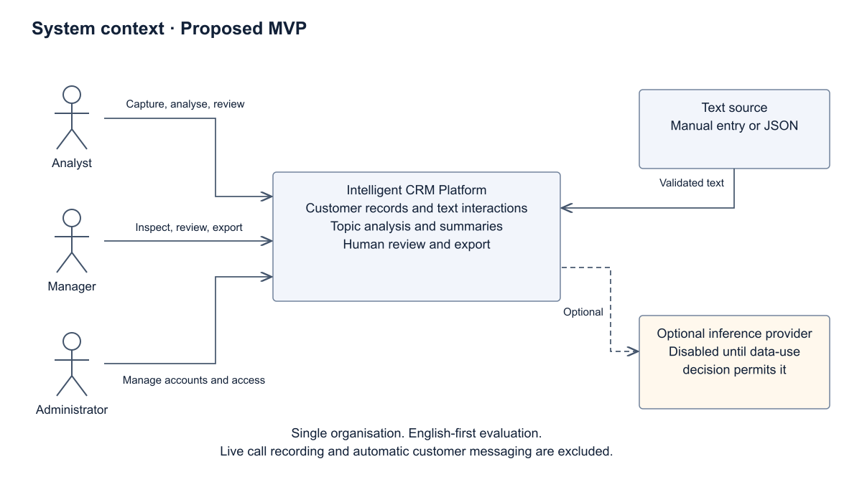
Editable source: diagrams/src/context.puml. Editable SVG: diagrams/exports/context.svg. Proposed design, not deployed components.

Use case diagram
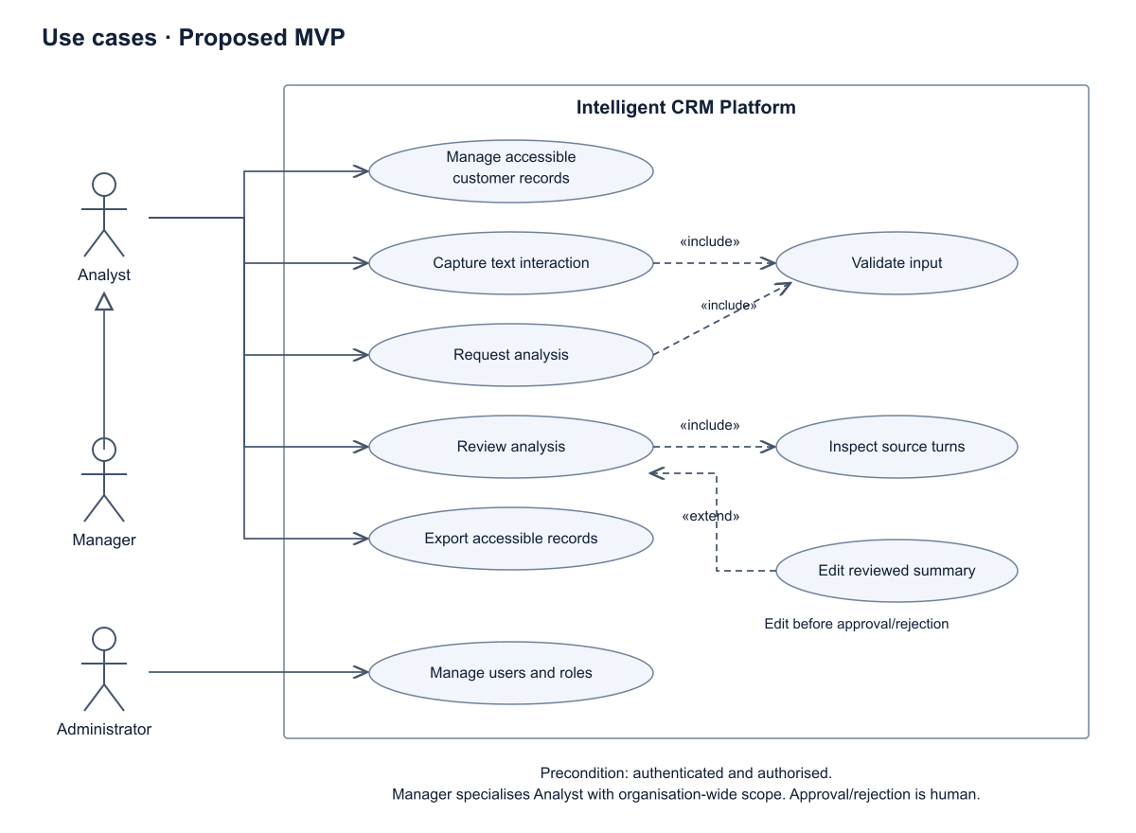
Editable source: diagrams/src/use-cases.puml. Editable SVG: diagrams/exports/use-cases.svg. Proposed design, not deployed components.

Draft component diagram
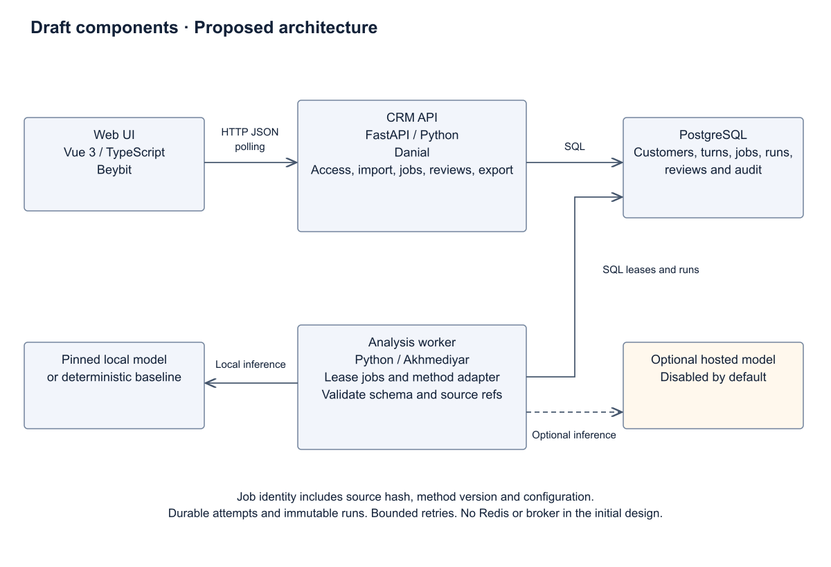
Editable source: diagrams/src/components.puml. Editable SVG: diagrams/exports/components.svg. Proposed design, not deployed components.

8 UX prototype

Audience and primary task
A customer-facing analyst needs to identify the issue and next step from a previous interaction, then check that an automated summary matches its source. The main action is Analyse interaction, followed by Review and approve. Search and source import support this flow. Aggregate insights are secondary.

Scope of the runnable prototype
Open prototype/index.html directly, or run python3 -m http.server 9137 --directory prototype. The prototype runs locally without network calls or external libraries. Fictional fixtures demonstrate customers, interaction text, topic tagging, extractive summaries, source references, review/edit/approve/reject, a failed-analysis recovery state, search, filters and JSON export. Data persist only in the browser's local storage where available. Reset restores fictional examples.
The analysis is a deterministic rule-based/extractive baseline. It is not a pretrained or hosted language model. Prototype role labels do not enforce backend authorisation. Performance, security and quality targets for the production architecture remain unmeasured.

Key scenarios
UX-01 Find a customer and select a text interaction. Inspect ordered speaker turns. UX-02 Run analysis. See the progress state, resulting topics and a short extractive summary with source-turn links. UX-03 Select a source reference. Check the original turn, edit the review text and approve or reject. The raw summary remains available. UX-04 Add an interaction. Reject missing name/text, save valid text and analyse it. UX-05 Inspect a failed run. Retry after the displayed error and verify that success still requires a separate review action. UX-06 Search/filter and export the selected interaction with provenance and review state.

Design decisions
A restrained slate/indigo workspace keeps the conversation as the main content, with the analysis panel beside it. Explicit labels distinguish raw output from reviewed text. Status words supplement colours. Controls have visible keyboard focus, meaningful labels, usable touch targets and responsive layouts. The interface uses synthetic records only and keeps its baseline label visible.

What to show at the checkpoint
Demonstrate one full import-to-review flow, one validation error, one failure/retry and one export. Show editable source and link these scenarios to FR-03, FR-04 and FR-06–FR-09. Do not claim the prototype proves local demand, learned NLP quality or backend access control.

Runnable prototype view
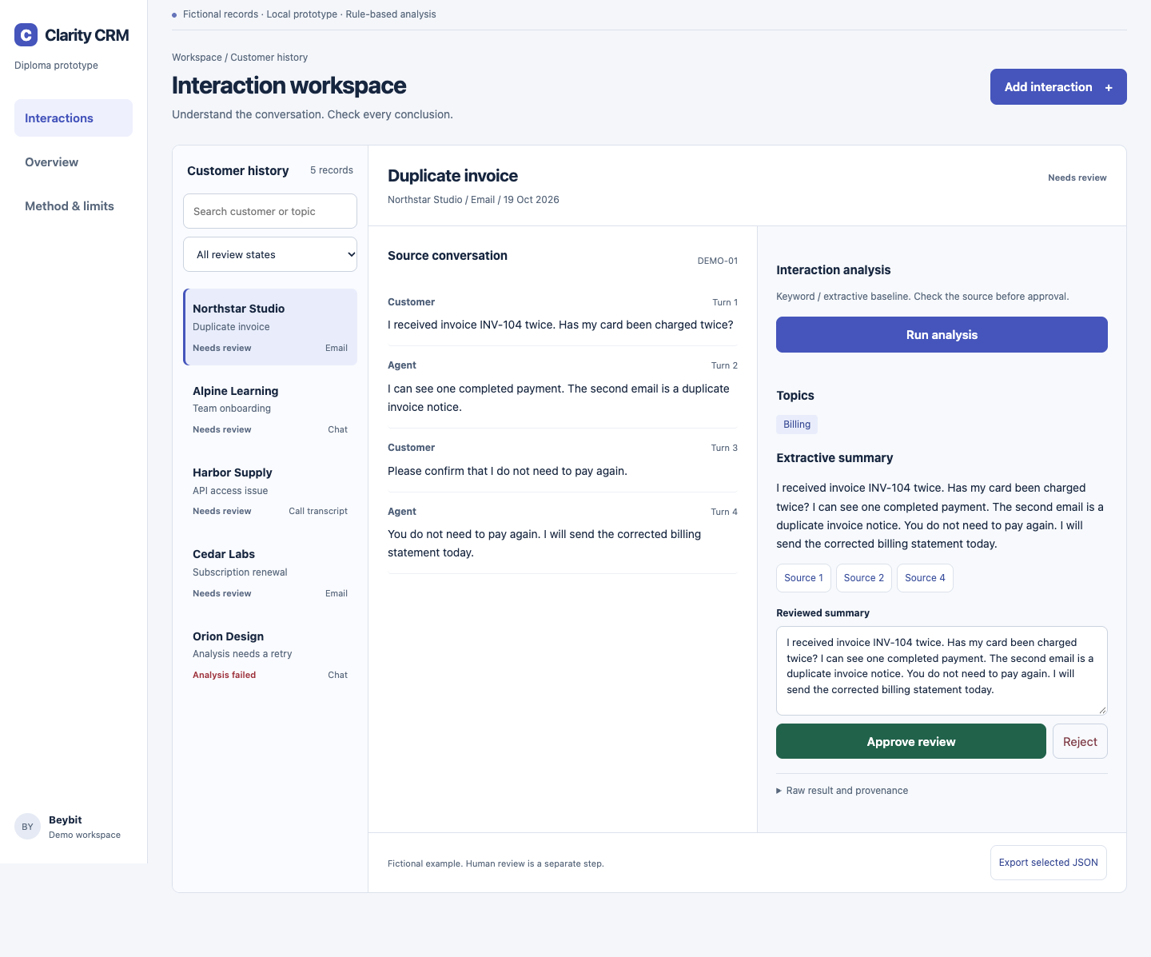
The screenshot shows fictional records and a deterministic extractive baseline. Use prototype/index.html for the full interactive walkthrough.

9 Verification and evaluation plan

Status and hypotheses
This is a prospective protocol. No user study, model benchmark or production performance measurement has been completed. UI/prototype tests are reported separately in the actual verification record. Literature scores are never substituted for project results.

Data and splits
Target 120 de-identified, permissioned or clearly synthetic CRM-like text interactions. Use 20 development records for prompt/rule tuning and 100 held-out records for final reporting. Freeze IDs and hashes before comparison. If fewer records are available, report the actual count and explain the limitation. Keep variants of one conversation in the same split. Include clear cases, ambiguous intent, negation, multiple participants, missing next steps, long inputs and out-of-vocabulary topics. Initial quality claims cover English only.
Public datasets [L01, L02] may support a separate smoke benchmark after licence review. They cannot replace the domain set. Synthetic fixtures establish functionality, not business validity or representative quality.

Annotation
Before scoring outputs, define topic classes and key facts: customer issue, relevant constraints, explicitly agreed action, responsible participant and date only where present. Two reviewers independently annotate source facts and output errors, then adjudicate disagreements. Rotate review to reduce conflicts when a developer evaluates their own method. Preserve raw labels and report agreement. With only team reviewers, disclose bias and seek an external reviewer if feasible. User participation requires permission for notes and any quotations.

Methods and controlled conditions
B0 manual reading is the workflow baseline. B1 deterministic keyword topics plus extractive summary is the algorithmic baseline. C1 is one pinned pretrained candidate selected after hardware/language/licence checks. A hosted LLM is an optional separate condition, not an implicit dependency. Each method sees identical held-out inputs and the same output schema. Freeze prompts/configurations after development. Record code commit, method/model revision, runtime, operating system, CPU/GPU/RAM, source hashes and seeds/settings. Use three repetitions for stochastic methods and report variation.

Metrics and planned decision rules
Topic tagging: report per-class precision, recall and F1 and macro-F1, including absent/rare classes. Proposed target macro-F1 >= 0.75 on the held-out set. Factuality: human-supported factual claims / all generated factual claims. Report unsupported and contradicted claims separately. Proposed target >= 0.95 supported claims and zero unsupported commitments or deadlines. Empty/no-claim summaries do not count as perfect: report them separately and score coverage. Key-fact coverage: correctly represented required source facts / all annotated required source facts. Proposed target >= 0.80, macro-averaged per interaction. Coherence/relevance: independent 1–5 rubric as secondary diagnostics [L03, L09]. Operational behaviour: schema-valid outputs, failed runs, timeouts, duplicate jobs, retries and source-reference validity. A raw result must have 100% valid source IDs. Report latency p50/p95, peak memory and cost per run when applicable. Limits and load conditions follow NFR-03–NFR-07. Targets are initial engineering acceptance proposals, not measured achievements and not a guaranteed result of any model.

User task comparison
After discovery, recruit at least five target-user representatives where feasible, distinct from the developers. Each completes four matched task pairs: manual reading versus the review workspace, using different but comparable interactions. Counterbalance order to reduce learning effects. Measure time from opening the task until an answer, accuracy on source-checked questions, correction actions and usability comments. Compare median paired time difference and error counts, with uncertainty intervals where the actual sample permits. A proposed success condition is a >= 20% median time reduction without more task errors; a small convenience sample supports exploratory conclusions only.
If independent users cannot be recruited, label a team-only pilot explicitly and leave the user-benefit question unresolved. The 3–5 discovery discussions and the later usability experiment serve different purposes and must not be conflated.

Test layers
Unit: schema validators, topic rules, reference validator and state transitions. Integration: authorised CRUD/import, durable job processing, duplicate creation, review history, export access and restart/restore. Browser: valid/invalid capture, search/filter, inspect source, analyse, edit/approve/reject, retry, export, keyboard navigation and mobile overflow. Adversarial: script strings, prompt-like instructions in transcripts, participant swaps, negation, fabricated dates, missing fields, oversized inputs, unavailable model and concurrent worker completion.

Reporting
Publish the frozen evaluation manifest, de-identified permitted data or a reproducible public substitute, raw predictions, reviewer annotations, aggregated metrics, failure examples and threats to validity. Provide a results table with fields unfilled until an experiment actually runs. Consider domain shift, small samples, language limits, annotation disagreement, model changes and synthetic-data bias.

10 Project management and risks

Responsibility and review
Beybit owns frontend, UX, discovery coordination and presentation flow. Danial owns backend, integrations, storage and architecture. Akhmediyar owns analysis, evaluation and platform QA. Every student owns module-level tests, documentation and an identifiable account. Proposed review rotation: Danial reviews frontend integration, Akhmediyar reviews backend acceptance, Beybit reviews analysis output usability. A task owner does not substitute for a completed contribution.

Milestones to the checkpoint
Date | Planned outcome
19 Oct | Research-backed candidate docs, diagrams, portable prototype and repository baseline
20 Oct | User recruitment/discussions, real YouTrack setup and scope decisions
21 Oct | Critical source/technology review and requirements revisions
22 Oct | Diagram/prototype review and evaluation protocol agreement
23 Oct | Actual supervisor comments, peer revisions and presentation rehearsal
24 Oct | Access check, evidence audit and frozen submission tag

Planned tasks
Local ID | Work item | Proposed owner | Priority | Deadline
PLN-01 | Validate customer workflow | Beybit | Critical | 2026-10-20
PLN-02 | Approve problem and MVP boundary | Danial | Critical | 2026-10-20
PLN-03 | Review scientific evidence | Akhmediyar | High | 2026-10-21
PLN-04 | Confirm existing system comparison | Beybit | High | 2026-10-21
PLN-05 | Review technology ADRs | Danial | High | 2026-10-21
PLN-06 | Baseline requirements and traceability | Danial | Critical | 2026-10-22
PLN-07 | Review required UML diagrams | Danial | High | 2026-10-22
PLN-08 | Validate prototype with users | Beybit | High | 2026-10-22
PLN-09 | Approve evaluation protocol | Akhmediyar | High | 2026-10-22
PLN-10 | Set up YouTrack and map tasks | Danial | Critical | 2026-10-20
PLN-11 | Collect supervisor review | Beybit | Critical | 2026-10-23
PLN-12 | Review source links and contracts | Akhmediyar | High | 2026-10-23
PLN-13 | Team review and checkpoint release | Danial | Critical | 2026-10-24
PLN-14 | Rehearse English presentation | Beybit | High | 2026-10-23

The table above preserves the original preparation schedule. Updated 23 October 2026: the real project CRM and 14 tasks have been created. PLN-01–PLN-14 map in order to CRM-1–CRM-14. Current dates are 23 October for preparatory tasks and 24 October for CRM-13. See live mapping (youtrack_live_2026-10-23.json). All 14 tasks are assigned to the three actual accounts; teammate invitations were submitted. Acceptance and access from their accounts remain unverified.

Risk register
Risk | Likelihood / impact | Owner | Mitigation and trigger
No target users or client | High / High | Beybit | Recruit immediately. If no evidence by 22 Oct, disclose the gap and narrow the claim to a technical prototype.
No approved domain dataset | High / High | Akhmediyar | Use synthetic/public data only with accurate labels. Do not infer market need or real-world accuracy.
Inaccurate summaries | High / High | Akhmediyar | Source references, human review, factual error taxonomy and held-out evaluation.
Scope exceeds three-person capacity | Medium / High | Danial | English text-only MVP, modular API/worker and exclusions. Cut optional analytics/connectors first.
Backend stack mismatch | Medium / Medium | Danial | Review ADR-02 before implementation and demonstrate a small API slice.
Disclosure of customer records | Medium / High | Danial | Keep real data outside Git, define permissions/retention and disable external inference by default.
Missing supervisor evidence or tracker follow-through | High / High | Beybit | Tracker is configured; verify invitation acceptance and request substantive supervisor review. A template is not evidence.
Apparent but untraceable contributions | Medium / High | All | Each student makes real reviewed changes from their own account. Do not backdate or fabricate commits.
Vendor/model version drift | Medium / Medium | Akhmediyar | Record access dates, exact model revisions and configuration. Recheck before final comparison.

Repository workflow
Use one repository throughout the diploma; it is public as checked on 23 October. Keep customer records, personal interview data and secrets outside Git. Add reviewers only after exact usernames and access levels are known. main is the reviewed baseline. Work on codex/<actual-youtrack-id>-description branches, submit PRs with acceptance evidence and obtain another member’s review before merging. Use actual CRM issue IDs from the live mapping.

Contribution and release integrity
The current preparation baseline is AI-assisted material created at the actual preparation date. It does not demonstrate progressive student development. Students must review, revise and understand it, then record genuine contributions and reviews. Never impersonate a student, create fake review comments or backdate commits. Freeze pre-defense-1 only when the team selects its actual submission version. Do not move or replace a previously submitted tag.

Actual access and publication state
A minimal initial scaffold was pushed as e5cfad1, with Codex as the author. On 23 October the user explicitly authorised an AI-assisted preparation branch and one PR for CRM-13. This candidate still requires student review; no peer approval, merge or submission tag is claimed. GitHub API checks on 23 October show a public repository, B4rt0n1 with write access and ZLHRS with a pending write invitation. Public reading is available; assigned supervisor reviews require their exact account. See RU_team_handoff.md for the division of review and revision work.

11 Supervisor feedback
Status: no substantive supervisor feedback has been received for this package. Supervisor: Arailym Orazova. Naming a supervisor does not imply approval.

Requested review agenda
1. Problem, target users and acceptable evidence of relevance.
2. Feasibility of the mandatory scope for three students and the proposed individual contributions.
3. Technology ADRs and context/use-case/component consistency.
4. Dataset permissions, evaluation baselines, metrics and target criteria.
5. Deadline risks and evidence required for the checkpoint.

Record template
Review date and channel: [not recorded] Artefact/version reviewed: [not recorded] Supervisor's actual comment: [not received] Team interpretation, separately identified: [not recorded] Decision: accept / revise / defer, with rationale [not recorded] Responsible student and deadline: [not assigned] Commit/PR demonstrating the revision: [not available] Supervisor follow-up or remaining disagreement: [not recorded]
Do not invent a review date, approval or quotation. Keep original comments and document how they changed the work. The earlier administrative justification letter is not evidence of this deliverable review.

12 Source register
All sources checked on 19 October 2026. Scientific sources are distinguished from living product and technical documentation. Product descriptions are not independent quality measurements.
L01 Chen et al. (2021). DialogSum: A Real-Life Scenario Dialogue Summarization Dataset. Findings of ACL
https://aclanthology.org/2021.findings-acl.449/
Use: Dataset and input design.
L02 Zhong et al. (2021). QMSum: A New Benchmark for Query-based Multi-domain Meeting Summarization. NAACL
https://aclanthology.org/2021.naacl-main.472/
Use: Evidence-linked UX.
L03 Gao and Wan (2022). DialSummEval: Revisiting Summarization Evaluation for Dialogues. NAACL
https://aclanthology.org/2022.naacl-main.418/
Use: Evaluation dimensions.
L04 Wang et al. (2022). Analyzing and Evaluating Faithfulness in Dialogue Summarization. EMNLP
https://aclanthology.org/2022.emnlp-main.325/
Use: Adversarial test cases.
L05 Laban et al. (2022). SummaC: Re-Visiting NLI-based Models for Inconsistency Detection in Summarization. TACL
https://aclanthology.org/2022.tacl-1.10/
Use: Optional consistency checker.
L06 Zhu et al. (2023). Annotating and Detecting Fine-grained Factual Errors for Dialogue Summarization. ACL
https://aclanthology.org/2023.acl-long.377/
Use: Review labels and error audit.
L07 Malkiel et al. (2023). GPT-Calls: Enhancing Call Segmentation and Tagging by Generating Synthetic Conversations via Large Language Models. arXiv preprint
https://arxiv.org/abs/2306.07941
Use: Topic taxonomy and baselines.
L08 She et al. (2024). Exploring the Factual Consistency in Dialogue Comprehension of Large Language Models. NAACL
https://aclanthology.org/2024.naacl-long.338/
Use: Factuality and reproducibility.
L09 Song et al. (2024). FineSurE: Fine-grained Summarization Evaluation using LLMs. ACL
https://aclanthology.org/2024.acl-long.51/
Use: Annotation rubric.
L10 Zhu et al. (2025). Factual Dialogue Summarization via Learning from Large Language Models. COLING
https://aclanthology.org/2025.coling-main.302/
Use: Model scope and feasibility.
S01 HubSpot (living documentation). Review call recordings and transcripts.
https://knowledge.hubspot.com/calling/review-call-recordings-and-transcripts
Use: Existing system comparison. Documentation read; no paid account or hands-on test.
S02 Salesforce (living documentation). Call Summaries and Generative Conversation Insights Powered by Einstein Generative AI.
https://help.salesforce.com/s/articleView?id=sf.eci_call_summaries.htm&language=en_US
Use: Existing system comparison. Search-index excerpt verified; direct page returns a CSS/loading error. Confirm entitlements in an actual tenant.
S03 Zoho CRM (living documentation). Zia Call Intelligence.
https://help.zoho.com/portal/en/kb/crm/zia-artificial-intelligence/communication/zia-for-calls/articles/zia-call-intelligence
Use: Existing system comparison. Documentation read; no tenant test. Vendor scoring claims are not independent accuracy evidence.
S04 Dynamics 365 Sales (living documentation). View and understand call summary page.
https://learn.microsoft.com/en-us/dynamics365/sales/view-and-understand-call-summary
Use: Existing system comparison. Documentation read; exact availability depends on configuration and licence.
S05 Dynamics 365 Sales (living documentation). Configure conversation content.
https://learn.microsoft.com/en-us/dynamics365/sales/configure-keywords-competitors-sales-app
Use: Existing system comparison. Documentation read; no tenant test.
S06 Dynamics 365 Sales (living documentation). Languages supported for conversation intelligence.
https://learn.microsoft.com/en-us/dynamics365/sales/language-support-conversation-intelligence
Use: Existing system comparison. Documentation read. Language support must be checked per feature, not inferred from product localisation.
T01 Official maintainers (living documentation). Vue introduction.
https://vuejs.org/guide/introduction.html
Use: Technology comparison and architecture. Component-based UI and reactivity; Vue experience is team-reported.
T02 Official maintainers (living documentation). React quick start.
https://react.dev/learn
Use: Technology comparison and architecture. Alternative component-based UI.
T03 Official maintainers (living documentation). Angular overview.
https://angular.dev/overview
Use: Technology comparison and architecture. Alternative application framework.
T04 Official maintainers (living documentation). FastAPI features.
https://fastapi.tiangolo.com/features/
Use: Technology comparison and architecture. Python API validation, OpenAPI and JSON Schema.
T05 Official maintainers (living documentation). NestJS OpenAPI.
https://docs.nestjs.com/openapi/introduction
Use: Technology comparison and architecture. TypeScript backend alternative with API documentation.
T06 Official maintainers (living documentation). Django overview.
https://docs.djangoproject.com/en/5.2/intro/overview/
Use: Technology comparison and architecture. Python framework alternative with ORM and administrative functionality.
T07 Official maintainers (living documentation). PostgreSQL JSON types.
https://www.postgresql.org/docs/current/datatype-json.html
Use: Technology comparison and architecture. Relational entities plus structured analysis payloads in JSONB.
T08 Official maintainers (living documentation). MongoDB transactions.
https://www.mongodb.com/docs/manual/core/transactions/
Use: Technology comparison and architecture. Document-storage alternative supports transactions; it is not rejected as non-transactional.
T09 Official maintainers (living documentation). Appropriate uses for SQLite.
https://sqlite.org/whentouse.html
Use: Technology comparison and architecture. Embedded-storage alternative; deployment and write concurrency affect suitability.
T10 Official maintainers (living documentation). GraphQL learning guide.
https://graphql.org/learn/
Use: Technology comparison and architecture. Typed querying alternative to resource-oriented HTTP endpoints.
T11 Official maintainers (living documentation). RabbitMQ tutorial.
https://www.rabbitmq.com/tutorials/tutorial-one-python
Use: Technology comparison and architecture. Brokered messaging alternative for asynchronous component interaction.
T12 Official maintainers (living documentation). TfidfVectorizer.
https://scikit-learn.org/stable/modules/generated/sklearn.feature_extraction.text.TfidfVectorizer.html
Use: Technology comparison and architecture. Possible extractive scoring extension; portable prototype uses its own documented keyword baseline.
T13 Official maintainers (living documentation). Transformers pipelines.
https://huggingface.co/docs/transformers/main_classes/pipelines
Use: Technology comparison and architecture. Pretrained classification and summarisation interfaces. Actual model suitability needs measurement.
T14 Official maintainers (living documentation). HTTP semantics.
https://www.rfc-editor.org/rfc/rfc9110.html
Use: Technology comparison and architecture. HTTP method and status semantics for the API contract.

