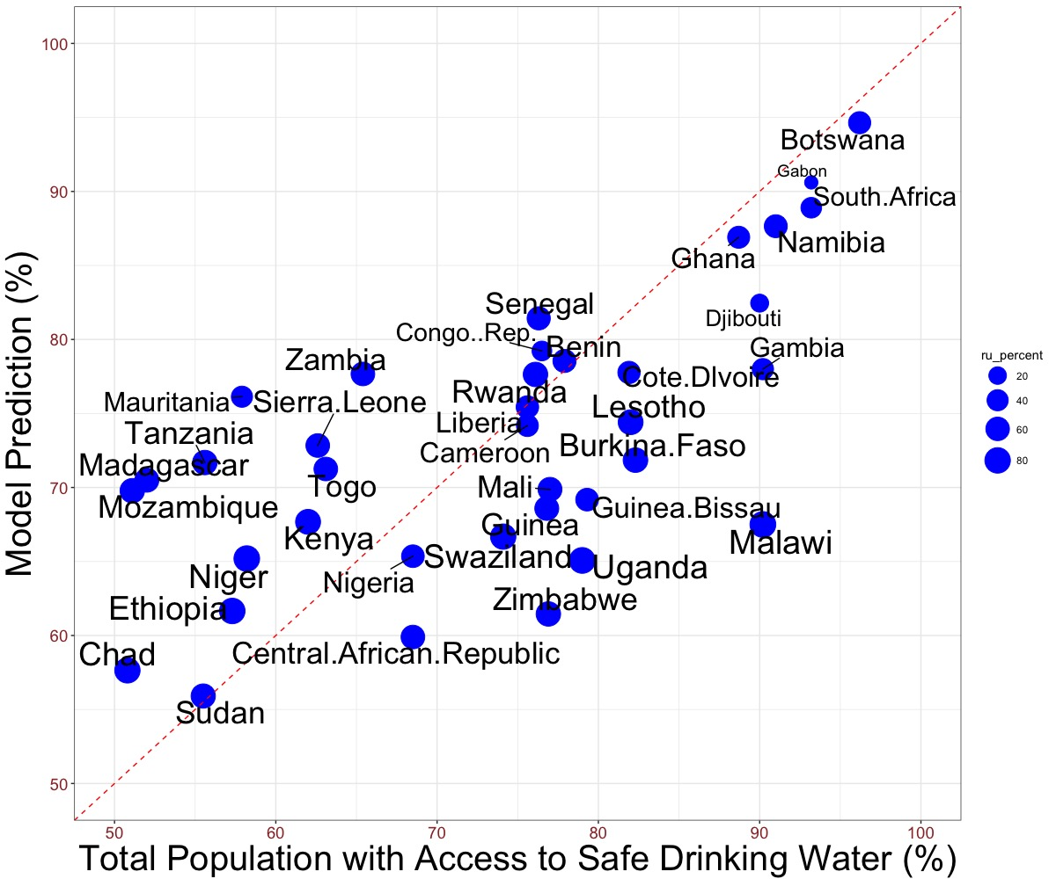

**Figure 1.** Observed vs model-estimated values for population with access to: safe drinking water; sizes of points represent the percentage of the rural population. The safe drinking water predictors are GDP, PC1 of water parameters, PC1 and PC2 of Governance Indicators and percentage of rural population; multiple R2 is 0.45 and F-Stat p-value is 0.001.

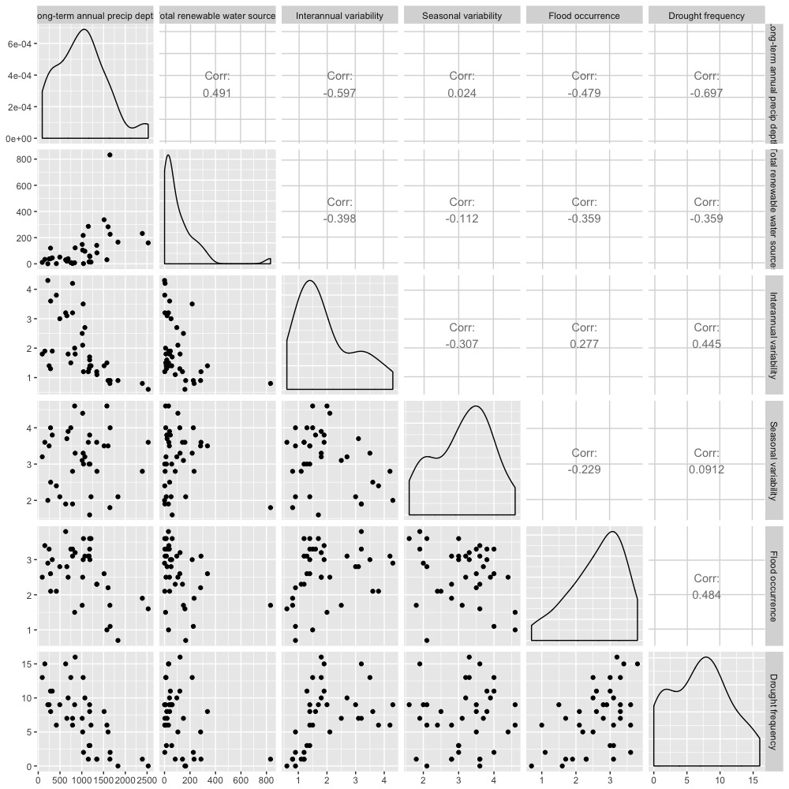

We can see the water resources availability, variability, and extreme weather events are highly correlated.

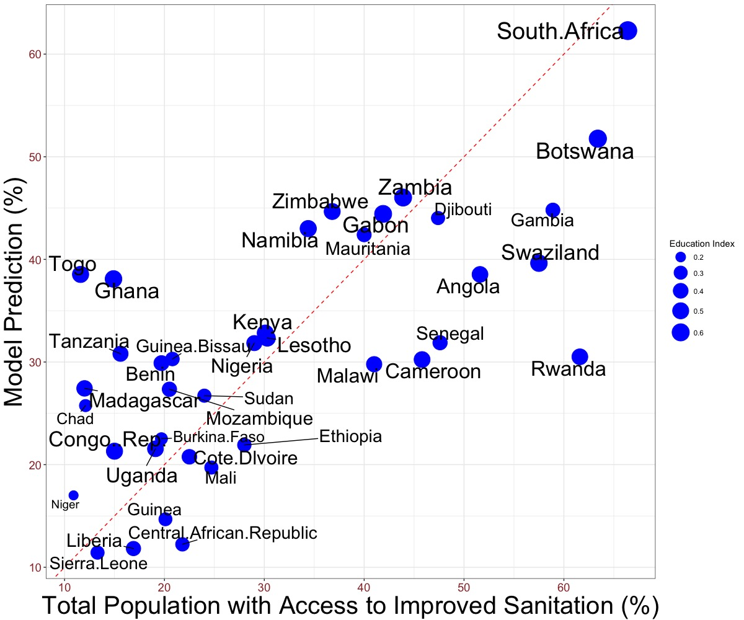

**Figure 2.** Observed vs model-estimated values for population with access to improved sanitation; sizes of points represent the Education Index (average of actual and expected years of schooling). The improved sanitation model predictors are GDP, Education Index, PC1 and PC2 of water parameters, PC2 of Governance Indicators, and percentage of rural population; multiple R2 is 0.5 and F-stat p-value is 8e-4.

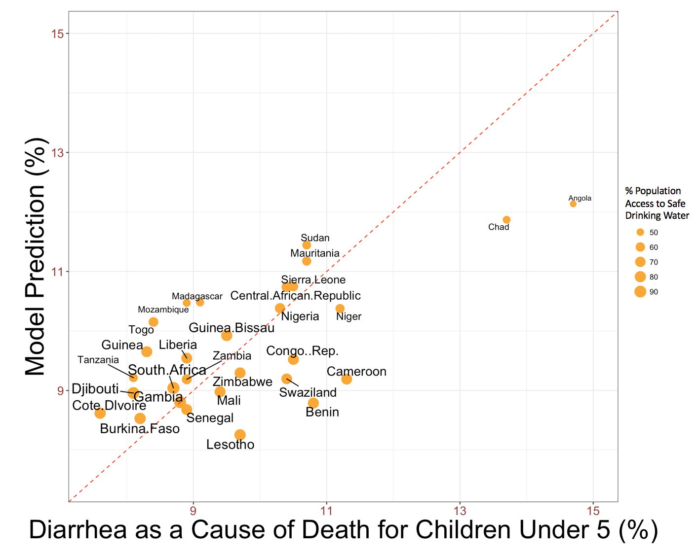

**Figure 3.** Observed vs model-estimated values for diarrhea as a cause of death for children under 5; sizes of points represent percentage of population with access to safe drinking water. The model predictors are percentage of population with access to safe drinking water, GDP, Education Index, rural population, and PC1 and PC2 of Governance Indicators; multiple R2 is 0.58 and F-stat p-value is 8.3e-5.

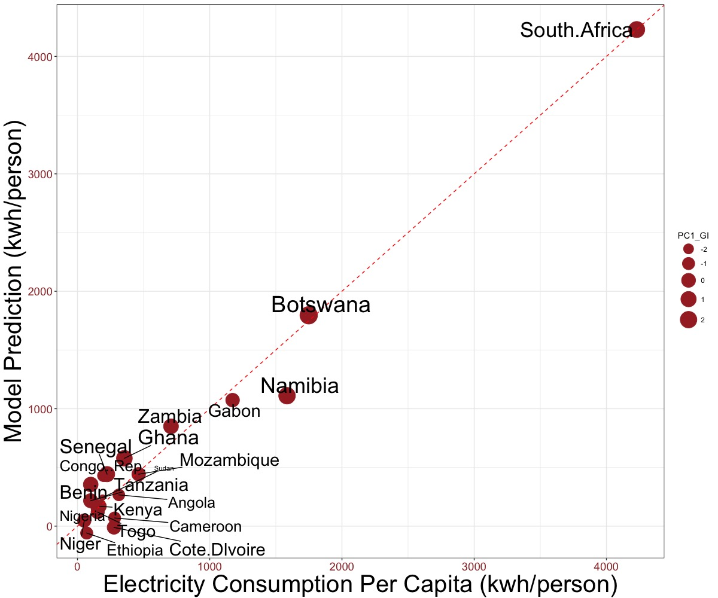

**Figure 4.** Observed vs model-estimated values for annual electricity consumption per capita; sizes of points represent the scores of the first principal component of World Bank Governance Indicators. The model predictors are coal production, natural gas production, net import (total primary energy), geothermal solar and other renewable energy production, nuclear production, hydro production, GDP, percentage of rural population, and PC1 of Governance Indicators; multiple R2 is 0.97 and F-stat p-value is 4e-6.

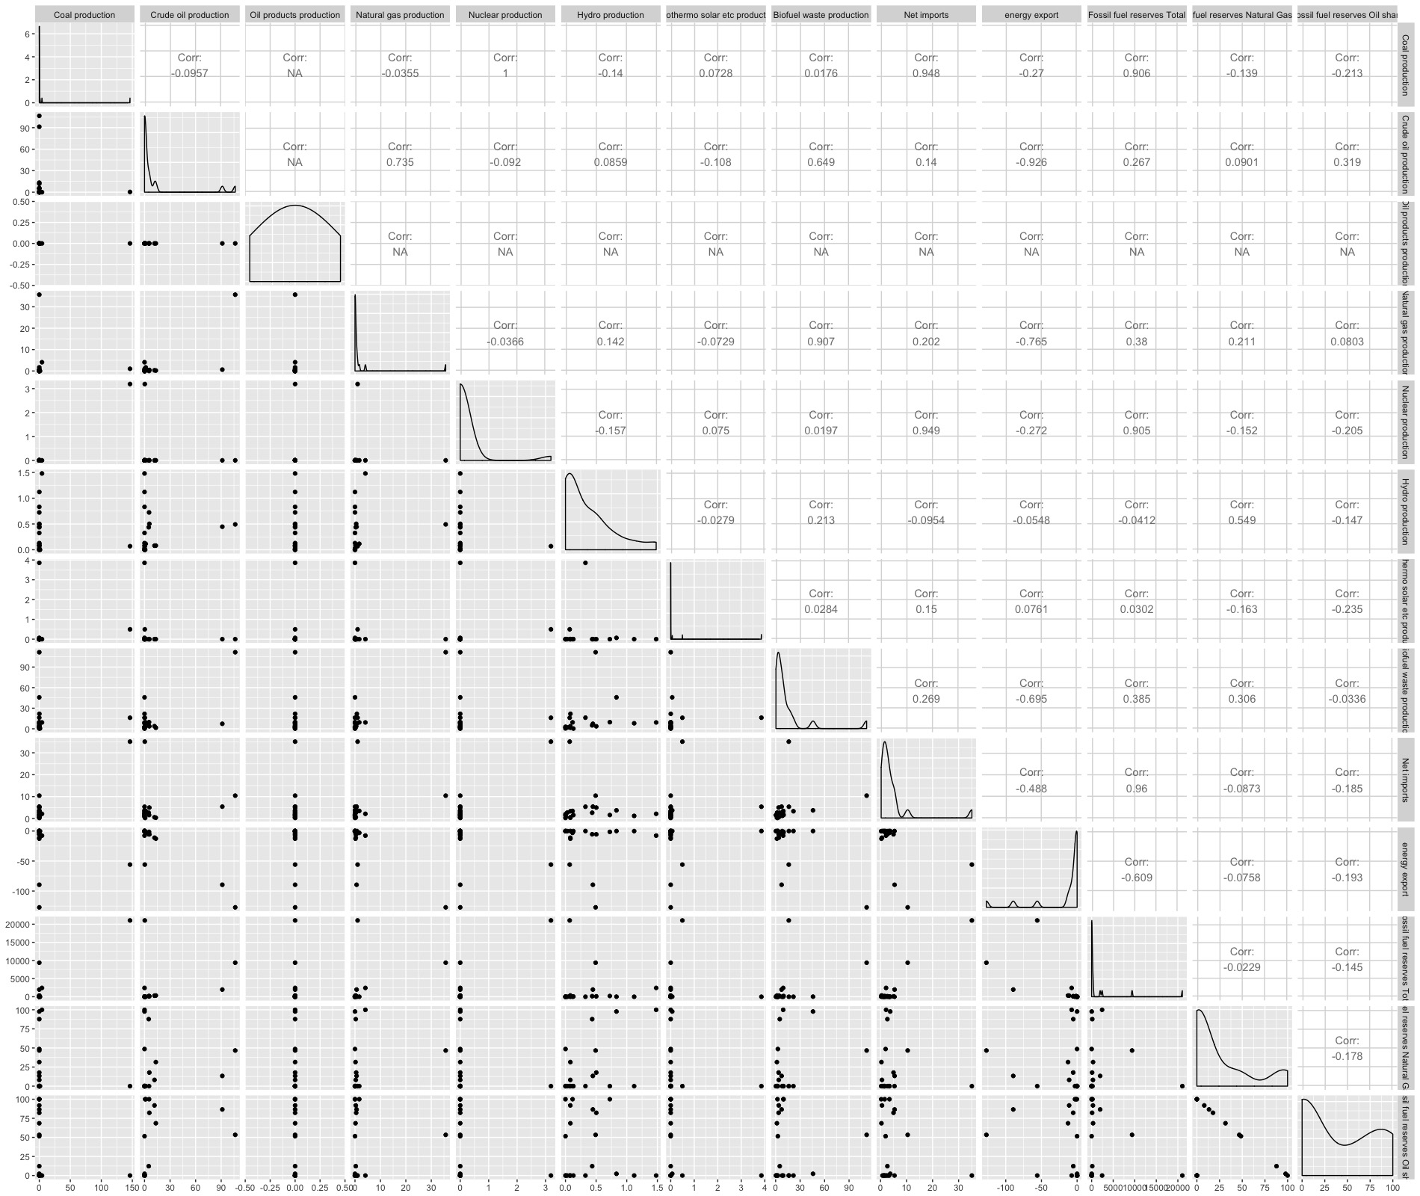

We can see from this correlation matrix of the independent variables of energy resources, many countries have numbers of zero, so we see na values. The distribution of the energy data are so skewed.

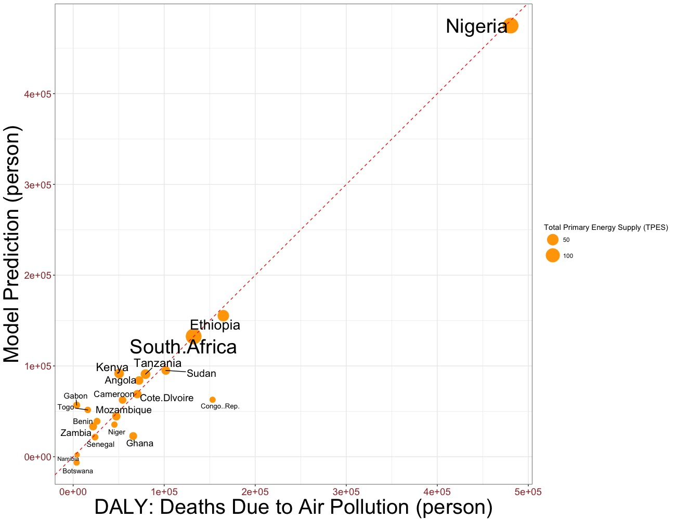

**Figure 5.** Observed vs model-estimated values for DALY: Total Deaths due to Air Pollution; sizes of points represent the Total Primary Energy Supply (TPES). The model predictors are electricity consumption, total primary energy supply (TPES), rural population, and PC1 of Governance Indicators; multiple R2 is 0.92 and F-stat p-value is 4.521e-8.

Note that there are also strong connections between sustainable energy, oil reliance (fossil reserve oil share) and air pollution and related health problems. (mineral direct to health)

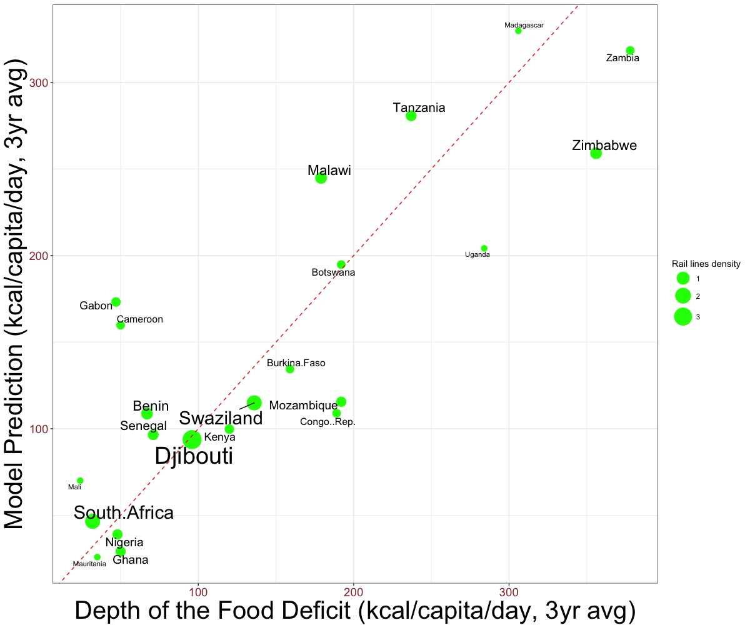

**Figure 6.** Observed vs model-estimated values for Depth of Food Deficit; sizes of points represent the rail lines density (total length of railroad divided by country area). The model predictors are percentage of total country area cultivated, arable land, permanent crops, rail lines density, value of food imports over total merchandise exports, percentage of arable land equipped for irrigation, GDP, education index, and PC2 of Governance Indicators; multiple R2 is 0.71 and F-stat p-value is 0.03.

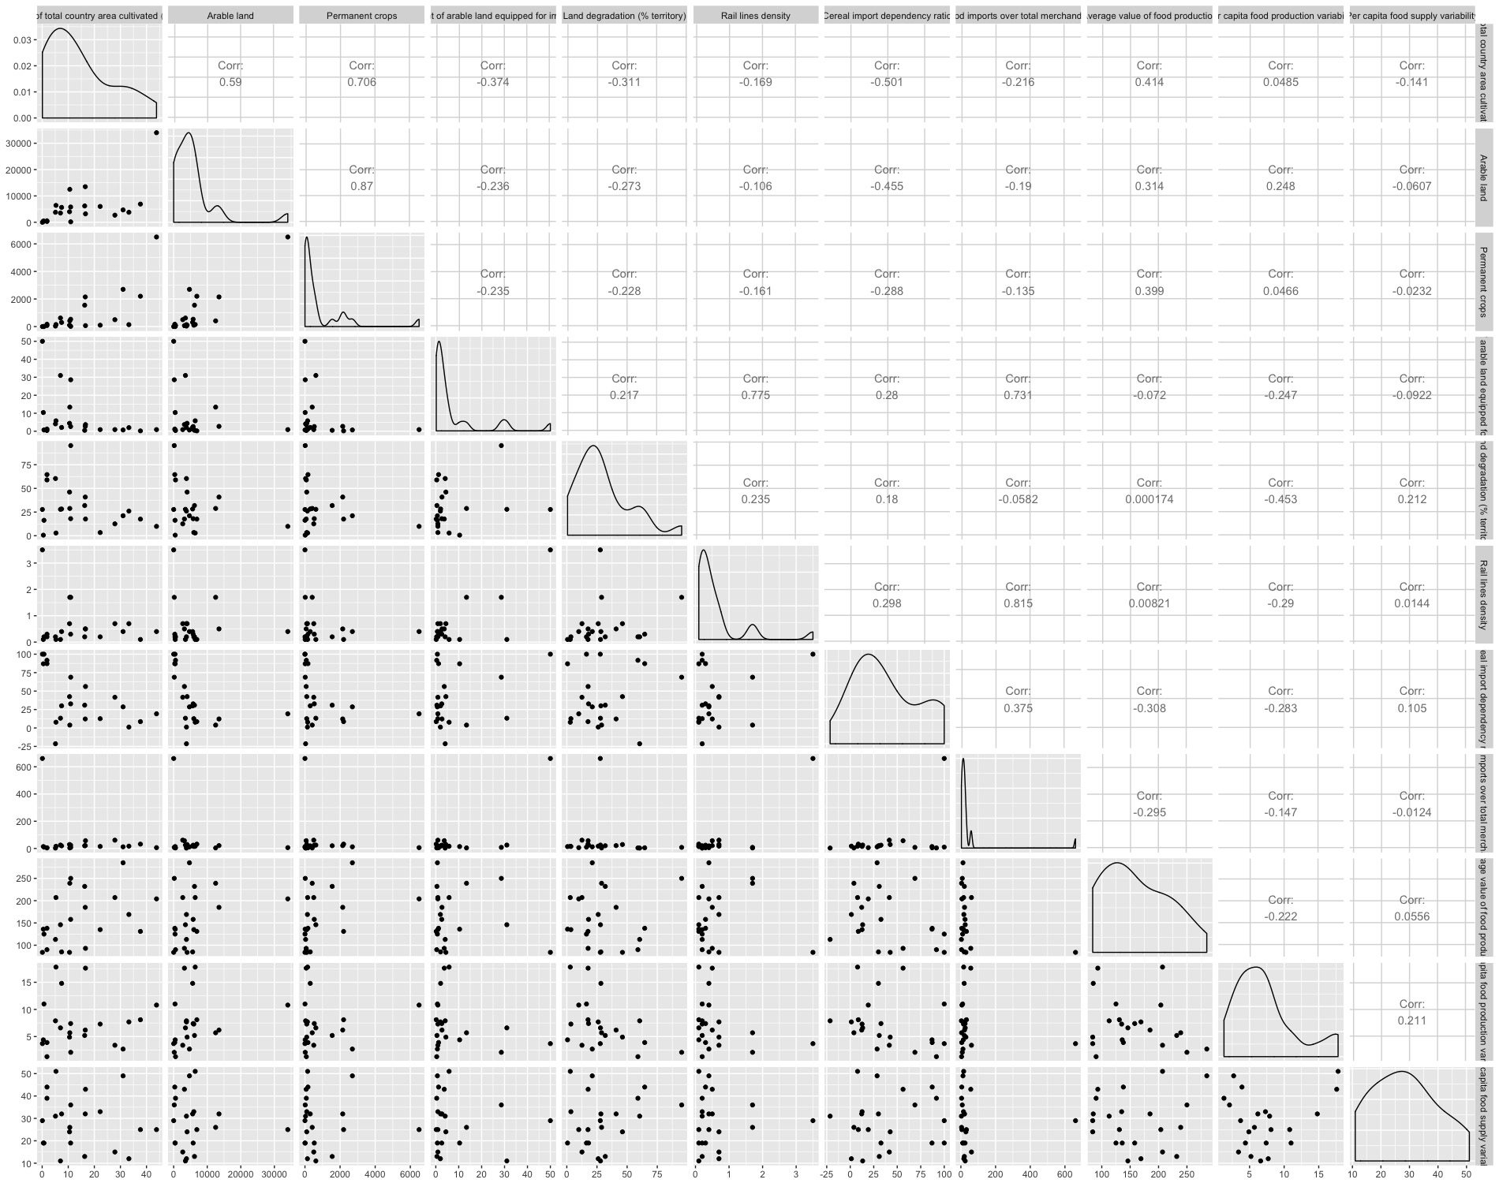

This is the correlation matrix of the food independent variables. The land resource availability variables (total area cultivated, permanent crops, arable land, percentage of irrigation, land degradation). Rail line density are highly correlated with most of the variables, which food import and percentage of irrigation land are the most correlated variables.

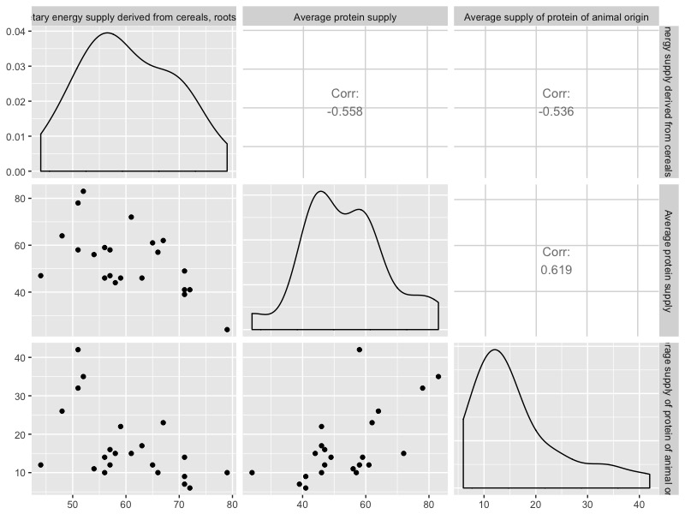

Share of dietary energy supply derived from cereals roots and tubers, average protein supply, average supply can be interpreted as measures of utilization: nutritional balance.

We can see that the three are also very highly correlated.

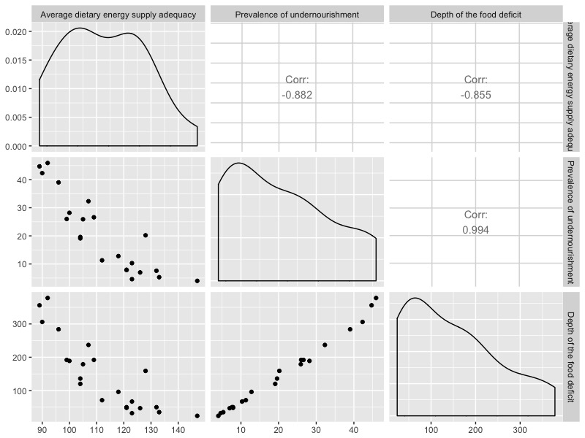

Average dietary energy supply adequacy, prevalence of undernourishment, and food deficit can be all interpreted as measures of general utilization of food. The three variables are highly correlated. Food deficit are rather significantly correlated to prevalence of undernourishment.

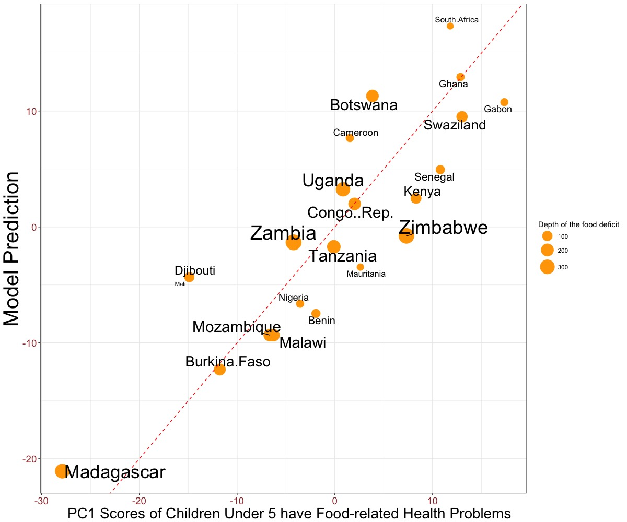

**Figure 7.** Observed vs model-estimated values for scores of the first principal component of children under year of 5 have food-related health problems (stunted, wasting, underweight, overweight); sizes of points represent the depth of food deficit. The model predictors are depth of food deficit, share of dietary energy supply derived from cereals, roots, and tubers, average protein supply, protein supply from animal region, per capita food supply variability, GDP, education index; multiple R2 is 0.72 and F-stat p-value is 0.004.

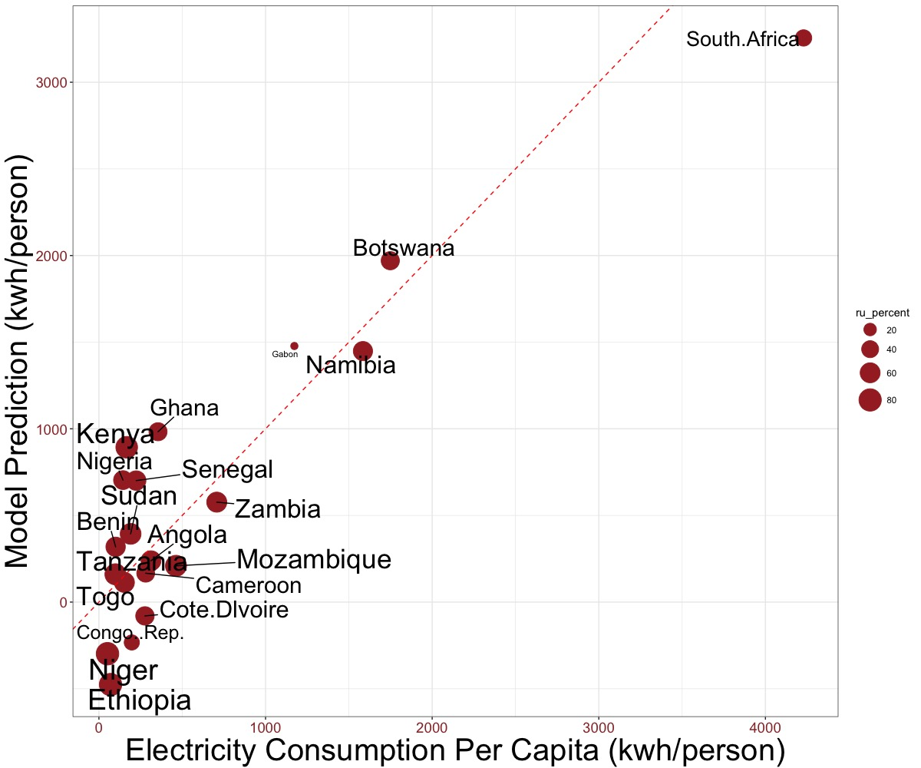

**Figure 8.** Observed vs model-estimated values for electricity consumption per capita (water availability related to energy service); sizes of points represent the percentage of the rural population. The model predictors are PC1 of water availability, variability, and extreme events, GDP, education index and percentage of rural population; multiple R2 is 0.76 and F-stat p-value is 2.9e-5.

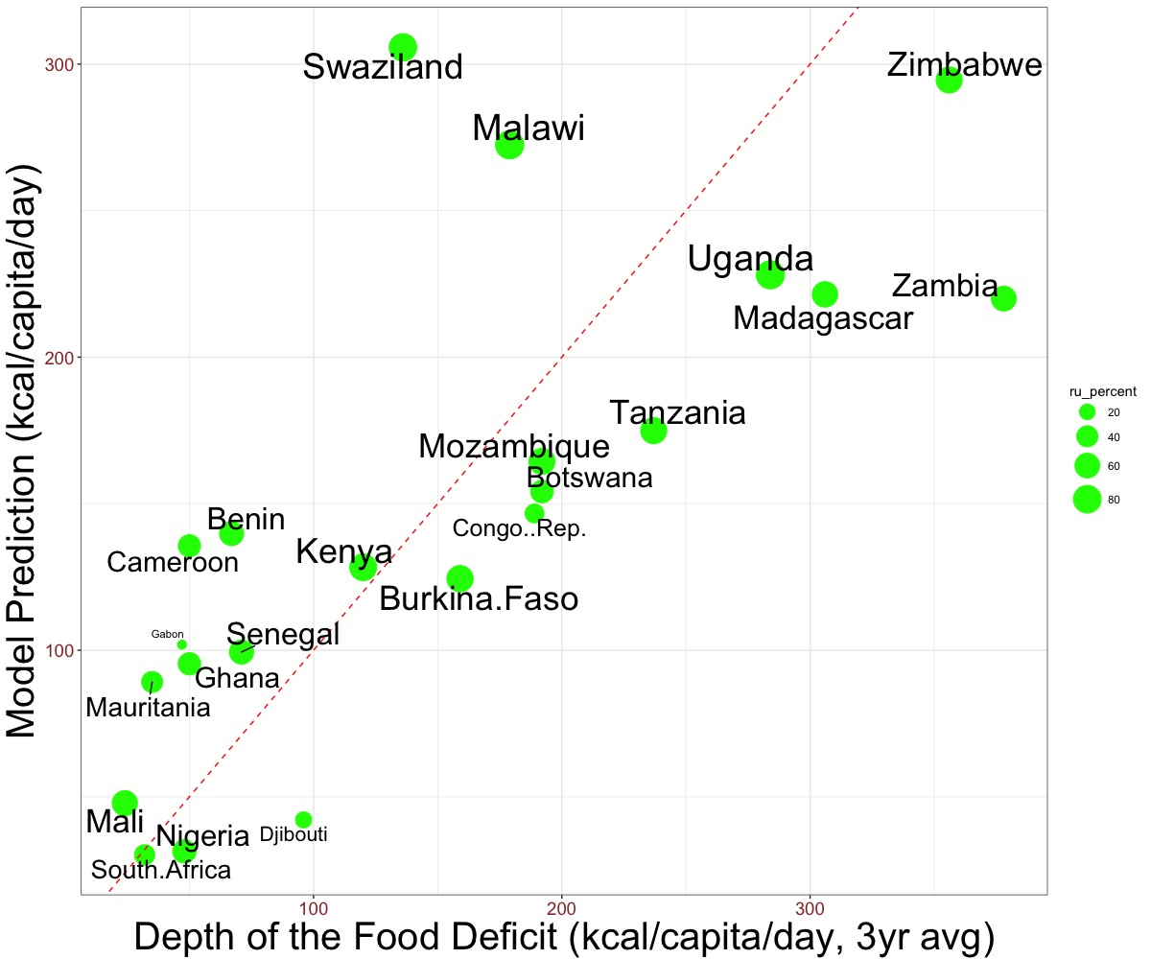

**Figure 9.** Observed vs model-estimated values for depth of food deficit (water availability related to food service); sizes of points represent the percentage of the rural population. The model predictors are PC1 of water availability, PC1 and PC2 of World Bank Governance Indicators, education index and percentage of rural population; multiple R2 is 0.56 and F-stat p-value is 0.014.

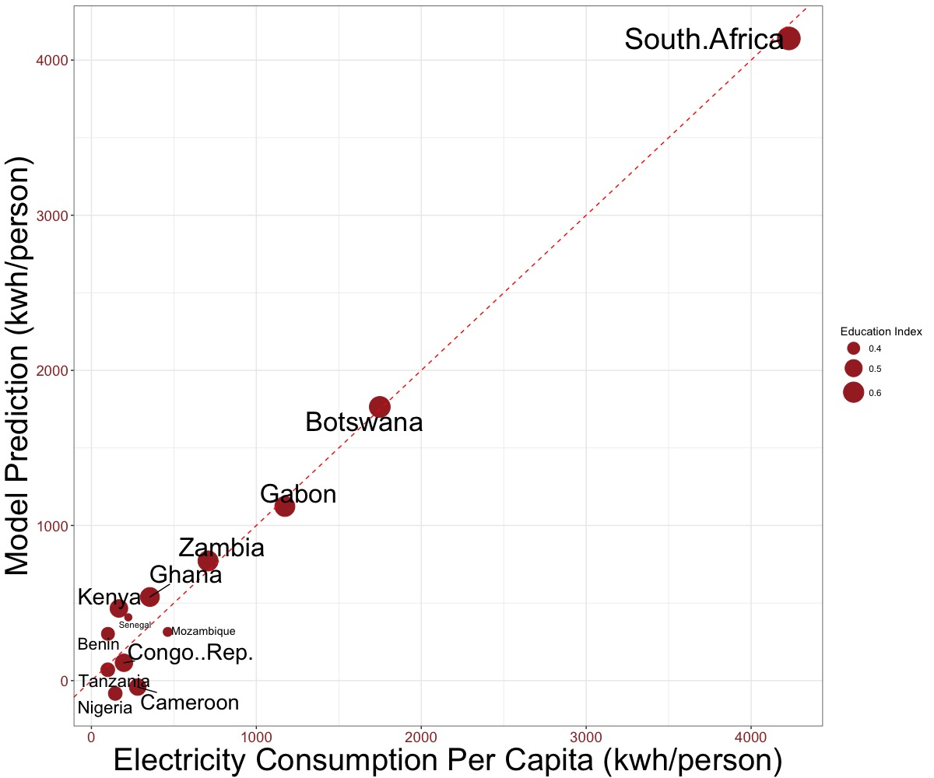

**Figure 10.** Observed vs model-estimated values for electricity consumption per capita (food raw resources related to energy service); sizes of points represent the education index. The model predictors are rail lines density, Per capita food production variability, education index, percentage of total country area cultivated, and percentage of arable land equipped for irrigation; multiple R2 is 0.98 and F-stat p-value is 1.9e-5.

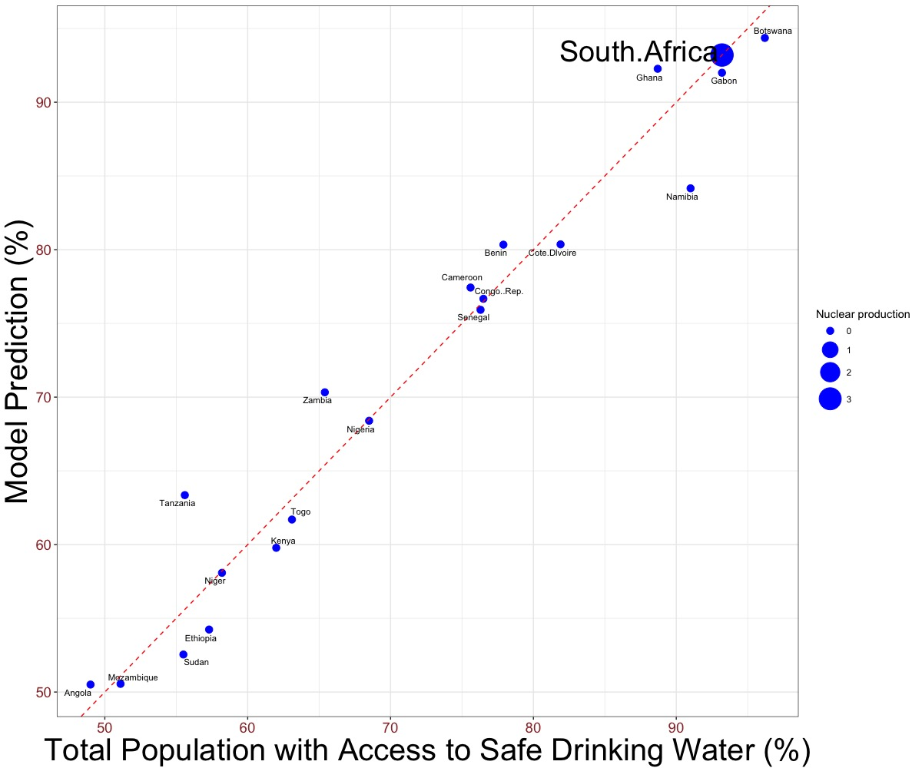

**Figure 11.** Observed vs model-estimated values for total population with access to safe drinking water (energy resources related to water service); sizes of points represent the nuclear energy production. The model predictors are natural gas production, nuclear production, total amount of fossil fuel reserves, shares of natural gas and oil of fossil fuel reserve, GDP, PC1 of governance indicators and percentage of rural population; multiple R2 is 0.96 and F-stat p-value is 1e-5.

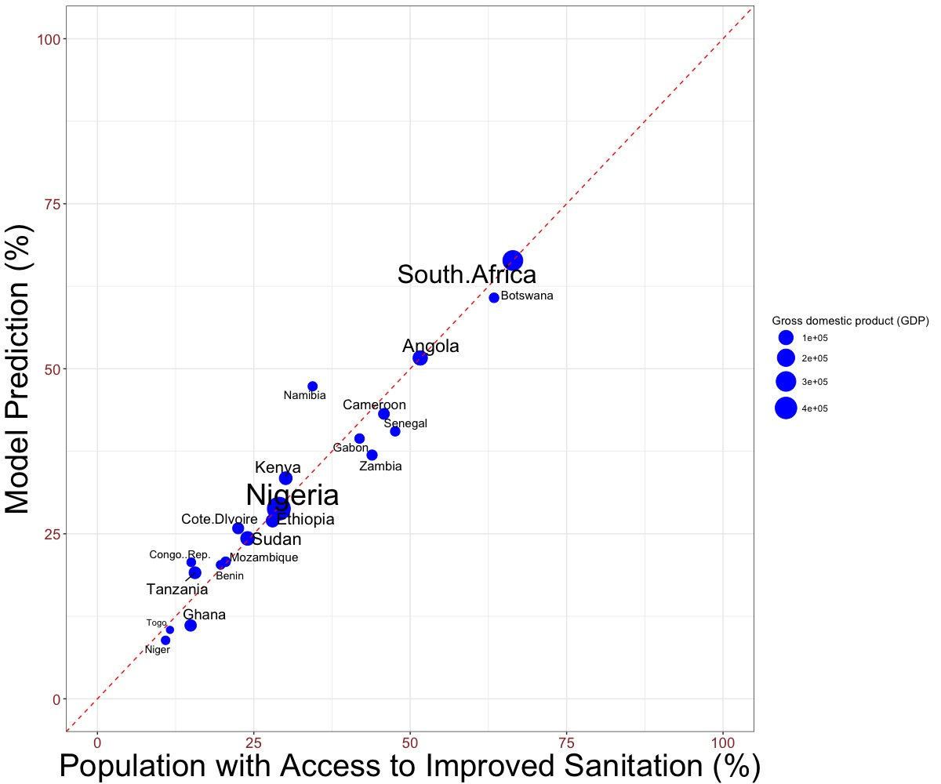

**Figure 12.** Observed vs model-estimated values for total population with access to improved sanitation (energy resources related to water service); sizes of points represent the gross domestic products (GDP). The model predictors are crude oil production, natural gas production, nuclear production, biofuel waste production, net imports, energy export, total fossil fuel reserves and the share of oil, GDP, education index, PC1 of governance indicators, and percentage of rural population; multiple R2 is 0.93 and F-stat p-value is 0.006.

Water Service relation to Undernourishment:

There is less significant relationship (F stat p value get down to 0.12 and multiple R squared get to 0.4) between water service (access to safe drinking water and improved sanitation) and Children Under 5 undernourishments (stunted, wasting, underweight, and overweight) with human interventions (GDP, Education, and Population) in consideration.

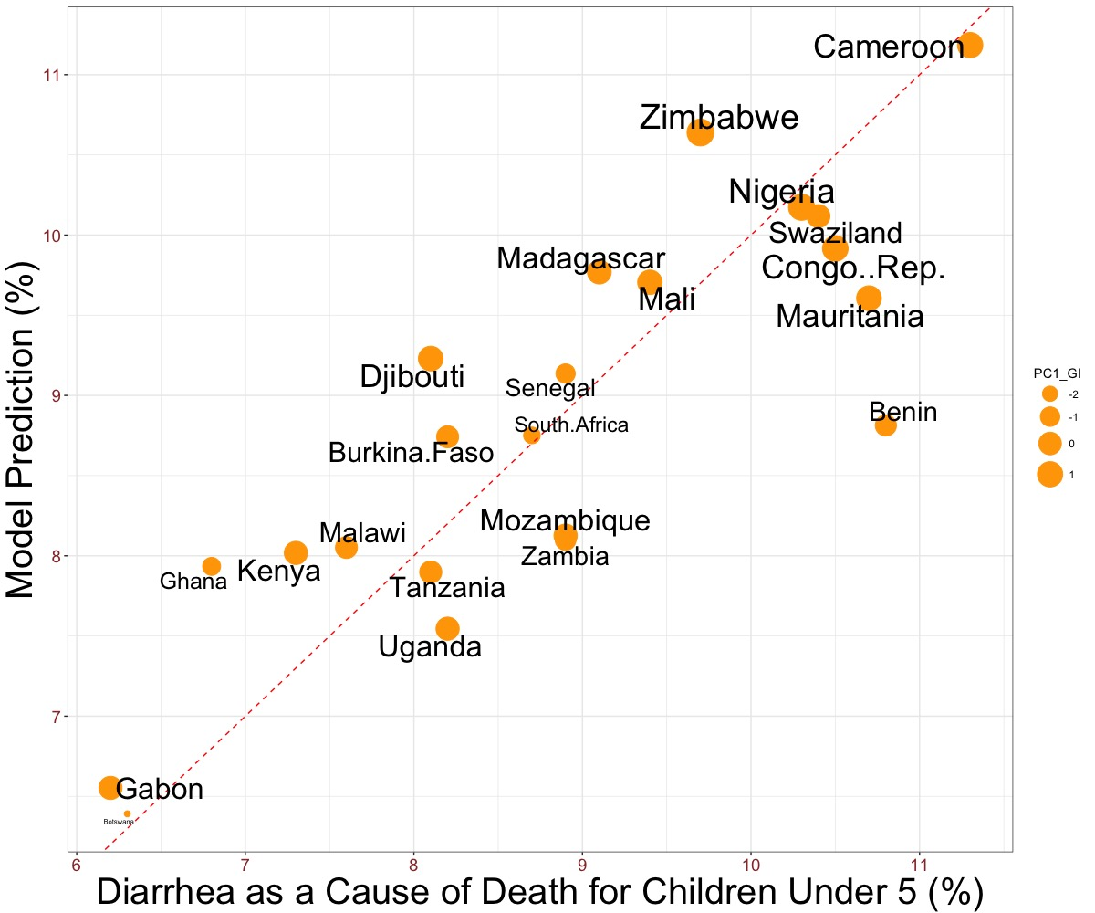

**Figure 13.** Observed vs model-estimated values for Diarrhea as a cause of a death for children under 5 (food service related to water-related health problems); sizes of points represent the first principal component of governance indicators. The model predictors are depth of food deficit, average dietary energy supply adequacy, average value of food production, average protein supply, GDP, Education Index, total and rural population, PC1 and PC2 of governance indicators, and percentage of rural population; multiple R2 is 0.72 and F-stat p-value is 0.048.

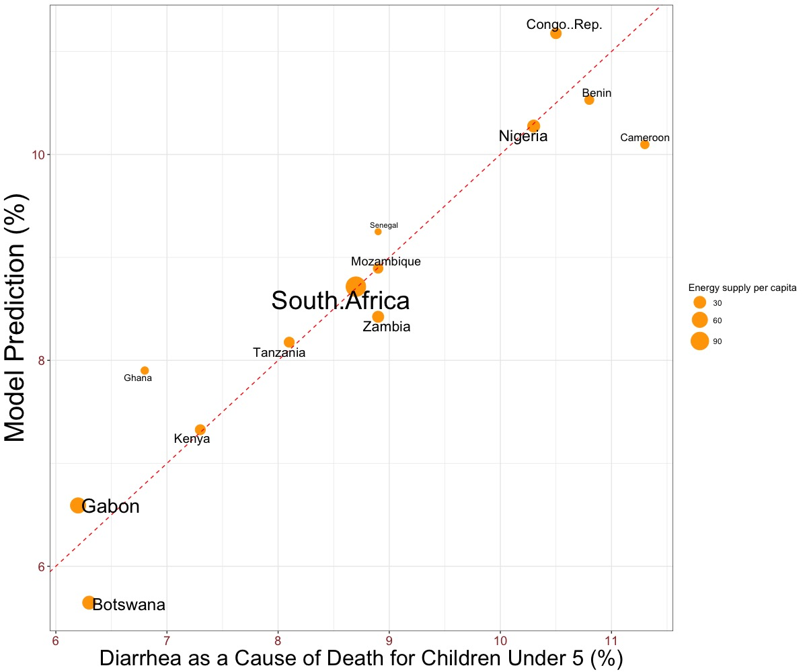

**Figure 14.** Observed vs model-estimated values for Diarrhea as a cause of a death for children under 5 (energy service related to water-related health problems); sizes of points represent energy supply per capita. The model predictors are electricity consumption, total primary energy supply (TPES), energy supply per capita, GDP, PC1 of governance indicators, and rural population; multiple R2 is 0.88 and F-stat p-value is 0.014.

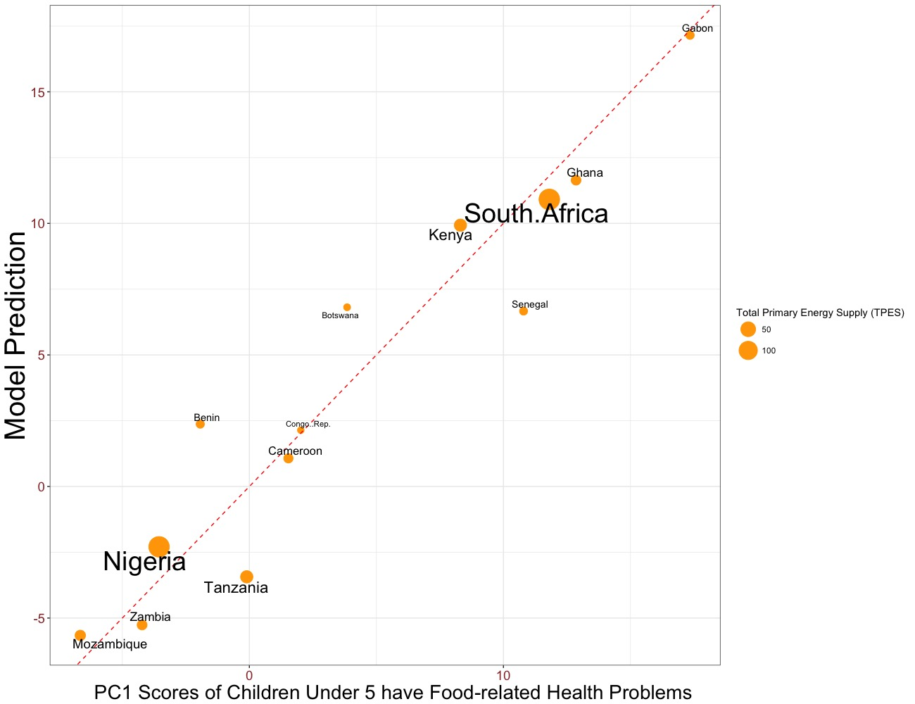

**Figure 7.** Observed vs model-estimated values for scores of the first principal component of children under year of 5 have food-related health problems (stunted, wasting, underweight, overweight) (energy service related to food-related health problems); sizes of points represent the total primary energy supply (TPES). The model predictors are electricity consumption, total primary energy supply (TPES), energy supply per capita, PC1 and PC2 of governance indicators, and percentage of rural population; multiple R2 is 0.91 and F-stat p-value is 0.0072.