**AACS1084**

**Programming Concepts & Design II**

**Assignment**

**2024**

| Programme | : | Diploma In Information Technology |
| --- | --- | --- |
| Tutorial Group | : | Group 1 |
| Date Submitted to Tutor | : | 5/5/2024 |

**Team Members:**

| **No** | **Student Name** | **Student ID** |
| --- | --- | --- |
| 1. | DING WEI JIE | 23WMD00418 |
| 2. | BRYAN LOW CHUN KAI | 23WMD00663 |
| 3. | KOK SIONG JET | 23WMD00411 |
| 4. | LEE ZI YONG | 23WMD00740 |

| No. | Team Member | Task(s) Allocated | Overall Contribution (%) |
| --- | --- | --- | --- |
| 1. | DING WEI JIE | Team leader, combine the whole module and debug the program  in charge of the staff information module | 25 |
| 2. | BRYAN LOW CHUN KAI | Assistant team leader, find the bug from the whole program and debug  in charge of the member information module | 25 |
| 3. | KOK SIONG JET | Team member coding for train schedule module | 25 |
| 4. | LEE ZI YONG | Team member coding for train booking module | 25 |

**Coursework Declaration**

We confirm that we have read and shall comply with all the terms and conditions of TAR University College’s plagiarism policy. We declare that this assignment is free from all forms of plagiarism and for all intents and purposes is our own properly derived work.

| Signature | : | DING | BRYAN |  | **YONG** |
| --- | --- | --- | --- | --- | --- |
| Name | : | DING WEI JIE | BRYAN LOW CHUN KAI | KOK SIONG JET | LEE ZI YONG |
| Photo | : |  |  |  |  |
| Date | : | 4/5/2024 | 4/5/2024 | 4/5/2024 | 4/5/2024 |

**Assignment Evaluation Form**

| **Student Name** | | DING WEI JIE | BRYAN LOW CHUN KAI | KOK SIONG JET | LEE ZI YONG |
| --- | --- | --- | --- | --- | --- |
| **Module handled** | | staff module | member module | train schedule module | train booking module |
| ***Assessment Criteria*** | ***Marks Awarded*** | | | | |
| ***Application of Programming Knowledge*** | |  | | | |
| Structures   * Basic + extra fields, * Use of nesting & arrays * Appropriate usage | **12** |  |  |  |  |
| File Processing   * successful processing * Validation of data * Appropriate usage | **12** |  |  |  |  |
| Functions   * 4 Basic file fns, * Extra file fns, useful/correct * Approp. menu design & process | **12** |  |  |  |  |
| Others   * Use of parameters; correct usage * Subsidiary working functions * Minimized global variables | **12** |  |  |  |  |
| Teamwork   * Main menu, logo etc * System/module integration * Report integration/content * Sharing of files, functions * Communication, cooperation | **12** |  |  |  |  |
| Program originality, efficiency and readability   * Innovation, uniqueness * Approp. logic structures * Code Readability | **10** |  |  |  |  |
| Report (indiv. section)   * Clarity of description * Narrated Screens for all processes (basic + extra) | **20** |  |  |  |  |
| Penalty - Late Submission   * 1-3 days late 🡪 -10 * 4-7 days late 🡪 -20   >7 days late => **Total mark = 0** |  |  |  |  |  |
| **Subtotal (i)** |  |  |  |  |  |
| Presentation   * Organization, explanation * Enthusiasm, preparedness, attitude, understanding * Q&A handling **Subtotal (ii)** | **10** |  |  |  |  |
| **TOTAL MARK** |  |  |  |  |  |

Note: In addition to the late penalty, marks will also be deducted under the different categories for other reasons, eg. bad programming practices, uncooperativeness, etc.

# Table of Contents

| ***Chapter*** | ***Description*** | ***Page No*** |
| --- | --- | --- |
| 1 | Introduction | 1 |
| 2 | Overall System - Module Structure Chart | 2 |
| 3 | Main Screen Design | 3 |
| 4 | System Modules | 4 |
| 4.1 | Staff Modules by DING WEI JIE | 4-11 |
| 4.2 | Member Modules by BRYAN LOW CHUN KAI | 12-26 |
| 4.3 | Train Schedule Module by LEE ZI YONG | 27-43 |
| 4.4 | Train Booking Module by KOK SIONG JET | 44-59 |

# Introduction

Our team has created and implemented this console-based train ticketing system using the C programming language. Our system seeks to expedite the booking of train tickets while offering practical assistance to members and staff. To ensure that every facet of the system is fully covered, each team member creates and maintains one crucial module.

1. The management of staff login accounts and the upkeep of staff login information are the main topics of the staff information module. It guarantees the integrity and security of the ticketing process by allowing authorised staff members to access the system safely.
2. Member Information Module: The purpose of the Member Information Module is to keep up-to-date, thorough member data. Managing member logins, passwords, contact information, and booking histories falls under this category. By monitoring member data, we can tailor their experience and deliver effective service.
3. Train Scheduling Module: The Train Scheduling Module is essential for effective train schedule management. It tracks important details like departure and arrival times, locations, ticket costs, and available seats. This module ensures that members and staff have easy access to current and accurate scheduling information.
4. Ticket Booking Module: The primary purpose of the Ticket Booking Module is to make booking train tickets easier. It includes choosing the departure and booking dates, choosing a seat, processing payments, and keeping track of the status of your ticket, among other aspects of making a reservation. This module ensures that our members have a simple and easy booking process.

Every module is essential to the overall operation of our train ticketing system, adding to its effectiveness and ease of use. Through the thoughtful design of every module and utilising the C language's capabilities, our goal is to provide a dependable and sturdy solution that caters to the requirements of both members and staff.

# Overall System – Module Structure Chart

[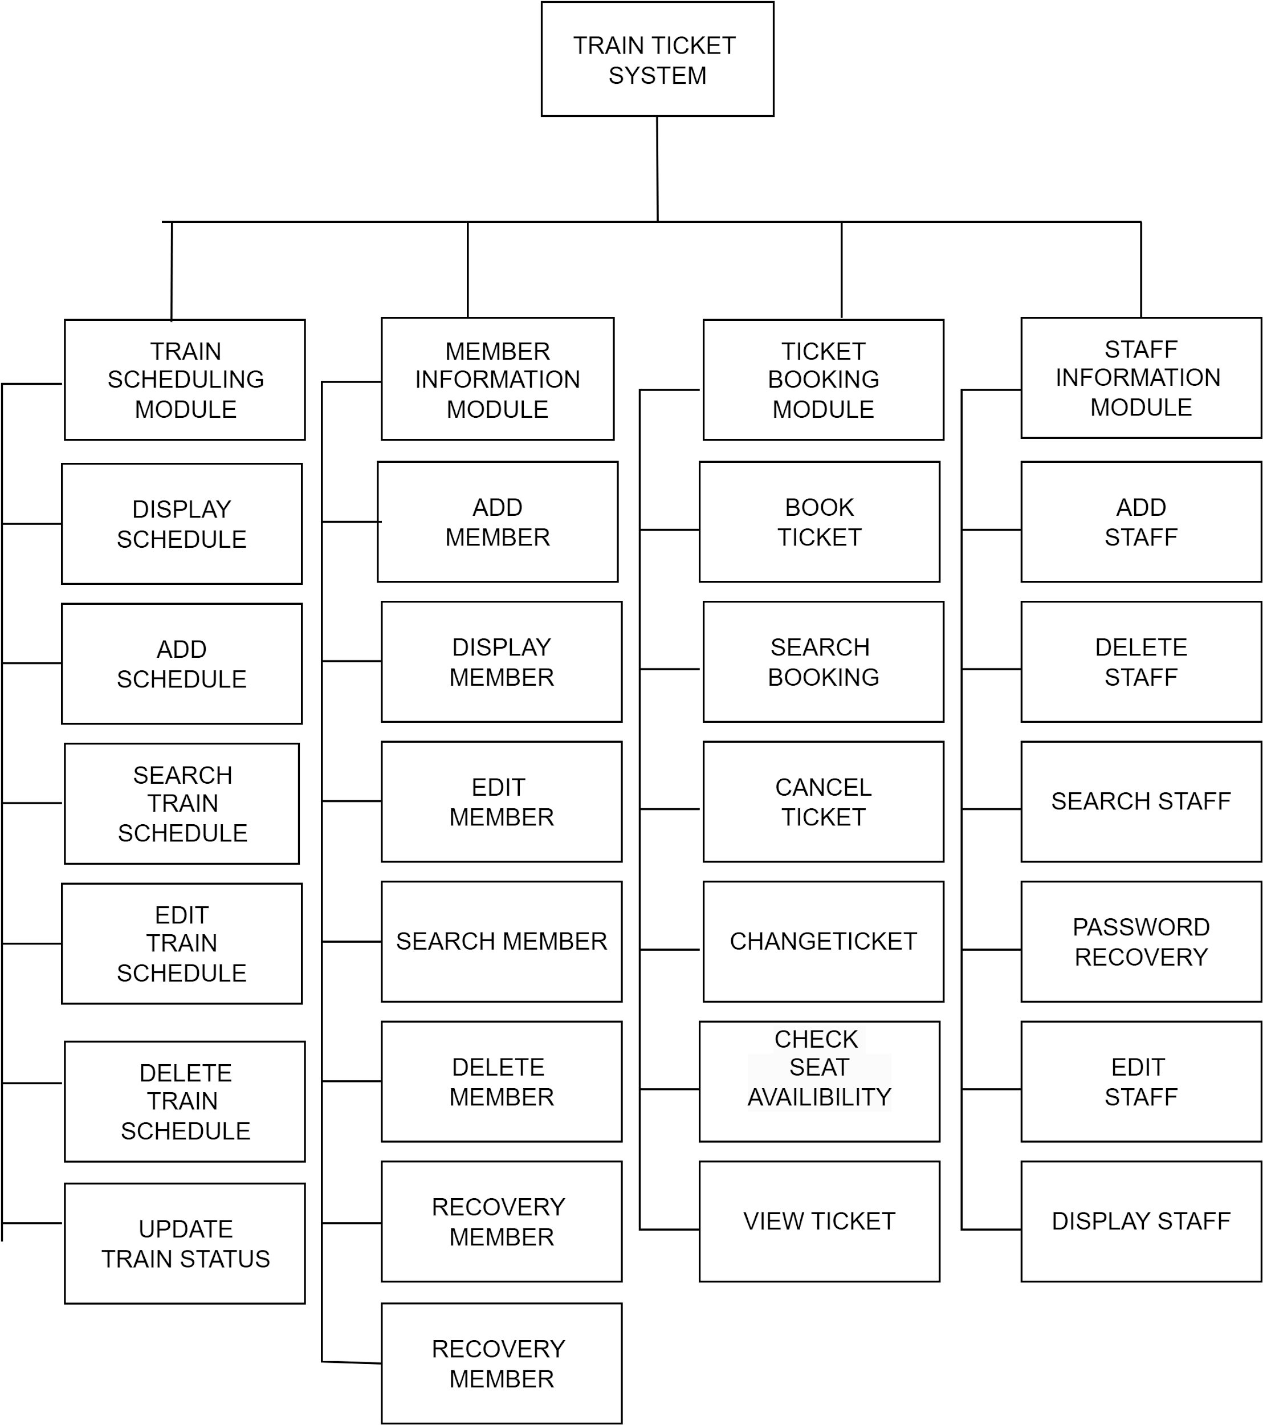](https://app.diagrams.net/?page-id=2kitAOzDo71Z86J_W_E_&scale=auto#G1BpJh_sMdhdki-PHdM1892cd8e4XUiCTa)

# 3.0 HOME SCREEN

# 

# 

# 

# 

# 

# 

Staff members can enter 1 to access the staff login page, where they can enter their staff ID and password to maintain the train schedule, staff details, and train booking.

Enter 2 lets users access the member login page using a member ID and password. After logging in as a member, users can view or search schedules, search booking history, change tickets, and maintain their own account.

Users can exit the system quickly by entering 3.

# 4.0 SYSTEM MODULE

## 4.1 STAFF INFORMATION MODULE BY DING WEI JIE

### 4.1.1 BRIEF DESCRIPTION

##### Add Staff Function

The feature allows the admin to add new staff details for login and other purpose.

##### Delete Staff Function

The feature allows the admin to delete specified staff details, but it's can't delete himself .

##### Edit Staff Function

The feature allows the editor to specify staff details if any are wrong.

##### Search Staff Function

The feature allows you to search some staff details by searching their name .

##### Display Staff Function

The feature will display all current staff details.

##### Staff Password Recovery Function

This feature allow staff to reset password if whom forget their password , by entering staff id and password recovery to reset password.

## 

### 

### 4.1.2 Outputs & File Contents

#### STAFF MAIN MENU

Staff can login to their account; if they forget their password, they also have the option to reset their password.

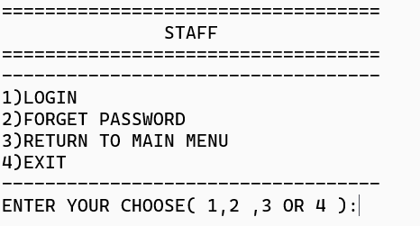

#### STAFF LOGIN

Staff login accounts with their own staff ID and password.

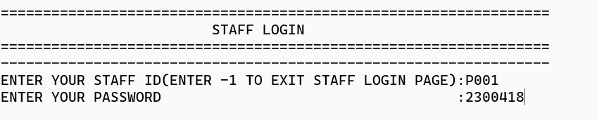

#### STAFF RECOVERY PASSWORD FUNCTION

If staff forget their own password, they can use a recovery password to reset it. Before entering a new password, the staff needs to enter their staff ID and password recovery to verify that the correct person is able to reset the password.

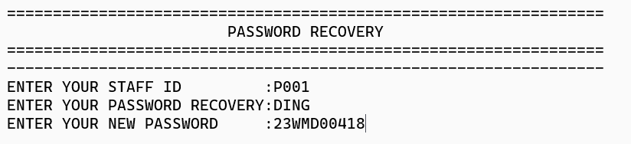

Before resetting the password, the record is in the staff text file.

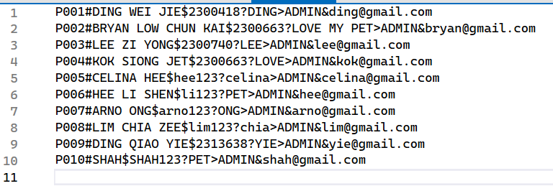

After resetting the password, the record is in the staff text file.

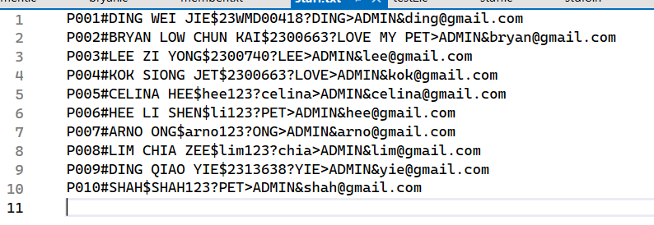

#### 

#### STAFF MENU

Staff can enter the choice and do any activity.

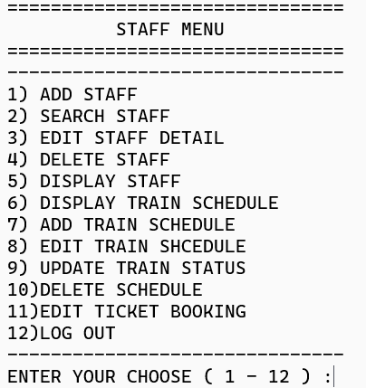

#### ADD STAFF FUNCTION

My staff text file has the most recent record before adding staff.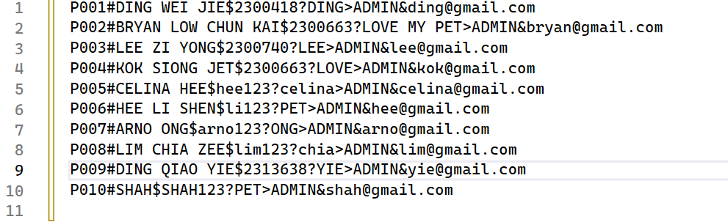

Before adding a new staff record, the staff ID will be verified against the current staff text record. 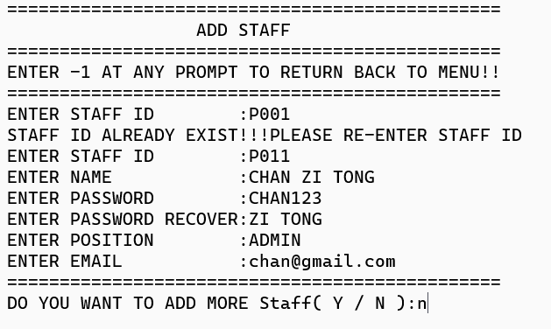

A newly added staff record will save to the staff text file after being added.

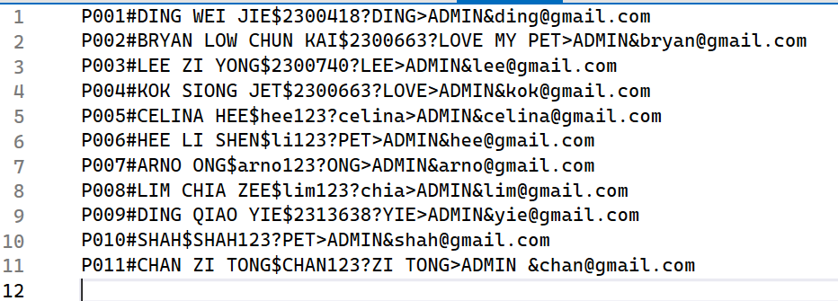

* **SEARCH STAFF FUNCTION**

Staff are able to look up colleagues by name.



The system will provide the results data once they have entered their name.

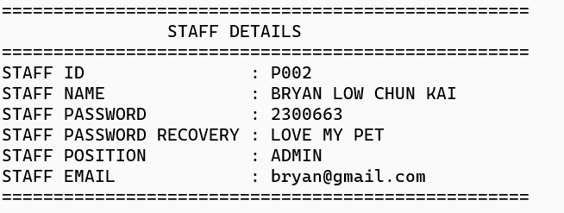

* **EDIT STAFF FUNCTION**

Staff can input their staff ID to modify other staff member data.

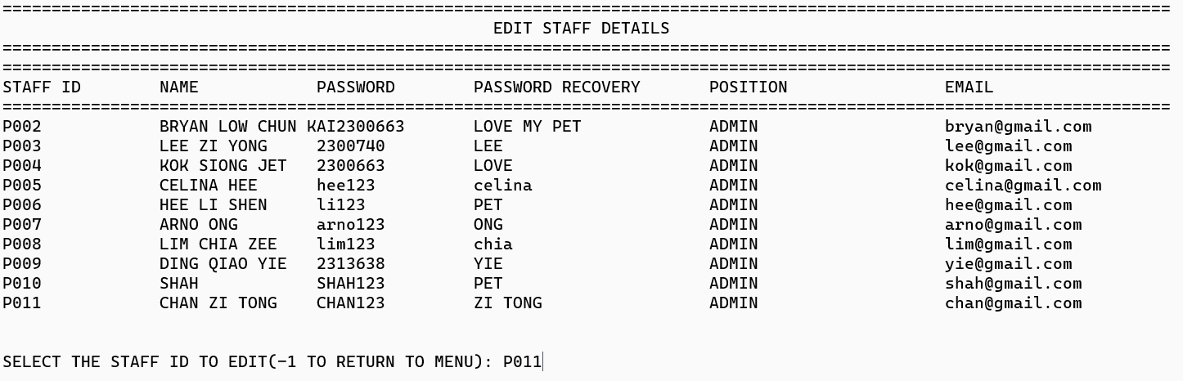

Before staff edit any staff details, record them in the staff text file.



After selecting a staff ID to modify their details.

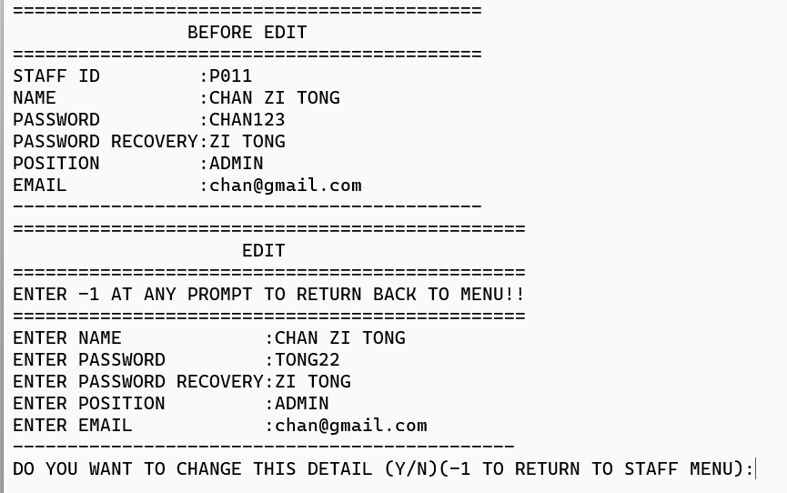

After confirm to change the detail , the specify record will change according input data in staff text file.

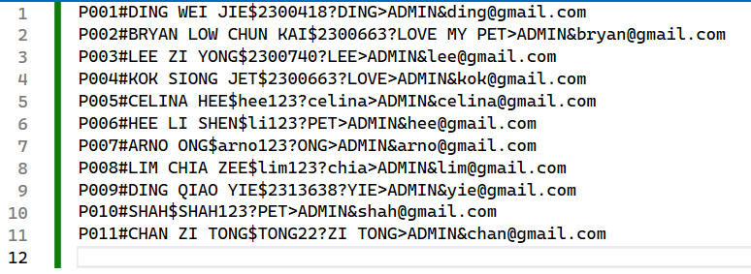

* **DELETE STAFF FUNCTION**

Staff are able to delete other staff by entering their staff ID.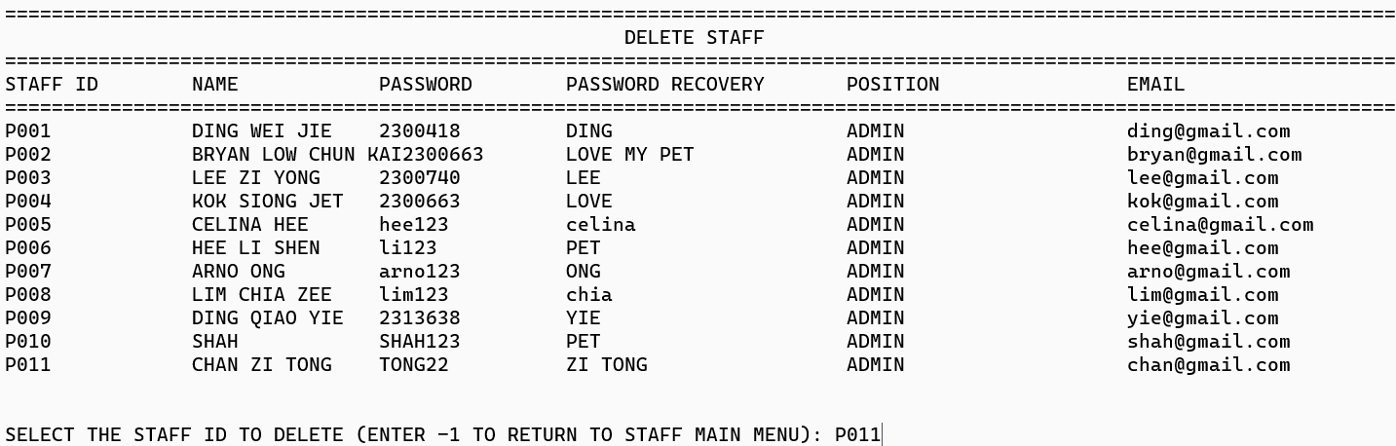

Before the specified staff is deleted, the record is in the staff text file.



After specifying the staff being deleted, the record is in the staff text file.

## 

## 

## 

* **DISPLAY ALL STAFF FUNCTION**

This function is display all the staff and their details

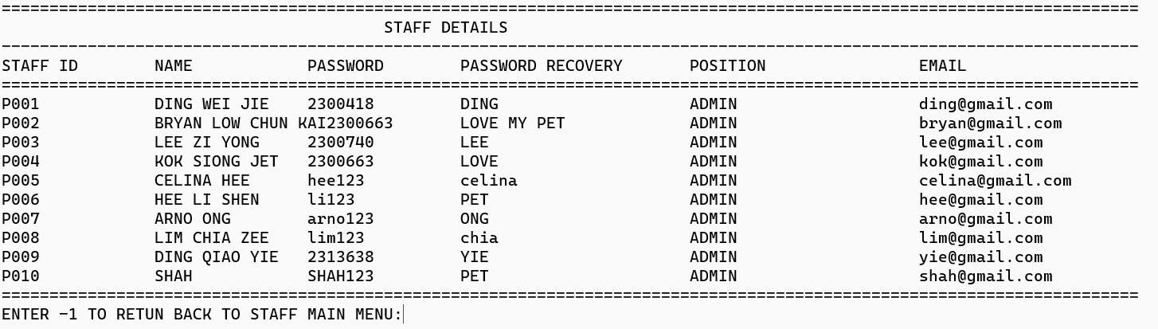

## 4.2 MEMBER INFORMATION MODULE

### 4.2.1 BRIEF DESCRIPTION

**memberAdd**

the feature allows users to create an account in the train booking system.

**memberLogin**

the feature that validates user input data with file, if so, allows the user to log in. If no, it will return an error message.

**searchMember**

the feature that helps users search for another user and get their contact information. If found, display detail. If not found, it will return not found message.

**editProfile**

the feature display the user own detail and allows users to edit their details,e.g. name, phone number, password and password recovery code.

**deleteMember**

the feature allows users to delete their details from this train booking system

**memberHelp**

the feature allows users to display contact details admin from this train booking system

**memberPasswRcv**

the feature allows users to change their password to a new password by inputting the code they are familiar

### 4.2.2 OUTPUTS AND FILE CONTENTS

#### Member Main Page

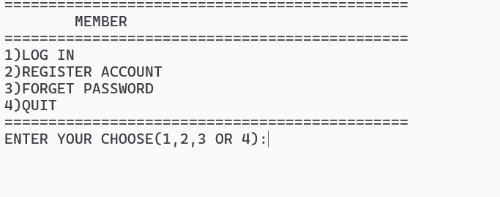

#### Member Login

if 1 , member login

This is my text file

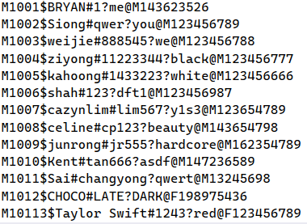

If not found, the same data from a file returns a message and allows the user to input again.

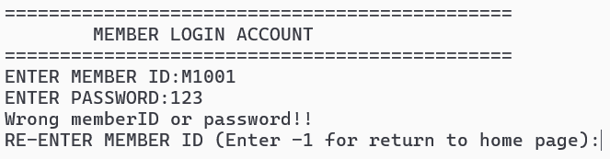

If found the exact data for password and id from a file, enter memberMenu():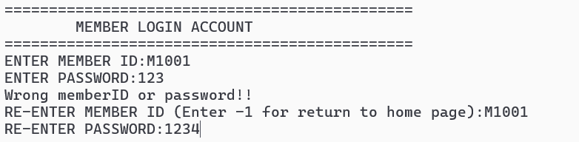

#### Member Edit Function

This is a display menu that allows users to input

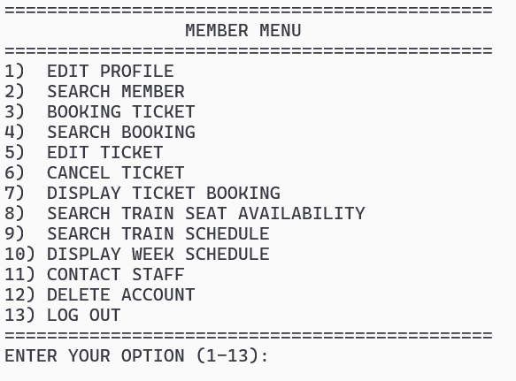

If input 1 will go to edit profile

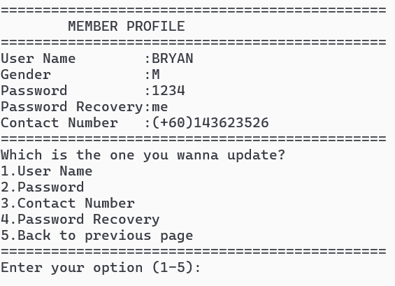

This page will display user details and allow users to input selections and edit them. For example, I input 3 to edit the phone number.If new contact number is different with confirmation phone will failed to change

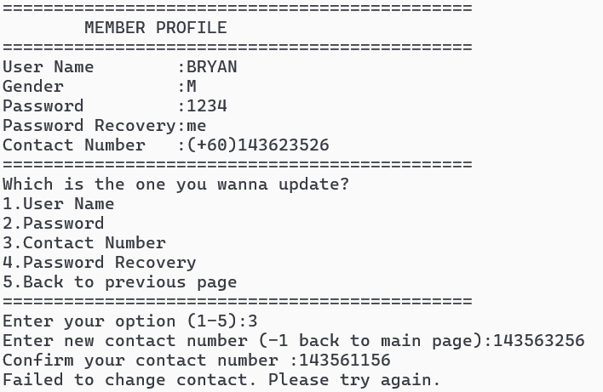

Once you click enter, if the new contact number is the same as the confirmation contact number, it will overwrite the data that users select.

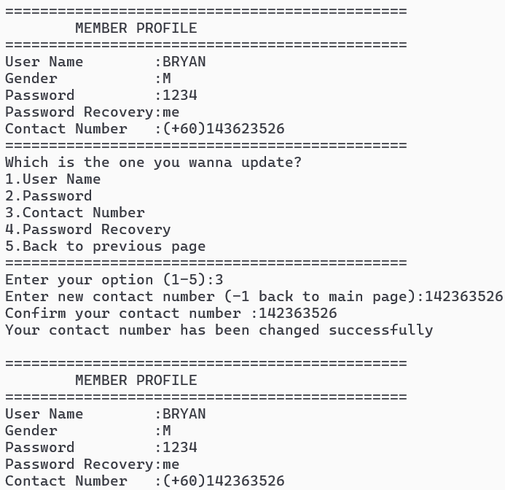

This is the updated data in the text file:

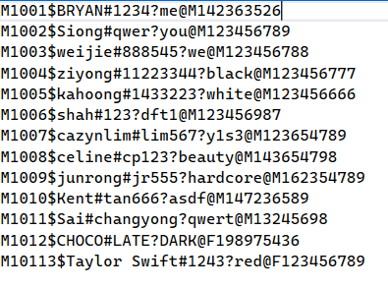

#### Member Search Function

This is the member menu, and input 2 is used to search for another member in the train booking system.

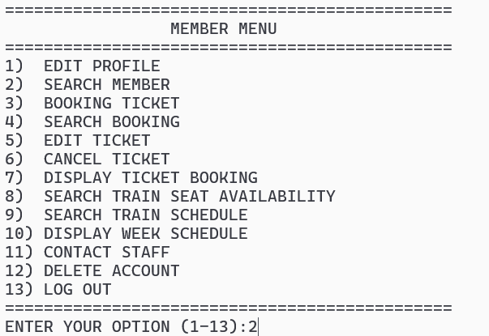

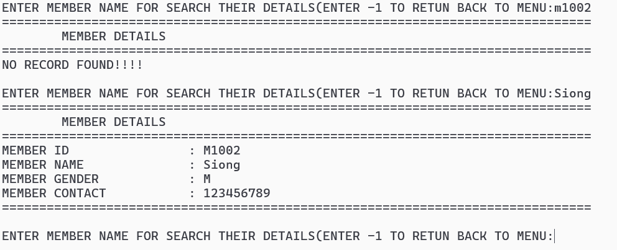

This search function will be based on the user input name and compare data in a text file. If the same data is found, then it will be displayed. If no, it will display that no record was found. When the user wants to return to the member menu, input -1 .

#### Member Delete Function

If the user inputs 12, it will go to the page for deleting the account.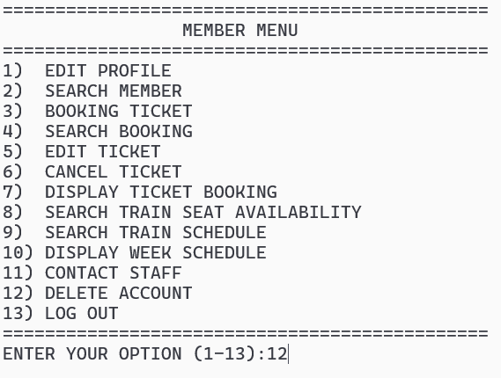

Users can input y(YES) or n(NO) for confirmation.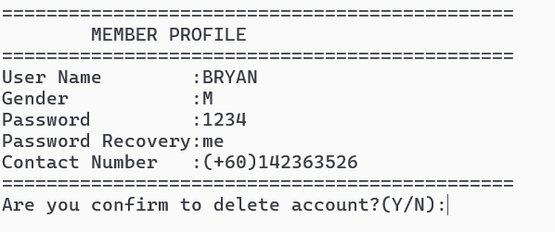

If input n/N: the system will clear and display deletion cancelled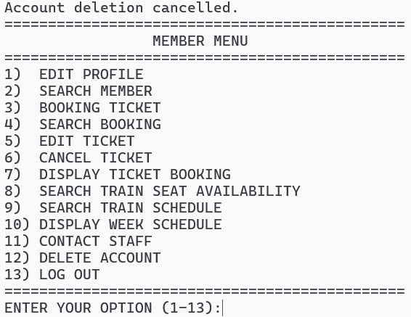

if input y/Y , the system page will clear ,display the account delete successful ande return to main menu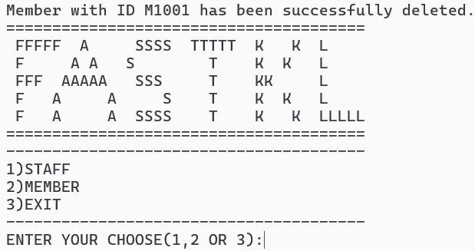.  
  
This is my updated text file

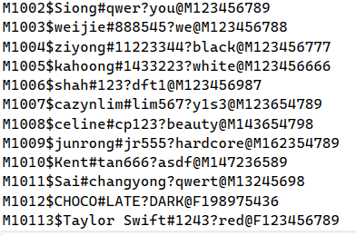

#### Member Help Function

If input 11 will go to the page for displaying admin contact details

and users can -1 for go back to member menu

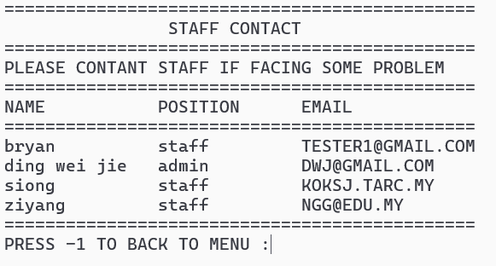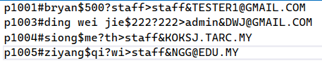

If input 13 will log out and return main menu

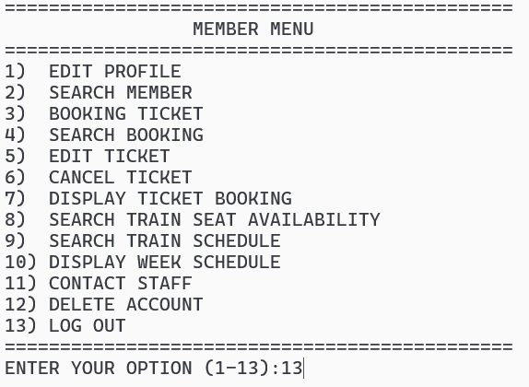

#### 

#### Member Add Function

input 2 and input 2 again at the Member Portal for register the account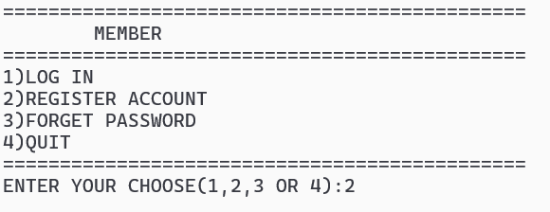

At the register account, if the same ID is inputted with a text file, it will return an existing message. If not allow the user to continue. Once done and entered, the complete register will go back to the Member Portal.

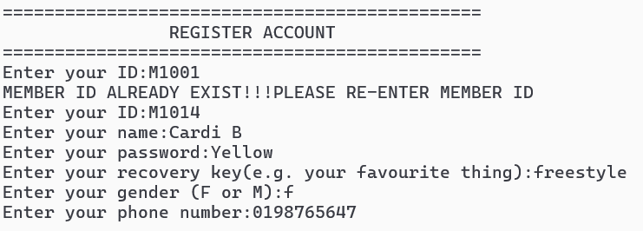

this is my updated text file.

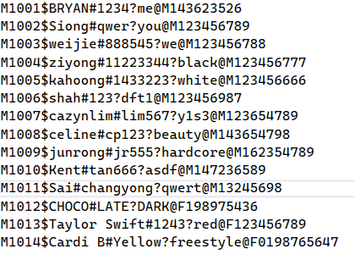

#### Member Password Recovery Function

If the user forgets the password, input 3 at the Member portal to reset the password.

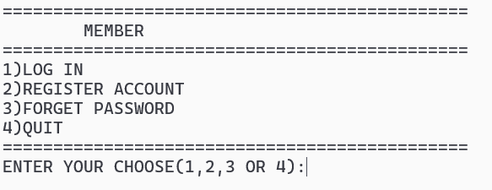

Users need to input details for password recovery. If input the incorrect data will return to the main menu.(Assume input the right data, I also return to the main menu)

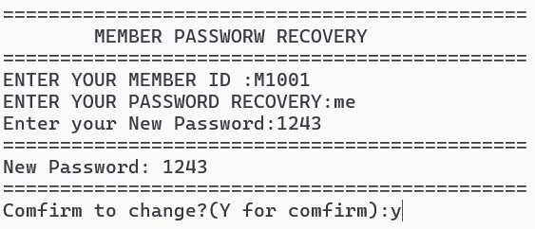

the data for M1001 from1234 is change to 1243

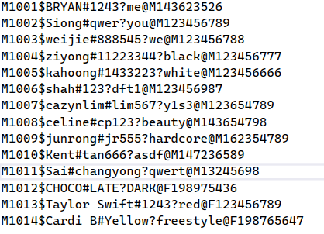

## 4.3 TRAIN SCHEDULE MODULE

### 4.3.1 BRIEF DESCRIPTION

#### Add Schedule Function

The feature allows the admin to add in a new schedule.

#### Edit Schedule Function

This feature allow admin to modify existing schedule

#### Update Status Function

Admin can update the train status through this feature

#### Delete Schedule Function

This feature is design to let admin delete the exist feature

#### Display Schedule Function

This feature allow user/admin select a choice and display all the schedule that select by user/admin

#### Search Schedule Function

This feature displays the result that is searched by the user.

### 

### 4.3.2 OUTPUTS AND FILE CONTENTS

The 10 demo records in the bin file.

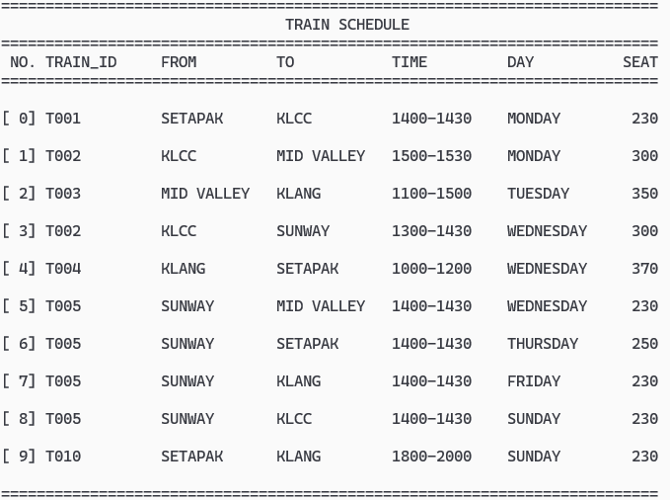

#### Add Schedule Function

In the staff menu, type ‘7’ to add train schedule.

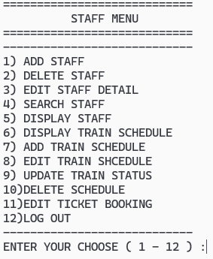

Let admin insert the train information and capture it

#### 

Asking admin’s confirmation, type ‘ y/Y’ will add a new schedule into train.bin, type ‘n/N’ will not insert the schedule that key in by admin. After Both select will return to staff Menu.

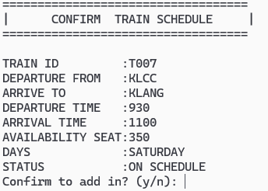

Train schedule if admin type ‘n/N’



Train Schedule if type ‘y/Y’

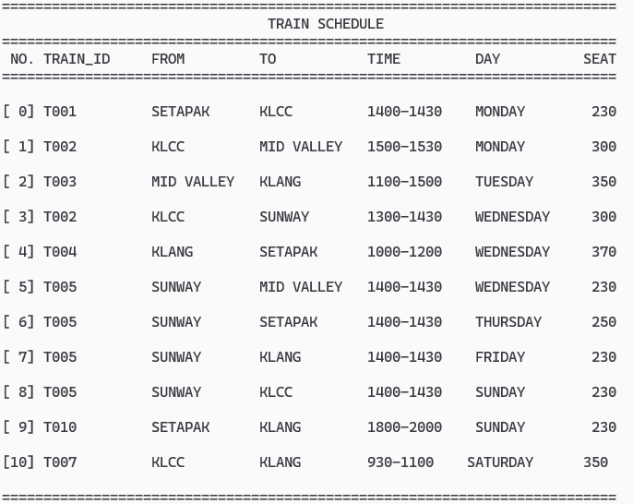

#### Edit Schedule Function

Type ‘8’ to edit the existing train schedule.



Display all schedule and capture admin’s choice, -1 for back to staff Menu

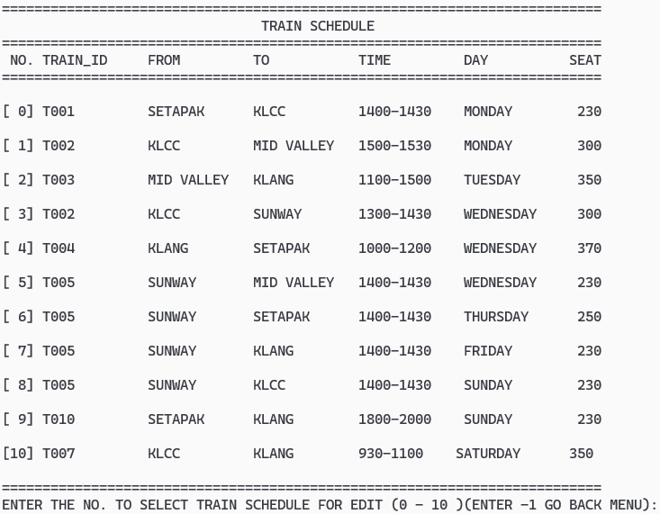

Showing the schedule choose by admin and ask admin which data is need to edit

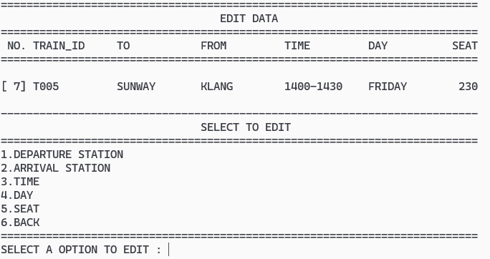

I use the day option as an example. The system will provide days selected after choosing the day option, the system will show the edited version of a specific schedule and ask for admin confirmation. Admin need to type ‘y’ or ‘n’.

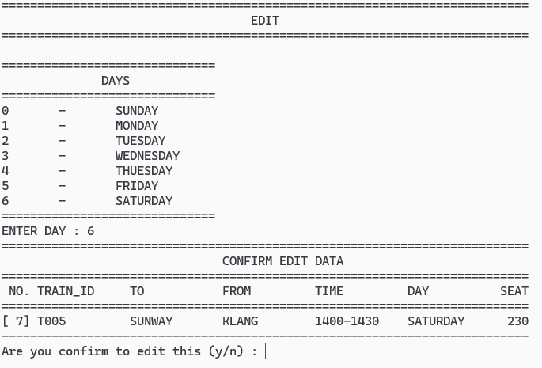

*If admin types ‘n/N’



The result when admin types ‘y/Y’.

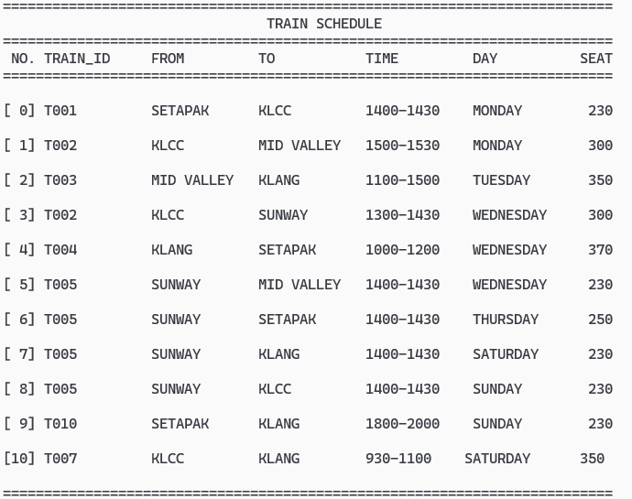

#### Update Status Function

Type ‘9’ for update status function

#### 

As usual, system will display all the schedule to let admin do a select, type ‘-1’ back to staff Menu

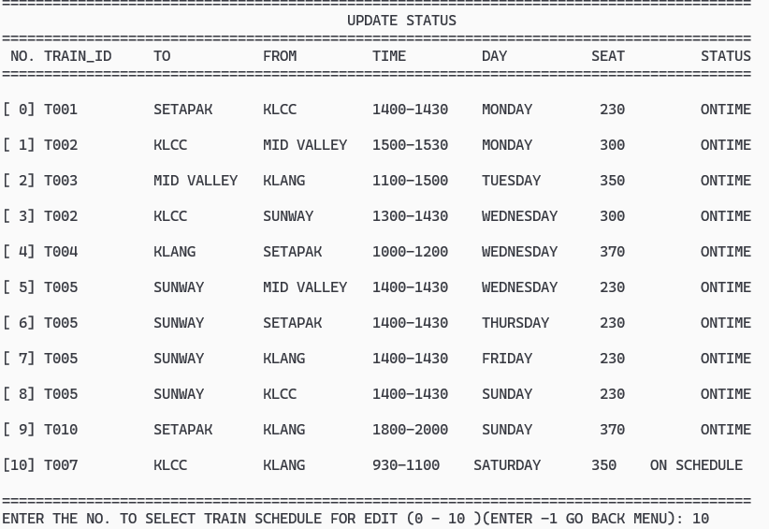

After selecting, the system will display the specific schedule and show the status can be choose by admin.

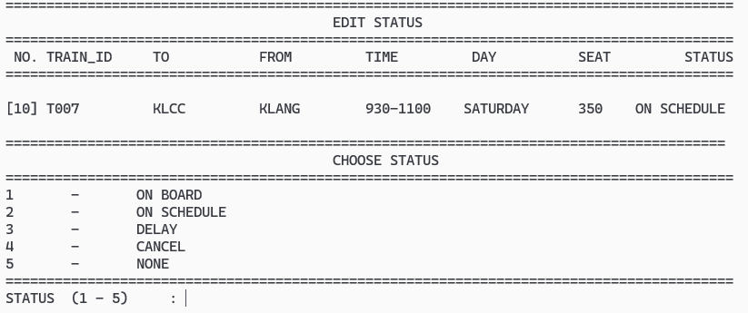

The system will show the edited version of a specific schedule and ask for admin confirmation. Admin needs to type ‘y’ or ‘n’.

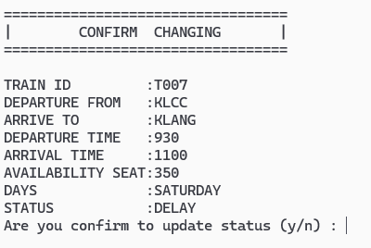

If admin type ‘y/Y’, status will be updated.

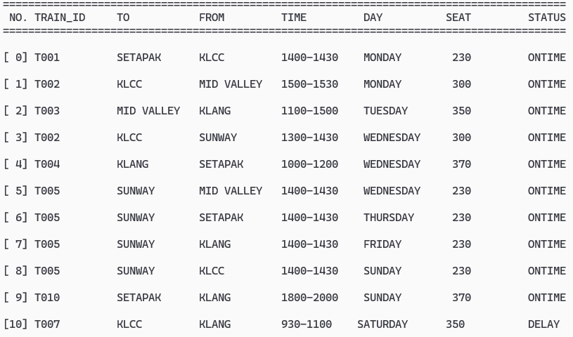

Status will not be updated when admin type ‘n/N’.



#### Delete Schedule Function

Type ‘10’ for access delete schedule function.

#### 

System provides all the schedules, type ‘-1’ for the back Staff menu. It displays a specific schedule and lets the admin confirm the choice he makes.

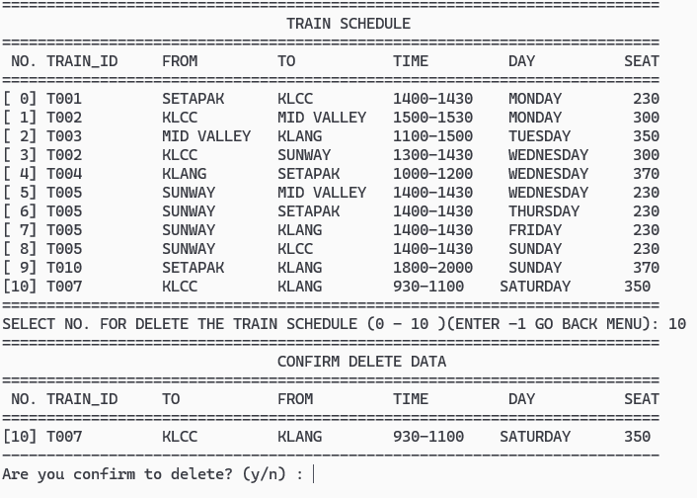

Schedule will be delete from bin file while admin type ‘y/Y’

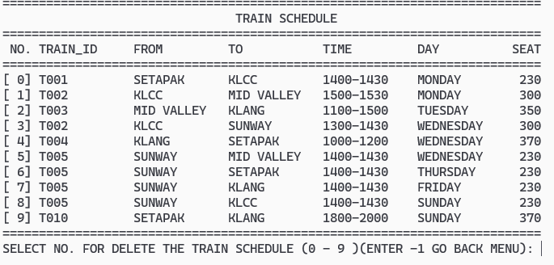

If admin type ‘n/N’, the schedule wont change anything

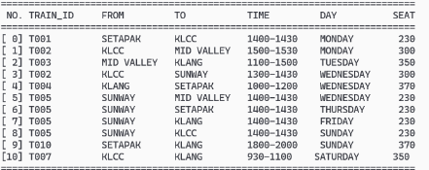

#### Display Schedule Function

If login as a member, type ‘4’ to view the weekly schedule

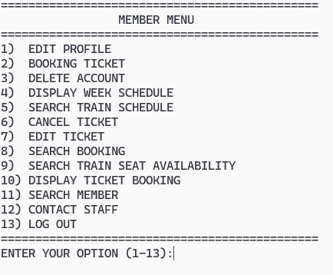

Members can the day of the schedule that he want to view, type ‘8’ to get back the member menu.

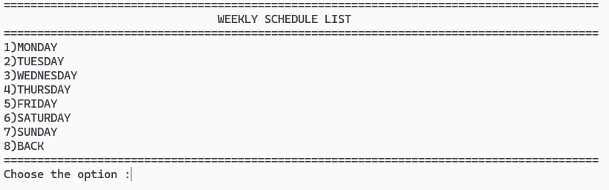

If the schedule of the day exists, the system will display the schedule, and type ‘1’ to return the day selection menu.

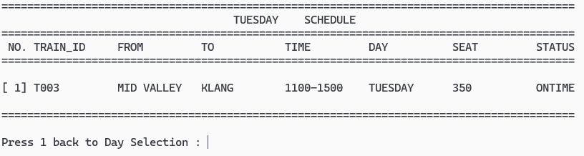

If the schedule does not exist, the system will display the message to tell members it doesn't exist, and type ‘1’ to return the day selection menu.

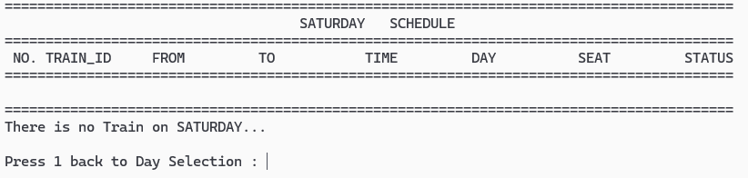

#### Search Schedule Function

Type ‘5’ to search the train schedule.



This function allows members to key in the Departure Station for Searching. Once the member types an existing departure Station, the system will list out all the matched schedules, type ‘1’ to get back the member menu .

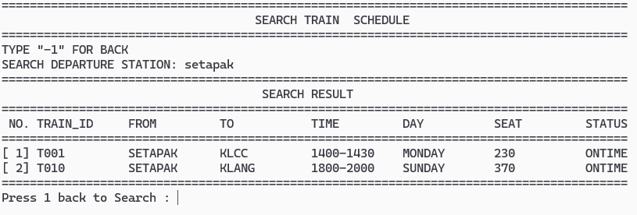

Else, the system displays a message to let members know that the schedule does not exist, type ‘1’ to get back to the member menu.

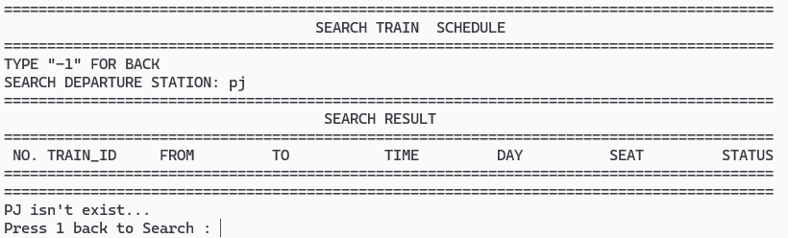

## 

## 

## 4.4 TRAIN BOOKING MODULE

### 4.4.1 BRIEF DESCRIPTION

**Book Tickets Function:**

Creates a new train ticket reservation.

**Find Booking Function:**

Finds and displays information about an existing reservation.

**Cancel Ticket Function:**

Cancels a previously booked train ticket.

**Change Ticket Function:**

Modifies details (date, passengers, etc.) of an existing ticket.

**Check Seat Availability Function:**

Check how many seats are open on a specific train.

**View Ticket Function:**

Displays a user's booked train tickets.

#### 

#### 

#### 

#### 

#### 

#### 

#### 

#### 

#### 

#### 

### 

### 

### 

### 4.4.2 OUTPUT AND FILE CONTENTS

#### BOOK TICKET FUNCTION

Member menu



This is member menu after user login

Booking Page

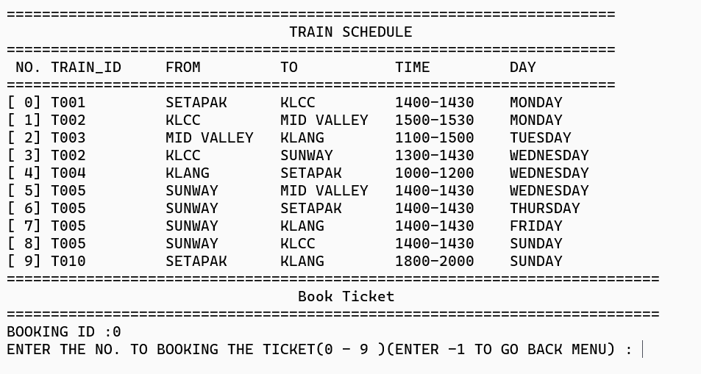

Once you input the integer '2', you'll be directed to the booking page where you can view all available train schedules. From there, users can select the desired train schedule for booking.

Book ticket , choose amount, confirm booking

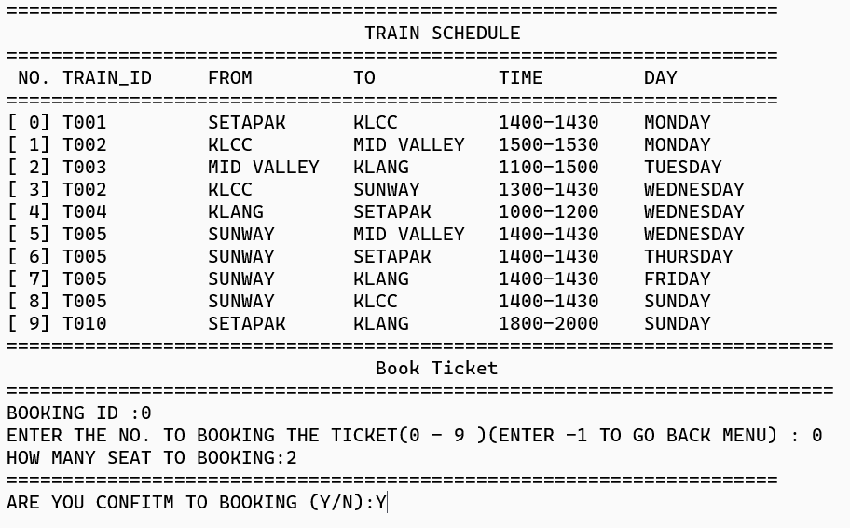

Once users select their desired train, they will specify the number of seats they wish to book. Upon entering the seat count, they will be prompted to confirm the booking. Once confirmed, the booking details will be saved, and a unique Booking ID will be provided to the user.

Second ticket

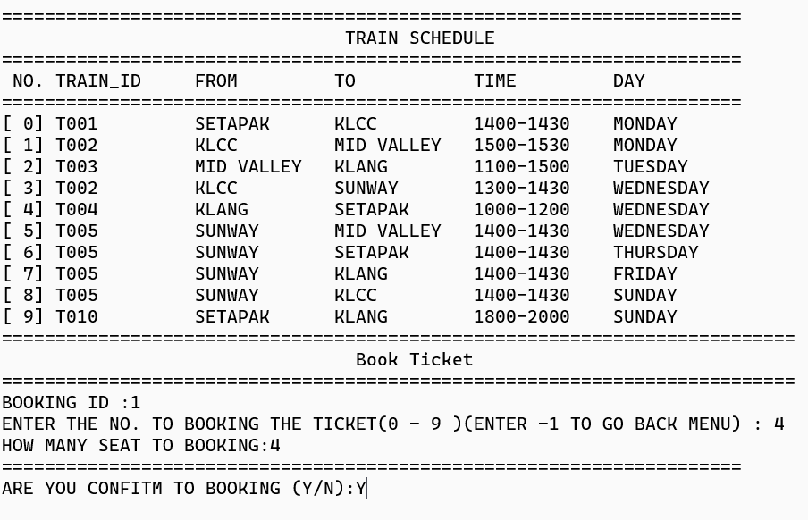

This will be the second ticket I book for a clearer comprehension.

#### FIND BOOKING FUNCTION

Search booking



After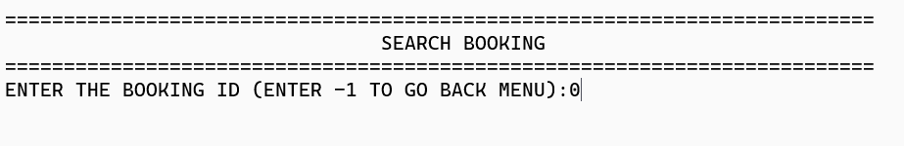 When users input the integer '8', they will be prompted to provide the booking ID.

Search booking id : 0 display booking id : 0 details

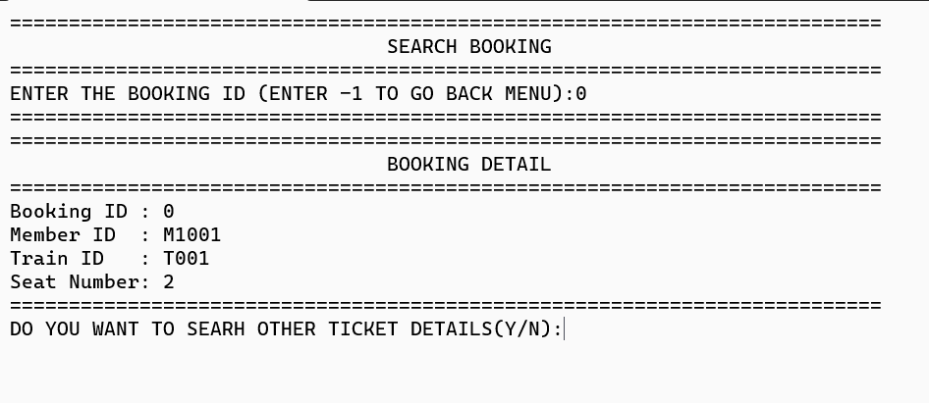

Upon inputting the booking ID, the system will present the booking details corresponding to the entered ID.

SEARCH BOOKING id : 1 display booking id : 1 details

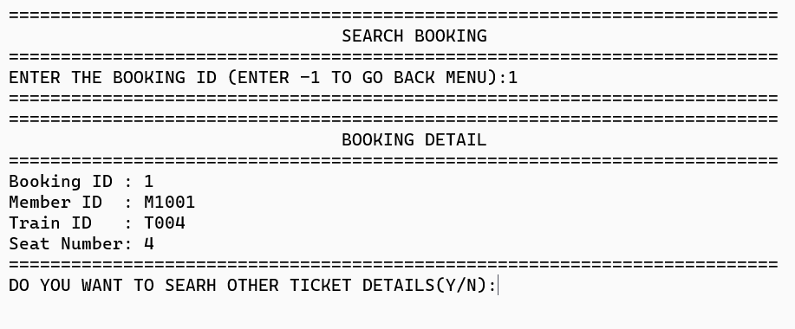

Once the initial Booking ID is shown to the user, the system will inquire whether they wish to seek details for another ticket. This pertains to the second set of ticket details.

#### CHANGE TICKET FUNCTION

Edit ticket

  
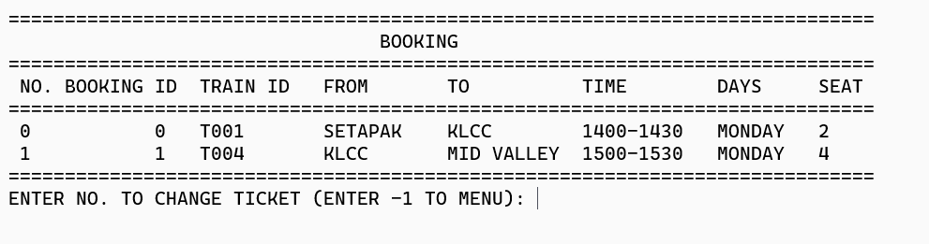

Once the user inputs the integer '7', they will proceed to the ticket editing function. Prior to that, the system will present all the booking details associated with the user. Users will then be prompted to input the ticket number they wish to modify.

Change ticket, reduce ticket from 4 to 2 for booking id : 1

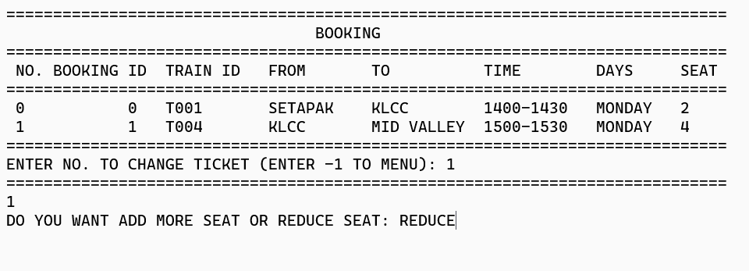

Upon inputting the booking number, the system prompts users to specify whether they wish to increase or decrease the number of seats. Users must type "ADD MORE" or "REDUCE" to proceed accordingly.

Seat reduce

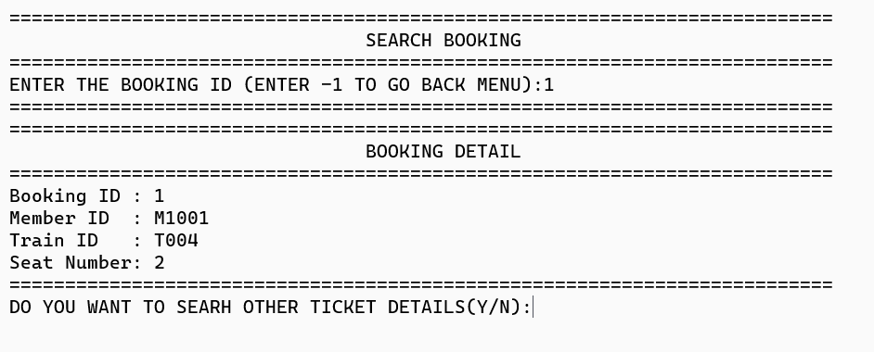

Once "Enter REDUCE" is selected, users can navigate to the search booking feature to verify if there have been any changes to the seat.

#### CANCEL TICKET FUNCTION

Cancel ticket



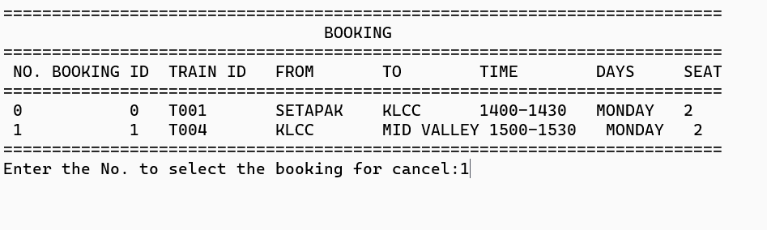

After the user enters integer ‘6’, the system will show all the booking data. users will be asked to enter which No. of booking they want to delete.

#### VIEW TICKET FUNCTION

View Ticket



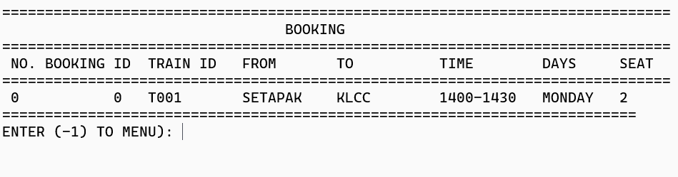

Following the deletion of the booking, users can proceed to the View Ticket feature. Simply input '10' to access this function. Here, users can review all tickets booked under their account.

#### CHECK SEAT AVAILABILITY FUNCTION

Check seat availability



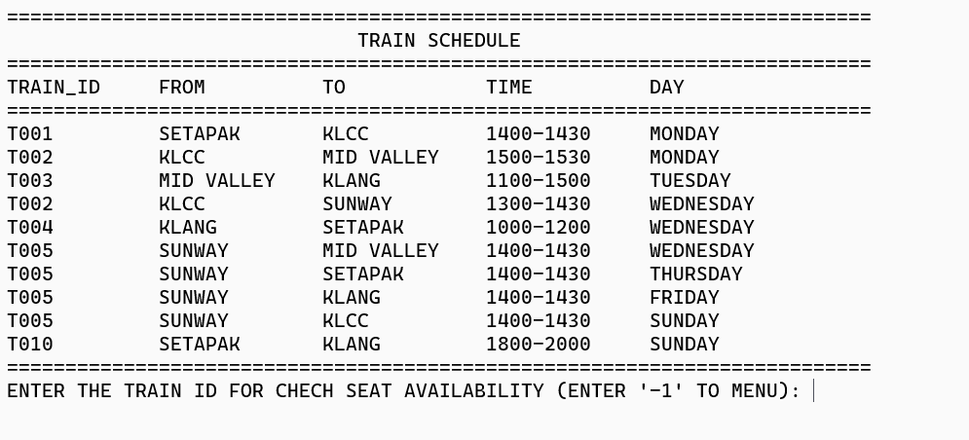

Once the user selects '9' from the member menu, the system will display all available train schedules. If the user wishes to inquire about seat availability for a specific train, they can input the train ID to search for seat availability on that train.

