SHOC SOP PORTAL – FINAL REPORT V3 (FULL PROFESSIONAL DESIGN)

1. Introduction
This report presents the complete architecture, structure, and implementation design for the SHOC SOP Portal. It integrates all 9 Volumes, their SOPs, Annexes, and a Streamlit-based digital system for operational use.
The objective is to:
- Provide a centralised digital access platform
- Enable structured navigation of SOPs and Annexes
- Support real-time operations, training, and audits
- Align with ISO 22301, ISO 45001, and BCM frameworks

2. Full Volume Structure
Volume No. | Volume Title | Focus Area
Vol 1 | Governance & Institutional Framework | Policy, mandate, coordination
Vol 2 | Preparedness & Activation | Early warning, activation
Vol 3 | Facilitation, Screening & Administration | Entry, quarantine, processing
Vol 4 | Cross-Border Coordination | Movement, logistics corridors
Vol 5 | Human Resources & Surge Staffing | Recruitment, mobilisation
Vol 6 | Logistics, ICT & Data Management | Systems, infrastructure
Vol 7 | Security & Access Control | Physical & personnel security
Vol 8 | Monitoring, Reporting & Learning (MEAL) | Reporting, AAR, KPIs
Vol 9 | Business Continuity Management (BCM) | Continuity, recovery

Table 2: Annex Distribution by Volume
Volume | Annex Coverage
Vol 1 | Governance templates, policy tools
Vol 2 | Activation checklists, readiness tools
Vol 3 | Screening forms, quarantine logs
Vol 4 | Cross-border coordination tools
Vol 5 | HR registers, vetting, mobilisation
Vol 6 | ICT, infrastructure, data governance
Vol 7 | Security registers, incident forms
Vol 8 | KPI trackers, SitReps, AAR templates
Vol 9 | BCM tools, risk matrices, continuity plans

3. SOP Breakdown
Volume | SOPs
Vol 7 | 7.1 Access Control; 7.2 Personnel Security; 7.3 Facility Security
Vol 8 | 8.1–8.5 Monitoring & Reporting
Vol 9 | 9.1–9.7 BCM Components

4. Annex Mapping
Volume | Annex Examples
Vol 7 | Visitor Register, Incident Forms, Risk Registers
Vol 8 | KPI Tracker, SitRep, AAR
Vol 9 | BCM Plans, Communication Tree

5. Portal Architecture

3-Level Navigation:
Level 1: Volumes
Level 2: SOPs
Level 3: Annexes
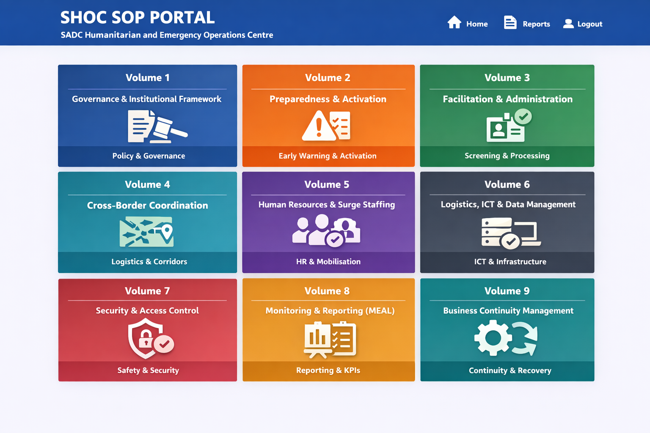

6. Navigation Flow
Portal → Volume → SOP → Annex

Navigation Logic Explained (Your System)
This is the exact flow your portal will follow:

LEVEL 1: MAIN PORTAL (Dashboard)
- Displays 9 Volume Tiles
- User selects a Volume
⬇️

LEVEL 2: VOLUME VIEW
User gets two options:
- 📄 Open Full Volume Document
- 📂 View SOPs
⬇️

LEVEL 3: SOP VIEW
- List of SOPs (e.g., SOP 7.1, 7.2, 7.3)
- Each SOP has:
Options:
- 📄 Open SOP Document
- 📎 View Annexes
⬇️

LEVEL 4: ANNEX VIEW
- Displays all annexes linked to that SOP
- User can:
  - Open
  - Download
  - Search/filter
MAIN PORTAL (9 Volumes)
↓
SELECT VOLUME
↓
[Open Volume] OR [View SOPs]
↓
SELECT SOP
↓
[Open SOP] OR [View Annexes]
↓
SELECT ANNEX
↓
Open / Download / Use Tool

7. Streamlit Architecture
Homepage with 9 volumes → Volume page → SOP page → Annex access → Document viewer

8. Functional Modules

- Dashboard
- Repository
- Search
- Access Control
- Reporting
- Audit Logs

Figure 1: SHOC SOP PORTAL – MAIN INTERFACE

🔹 Description:
The main interface displays:
- 9 clickable tiles (Volumes 1–9)
- Each tile includes:
  - Volume Name
  - Icon (e.g., Security, HR, BCM)
  - Quick summary

User Interaction (Level 1)
When user clicks a Volume:
Two options appear:
- Open Volume Document (PDF/Word)
- Open SOP Structure

Figure 2: VOLUME NAVIGATION FLOW

Flow Logic:
MAIN PORTAL
↓
SELECT VOLUME
↓
[Open Document] OR [View SOPs]

5. SOP-LEVEL INTERFACE

Figure 3: SOP INTERFACE DESIGN

🔹 SOP Navigation Logic:
When inside a Volume:
Action | Result
Click SOP | Opens SOP
Click Annex | Opens Annex list

🔹 SOP Interaction Flow:
VOLUME
↓
SELECT SOP (e.g., SOP 7.1)
↓
[Open SOP] OR [View Annexes]

6. ANNEX INTERFACE DESIGN

🔹 Annex View Features:
- List of annexes per SOP
- Search/filter functionality
- Download options (Word, PDF, Excel)

🔹 Example:
SOP | Annex Options
SOP 7.1 | Visitor Register, Incident Form
SOP 7.2 | Personnel Register
SOP 7.3 | Asset Register

7. SYSTEM FUNCTIONAL ARCHITECTURE

🔷 Table 3: Portal Functional Modules
Module | Function
Document Repository | Stores SOPs & Annexes
Dashboard UI | Navigation interface
Search Engine | Find SOPs/Annexes
User Access Control | Role-based permissions
Reporting Engine | KPI dashboards
Audit Trail | Track document usage

8. USER ROLES (RECOMMENDED)
Role | Access Level
Admin | Full control
Operations | SOP + Annex access
Viewer | Read-only
External Partner | Limited access

ENHANCEMENTS (HIGH VALUE)

Recommended Advanced Features

1. Interactive Dashboard
- KPI visualisation (Vol 8)
- Incident tracking (Vol 7)

2. Smart Search
- Search by:
  - SOP number
  - Keyword
  - Annex type

3. Offline Mode
- Download full Volume packs

4. GIS Integration (Your Strength 💡)
- Link SOPs to:
  - Hazard maps
  - EOC locations
  - Flood risk zones

5. Mobile-Friendly Interface
- Field teams can access SOPs on-site9. MASTER INDEX (CONTROL SHEET)

Annex ID | Annex Name | Linked SOP | Phase | Tool Type | Owner | Status | Last Updated
A4.1 | MEAL Dashboard Template | SOP 10 | S1–S3 | Dashboard | IM Officer | Active
A4.2 | Incident Reporting Template | SOP 10 | S1–S2 | Form | Ops | Active
A4.3 | KPI Tracker (PMIs) | SOP 10 | All | Tracker | IM | Active
A4.4 | After Action Review (AAR) Template | SOP 9 | S3 | Template | Ops | Active
A4.5 | Lessons Learned Register | SOP 9 | S3 | Register | IM | Active
A4.6 | Beneficiary Feedback Mechanism | SOP 3/9 | S1–S3 | Tool | Comms | Active
A4.7 | Situation Report (SitRep) Template | SOP 10 | S1–S2 | Template | IM | Active
A4.8 | Data Quality Assurance Checklist | SOP 10 | All | Checklist | IM | Active
A4.9 | Reporting Calendar | SOP 10 | All | Planner | Ops | Active
A4.10 | Evaluation Framework (Mid/Final) | SOP 9 | S3 | Framework | MEAL | Active

