1.1.

This network is weakly balanced because the three villages are forming - - - pattern between people of different villages, meanwhile forming + + + within each individual village. However, the graph is unbalanced.

1.2.

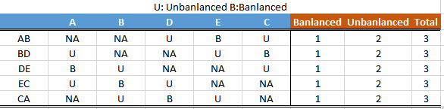

For each of the positive edges, there will be exactly one balanced triangle and two unbalanced triangles. For each of the negative edges, there will be exactly one unbalanced triangle and two balanced triangles.

1.3.(a).

Impossible. All current nodes ABC are negative to each other, thus it is impossible for D to form any +++ triangle with any of the nodes. Thus the only viable way to achieve balance is to construct +-- triangle. In each of the three triangles (ABD, BCD, and ACD), one of the edges (AB AC and BC) is already confirmed to be negative. Thus AB, AC, and BC will all have two edges, one positive and one negative, in order to form balanced triages with D. However, AB, AC, and BC also share edges with each other, which means it is impossible to have

1.3.(b).

Impossible

ABD and ACD can be either +++ or +--, and BCD can only be +--

ABD and ACD can’t be +++ or +-- at the same time, otherwise BCD will be either ++- or ---, which is either unbalanced or weakly balanced

However, +++ and +-- can’t exist at the same time either, because the two +s are confirmed to be AB and AC, thus leaving – and ++. But AB and AC will unavoidably share a same edge in order to form a triangle.

Therefore this is impossible to add D and label edges such that D is not in any unbalanced or weakly balanced triangles

1.3.(c).

If there is at least one unbalanced triangle and it is a complete graph, then X is destined to connect with every node of this triangle, which is either scenario (a) or (b), which are proven to create new unbalanced/ weakly balanced triangles. Thus it is impossible to add X and label the edges such that adding X does not create any unbalanced/ weakly balanced triangle.

1.4.

The network is not balanced because farmers next to each other who are friends will not share the same friend/enemy relationship with the farmer that is 20 miles away. For example, farmer M0 is a friend with M1, and farmer M0 is an enemy with M23. However, farmer M1 is a friend with M23 because the distance is less than 20. Thus there is a ++- triangle, and it is unbalanced. Thus the entire network can't be balanced.

2.

If a 4-node cycle with an odd number of negative edges is not balanced, then a complete balanced network cannot contain a 4-node cycle with an odd number of negative edges.

To prove a 4-node cycle with an odd number of negative edges is not balanced:

To be balanced, there must be either +++ or +--

There are a total of 6 edges, and odd number of negative edges

Because there is negative edge, thus it can't be all +++, there must be at least one +--

If there is at least one +--, there must be at least 2 negative edges

Because there are odd number of negative edges, there could be 3 or 5 negative edges

First consider if there are only 5 negative edges, then there will be at least one instance where three negative edges forming a weakly balanced triangle, thus causing the graph not balanced.

Then examine the case with 3 negative edges and 3 positive edges (because there are a total of 6 edges)

There is a solution to balance this graph as the following:

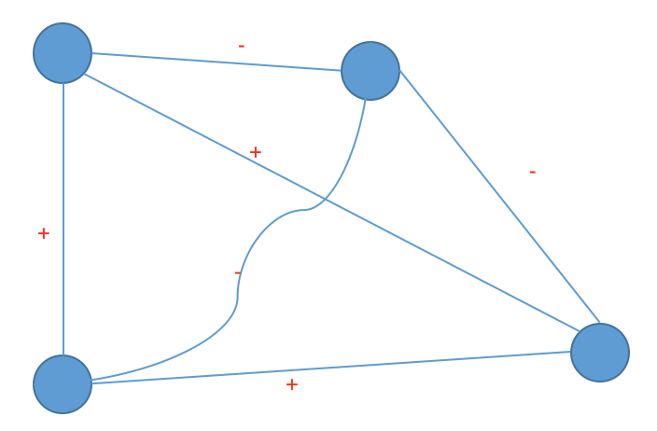

Thus, it is possible to have a 4-node cycle with an odd number of negative edges that is balanced

3.a.

No, because there are --- triangles (for example CFE) which are weakly balanced

3.b.

Yes, because there is no ++- relationship observed. Only nodes with two ++ originating from the same node are B A, and E. Which are parts of the +++ relationship (BAE)

3.c.

Three groups, ABE, DF, and C on its own.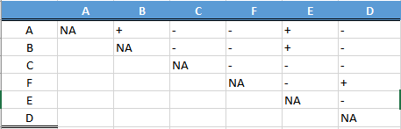

3.d.

Make CFD a group and ABE another group

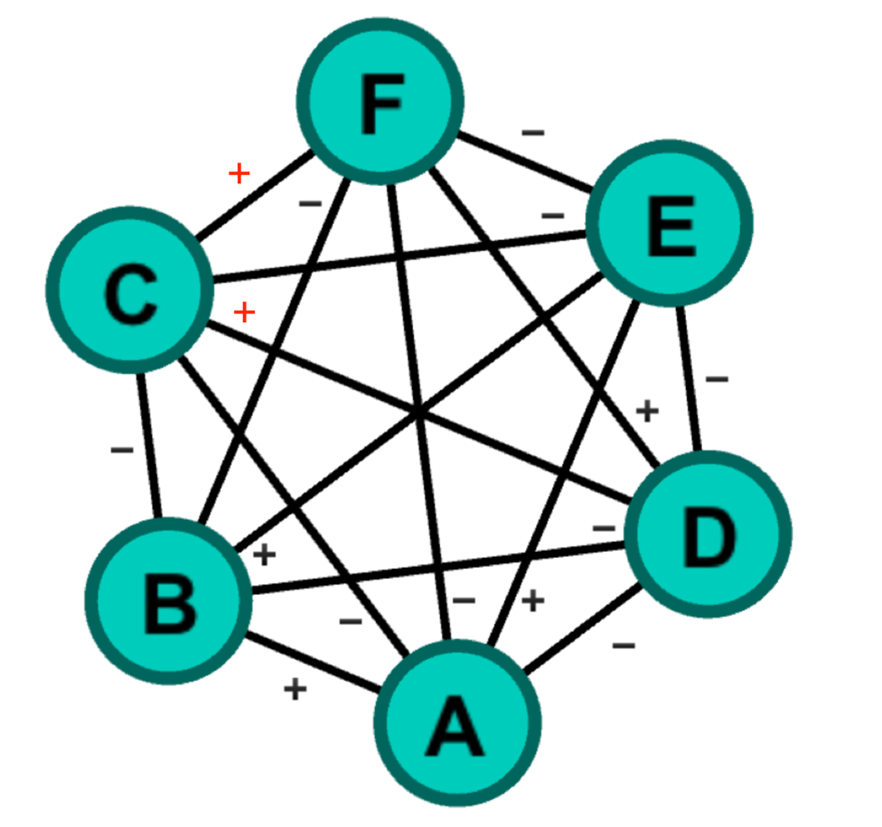

4. See attached