**AWS**

1. AWS EC2 Console

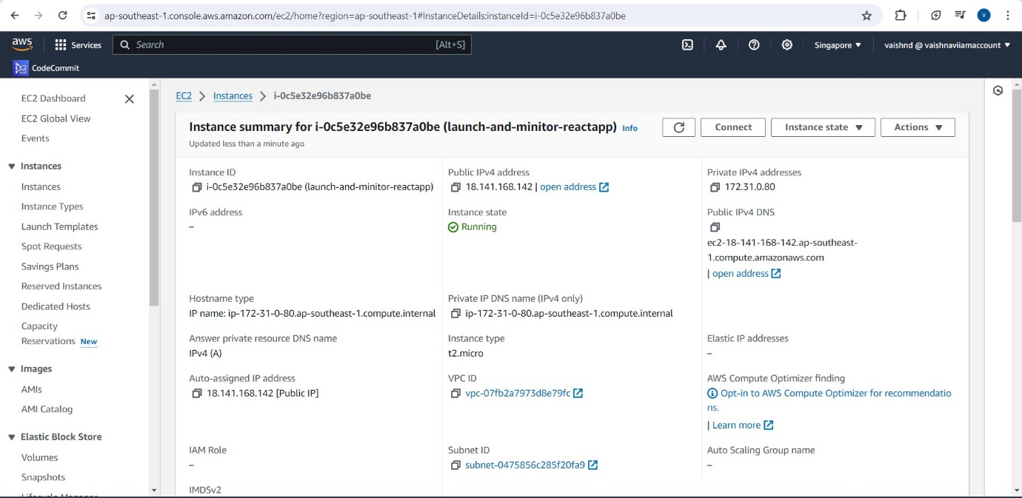

1. SG Configs

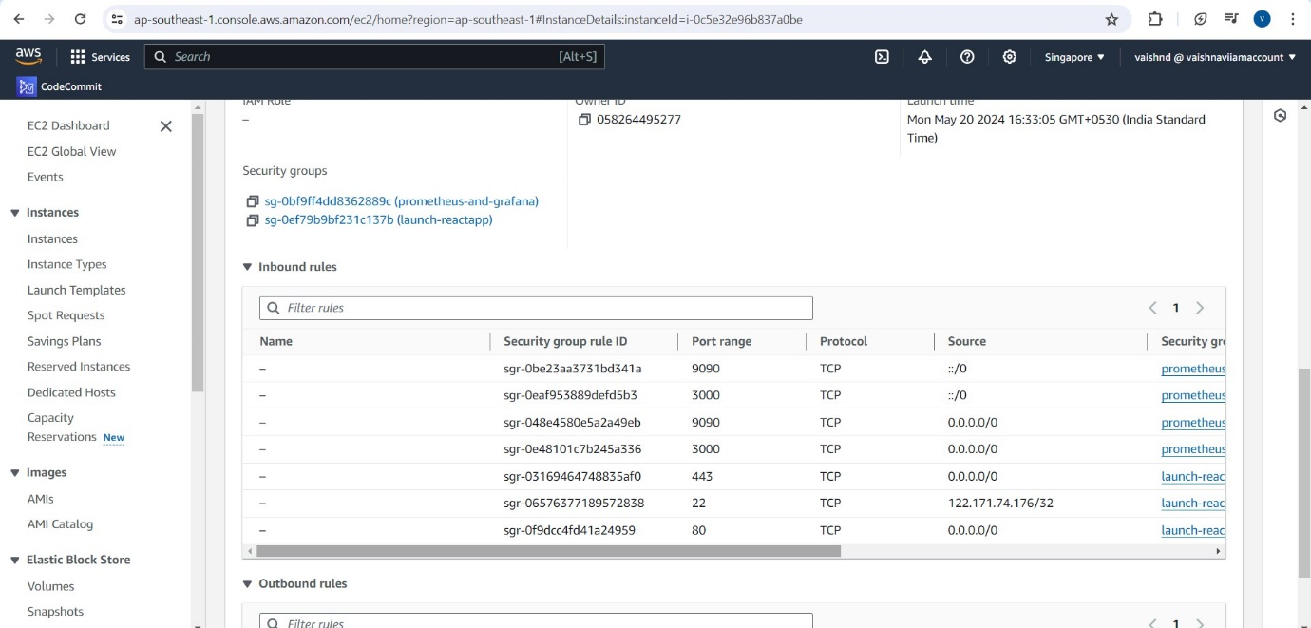

1. Deploying react js app from the AWS EC2 instance

**Public IP : 18.141.168.142**

1. 