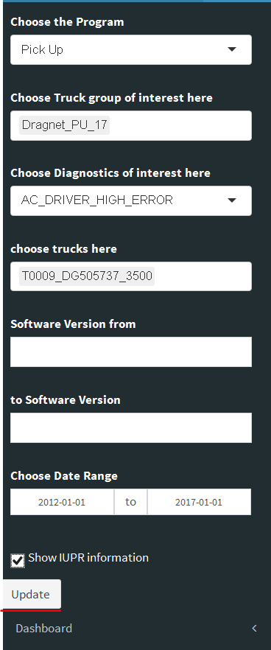

Unhandled error:

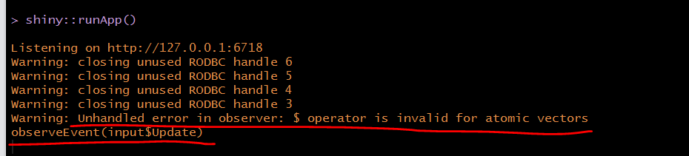

Logic error, denotes a situation where the program executes but gives the wrong result. This can be due to an error in the underlying algorithm or an error in your translation of that algorithm. In some cases, logic errors lead to very bad situations such as trying to divide by zero or trying to access an item in a list where the index of the item is outside the bounds of the list. In this case, the logic error leads to a runtime error that causes the program to terminate. These types of runtime errors are typically called **exceptions**.

Most of the time, beginning programmers simply think of exceptions as fatal runtime errors that cause the end of execution. However, most programming languages provide a way to deal with these errors that will allow the programmer to have some type of intervention if they so choose. In addition, programmers can create their own exceptions if they detect a situation in the program execution that warrants it