**Q5a**

**\*\*Question:** Choose __one__ comparison scenario and create at least three alternative designs that would allow this comparison.**

I choose to compare the selected data against overall average scenario

There are three alternative designs that would allow this comparison

1. Show two comparisons on the same graph, with two bars belonging to the same prio be ajacent to each other and distinct the two bars in the same prio with different color

an exmaple would be like this

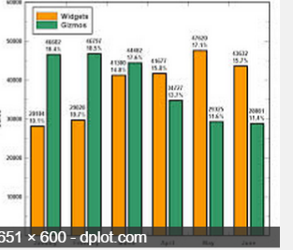

2. Show two comparisons on the same graph, with two bars beloning to the same prio overlap each other( same x location) and to distinct the two bars in the same prio with different color and opacity, and use color to differentiate if it is over the average or below the average, for example, if it is over the average show the difference with red, and show the difference below average with blue

a smilar idea is like this

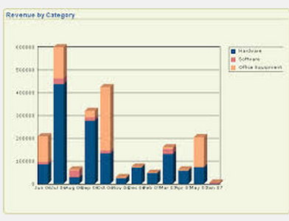

3. Show two comparisons at two different graphs side by side

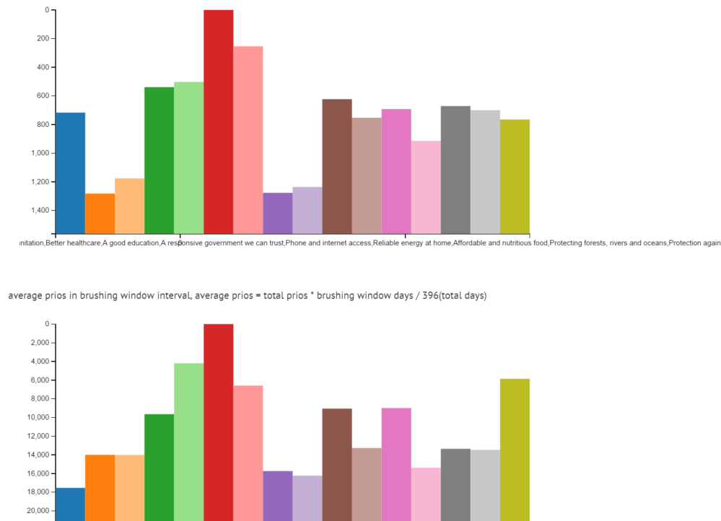

**Q5b**

Question: Implement one design in your visualization for PrioVis and explain why you have chosen this design.

**Answer:**

your reasoning goes here.

I choose the design #3 which is to show two comparisons at two different graphs side by side, because it is easier to be implemented compared to other two designs which would require a new layout of priocount graph, while the 3rd design can be quickly made by slightly modifying the priovis.js without changing layout of graph.

**Q5C**

**Interesting pattern**

-A good education is the hightest vote overall, however in the period of March2013 survey, access to clean water and

- a better healthcare exceeds it, except that month, all other months A good education is the highest.

- Phone and internet access, reliable energy at honme are constantly the lowest.

- Action taken on climate change was among the highest vote in the begining of the survey, and then rank goes down and up.

In 2013 March seems very different from the overall survey, see the bewlow graph, the buttom one is the average, the upper one is the March 2013, we see A good education is the hightest vote overall, however in the period of March2013 survey, access to clean water and a better healthcare exceeds it

