**Question 1.1, Problem Set 0, CS224W**

There are 7115 nodes

**Question 1.2, Problem Set 0, CS224W**

______________________________________________________________________________

There are 0 self-edge nodes

**Question 1.3, Problem Set 0, CS224W**

______________________________________________________________________________

There are 103689 directed edge nodes

**Question 1.4, Problem Set 0, CS224W**

______________________________________________________________________________

There are 100762 undirected edge nodes

**Question 1.5, Problem Set 0, CS224W**

______________________________________________________________________________

There are 2927 reciprocated edge nodes

**Question 1.6, Problem Set 0, CS224W**

______________________________________________________________________________

There are 1005 nodes of zero out-degree

**Question 1.7, Problem Set 0, CS224W**

______________________________________________________________________________

There are 4734 nodes of zero in-degree

**Question 1.8, Problem Set 0, CS224W**

______________________________________________________________________________

There are 1950 nodes with more than 10 incoming edges

**Question 1.9, Problem Set 0, CS224W**

______________________________________________________________________________

There are 5165 nodes with fewer than 10 incoming edges

**Question 2.1, Problem Set 0, CS224W**

______________________________________________________________________________

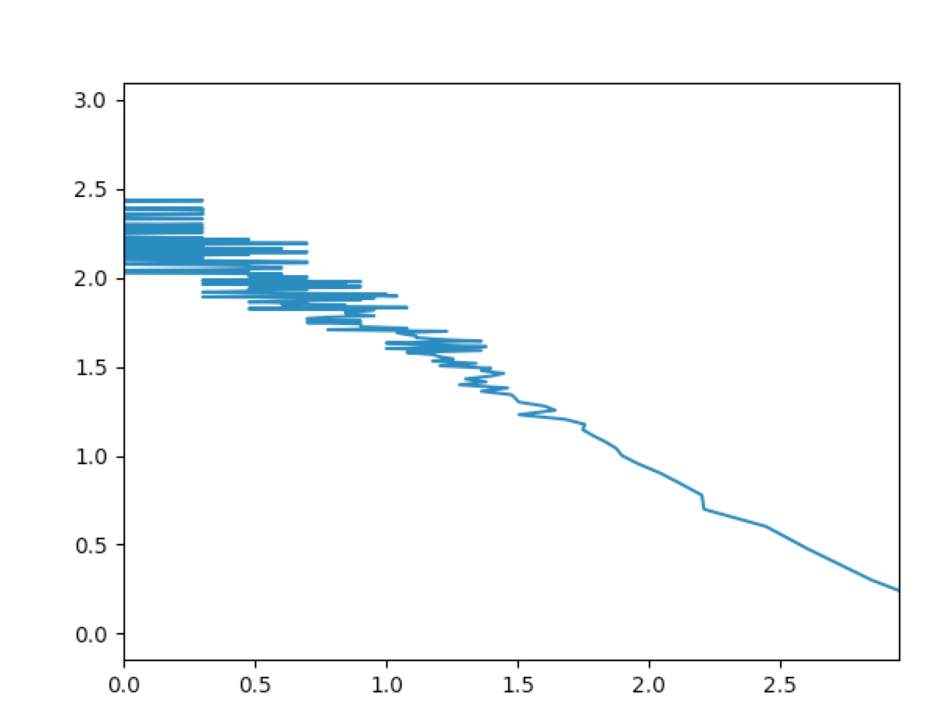

**Question 2.2, Problem Set 0, CS224W**

______________________________________________________________________________

coefficient a is -0.695185 and b is 2.396496

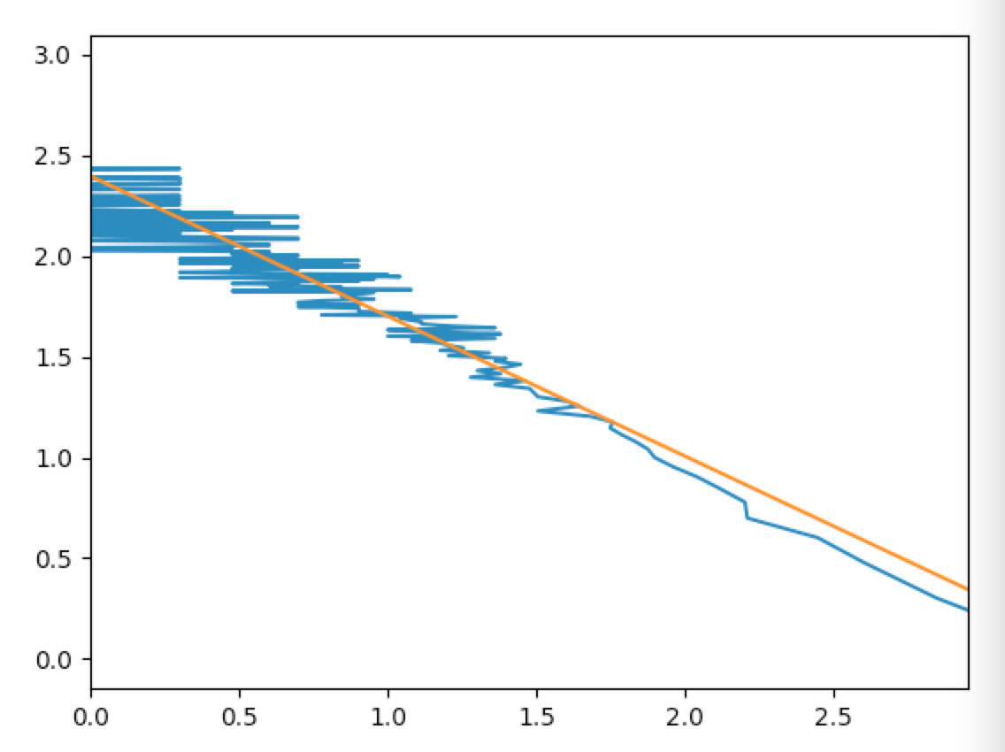

**Question 3.1, Problem Set 0, CS224W**

______________________________________________________________________________

There are 131188 nodes and 322486 edges in the larges Wcc

**Question 3.2, Problem Set 0, CS224W**

______________________________________________________________________________

Top 3 nodes are: [22656, 135152, 992484]

**Question 3.3, Problem Set 0, CS224W**

______________________________________________________________________________

Top 3 hubs are: [22656, 135152, 992484]

**Question 3.4, Problem Set 0, CS224W**

______________________________________________________________________________

Top 3 authorities are: [571407, 157882, 22656]

**Information sheet CS224W:**

**Analysis of Networks**

**Assignment Submission** Fill in and include this information sheet with each of your assign- ments. This page should be the last page of your submission. Assignments are due at 11:59pm and are always due on a Thursday. All students (SCPD and non-SCPD) must submit their homeworks via GradeScope (http://www.gradescope.com). Students can typeset or scan their homeworks. Make sure that you answer each (sub-)question on a separate page. That is, one answer per page regardless of the answer length. Students also need to upload their code at http://snap.stanford.edu/submit. Put all the code for a single question into a single file and upload it. Please do not put any code in your GradeScope submissions.

**Late Homework Policy** Each student will have a total of two free late periods. Homeworks are due on Thursdays at 11:59pm PDT and one late period expires on the following Monday at 11:59pm PDT. Only one late period may be used for an assignment. Any homework received after 11:59pm PDT on the Monday following the homework due date will receive no credit. Once these late periods are exhausted, any assignments turned in late will receive no credit.

**Honor Code** We strongly encourage students to form study groups. Students may discuss and work on homework problems in groups. However, each student must write down their solutions independently i.e., each student must understand the solution well enough in order to reconstruct it by him/herself. Students should clearly mention the names of all the other students who were part of their discussion group. Using code or solutions obtained from the web (github/google/previous year solutions etc.) is considered an honor code violation. We check all the submissions for plagia- rism. We take the honor code very seriously and expect students to do the same.

**Your name: Dingchao Zhang  
Email: Dingchao@stanford.edu SUID: dingchao**

Discussion Group:

I acknowledge and accept the Honor Code.

(Signed) 