Comment on “China’s solar expansion policy reduces bird diversity”
Chenchen Ding¹*
¹ School of Life Sciences and Institute of Ecology, Peking University, Beijing 100871, China.
* Corresponding author. Email: dingchenchen@pku.edu.cn
One-sentence summary: The reported decline in bird diversity under China’s solar-expansion policy reflects birdwatching effort and unvalidated data, not bird communities, and vanishes under standard corrections.

Abstract
Zhang et al. (Research Articles, 21 August 2026) report that solar-policy stringency reduced county-level bird diversity across China. Reanalyzing their public replication data, we show their outcome variable tracks birdwatching effort rather than bird communities; correcting effort, data contamination, and unvalidated policy zeros eliminates the reported effect entirely.

Main Text
Zhang et al. (1) link a photovoltaic policy-stringency index (PSI) to citizen-science bird records aggregated to county-months and conclude that a one-standard-deviation policy increase reduced Shannon diversity by 2.10%. The finding, accompanied by a Perspective (2), has been widely reported as evidence that China’s solar expansion harms birds. Using the authors’ public replication package, we reproduce their preferred estimate exactly (β = −0.0125, clustered SE = 0.0037, n = 46,371). The reproduction, however, exposes problems of measurement, confounding, and inference, each of which independently undermines the conclusion.
The outcome variable measures the observation process. The dependent variable is a Shannon index computed from unstructured birdwatching reports within each county-month. In the estimation sample, 38.8% of county-months derive from a single birdwatcher, and the median county is observed in 11 of 120 months (Fig. 1C). Observed richness and Shannon diversity are steep, saturating functions of the number of birdwatchers present (Fig. 1B): county-months with one birder average 15 species (H = 1.90), while those with >100 birders average 142 species (H = 3.60). This pattern is a species-accumulation curve rather than a property of bird communities. The authors’ own supplementary results carry its signature: PSI associates with lower observed richness but higher evenness (their table S19), the mechanical signature of shorter species lists; in our reproduction, evenness declines monotonically with effort (0.84 at one birder; 0.73 above 100).
The input data are also unvalidated. In record-level platform data held by our own project, every count equals one in 46.9% of 2014–2023 checklists, and in 43.7% of the platform’s raw 2024 provincial delivery, in which we verified the count field to be genuine per-species abundance. Both figures are consistent with the 40.5% reported platform-wide by the China Ornithological Society, which also documents impossible counts in the source data (3). Such records cannot support abundance-weighted indices. At least one such record demonstrably contaminates the published analysis: a single report of 2,147,483,647 little egrets (Egretta garzetta; the 32-bit integer maximum) collapses Shannon diversity for Xinhui County in March 2015 to 8 × 10⁻⁷, against 2.2–2.9 in adjacent months, and this value enters the regression as an observation of the dependent variable (Fig. 1D). Eighteen further county-months share this corruption signature (≥20 species, H < 0.2). No data-quality screening is described in (1).
Birdwatching effort is confounded with the treatment. Summed birdwatcher counts grew 171-fold over 2014–2023 and observed county-months 25-fold, precisely as mean PSI quadrupled (Fig. 1A). The authors control only for Duration, the logarithm of birdwatching hours per birder, a ratio that discards the explosive growth in total effort. Moreover, Duration itself responds to PSI (β = −0.0177, P < 10⁻⁴), making it a “bad control” that conditions on a post-treatment variable (4). Birdwatcher numbers serve as a negative-control outcome: PSI “reduces” birdwatchers (β = −0.041, P = 2 × 10⁻¹¹), an association unlikely to reflect birdwatcher behaviour. The association shrinks by 81% within policy-documented counties (β = −0.008, P = 0.17); next-year PSI “affects” current birdwatchers conditional on current PSI (β = −0.045, P < 10⁻⁵), a causally impossible direction that indicates differential county trends; and PSI does not predict realized PV area within counties (P = 0.27), which weakens any construction-disturbance pathway. A design in which future policy shifts a non-ecological outcome can generate spurious effects for any outcome, including birds.
The remedy is standard in the citizen-science literature: model the observation process explicitly (5–8). Within the authors’ own specification (same data, fixed effects, and clustering), adding ln(birdwatchers) flips the PSI coefficient to +0.0032 (P = 0.31); adding ln(total hours) or both terms gives the same null (Fig. 2A). The richness decline of −0.98 species per PSI unit (their table S19) shrinks by 92% to −0.07 (P = 0.37), and the corrected effect within the 2020–2023 boom is +0.0002 (P = 0.96).
The estimate is fragile and, at face value, negligible. The policy variable is equally problematic: 703 of 2,344 sample counties (43.9% of observations) never appear in the policy-text source, and their PSI is imputed as zero even though the source distinguishes true zeros. Restricting the panel to counties actually documented in the policy source yields β = −0.0027 (P = 0.49). Even taken at face value, PSI adds 0.0003 to the model’s R², or 0.03% of the variance in Shannon diversity, against 31% absorbed by fixed effects (Fig. 2B); the implied one-standard-deviation shift (0.052 on H) is 6.5% of the residual standard deviation (0.80). A statistically significant coefficient of this size, estimated from a contaminated, effort-driven outcome, carries little ecological information (9, 10).
To establish what the data do support, we estimated all 36 combinations of sample (full or policy-documented), cleaning (as published, corrupted rows removed, or ≥2 birders), metric (Shannon, Simpson, log richness), and effort adjustment (fig. S1). All seven significant negative estimates come from paths without effort terms; all 18 effort-adjusted paths are null (median +0.10%). Our preferred estimate (corrupted records removed, policy-documented counties, explicit effort terms) is +0.14% for Shannon diversity (95% CI, −0.96 to +1.24%), an interval that excludes the published −2.10%. Had that effect been real, this corrected design would have detected it with 96% power.
Implications. Our reanalysis does not show that photovoltaic development is harmless; ground-mounted solar can displace habitat, and rigorous impact studies are needed. It shows that this dataset, under this design, cannot detect such an effect in either direction. The subgroup results (no significant effect in desert counties) are already being read as support for concentrating gigawatt-scale development in arid lands, yet deserts are precisely where citizen-science coverage is sparsest; absence of evidence is not evidence of absence. Birdwatching records can support diversity inference under explicit conditions: effort-standardized richness, a presence-based quantity, is defensible with coverage-based rarefaction, list-length corrections, or occupancy models (5–8, 10, 11), whereas abundance-weighted indices such as Shannon additionally require complete checklists, validated counts, and detection-heterogeneity corrections. None of these conditions is met here. We encourage the authors to release the species-level records underlying their indices.

References and Notes
- H. Zhang, A. Zhang, K. Wu, Y. Cai, S. Li, S. Wang, Y. Qiu, S. Huang, T. T. A. Phan, China’s solar expansion policy reduces bird diversity. Science 393, 831–836 (2026). doi:10.1126/science.aee0747
- Y. Liang, Beyond carbon in renewable energy policy. Science 393, 758–759 (2026).
- China Ornithological Society (中国动物学会鸟类学分会), Using birdwatching data for biodiversity assessment requires attention to data characteristics and applicability (2026); https://mp.weixin.qq.com/s/cDlMUCQXkIHZZ_sBBRdDTw.
- C. Cinelli, A. Forney, J. Pearl, A crash course in good and bad controls. Sociol. Methods Res. 53, 1071–1104 (2024).
- A. Johnston, W. M. Hochachka, M. E. Strimas-Mackey, V. Ruiz Gutierrez, O. J. Robinson, E. T. Miller, T. Auer, S. T. Kelling, D. Fink, Analytical guidelines to increase the value of community science data. Divers. Distrib. 27, 1265–1277 (2021).
- S. Kelling, A. Johnston, A. Bonn, D. Fink, V. Ruiz-Gutierrez, R. Bonney, M. Fernandez, W. M. Hochachka, R. Julliard, R. Kraemer, R. Guralnick, Using semistructured surveys to improve citizen science data for monitoring biodiversity. BioScience 69, 170–179 (2019).
- N. J. B. Isaac, A. J. van Strien, T. A. August, M. P. de Zeeuw, D. B. Roy, Statistics for citizen science: extracting signals of change from noisy ecological data. Methods Ecol. Evol. 5, 1052–1060 (2014).
- D. I. MacKenzie, J. D. Nichols, G. B. Lachman, S. Droege, J. A. Royle, C. A. Langtimm, Estimating site occupancy rates when detection probabilities are less than one. Ecology 83, 2248–2255 (2002).
- L. Jost, Entropy and diversity. Oikos 113, 363–375 (2006).
- A. Chao, N. J. Gotelli, T. C. Hsieh, E. L. Sander, K. H. Ma, R. K. Colwell, A. M. Ellison, Rarefaction and extrapolation with Hill numbers: a framework for sampling and estimation in species diversity studies. Ecol. Monogr. 84, 45–67 (2014).
- J. K. Szabo, P. A. Vesk, P. W. J. Baxter, H. P. Possingham, Regional avian species declines estimated from volunteer-collected long-term data using List Length Analysis. Ecol. Appl. 20, 2157–2169 (2010).

Acknowledgments
Funding: The author received no specific funding for this work. Author contributions: C.D. conceived the reanalysis, performed all analyses, and wrote the manuscript. Competing interests: The author declares no competing interests. Data and materials availability: All analyses use the original authors’ public replication package (github.com/jianke22/China-s-solar-expansion-policy-reduces-bird-diversity). R scripts, derived tables, and figure source data reproducing every number in this Comment are available at github.com/dingchenchen6/reanalysis-zhang2026-solar-birds and will be archived with a DOI upon acceptance. Record-level birdwatching-platform data used for species-level verification are held under a data agreement with the China Birdwatching Record Center; aggregated verification outputs are included in the repository.

Supplementary Materials
Materials and Methods; Figs. S1 and S2; Tables S1 and S2.

Figure Legends
Fig. 1. The dependent variable of Zhang et al. measures the observation process, not bird communities. (A) Within the authors’ estimation sample, summed birdwatcher counts (red) grew 171-fold during 2014–2023 and observed county-months (orange) 25-fold, while mean policy stringency (blue) quadrupled; mean observed Shannon H (green) rose accordingly. All series indexed to 2014 = 1, log scale. (B) Observed Shannon H (green, left axis; mean ± s.d.) and species richness (blue, right axis) against the number of birdwatchers per county-month: a species-accumulation curve. 38.8% of county-months derive from a single birder. (C) Distribution of the number of months (of 120) in which each county has any birdwatching record; median 11. (D) Monthly Shannon H for Xinhui County, Guangdong: a single record of 2,147,483,647 little egrets (the int32 maximum) collapses March 2015 to H = 8 × 10⁻⁷, which enters the regression unfiltered; 18 further county-months show ≥20 species yet H < 0.2.
Fig. 2. The reported policy effect vanishes under correction and is negligible in magnitude. (A) Effect of a one-standard-deviation PSI increase, expressed as % of the outcome mean with 95% CIs, under the authors’ exact specification and minimal corrections (identical data, county and year-month fixed effects, county-clustered SEs). Adding total-effort terms, restricting to counties documented in the policy source, or splitting by period eliminates the effect; the richness outcome (triangles) shrinks 92% under effort control. Red dotted line: the headline −2.10%. (B) Variance ledger for county-month Shannon H: county and year-month fixed effects absorb 31.0%, the nine controls 2.7%, and PSI, the headline variable, 0.03%, with 66.3% unexplained.
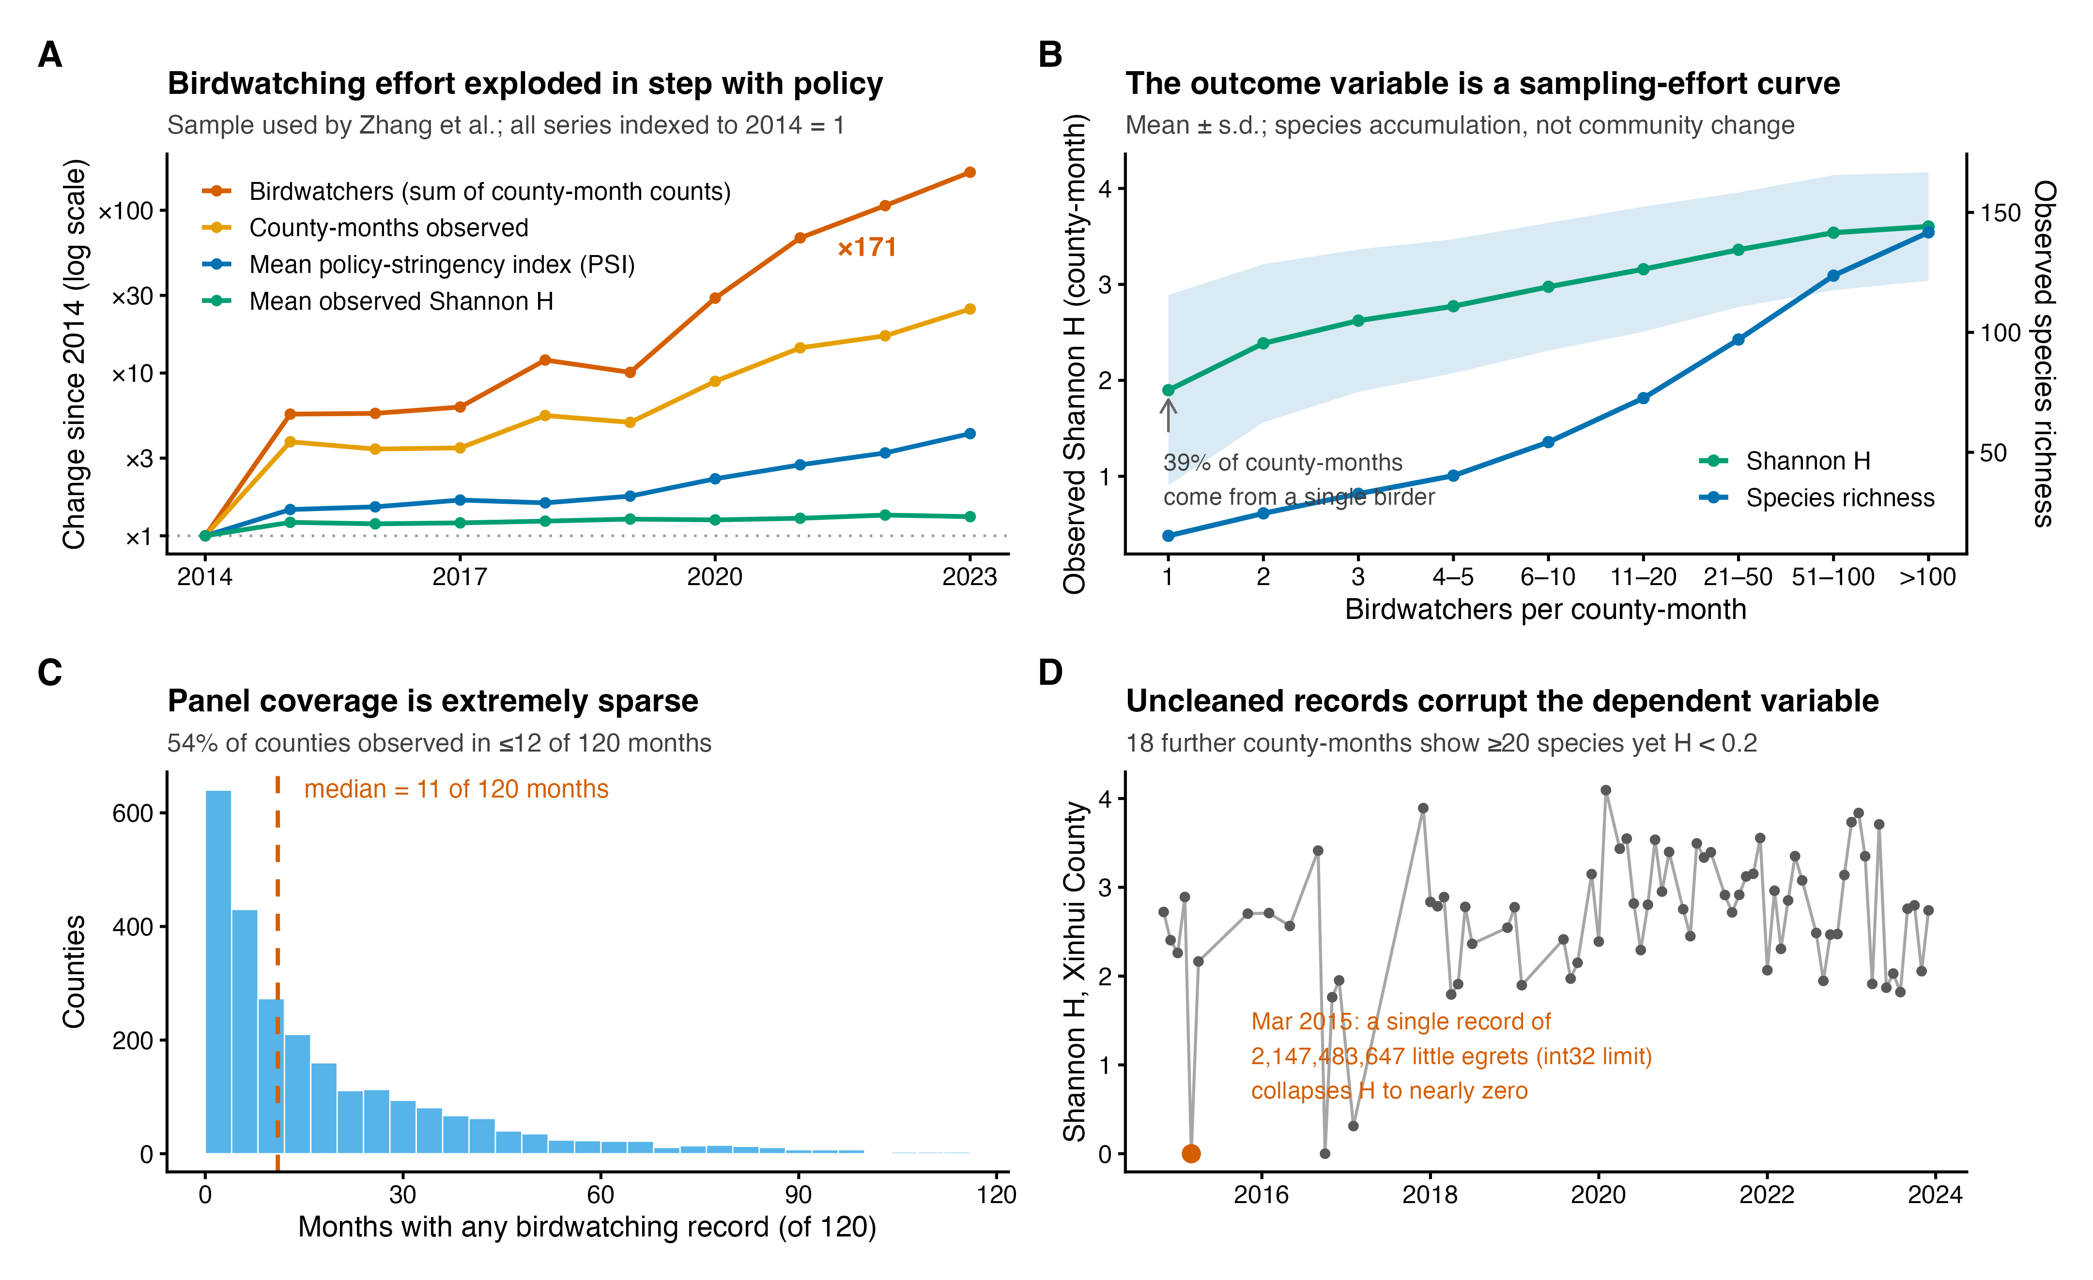
Fig. 1.
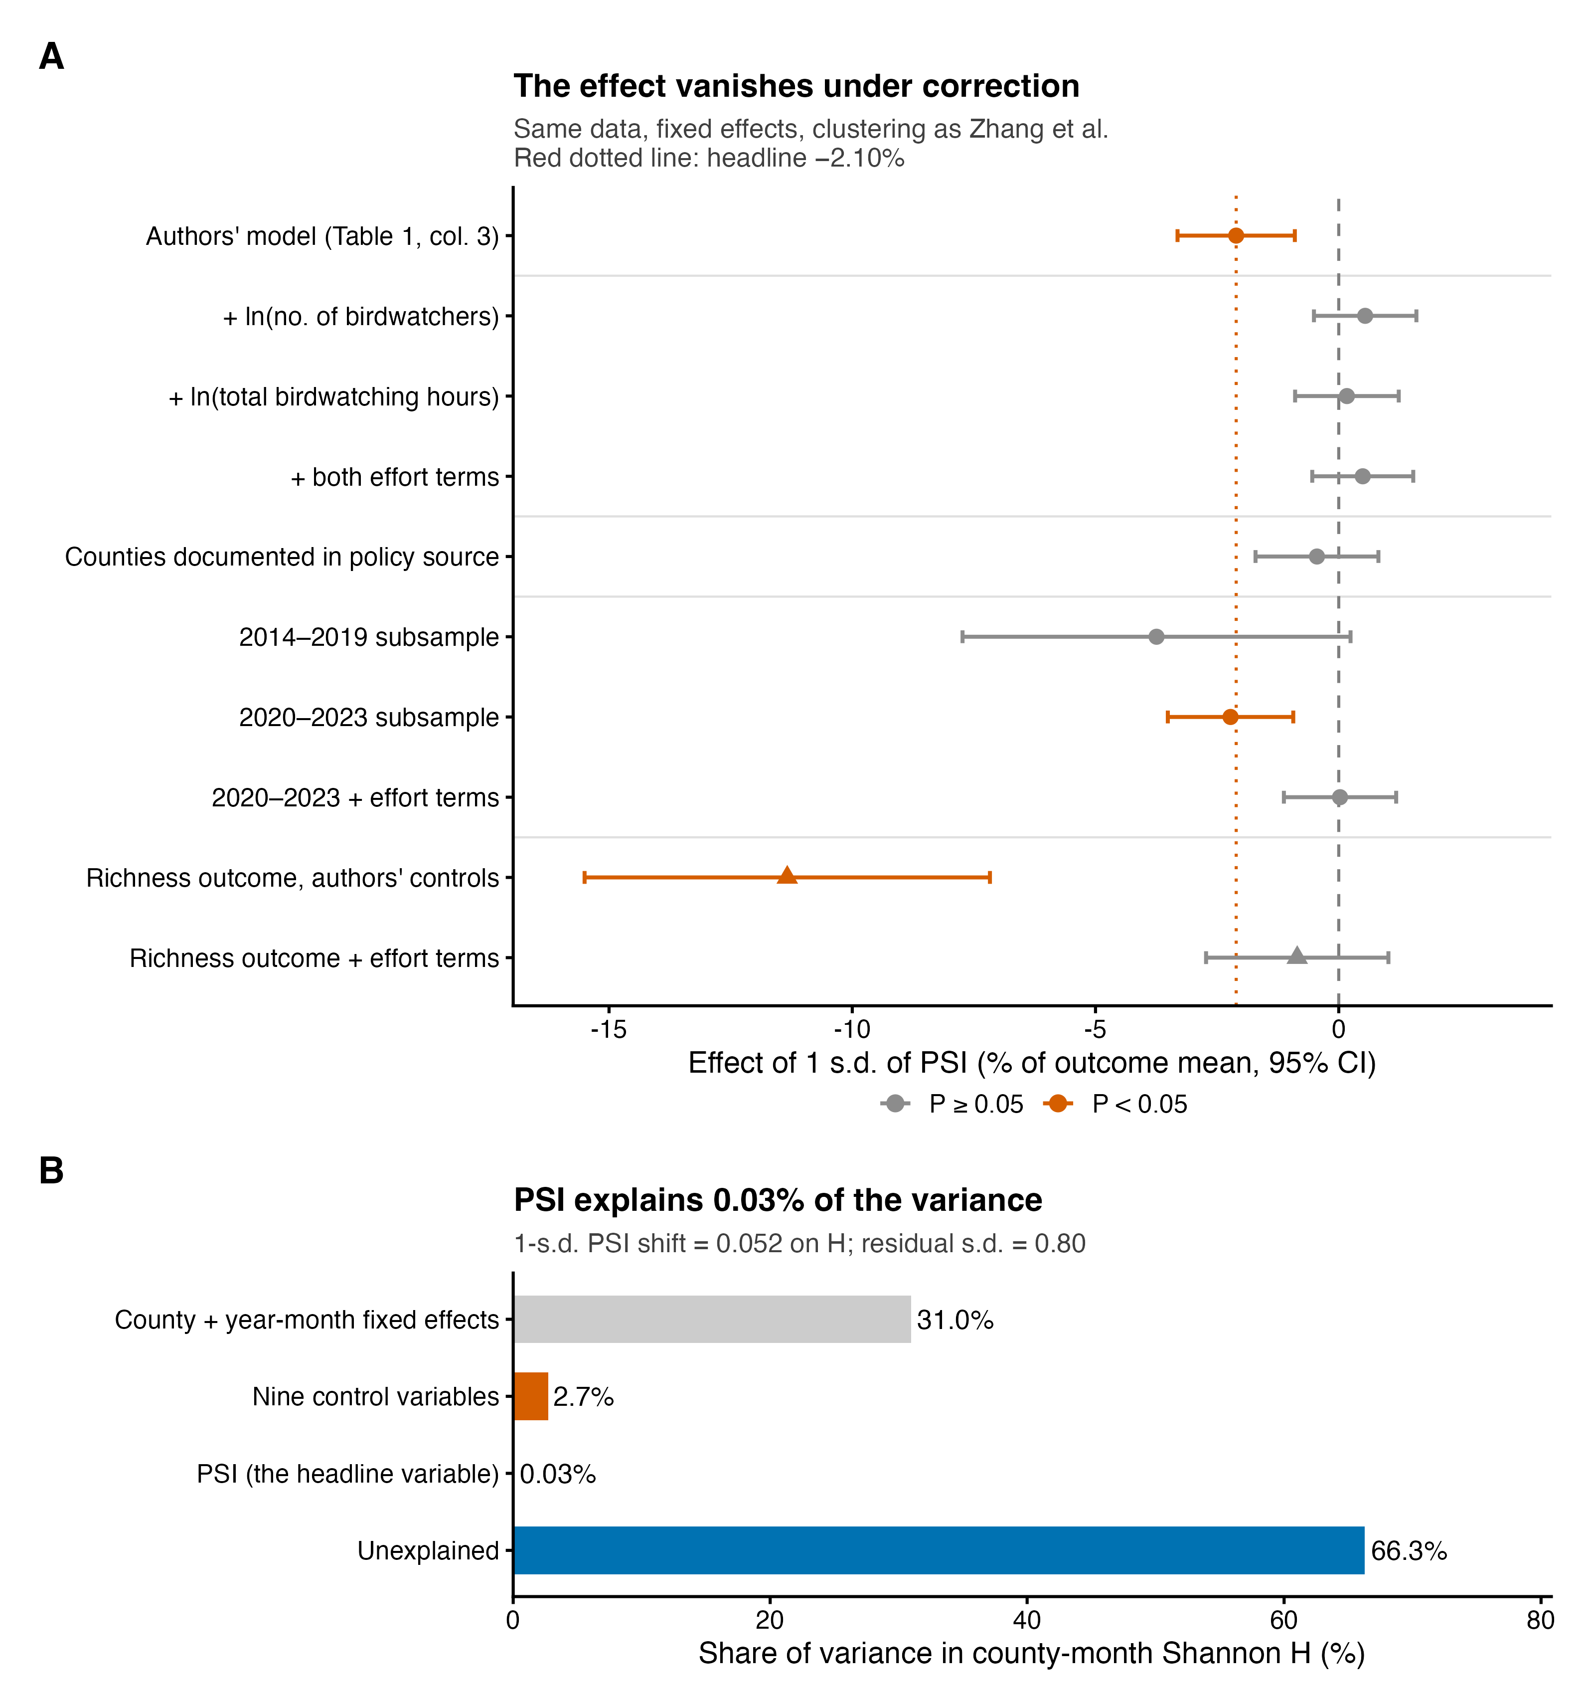
Fig. 2.

