Supplementary Materials for

Comment on “China’s solar expansion policy reduces bird diversity”
Chenchen Ding. Correspondence to: dingchenchen@pku.edu.cn
This PDF file includes: Materials and Methods; Figs. S1 and S2; Tables S1 and S2.

Materials and Methods
Data and exact replication. All analyses start from the replication package released by Zhang et al. (Stata code and county-month data; github.com/jianke22/China-s-solar-expansion-policy-reduces-bird-diversity). We rebuilt the estimation panel in R 4.5.1 (fixest, data.table, haven), following the authors’ merge order, variable construction, 1%/99% winsorization, and singleton-dropping conventions. The preferred specification regresses the county-month Shannon index on the policy-stringency index (PSI) and nine controls with county and year-month fixed effects and county-clustered standard errors. Our estimates match Table 1 of the original article to the fourth decimal place (column 3: β = −0.01253, SE = 0.00366, n = 46,371), and the headline −2.10% equals β × s.d.(PSI)/mean(H) = −0.0125 × 4.116/2.446.
Effort variables and adjusted specifications. The replication data include, for every county-month, the number of birdwatchers (BN) and total birdwatching hours (BT). The authors’ only effort control, Duration = ln(BT/BN + 1), is a per-birder ratio: within the estimation sample it correlates only weakly with total effort, whereas summed BN grew 171-fold over 2014–2023. Adjusted specifications add ln(BN), ln(BT + 1), or both to the authors’ model without any other change. Effects are reported as percentages of the outcome mean per 1 s.d. of PSI throughout.
Policy-source restriction and negative-control tests. The policy file covers 1,641 of the 2,344 sample counties; the authors set PSI to zero for the remaining 703 counties (43.9% of observations), although the source itself contains explicit zeros. The restricted sample retains policy-documented counties only. Negative-control regressions replace the outcome with ln(BN), realized photovoltaic area (converted from installed capacity as in the authors’ code), or ln(nightlight + 1); the pre-trend test adds next-year PSI alongside current PSI; a further variant adds county-specific linear trends to the authors’ specification. Results are collected in Table S2.
Data-quality rules. Because Shannon H, Gini–Simpson D, and richness S computed from one assemblage must satisfy H ≤ ln S, D ≤ 1 − e^{−H} (equivalent to ²D ≤ ¹D), D ≤ 1 − 1/S, and H > 0 whenever S ≥ 2, violations identify impossible entries without ecological judgment. Applied to all 46,283 pre-winsorization county-months, the rules flag a single hard violation (S = 4, H = 8 × 10⁻⁷; Xinhui County, March 2015), which coincides with the 2,147,483,647-egret record verified by the China Ornithological Society, plus 18 county-months carrying the same single-huge-count signature (S ≥ 20, H < 0.2). “Corrupted removed” specifications exclude these 19 county-months.
Species-level verification. Through a separate project we hold record-level data from the same platform: the platform’s raw provincial delivery (2024 increment: 32 provinces, 8.1 million species-by-checklist rows, 282,197 checklists) and an event table built from an earlier multi-year delivery (2000–2025, 11.7 million rows). In the raw delivery the count column has zero missingness, and checklists in which a constant count equals the species count — the signature of a list-length leak — comprise at most 0.35% in any province, confirming genuine per-species abundance. Every count equals one in 43.7% of raw-delivery checklists and in 46.9% of 2014–2023 checklists in the event table, consistent with the 40.5% reported platform-wide by the Ornithological Society. Platform deliveries are ceiling-cleaned (maximum count 10⁵); the three astronomical records verified by the Society appear in none of them, yet one demonstrably enters the published outcome variable. County-month Shannon recomputed from the event table correlates with the published outcome at r = 0.71 across 17,404 overlapping county-months, indicating strong sensitivity of the aggregated index to checklist-set choice.
Specification curve. We estimated every combination of sample (all counties; policy-documented), cleaning (as published; corrupted county-months removed; ≥2 birders), outcome metric (Shannon; Simpson; log richness), and effort adjustment (authors’ Duration only; explicit total-effort terms), yielding 36 specifications with identical fixed effects and clustering (Table S1; fig. S1). Poisson fixed-effects models for richness with a ln(BN) offset — the catch-per-unit-effort convention — appear in Table S2.
Power and minimum detectable effects. For the preferred corrected specification (corrupted records removed, policy-documented counties, explicit effort terms), the minimum detectable effect at 80% power and α = 0.05 is 2.80 × SE, i.e., 1.57% (Shannon), 1.20% (Simpson), and 4.04% (log richness) per 1 s.d. of PSI. The power to detect the published −2.10%, were it real, is Φ(0.0125/SE − 1.96) = 96%.
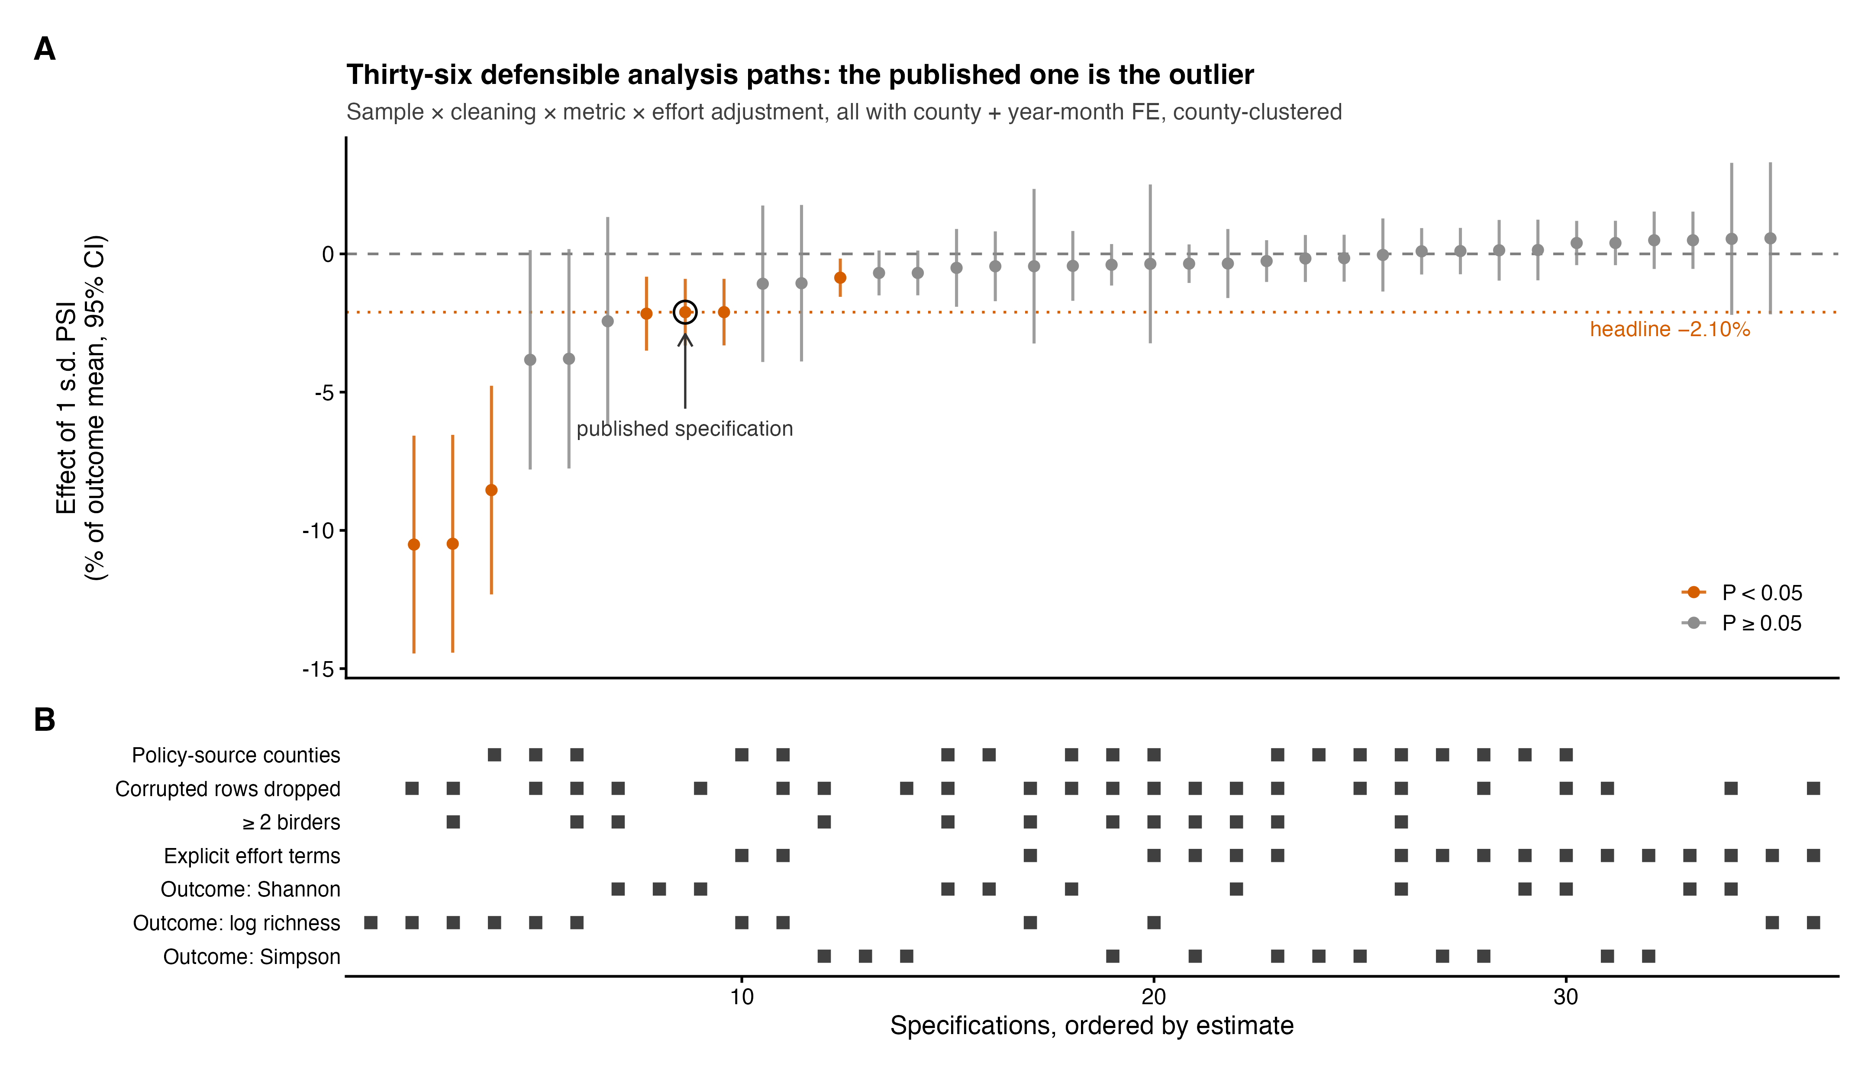
Fig. S1. Specification curve across 36 defensible analysis paths. Estimates of the PSI effect (% of outcome mean per 1 s.d., 95% CIs) for the full cross of sample, cleaning, outcome metric, and effort adjustment, ordered by estimate; the lower panel indicates each path’s decisions. All seven significant negative estimates (orange) arise without effort terms; all 18 effort-adjusted paths are null. The open circle marks the published specification.
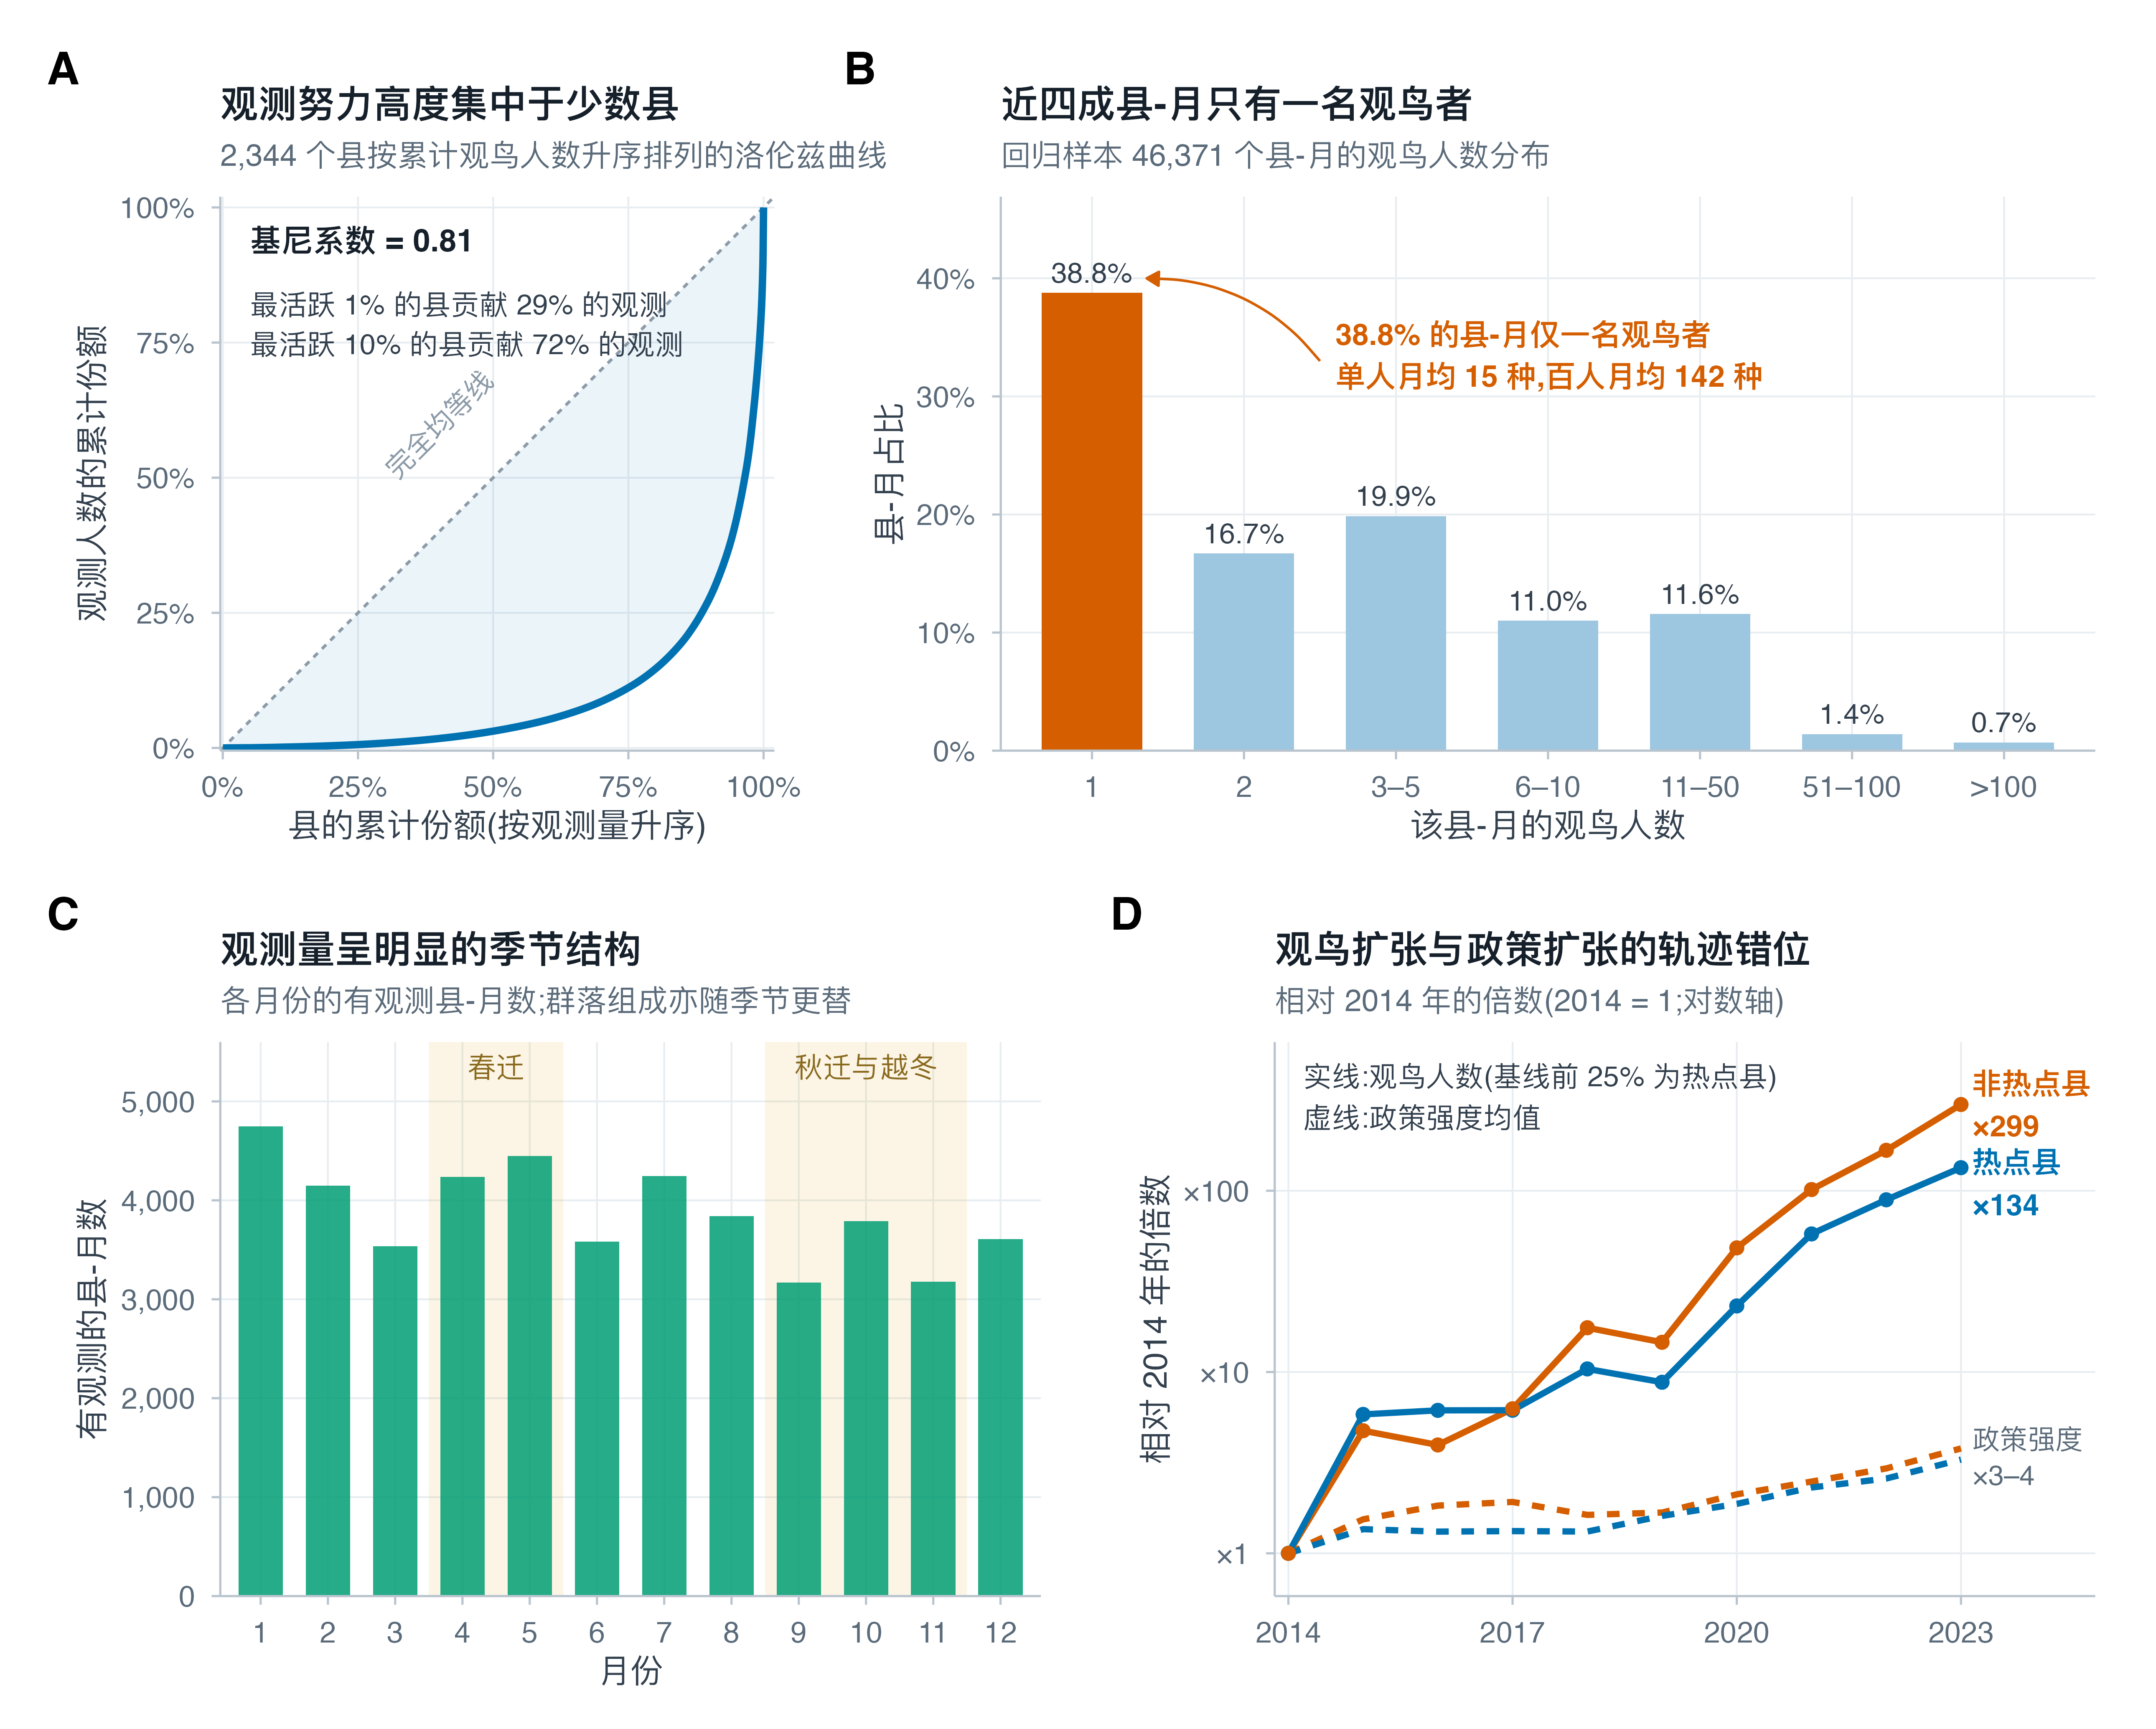
Fig. S2. Structure of the birdwatching data underlying the outcome variable. (A) Observation effort is highly concentrated among counties (Gini = 0.81; 1% of counties contribute 29% of effort). (B) 38.8% of county-months derive from a single birdwatcher. (C) Reporting is strongly seasonal, peaking in wintering and migration periods. (D) Effort growth (solid lines) outpaces policy growth (dashed) by two orders of magnitude, and non-hotspot counties (×299) outgrow hotspot counties (×134): the phase mismatch between these diffusion processes underlies the within-county association between policy and effort.
Table S1. Specification curve: all 36 combinations of sample, cleaning, outcome metric, and effort adjustment. All models include county and year-month fixed effects with county-clustered standard errors. Effects are % of the outcome mean per 1 s.d. of PSI; rows ordered by estimate. Rows in bold denote statistically significant negative estimates (all arise without effort terms).
# | Sample | Cleaning | Metric | Effort | Effect (%/s.d.) | 95% CI | P | n
1 | All counties | As published | log richness | Duration only | -10.51 | [-14.45, -6.57] | 1.8e-07 | 45,606
2 | All counties | Corrupted removed | log richness | Duration only | -10.48 | [-14.42, -6.55] | 2e-07 | 45,588
3 | All counties | ≥2 birders | log richness | Duration only | -8.54 | [-12.32, -4.77] | 9.7e-06 | 27,571
4 | Policy-documented | As published | log richness | Duration only | -3.83 | [-7.80, +0.14] | 0.059 | 25,245
5 | Policy-documented | Corrupted removed | log richness | Duration only | -3.79 | [-7.76, +0.17] | 0.061 | 25,234
6 | Policy-documented | ≥2 birders | log richness | Duration only | -2.43 | [-6.20, +1.33] | 0.21 | 14,032
7 | All counties | ≥2 birders | Shannon | Duration only | -2.16 | [-3.50, -0.82] | 0.0016 | 28,052
8 | All counties | As published | Shannon | Duration only | -2.11 | [-3.31, -0.90] | 0.00062 | 46,371
9 | All counties | Corrupted removed | Shannon | Duration only | -2.11 | [-3.31, -0.90] | 0.00062 | 46,353
10 | Policy-documented | As published | log richness | Explicit effort | -1.08 | [-3.91, +1.75] | 0.45 | 25,245
11 | Policy-documented | Corrupted removed | log richness | Explicit effort | -1.06 | [-3.89, +1.77] | 0.46 | 25,234
12 | All counties | ≥2 birders | Simpson | Duration only | -0.86 | [-1.55, -0.17] | 0.015 | 28,052
13 | All counties | As published | Simpson | Duration only | -0.69 | [-1.50, +0.12] | 0.096 | 46,371
14 | All counties | Corrupted removed | Simpson | Duration only | -0.69 | [-1.50, +0.12] | 0.095 | 46,353
15 | Policy-documented | ≥2 birders | Shannon | Duration only | -0.51 | [-1.91, +0.90] | 0.48 | 14,510
16 | Policy-documented | As published | Shannon | Duration only | -0.45 | [-1.71, +0.82] | 0.49 | 26,007
17 | All counties | ≥2 birders | log richness | Explicit effort | -0.45 | [-3.24, +2.35] | 0.75 | 27,571
18 | Policy-documented | Corrupted removed | Shannon | Duration only | -0.43 | [-1.70, +0.83] | 0.5 | 25,996
19 | Policy-documented | ≥2 birders | Simpson | Duration only | -0.39 | [-1.14, +0.36] | 0.3 | 14,510
20 | Policy-documented | ≥2 birders | log richness | Explicit effort | -0.36 | [-3.23, +2.51] | 0.81 | 14,032
21 | All counties | ≥2 birders | Simpson | Explicit effort | -0.35 | [-1.05, +0.34] | 0.32 | 28,052
22 | All counties | ≥2 birders | Shannon | Explicit effort | -0.35 | [-1.60, +0.90] | 0.58 | 28,052
23 | Policy-documented | ≥2 birders | Simpson | Explicit effort | -0.26 | [-1.01, +0.50] | 0.5 | 14,510
24 | Policy-documented | As published | Simpson | Duration only | -0.17 | [-1.02, +0.68] | 0.7 | 26,007
25 | Policy-documented | Corrupted removed | Simpson | Duration only | -0.16 | [-1.00, +0.69] | 0.72 | 25,996
26 | Policy-documented | ≥2 birders | Shannon | Explicit effort | -0.04 | [-1.36, +1.28] | 0.95 | 14,510
27 | Policy-documented | As published | Simpson | Explicit effort | +0.09 | [-0.75, +0.93] | 0.83 | 26,007
28 | Policy-documented | Corrupted removed | Simpson | Explicit effort | +0.10 | [-0.74, +0.94] | 0.81 | 25,996
29 | Policy-documented | As published | Shannon | Explicit effort | +0.13 | [-0.97, +1.23] | 0.81 | 26,007
30 | Policy-documented | Corrupted removed | Shannon | Explicit effort | +0.14 | [-0.96, +1.24] | 0.8 | 25,996
31 | All counties | Corrupted removed | Simpson | Explicit effort | +0.39 | [-0.41, +1.19] | 0.33 | 46,353
32 | All counties | As published | Simpson | Explicit effort | +0.39 | [-0.41, +1.20] | 0.34 | 46,371
33 | All counties | As published | Shannon | Explicit effort | +0.49 | [-0.54, +1.53] | 0.35 | 46,371
34 | All counties | Corrupted removed | Shannon | Explicit effort | +0.49 | [-0.54, +1.53] | 0.35 | 46,353
35 | All counties | As published | log richness | Explicit effort | +0.54 | [-2.21, +3.29] | 0.7 | 45,606
36 | All counties | Corrupted removed | log richness | Explicit effort | +0.56 | [-2.19, +3.31] | 0.69 | 45,588
Robustness variants of the preferred specification (corrupted removed, policy-documented, explicit effort):
Variant | Metric | Effect (%/s.d.) | 95% CI | P | n
Province-clustered SEs | Shannon | +0.14 | [-1.40, +1.68] | 0.86 | 25,996
Province-clustered SEs | log richness | -1.06 | [-5.96, +3.83] | 0.67 | 25,234
Period 2014–2019 | Shannon | -3.40 | [-7.39, +0.59] | 0.095 | 11,406
Period 2020–2023 | Shannon | +0.03 | [-1.12, +1.18] | 0.96 | 34,496
Period 2020–2023 | log richness | +0.36 | [-2.52, +3.23] | 0.81 | 33,904
Table S2. Diagnostic and negative-control regressions. All models include county and year-month fixed effects; standard errors clustered by county.
Regression (county and year-month FE, county-clustered) | β(PSI) | P | n | Note
ln(birdwatchers) on PSI, full sample | -0.0410 | 2.1e-11 | 46,371
ln(birdwatchers) on PSI, policy-documented counties | -0.0078 | 0.166 | 26,007 | 81% attenuation
ln(birdwatchers) on next-year PSI, conditional on current PSI | -0.0447 | 1.51e-06 | 32,778 | pre-trend
Realized PV area on PSI | -0.0175 | 0.268 | 46,371 | no exposure link
ln(nightlight) on PSI | -0.0017 | 0.237 | 46,371 | clean negative control
Shannon on PSI, county-specific linear trends added | -0.0079 | 0.102 | 46,371 | headline non-significant
Shannon on PSI + ln(birdwatchers) | +0.0032 | 0.31 | 46,371 | effect null under effort control
Richness (Poisson FE): Poisson FE, no effort (authors’ logic) | -0.0233 | 6.29e-08 | 45,606 | -9.2%/s.d.
Richness (Poisson FE): + offset log(birdwatchers) [CPUE] | +0.0151 | 0.00568 | 45,606 | +6.4%/s.d.
Richness (Poisson FE): offset + policy-documented counties | +0.0055 | 0.318 | 25,245 | +2.3%/s.d.
Richness (Poisson FE): offset + ln(hours) + policy-documented | +0.0029 | 0.553 | 25,245 | +1.2%/s.d.

