**Ziyun Ding**

**data** work.interaction;

length filename $ **40** type $ **20**; /*7a*/

infile 'W:\interactions.dat' dlm='09'x dsd missover; /*7b,7d, 7e*/

input PROT1 $ PROT2 $ RANK_MAJOR RANK_MINOR TYPE $

PDB_ID $ BIO_UNIT CHAIN1 $ MODEL1 SEQ_IDENT1

COVERAGE1 SEQ_BEGIN1 $ SEQ_END1 $ DOMAIN1 $ CHAIN2 $

MODEL2 SEQ_IDENT2 COVERAGE2 SEQ_BEGIN2 SEQ_END2

DOMAIN2 $ FILENAME $; /*7c*/

coverage1=round(coverage1); /*20a*/

coverage2=int(coverage2); /*20b*/

totoal_coverage=sum(coverage1,coverage2); /*20c*/

maximum_coverage=max(coverage1,coverage2); /*20d*/

miss_domain1=cmiss(domain1); /*20e*/

**run**;

**proc** **print** data=work.interaction; /*7f*/

**run**;

===========================================================

libname orion 'w:\'; /*1a*/

**proc** **contents** data=orion._ALL_ NODS; /*1b*/

**run**;

**proc** **contents** data=work.interaction; /*1c*/

**run**;

**proc** **print** data=work.interaction label;

label prot1='protein1' prot2='protein2'; /*1d*/

**run**;

===========================================================

title 'Protein Protein Interaction Data in Arabidopsis'; /*3c*/

footnote 'Downloaded from Interactome3D Website'; /*3d*/

**proc** **print** data=work.interaction split='*'; /*3a, 3b*/

label seq_ident1='sequence*identity 1' seq_ident2='sequence*identity 2'; /*3b*/

**run**;

title; footnote;

===========================================================

**data** model domain structure; /*14a*/

keep prot1 prot2 type domain1 rank_major /*14c*/

bio_unit seq_ident1 seq_begin1 seq_end1;

set work.interaction (firstobs=**10** obs=**1000**); /*14d*/

select(Type); /*14b*/

when('Model') output model;

when('Dom_dom_model') output domain;

when('Structure') output structure;

otherwise;

end;

**run**;

===========================================================

libname orion 'W:\';

ods pdf file="W:\interaction_freq.pdf"; /*13d*/

**proc** **freq** data=model nlevels; /*13a*/

tables _all_ / noprint;

**run**;

ods pdf close;

libname orion 'W:\';

ods rrf file="W:\interaction_mean.rtf"; /*13d*/

**proc** **means** data=interaction nmiss min max sum; /*13b*/

var seq_ident1;

class type;

**run**;

ods rtf close;

libname orion 'W:\';

ods html file="W:\interaction_univar.html"; /*13d*/

**proc** **univariate** data=interaction nextrobs=**5**; /*13c*/

var seq_ident1;

**run**;

ods html close;

===========================================================

**data** extract(keep=interaction type template filename file_length categary1);

set interaction;

filename=propcase(filename,'.'); /*18d*/

template=scan(filename,**4**,'-'); /*18c*/

categary1=substr(prot1,**1**,**1**); /*18a*/

file_length=length(filename); /*18b*/

type=upcase(type); /*18e*/

interaction=catx('-',prot1,prot2); /*18f*/

**run**;

===========================================================

**data** model_converted;

set model;

Ndomain=input(seq_begin1, **5.**); /*21a*/

Crankmajor=put(rank_major, **2.**); /*21b*/

new_begin=seq_begin1+**100**; /*21c*/

**run**;

**proc** **contents** data=model_converted; /*21d*/

**run**;

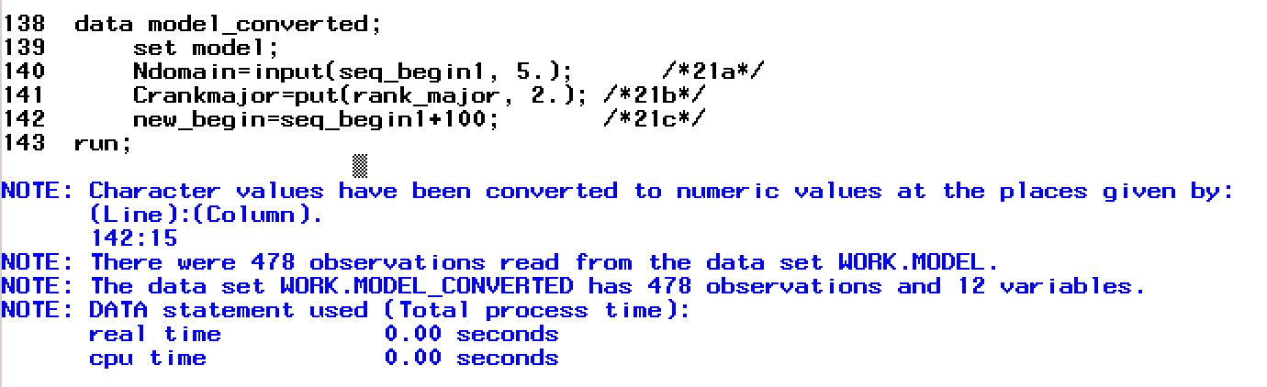

===========================================================

**data** interaction_2;

infile 'W:\interactions.dat' dlm='09'x; /*8a*/

input protein1 :$6. protein2 :$6. RANK_MAJOR

RANK_MINOR TYPE :$20. PDB_ID :$4. BIO_UNIT

CHAIN1 :$1. MODEL1 SEQ_IDENT1 COVERAGE1 :**2.** SEQ_BEGIN1 SEQ_END1 DOMAIN1 CHAIN2 :$1. MODEL2 SEQ_IDENT2 COVERAGE2 :**2.** SEQ_BEGIN2 SEQ_END2

DOMAIN2 FILENAME :$40.; /*8b*/

format coverage1 **4.1** converage2 **4.1**; /*8c*/

**run**;

**proc** **print** data=interaction_2; /*8d*/

**run**;

===========================================================

**data** compare;

set structure;

array template{**4**} seq_ident1 seq_ident2 coverage1 coverage2;

array diff{**4**};

array aver{**4**} _temporary_ (**80**,**80**,**75**,**75**); /*23a*/

do i=**1** to dim(diff); /*23b*/

diff{i}=template{i}-aver{i};

end;

**run**;

**proc** **print** data=compare;

**run**;

===========================================================

%put Starting with topics from mac1; /*25b*/

%let filename=structure; /*25c*/

%let opt=noobs;

%let name=protein;

options symbolgen; /*25a*/

**proc** **print** data=&filename &opt label;

footnote "Created &systime &sysday, &sysdate9"; /*25d*/

label prot1="&name.1" prot2="&name.2"; /*26a*/

**run**;

%symdel opt name; /*25e*/

===========================================================

options mcompilenote=ALL; /*27d*/

**%macro** ***classify***; /*27a*/

proc means data=structure;

run;

**%mend** classify; /*27b*/

options mprint; /*27c*/

%***classify***