# 旋转标签实验

标签绕三个坐标轴旋转，坐标和旋转方向如下图所示

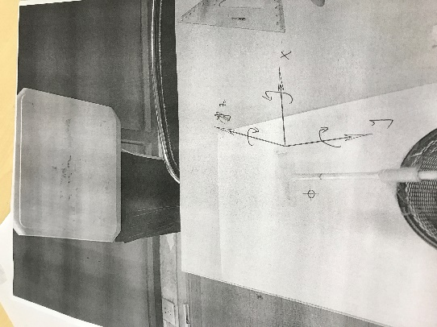

横坐标(旋转角度)

[0, 30, 60, 90, 120, 150, 180, 210, 240, 270, 300, 330]

纵坐标(相位)：

x: [1.4472657562881059, 1.4770591436494573, 1.4353828503470605, 1.2816138780292552, 1.2057383989086514, 1.1249009827734238, 1.0603760803021445, 1.0102449555846449, 0.98974419764430488, 1.0423152037426822, 1.1455831780869679, 1.3133520338762965]

y: [2.7686868723799152, 2.0568523429622747, 1.2052477024399273, 0.46649451460165131, 5.7918475708316661, 4.4196543133631794, 2.7888299682653317, 2.0875594687068273, 1.1134055725587879, 0.46677757058036828, 5.6116877569859369, 4.4711532269312499]

z: [1.4033135153175635, 1.887608476575279, 2.5997906393085848, 5.0164874476107091, 0.22881733992552442, 0.60820853742129011, 0.91601574588775658, 1.7145160938083475, 2.357463991534043, 5.2594437704967865, 0.3785944271815419, 0.65203206901539079]

散点图：

