Algonquin College Logo

# SCHOOL OF ADVANCED TECHNOLOGY

### ICT - Applications & Programming

### Computer Engineering Technology – Computing Science



A11

Game Interface

Team:

[Soomin Lee] - Id: [113]

Game Proposal - NumPuz

***This template is suggested (not mandatory) to answer A11 Specification.***

|  |  |
| --- | --- |
| **Part**  **1** | **GUI Definition** |

**EXPLANATION**

**Number Puzzle game is that user need to match all numbers in the order.**

*The purpose of this assignment is to define the elements of the GUI application to be used in your game implementation.*

* ***Example****:*

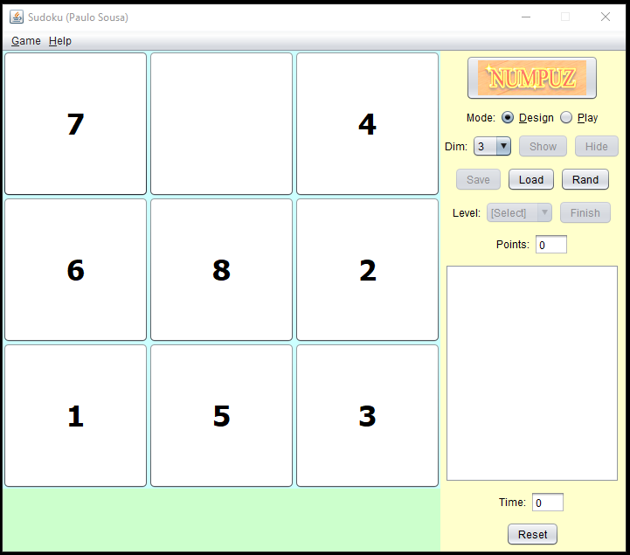

* ***Note****: The professor interface is also a proposal. It means that your own implementation can be different. What does matter is that the game functionality will be respected.*
  1. **Defining the Components**

**List of components**

**JFrame, JLabel, JPanel, JRadioButton, JTextArea, JTextField, JButton, JComboBox, FlowLayout, GridLayout, Image**

**Functionalities and Behaviors**

**The dimension can be selected by ComboBox.**

**The level can be selected by ComboBox.**

**The point will be shown in TextArea.**

**The success image will be shown with Image.**

**The numbers for game will be organized with GridLayout.**

**The play time will be shown by Timer in TextArea.**

**The game will reset with reset JButton.**

**The game mode can be selected by RadioButtons.**

**Details**

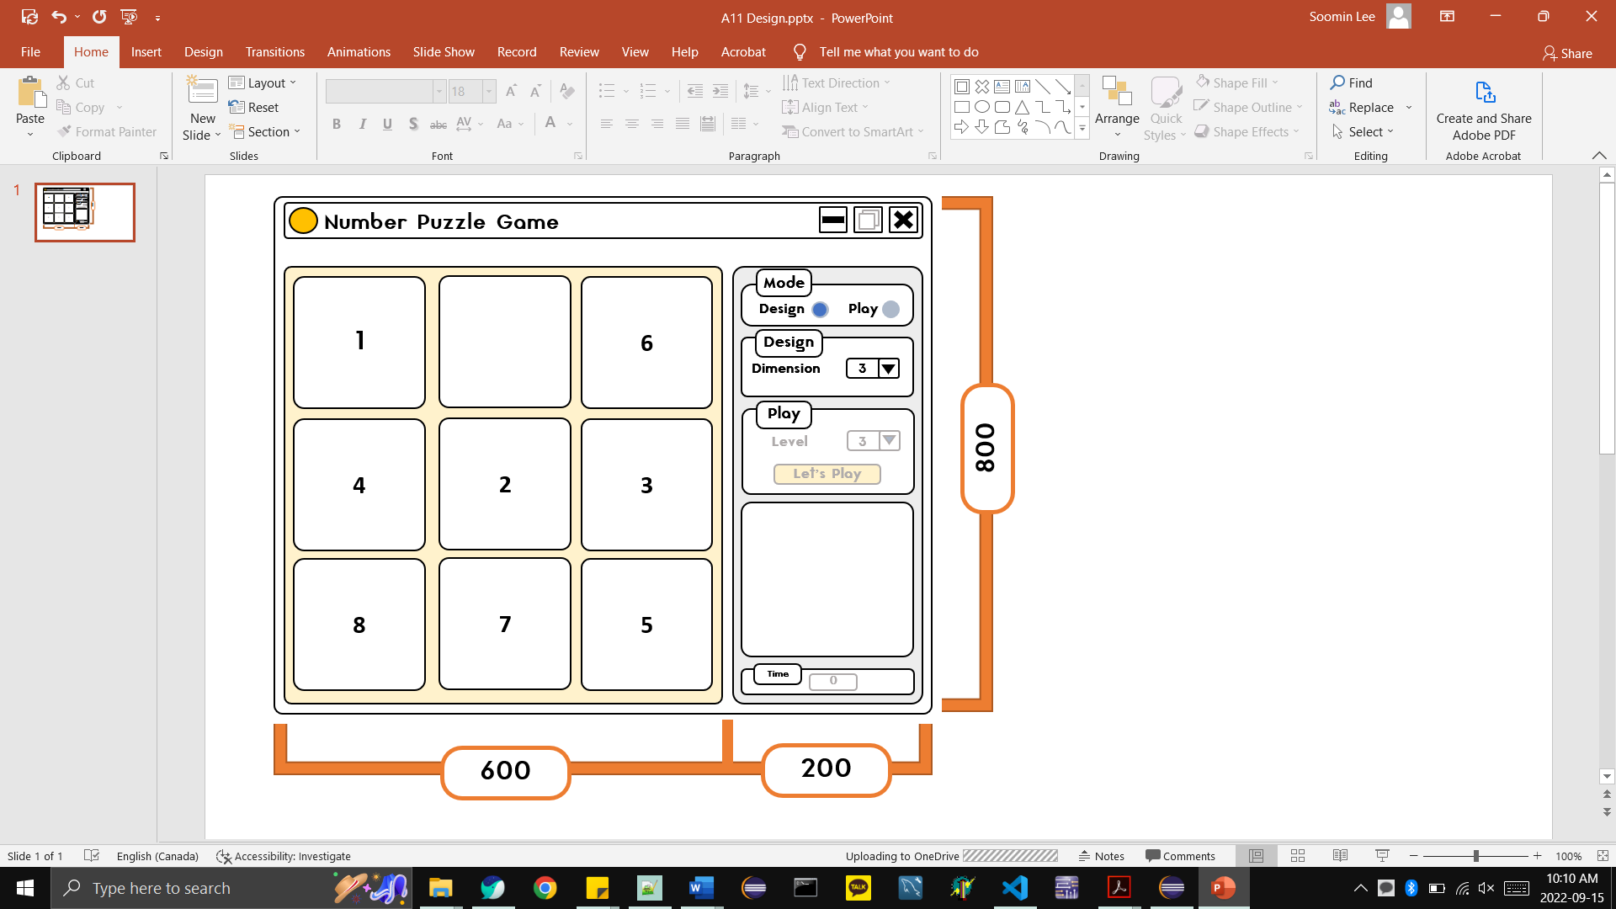

* 1. **User Manual**

**Basic cycle**

**User will chose design for the game. – dimension**

**User will play the game with selected level – 1,2,3**

**User will play the game (moving numbers) then timer will start.**

**If all numbers are in the order, “Success” image will be shown. If user wants to reset the number order(click reset button), it will show random order again.**

**FINAL SUGGESTIONS**

*Here some ideas to think about your language....*

* *Try to create a game whose execution can be very intuitive (easy to be played).*
* *Remember that this game will be in fact implemented only in the next assignment.*

**References**

*[Include eventual references used here]*

Algonquin College

Fall, 2022