Ding Jin
CS455 PA2
11/3/2015

Implementing a Reliable Transport Protocol

Objective:
The general goal will be writing the sending and receiving transport-level code for implementing the Go-Back-N reliable data transfer protocol. Specifically, the procedures in this simulator are for the sending entity (A) and the receiving entity (B). Only unidirectional transfer of data (from A to B) is required. Of course, the B-side will have to send packets to A to acknowledge receipt of data.
The emulated network environment was given. The modified routines are in the StudentNetworkSimulator.java.

Design:
checkSum(packet) --where packet is a structure of type pkt. I implemented a TCP-like checksum, which consists of the sum of the (integer) sequence and ACK field values, added to a character-by-character sum of the payload field of the packet.
updateSeq(int) --update the sequence number in window, if the incremented number exceeded window size, start over.
averageRTT() --compute the average RTT at the end of the statistics.
aOutput(message) --where message is a structure of type msg, containing data to be sent to the B-side. This routine will be called whenever the upper layer at the sending side (A) has a message to send. It firstly created packet and do the checksumming, then make the call to layer3.
aInput(packet) --where packet is a structure of type pkt. This routine will be called whenever a packet sent from the B-side arrives at the A-side. packet is the (possibly corrupted) packet sent from the B-side.It checks corrupted and out-dated situation. Corruption situation terminates the routines and out-dated situation make the window slide(GBN)
aTimerInterrupt() --This routine will be called when A's timer expires. It can re-transmit the packet by implementing a iterative traverse through the window
aInit() --Initialization of side A.
bInput(packet) --where packet is a structure of type pkt. This routine will be called whenever a packet sent from the A-side arrives at the B-side. packet is the (possibly corrupted) packet sent from the A-side. The structure is similar with aInput(packet). It also has a call to layer 5.
bInit() --Initialization of side B.

Test:
After compiling all the files(“javac Project.java”), I started the test by running the Project.java. Since I should gather statistics under various loss and corruption probabilities as well as considering different RTT, part of the variables will be the standard(which I will used the example in the instruction):

Number of messages to simulate: 1000
Average time between messages from sender's layer 5: 10
Window size: 8
Retransmission timeout: 20
Trace level: 0

The controllable variable:

Packet loss probability: 0, 0.3, 0.6
Packet corruption probability: 0, 0.3, 0.6
Random seed: 2364, 4801, 6829, 8274

Result:

0 loss probability ; 0 corruption probability
 | 2364 Seed | 4801 seed | 6829 seed | 8274 seed
Total packet sent | 1000 | 1000 | 1000 | 1000
#lost packet | 0 | 0 | 0 | 0
%lost packet | 0 | 0 | 0 | 0
#corrupt packet | 0 | 0 | 0 | 0
%corrupt packet | 0 | 0 | 0 | 0
#original packet | 1000 | 1000 | 1000 | 1000
#ACK sent | 1000 | 1000 | 998 | 999
#retransmission | 0 | 0 | 0 | 0
average RTT(s) | 33.134 | 29.362 | 31.137 | 30.991

0.3 loss probability ; 0 corruption probability
 | 2364 Seed | 4801 seed | 6829 seed | 8274 seed
Total packet sent | 3670 | 3309 | 3658 | 3636
#lost packet | 1138 | 1057 | 1139 | 1101
%lost packet | 0.310 | 0.319 | 0.311 | 0.302
#corrupt packet | 0 | 0 | 0 | 0
%corrupt packet | 0 | 0 | 0 | 0
#original packet | 118 | 296 | 159 | 173
#ACK sent | 111 | 289 | 151 | 165
#retransmission | 3552 | 3013 | 3499 | 3463
average RTT | 2195.399 | 2678.792 | 2098.265 | 2255.647

0.6 loss probability ; 0 corruption probability
 | 2364 Seed | 4801 seed | 6829 seed | 8274 seed
Total packet sent | 3900 | 3769 | 3745 | 3739
#lost packet | 2378 | 2344 | 2336 | 2367
%lost packet | 0.61 | 0.62 | 0.62 | 0.63
#corrupt packet | 0 | 0 | 0 | 0
%corrupt packet | 0 | 0 | 0 | 0
#original packet | 25 | 154 | 137 | 185
#ACK sent | 25 | 154 | 137 | 185
#retransmission | 3875 | 3615 | 3608 | 3554
average RTT | 574.538 | 2531.861 | 2560.632 | 3424.013

0 loss probability ; 0.3 corruption probability
 | 2364 Seed | 4801 seed | 6829 seed | 8274 seed
Total packet sent | 3823 | 3886 | 3849 | 3943
#lost packet | 0 | 0 | 0 | 0
%lost packet | 0 | 0 | 0 | 0
#corrupt packet | 1183 | 1203 | 1232 | 1202
%corrupt packet | 0.31 | 0.31 | 0.32 | 0.304
#original packet | 54 | 79 | 62 | 57
#ACK sent | 49 | 71 | 54 | 51
#retransmission | 3769 | 3807 | 3787 | 3886
average RTT | 1944.562 | 2202.783 | 2177.701 | 1821.258

0 loss probability ; 0.6 corruption probability
 | 2364 Seed | 4801 seed | 6829 seed | 8274 seed
Total packet sent | 3884 | 4041 | 3925 | 3981
#lost packet | 0 | 0 | 0 | 0
%lost packet | 0 | 0 | 0 | 0
#corrupt packet | 2407 | 2422 | 2385 | 2389
%corrupt packet | 0.62 | 0.59 | 0.60 | 0.60
#original packet | 38 | 12 | 35 | 45
#ACK sent | 32 | 12 | 28 | 37
#retransmission | 3846 | 4029 | 3890 | 3936
average RTT | 3628.112 | 25.856 | 3176.162 | 2648.109

The relation between RTT and loss % and corrupted% can be summarized in the graph.

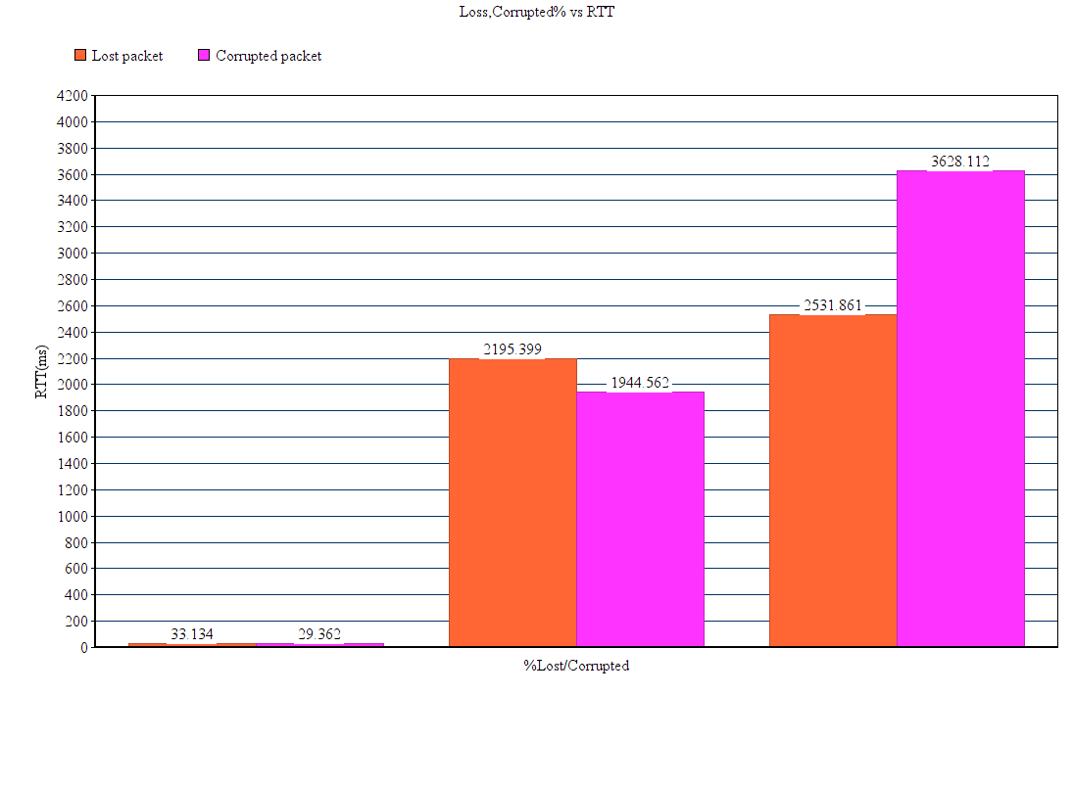
I choose to graph the data of random seed 2364. The red bar represents lost packets while purple bar represents corrupted packets. The RTT when lost percentage equals corrupted percentage are stably the similar. This could mean the way that GBN deals with loss and corruption process the similar time.

