Google Chrome Version: Version 87.0.4280.141 (Official Build) (64-bit)

**Issue:** Able to see the entered/Saved google password, When I inspect the HTML in Backend and change the Input type as “Text” from “Password”

**Severity:** This will expose my password to anyone.

If I’ve saved my password in browser, Of Couse, People who are using my machine can login my account of mine, but not able see what my password is.

But when they change the HTML Type, anyone can see what my password is.

In Chrome, As of now, We can see the saved password by accessing <chrome://settings/passwords> only **entering the machine password**. But, We can override this security feature by the above reported issue.!

**Reproduction steps:**

1. Go to Gmail.com - login
2. Enter Username and Password
3. Click ‘F12’ and change the HTML Tag - Type = “Password” as Type = “Text” as for password box
4. Can able to see the saved password of any one’s

**Existing security feature in Chrome to see the saved password:**

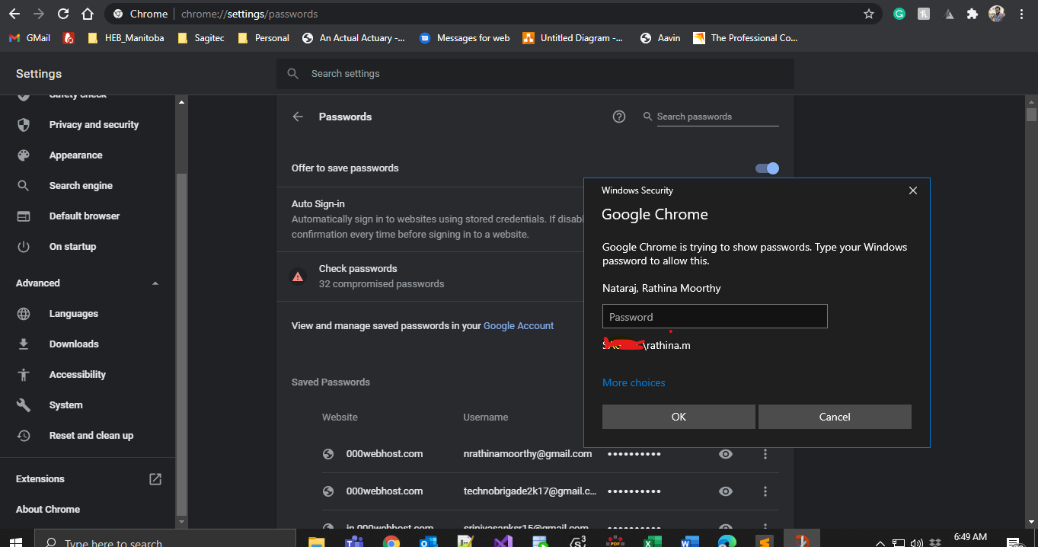

**Shortcut bug:**

