JAVA大作业--记事本
（06级计算机科学与技术专业8班 丁飞 200631500240）
- 开发平台
myEclipse6.5
JDK 1.5
- 程序功能
- 新建文件进行编辑
- 打开文件进行编辑
- 保存文件
- 退出程序保存提示
- 字体、字形及大小设置
- 编辑区背景颜色设置
- 作者信息
- 项目结构
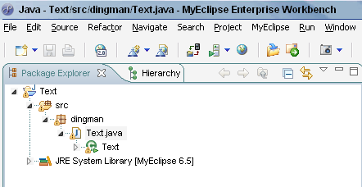
- 功能图示
- 初始化界面
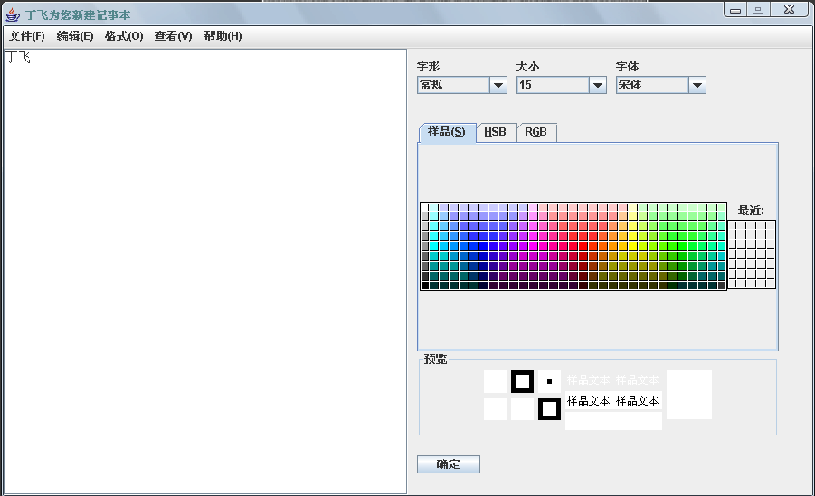
- 改变字体（宋体->华文行楷）
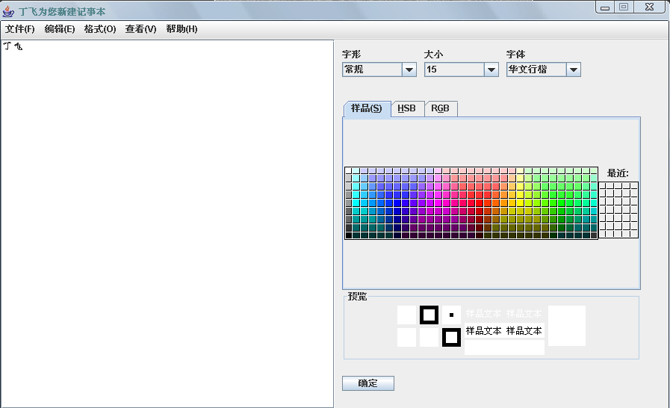
- 改变字体大小（15->40）
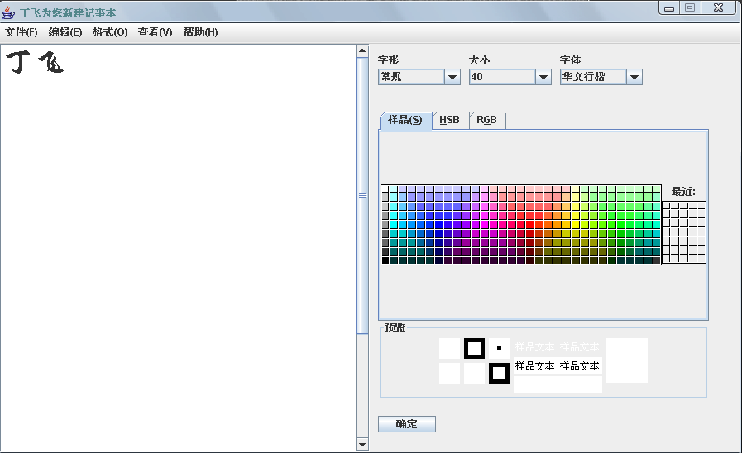
- 改变字形（常规->粗斜体）
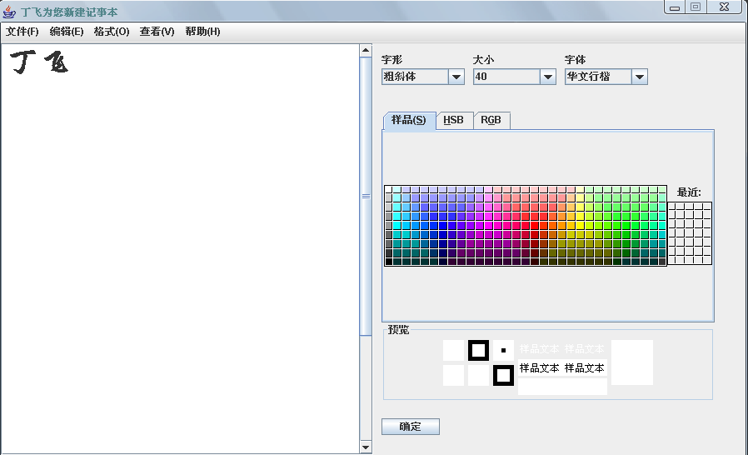
- 背景颜色设置
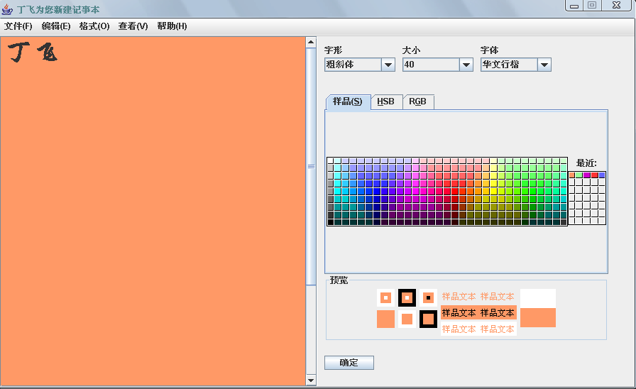
- 打开文件
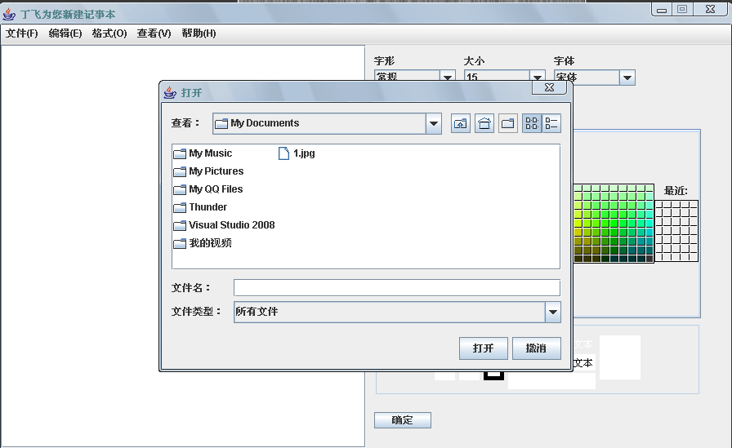
- 保存文件
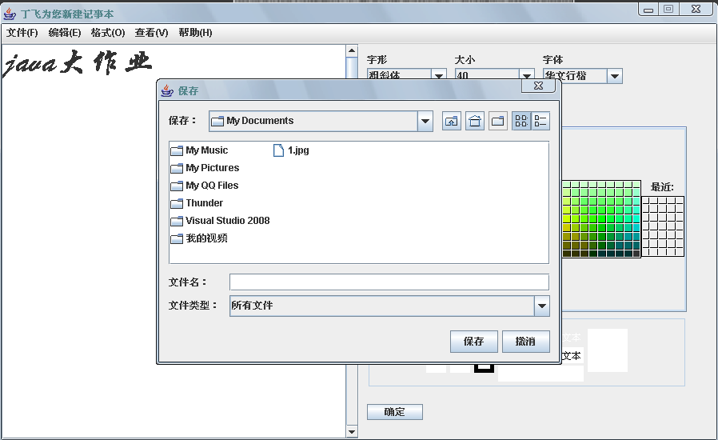
- 退出程序保存提示
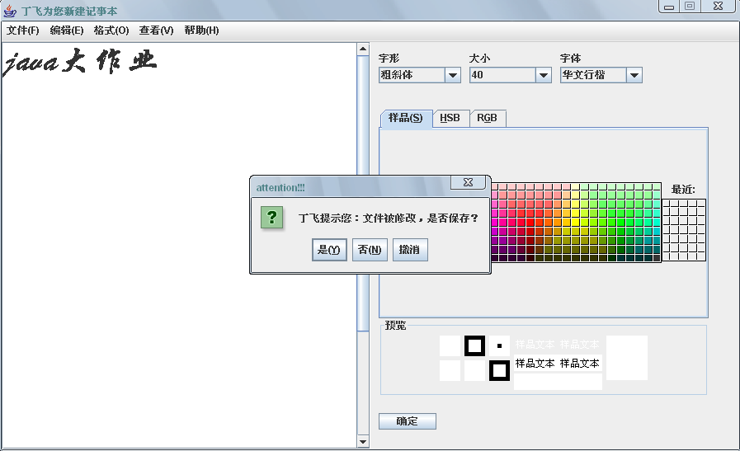
- 关于作者
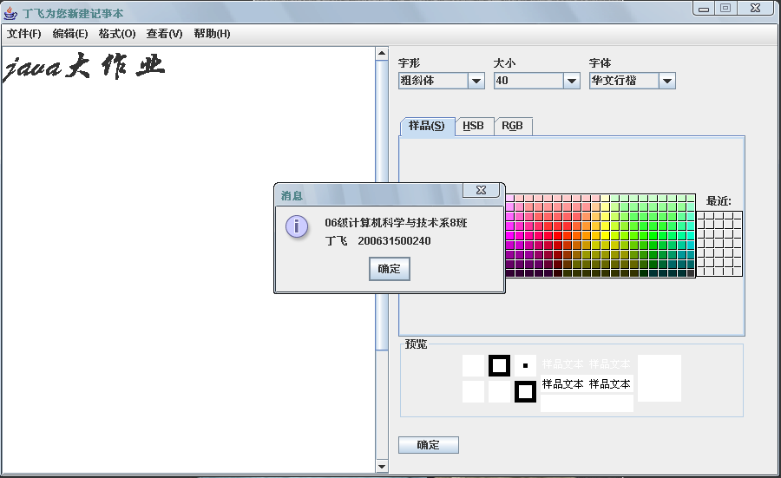
- 代码
package dingman;

import java.awt.BorderLayout;
import java.awt.Container;
import java.awt.HeadlessException;
import java.awt.event.ActionEvent;
import java.awt.event.ActionListener;

import javax.swing.JFrame;
import javax.swing.JLabel;
import javax.swing.JMenu;
import javax.swing.JMenuBar;
import javax.swing.JMenuItem;
import javax.swing.JScrollPane;
import javax.swing.JTextArea;
import javax.swing.JPanel;
import javax.swing.JButton;
import java.awt.GridLayout;
import javax.swing.JComboBox;
import java.awt.FlowLayout;
import java.awt.Font;
import java.io.File;
import javax.swing.JFileChooser;
import java.io.FileReader;
import java.io.BufferedReader;
import java.io.FileNotFoundException;
import java.io.IOException;
import java.io.FileWriter;
import java.io.BufferedWriter;
import javax.swing.JOptionPane;
import java.awt.event.WindowListener;
import java.awt.event.WindowEvent;
import java.awt.Graphics;
import java.awt.Color;
import javax.swing.JColorChooser;

public class Text extends JFrame implements ActionListener, WindowListener {
private Container c = this.getContentPane();
private JMenuBar menuBar = new JMenuBar();
private JPanel panel1 = new JPanel(); //该panel包含文本编辑区 和字体设置区
private JPanel fontSetPanel = new JPanel(); //字体设置区
private JColorChooser colorChooser = new JColorChooser();
private JLabel fontShapeLabel = new JLabel( "字形" );;
private JLabel fontSizeLabel = new JLabel( "大小" );
private JLabel fontStyleLabel = new JLabel("字体");
private JComboBox fontShape = new JComboBox();
private JComboBox fontSize = new JComboBox();
private JComboBox fontStyle = new JComboBox();
private JButton ok = new JButton( "确定" );
private JMenu menuF = new JMenu( "文件(F)" );
private JMenu menuE = new JMenu( "编辑(E)" );
private JMenu menuO = new JMenu( "格式(O)" );
private JMenu menuV = new JMenu( "查看(V)" );
private JMenu menuH = new JMenu( "帮助(H)" );
private JMenuItem menuFItemN = new JMenuItem( "新建(N)" );
private JMenuItem menuFItemO = new JMenuItem( "打开(O)..." );
private JMenuItem menuFItemS = new JMenuItem( "保存(S)" );
private JMenuItem menuFItemQ = new JMenuItem( "退出(Q)" );
private JMenuItem menuEItemL = new JMenuItem("删除(L)");
private JMenuItem menuHItemA = new JMenuItem( "关于作者(A)" );
public JTextArea textArea = new JTextArea( 15, 15);
private JScrollPane scrollPane = new JScrollPane( textArea );
public Text() throws HeadlessException {
c.setLayout( new BorderLayout() );
menuBar.add( menuF );
menuBar.add( menuE );
menuBar.add( menuO );
menuBar.add( menuV );
menuBar.add( menuH );
//文件菜单
menuF.add( menuFItemN );
menuFItemN.addActionListener( this );
menuF.add( menuFItemO );
menuFItemO.addActionListener( this );
menuF.add( menuFItemS );
menuFItemS.addActionListener( this );
menuF.addSeparator();
menuF.add( menuFItemQ );
menuFItemQ.addActionListener( this );
//编辑菜单
menuE.add( menuEItemL );
menuEItemL.addActionListener( this );
//格式菜单
//帮助菜单
menuH.add( menuHItemA );
menuHItemA.addActionListener( this );
//menuBar.setBackground( Color.lightGray ) ;
c.add( menuBar, BorderLayout.NORTH );
c.add( panel1 );
panel1.setLayout( new GridLayout( 1, 2 ) );
panel1.add( scrollPane );
panel1.add( fontSetPanel );
fontSetPanel.setLayout( null );
fontShapeLabel.setBounds( 10, 10, 100, 20 );
fontSetPanel.add( fontShapeLabel );
fontSizeLabel.setBounds( 120, 10, 100, 20 );
fontSetPanel.add( fontSizeLabel );
fontStyleLabel.setBounds( 230, 10, 100, 20 );
fontSetPanel.add( fontStyleLabel );
fontShape.setBounds( 10, 30, 100, 20 );
fontSetPanel.add( fontShape );
fontSize.setBounds( 120, 30, 100, 20 );
fontSetPanel.add( fontSize );
fontStyle.setBounds( 230, 30, 100, 20 );
fontSetPanel.add( fontStyle );
fontShape.addItem( "常规" );
fontShape.addItem( "斜体" );
fontShape.addItem( "粗体" );
fontShape.addItem( "粗斜体" );
fontSize.addItem( new Integer( 15 ) );
fontSize.addItem( new Integer( 16 ) );
fontSize.addItem( new Integer( 17 ) );
fontSize.addItem( new Integer( 18 ) );
fontSize.addItem( new Integer( 19 ) );
fontSize.addItem( new Integer( 20 ) );
fontSize.addItem( new Integer( 21 ) );
fontSize.addItem( new Integer( 22 ) );
fontSize.addItem( new Integer( 23 ) );
fontSize.addItem( new Integer( 24 ) );
fontSize.addItem( new Integer( 25 ) );
fontSize.addItem( new Integer( 26 ) );
fontSize.addItem( new Integer( 27 ) );
fontSize.addItem( new Integer( 28 ) );
fontSize.addItem( new Integer( 29 ) );
fontSize.addItem( new Integer( 30 ) );
fontSize.addItem( new Integer( 31 ) );
fontSize.addItem( new Integer( 32 ) );
fontSize.addItem( new Integer( 33 ) );
fontSize.addItem( new Integer( 34 ) );
fontSize.addItem( new Integer( 35 ) );
fontSize.addItem( new Integer( 36 ) );
fontSize.addItem( new Integer( 37 ) );
fontSize.addItem( new Integer( 38 ) );
fontSize.addItem( new Integer( 39 ) );
fontSize.addItem( new Integer( 40 ) );
fontStyle.addItem( "宋体" );
fontStyle.addItem( "楷体" );
fontStyle.addItem( "华文行楷" );
fontStyle.addItem( "仿宋体" );
fontStyle.addItem( "Arial" );
fontStyle.addItem( "Basemic" );
fontStyle.addItem( "Comic Sans" );
fontStyle.addItem( "Garamond" );
fontStyle.addItem( "Impact" );
fontStyle.addItem( "Latha" );
fontStyle.addItem( "Modern" );
fontStyle.addItem( "Nina" );
fontStyle.addItem( "Raavi" );
fontStyle.addItem( "Verdana" );
fontSetPanel.add( ok );
ok.addActionListener( this );
ok.setBounds( 10,450,70,20 );
colorChooser.setBounds( 10, 80, 400, 350 );
fontSetPanel.add( colorChooser );
this.setDefaultCloseOperation( JFrame.DISPOSE_ON_CLOSE );
this.setTitle("丁飞为您新建记事本");
this.setSize( 900, 550);
this.setLocation( 200, 200);
this.setResizable( false );
this.show();
}

public void actionPerformed(ActionEvent e) {
// TODO 自动生成方法存根
if( e.getSource() == menuFItemN ){ //新建文件
textArea.setText( "" );
setTitle( "丁飞为您新建记事本" );
}
if( e.getSource() == menuFItemO ){ //打开文件
File file;
JFileChooser fileChooser = new JFileChooser();
int num = fileChooser.showOpenDialog( this );
if( num == JFileChooser.APPROVE_OPTION ){
try{
file = fileChooser.getSelectedFile();
this.setTitle( file.getName() );
FileReader fileReader = new FileReader( file );
BufferedReader bufferedReader = new BufferedReader( fileReader );
String str;
while( ( str = bufferedReader.readLine() ) != null ){
textArea.setText( str );
}
fileReader.close();
bufferedReader.close();
}catch( FileNotFoundException fnfe ){
fnfe.printStackTrace();
}catch( IOException ioe ){
ioe.printStackTrace();
}
}
}
if( e.getSource() == menuFItemS ){ //保存文件
File file = null;
JFileChooser fileChooser = new JFileChooser();
int num = fileChooser.showSaveDialog( this );
if( num == JFileChooser.APPROVE_OPTION ){
file = fileChooser.getSelectedFile();
this.setTitle( file.getName() );
try{
FileWriter fileWriter = new FileWriter( file ) ;
BufferedWriter bufferedWriter = new BufferedWriter( fileWriter );

bufferedWriter.write( textArea.getText() );
bufferedWriter.close();
fileWriter.close();
}catch( IOException ioe ){
ioe.printStackTrace();
}
}
}
if( e.getSource() == menuFItemQ ){ //退出文件
int a = JOptionPane.showConfirmDialog( this,
"丁飞提示您：文件被修改，是否保存？", "attention!!!",
JOptionPane.YES_NO_CANCEL_OPTION);
if( a == 1 ){
this.dispose();
}
else if( a == 0 ){
File file = null ;
JFileChooser fileChooser = new JFileChooser();
int num = fileChooser.showSaveDialog( this );
if( num == JFileChooser.APPROVE_OPTION ){
file = fileChooser.getSelectedFile();
this.setTitle( file.getName() );
try{
FileWriter fileWriter = new FileWriter( file );
BufferedWriter bufferedWriter = new BufferedWriter( fileWriter );
bufferedWriter.write( textArea.getText() );
bufferedWriter.close();
fileWriter.close();
}catch( IOException ioe ){
ioe.printStackTrace();
}
this.dispose();
}
}
}
if( e.getSource() == menuEItemL ){ //删除
textArea.setText( "" );
}
if( e.getSource() == menuHItemA ){
JOptionPane.showMessageDialog( this, "06级计算机科学与技术系8班\n丁飞 200631500240" );
}
if( e.getSource() == ok ){
String shape = (String)fontShape.getSelectedItem();
if ( shape == "粗体" ){
textArea.setFont( new Font( textArea.getFont().getFontName(), Font.BOLD, textArea.getFont().getSize() ) );
}else if( shape == "斜体" ){
textArea.setFont( new Font( textArea.getFont().getFontName(), Font.ITALIC, textArea.getFont().getSize() ) );
}else if( shape == "常规" ){
textArea.setFont( new Font( textArea.getFont().getFontName(), Font.PLAIN, textArea.getFont().getSize() ) );
}else if( shape == "粗斜体" ){
textArea.setFont( new Font( textArea.getFont().getFontName(), Font.BOLD + Font.ITALIC, textArea.getFont().getSize() ) );
}
Integer size = (Integer)fontSize.getSelectedItem();
textArea.setFont( new Font( textArea.getText(), textArea.getFont().getStyle(), size.intValue() ) );
String style = (String)fontStyle.getSelectedItem();
textArea.setFont( new Font( style,
textArea.getFont().getStyle(), size.intValue() ) );
Color color = colorChooser.getColor();
textArea.setSelectedTextColor( color );
textArea.setBackground( color );

}
}

public void windowClosing( WindowEvent we ) {
int a = JOptionPane.showConfirmDialog(this,
"丁飞提示您：\n窗口即将关闭，文件保存不？","attention!!!",
JOptionPane.YES_NO_CANCEL_OPTION);
if( a == 1 ){
this.dispose();
}
else if( a == 0 ){
File file = null;
JFileChooser fileChooser = new JFileChooser();
int num2 = fileChooser.showSaveDialog(this);
if(num2==JFileChooser.APPROVE_OPTION){
file = fileChooser.getSelectedFile();
this.setTitle( file.getName() );
try{
FileWriter fileWriter = new FileWriter( file );
BufferedWriter bufferedWriter = new BufferedWriter( fileWriter );

bufferedWriter.write(textArea.getText());
bufferedWriter.close();
fileWriter.close();
}
catch(IOException e2)
{
e2.printStackTrace();
}
this.dispose();
}
}
}

public void windowOpened( WindowEvent we ) {}
public void windowClosed( WindowEvent we ) {}
public void windowIconified( WindowEvent we ) {}
public void windowDeiconified( WindowEvent we ) {}
public void windowActivated( WindowEvent we ) {}
public void windowDeactivated( WindowEvent we ) {}

public static void main(String[] args) {
new Text();
}
}

