**代码：**

**package** test;  
  
**public class** Homework {  
 **public static void** main(String[] args) {  
  
 System.***out***.print(**"计算1+2+3+ *** +100的和："**);  
 **int** sum = 0;  
 **for** (**int** i = 1; i <= 100; i++) {  
 sum += i;  
 }  
 System.***out***.println(sum);  
 System.***out***.println();  
  
 System.***out***.println(**"打印九九乘法表："**);  
 **for** (**int** i = 1; i <= 9; i++) {  
 **for** (**int** j = 1; j <= i; j++) {  
 System.***out***.print(j + **"*"** + i + **"="** + (**int**)(i*j) + **" "**);  
 }  
 System.***out***.println();  
 }  
 System.***out***.println();  
 **int** c = 0;  
 System.***out***.println(**"打印1-100所有整数中的单数的代码："**);  
 **for** (**int** i = 1; i <= 100; i++) {  
 **if**( i % 2 != 0){  
 System.***out***.print(i + **" "**);  
 c++;  
 **if**( c == 25){  
 System.***out***.println();  
 c = 0;  
 }  
 }  
 }  
 System.***out***.println();  
  
 System.***out***.println(**"打印101-200中的素数并求和："**);  
 sum = 0;  
 **int** k;  
 **boolean** flag;  
 **for** (**int** i = 101; i <= 200; i++) {  
 k = (**int**) Math.*sqrt*(i);  
 flag = **true**;  
 **for** (**int** j = 2; j <= k; j++) {  
 **if**( i % j == 0){  
 flag = **false**;  
 }  
 }  
 **if**(flag == **true**){  
 sum += i;  
 System.***out***.print(i + **" "**);  
 }  
 }  
 System.***out***.println();  
 System.***out***.println(**"素数和为："** + sum);  
 }  
}

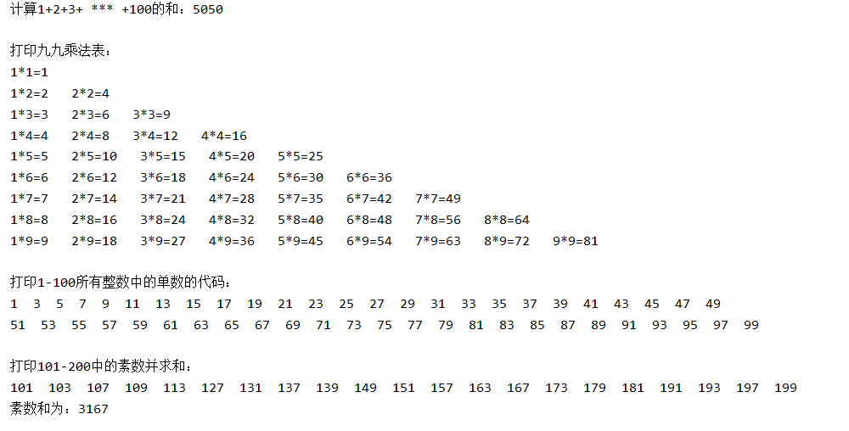**运行结果**：