题目：



答案：

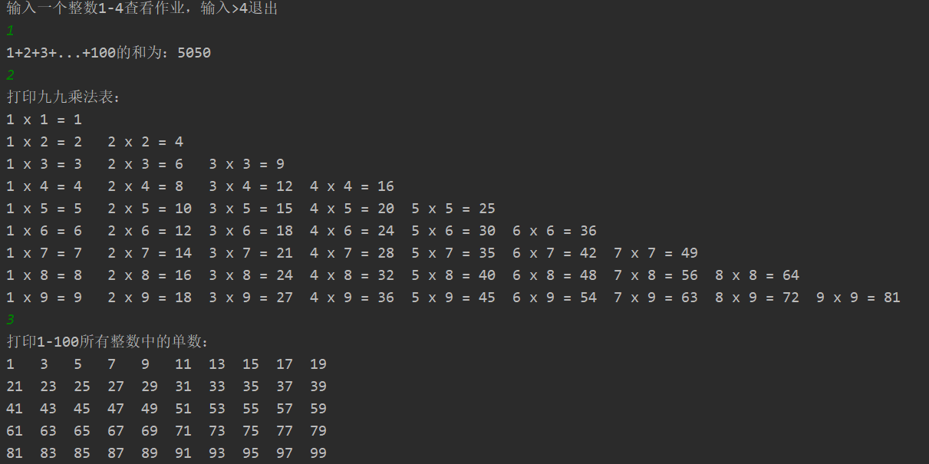



代码：

主方法如下

import java.util.Scanner;

public class Main {

public static void main(String[] args) {

DoHomework doHomework = new DoHomework();

Scanner scanner = new Scanner(System.in);

System.out.println("输入一个整数1-4查看作业，输入>4退出");

int num = scanner.nextInt();

while(num <= 4){

doHomework.homework(num);

num = scanner.nextInt();

}

}

}

DoHomework方法如下

import java.lang.reflect.Array;

import java.util.Arrays;

import java.util.Scanner;

public class DoHomework {

public void homework1(){

int sum = 0;

for(int count = 1 ; count <= 100 ; count++ ){

sum += count;

}

System.out.println("1+2+3+...+100的和为：" + sum);

}

public void homework2(){

System.out.println("打印九九乘法表：");

for(int i = 1 ; i < 10 ;i ++ ){

for(int j = 1 ; j <= i ; j++ ){

System.out.printf("%-2dx%2d = %-4d",j,i,i\*j );

}

System.out.println();

}

}

public void homework3(){

System.out.println("打印1-100所有整数中的单数：");

for(int i = 1, count = 1 ; i < 101 ; i+=2 , count++ ){

System.out.printf("%-4d", i);

if( count % 10 ==0 ){

System.out.println();

}

}

}

final int MAX = 201;

final int MIN = 101;

private int sum = 0;

public void fun1(){

boolean isPrime[] = new boolean[MAX];

int count = 0;

sum = 0;

Arrays.fill(isPrime , true);

for(int i = 2 ; i < Math.sqrt(MAX) ; i ++ ){

if( isPrime[i] == false){

continue;

}

for(int j = i + i ; j < MAX ; j += i){

isPrime[j]=false;

}

}

for(int i = MIN ; i < MAX ; i++){

if(isPrime[i] == true ){

count++;

//System.out.print(i + " ");

sum += i;

}

}

System.out.println(sum + "一共有" + count + "个素数");

}

public void fun2(){

sum = 0;

int count = 0;

for (int i = MIN ; i < MAX ; i ++){

boolean flag = true ;

for (int j = 2 ; j <= Math.sqrt(i) ; j++){

if( i % j == 0 ){

flag = false;

break;

}

}

if( flag == true ){

sum += i ;

//System.out.print(i + " ");

count++ ;

}

}

System.out.println(sum + "一共有" + count + "个素数");

}

public void homework4(){

System.out.println("打印101-201之间的素数和（请选择方法1或2）：");

Scanner scanner = new Scanner(System.in) ;

int fun = scanner.nextInt() ;

if(fun == 1){

fun1();

}else {

fun2();

}

}

public void homework(int num){

if(num == 1){

homework1();

}else if ( num == 2){

homework2();

}else if ( num == 3){

homework3();

}else {

homework4();

}

}

}