数组练习：

1. 数组排序：{1,23,6,74,8,19,104} 按 从小到大排序。
2. public class daxiaopaixu {  
     
    public static void main(String[] args) {  
    //冒泡排序算法  
    int[] numbers=new int[]{1,23,6,74,8,19,104};  
    int i,j;  
    for(i=0;i<numbers.length-1;i++)  
    {  
    for(j=0;j<numbers.length-1-i;j++)  
    {  
    if(numbers[j]>numbers[j+1])  
    {  
    int temp=numbers[j];  
    numbers[j]=numbers[j+1];  
    numbers[j+1]=temp;  
    }  
    }  
    }  
    System.*out*.println("从小到大排序后的结果是:");  
    for(i=0;i<numbers.length;i++)  
    System.*out*.print(numbers[i]+" ");  
    }  
     
     
     
   }

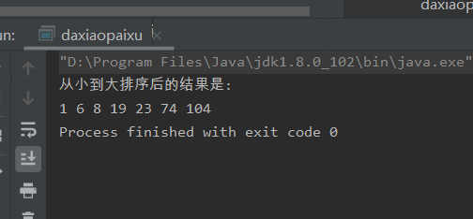

2. 数组{1,2,3,4,5,5,5,5,5,6,7,8,9}，去掉数组中的5 生成新的数组。

public class test22 {  
 public static void main(String[] args) {  
 int[] arrays = {1, 2, 3, 4, 5, 5, 5, 5, 5, 6, 7, 8, 9};  
 int[] a = new int[8];  
 int b = 0;  
 for (int i = 0; i < arrays.length; i++) {  
  
 if (arrays[i] == 5) {  
 continue;  
 } else {  
 a[b] = arrays[i];  
 b++;  
 }  
  
 }  
 for (int i : a) {  
 System.*out*.print(i + " ");  
 }  
  
  
 }

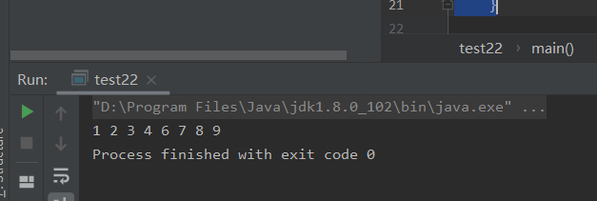

1. 数字 a{1,3,5,7,9} b{2,4,6,8,10},将两个数组合并，并按照从小到大的顺序排序，生成新数组。
2. public class test23 {  
    public static void main(String[] args) {  
    int[] a = {1, 3, 5, 7, 9};  
    int[] b = {2, 4, 6, 8, 10};  
    int sum = 0;  
    int[] c = new int[a.length + b.length];  
    for (int i = 0; i < a.length; i++) {  
    c[sum++] = a[i];  
    }  
    for (int i = 0; i < b.length; i++) {  
    c[sum++] = b[i];  
    }  
    for (int i = 0; i < c.length - 1; i++) {  
    for (int j = 0; j < c.length - 1 - i; j++) {  
    if (c[j] > c[j + 1]) {  
    int temp = c[j];  
    c[j] = c[j + 1];  
    c[j + 1] = temp;  
    }  
    }  
    }  
     
    for (int num : c) {  
    System.*out*.print(num + " ");  
    }  
    }  
   }

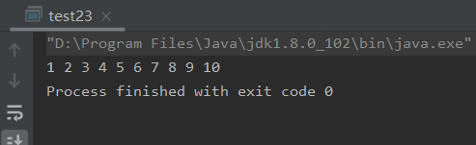

字符串操作练习：

1. 字符串：“Hello World!”，在字符串前面拼接自己的名字。
2. public class text24 {  
     
    public static void main(String[] args) {  
     
    String name = "刘晨曦";  
    String str1 = "Hello World!";  
    String str2 = name.concat(str1);  
    System.*out*.println(str2);  
    }  
   }

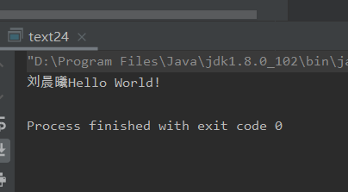

2.字符串“1,2,3,4,5,6,7”，根据“，”分开，将其转化为字符串数组，并在控制台打印。

public class text25 {  
 public static void main(String[] args) {  
  
 String str1 = "1,2,3,4,5,6,7";  
 String[] str2 = str1.split(",");  
  
 for (String s : str2) {  
 System.*out*.print(s + " ");  
  
 }  
 }  
}

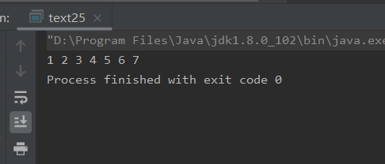

1. 计算Hello World! 中出现了几次l。
2. public class text26 {  
    public static void main(String[] args) {  
     
    String str = "HellowWorld!";  
    char[] chars = str.toCharArray();  
    int count = 0;  
    for (int i = 0; i < chars.length; i++) {  
    if (chars[i] == 'l') {  
    count++;  
     
    }  
     
    }  
    System.*out*.println(count);  
    }  
   }

