运行结果：

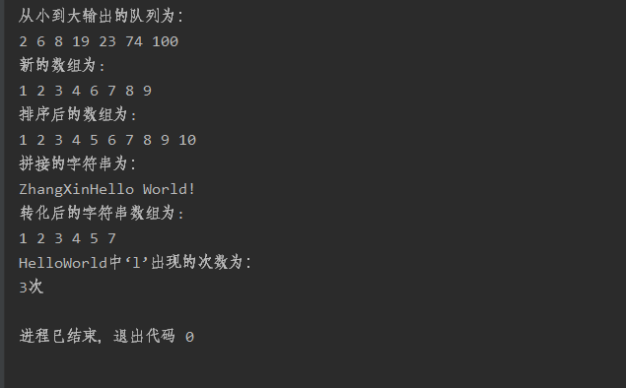

代码：

import java.util.ArrayList;  
import java.util.Arrays;  
import java.util.List;  
  
public class array {  
 public static void main(String[] args) {  
 *First*();  
 *Second*();  
 *Third*();  
 *Four*();  
 *Five*();  
 *Six*();  
 }  
 */\*\*  
 \* 第一小题  
 \*/* public static void First(){  
 int[] array1 = new int[]{100,23,6,74,8,19,2};  
 int temp;  
 for(int i = 1; i < array1.length; i++){  
 for(int j = 0; j < array1.length - i;j++){  
 if(array1[j] > array1[j+1]){  
 temp = array1[j];  
 array1[j] = array1[j+1];  
 array1[j+1] = temp;  
 }  
 }  
 }  
 System.*out*.println("从小到大输出的队列为：");  
 for(int k = 0;k < array1.length;k++){  
 System.*out*.print(array1[k] + " ");  
 }  
 System.*out*.println(" ");  
 }  
 */\*\*  
 \* 第二小题  
 \*/* public static void Second(){  
 int[] array2 = new int[]{1,2,3,4,5,5,5,5,5,6,7,8,9};  
 int[] temparray = new int[8];  
 int flag = 0;  
 for (int i = 0;i < array2.length;i++){  
 if(array2[i]!=5){  
 temparray[flag] = array2[i];  
 flag++;  
 }  
 }  
 System.*out*.println("新的数组为:");  
 for (int j = 0;j < temparray.length;j++){  
 System.*out*.print(temparray[j] + " ");  
 }  
 System.*out*.println(" ");  
 }  
 */\*\*  
 \* 第三小题  
 \*/* public static void Third(){  
 int[] array1 = new int[]{1,3,5,7,9};  
 int[] array2 = new int[]{2,4,6,8,10};  
 int[] array3 = new int[10];  
 int temp;  
 System.*arraycopy*(array1,0,array3,0,5);  
 System.*arraycopy*(array2,0,array3,5,5);  
 for(int i = 1; i < array3.length; i++){  
 for(int j = 0; j < array3.length - i;j++){  
 if(array3[j] > array3[j+1]){  
 temp = array3[j];  
 array3[j] = array3[j+1];  
 array3[j+1] = temp;  
 }  
 }  
 }  
 System.*out*.println("排序后的数组为:");  
 for (int k = 0; k < array3.length;k++){  
 System.*out*.print(array3[k] + " ");  
 }  
 System.*out*.println(" ");  
 }  
  
 */\*\*  
 \* 第四小题  
 \*/* public static void Four(){  
 System.*out*.println("拼接的字符串为：");  
 String name = "ZhangXin";  
 String word = "Hello World!";  
 String link = name.concat(word);  
 System.*out*.println(link);  
 }  
  
 */\*\*  
 \* 第五小题  
 \*/* public static void Five(){  
 System.*out*.println("转化后的字符串数组为:");  
 String ch = "1,2,3,4,5,7";  
 String[] change = ch.split(",");  
 int[] result = new int[6];  
 for(int i = 0;i < change.length;i++){  
 result[i] = Integer.*parseInt*(change[i]);  
 System.*out*.print(result[i] + " ");  
 }  
 System.*out*.println(" ");  
 }  
 */\*\*  
 \* 第六小题  
 \*/* public static void Six(){  
 System.*out*.println("HelloWorld中‘l’出现的次数为：");  
 String word = "Hello World";  
 int time = 0;  
 for (int i = 0; i < word.length();i ++){  
 if (word.charAt(i) == 'l'){  
 time++;  
 }  
 }  
 System.*out*.println(time + "次");  
 }  
}