# 数组练习：

题目和答案：

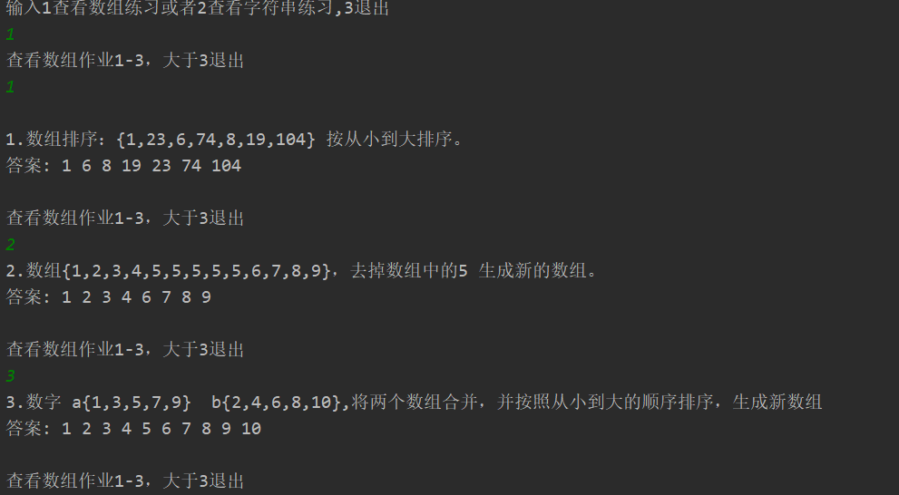

# **字符串操作练习**：

题目和答案：

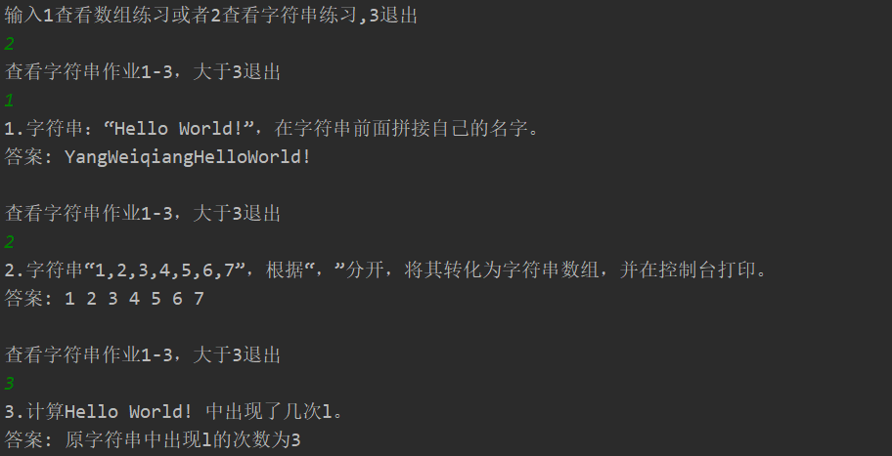

# 代码：

**Main类：**

import java.util.Scanner;

public class Main {

public static void main(String[] args) {

Scanner scanner = new Scanner( System.in );

System.out.println("输入1查看数组练习或者2查看字符串练习,3退出");

DoArraryHomework doArraryHomework = new DoArraryHomework();

DoStringHomework doStringHomework = new DoStringHomework();

int op = scanner.nextInt();

int num;

while ( 1 <= op && op <= 2 ) {

if( op == 1 ) {

System.out.println("查看数组作业1-3，大于3退出");

num = scanner.nextInt();

while( 1 <= num && num <= 3 ){

doArraryHomework.homework(num);

System.out.println("查看数组作业1-3，大于3退出");

num = scanner.nextInt();

}

}else {

System.out.println("查看字符串作业1-3，大于3退出");

num = scanner.nextInt();

while( 1 <= num && num <= 3 ) {

doStringHomework.homework(num);

System.out.println("查看字符串作业1-3，大于3退出");

num = scanner.nextInt();

}

}

System.out.println("输入1查看数组练习或者2查看字符串练习,3退出");

op = scanner.nextInt();

}

}

}

**DoArrayHomework类：**

import com.sun.scenario.effect.impl.sw.java.JSWColorAdjustPeer;

import java.lang.reflect.Array;

import java.util.Arrays;

public class DoArrayHomework {

/**

* 数组练习第一题，采用冒泡排序

*/

public void homework1(){

System.out.println();

int[] array = { 1, 23, 6, 74, 8, 19, 104};

int len = array.length;

for (int i = 0 ; i < len - 1 ; i++ ) {

for (int j = i + 1 ; j < len ; j++ ) {

if( array[i] > array[j] ){

int tmp = array[j];

array[j] = array[i];

array[i] = tmp;

}

}

}

System.out.println("1.数组排序：{1,23,6,74,8,19,104} 按从小到大排序。");

System.out.print("答案:");

for (int i = 0 ; i < len ; i++ ) {

System.out.print( " " + array[i] );

}

System.out.println();

System.out.println();

}

/**

* 数组练习第二题，当遇到要删除的数字x的时候，

* 直接找到下一个不是x的数字放到当前位置上

*/

public void homework2(){

int[] array = { 1, 2, 3, 4, 5, 5, 5, 5, 5, 6, 7, 8, 9 };

int len = array.length , j = 0 ;

for ( int i = 0 ; i < array.length ; ){

if( array[i] == 5 ){

//当遇到5的时候，找到下一个不为5的位置

for( ; array[i] == 5 ; i++ ){

len--;

}

}else{

array[ j++ ] = array [ i++ ];

}

}

System.out.println("2.数组{1,2,3,4,5,5,5,5,5,6,7,8,9}，去掉数组中的5 生成新的数组。");

System.out.print("答案:");

for (int i = 0 ; i < len ; i++ ){

System.out.print( " " + array[i] );

}

System.out.println();

System.out.println();

}

/**

* 数组练习第三题，采用插入排序，就是边比较边放入数字

*/

public void homework3(){

int[] a = { 1, 3, 5, 7, 9 };

int[] b = { 2, 4, 6, 8, 10 };

int len = a.length + b.length;

int[] c = new int[ len ];

for ( int i = 0, j = 0 , k = 0 ; i < len ; i++ ){

if( j < a.length && a[j] < b[k] ){

//当a数组还有数字为比较时，与b数组比较小的放入后c的i位置

c[i] = a[j++];

}else if( k < b.length ){

//当前a[j]>=b[k]的时候，且b数组还有未参加比较的数字

c[i] = b[k++];

}else {

//当a，b数组至少一个都被比较完了，选择还有剩余的放入

if( j < a.length ){

c[i] = a[j++];

}else{

c[i] = b[k++];

}

}

}

System.out.println("3.数字 a{1,3,5,7,9} b{2,4,6,8,10},将两个数组合并，并按照从小到大的顺序排序，生成新数组");

System.out.print("答案:");

for (int i = 0 ; i < len ; i++ ){

System.out.print( " " + c[i] );

}

System.out.println();

System.out.println();

}

public void homework(int num){

if(num == 1){

homework1();

}else if ( num == 2){

homework2();

}else {

homework3();

}

}

}

**DoStringHomework类：**

public class DoStringHomework {

public void homework1(){

String str = "HelloWorld!";

String str1 = "YangWeiqiang";

str1 = str1.concat(str);

System.out.println("1.字符串：“Hello World!”，在字符串前面拼接自己的名字。");

System.out.print("答案: ");

System.out.println(str1);

System.out.println();

}

public void homework2(){

String str = "1,2,3,4,5,6,7";

String[] str1 = str.split(",");

System.out.println("2.字符串“1,2,3,4,5,6,7”，根据“，”分开，将其转化为字符串数组，并在控制台打印。");

System.out.print("答案:");

for (int i = 0 ; i < str1.length ; i++ ){

System.out.print( " " + str1[i] );

}

System.out.println();

System.out.println();

}

public void homework3(){

String str = "HelloWorld!";

String str1 = "l";

System.out.println("3.计算Hello World! 中出现了几次l。");

int count = (str.length() - str.replace(str1, "").length()) / str1.length();

//将原字符串长度-替换后的长度(删除str1)的长度就是原来str1一共有多长

System.out.print("答案: ");

System.out.println("原字符串中出现" + str1 + "的次数为" + count);

System.out.println();

}

public void homework(int num){

if(num == 1){

homework1();

}else if ( num == 2){

homework2();

}else {

homework3();

}

}

}