Java基础练习3

1. 建立一个实体类Student类，属性：姓名，年龄，成绩，班级

建立一个list1，包含 “张三，18岁，80分，1班”，“李四，19岁，100分，1班”，“王五，17岁，59分，1班”。

建立一个list2，包含 “赵六，18岁，85分，2班”，“刘七，19岁，93分，2班”，“孙八，17岁，55分，2班”。

1. 整合两个list学生信息成一个新的list

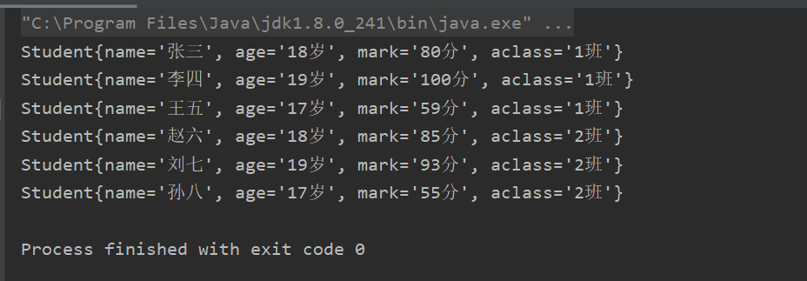

1. 按照分数给出学生信息排名

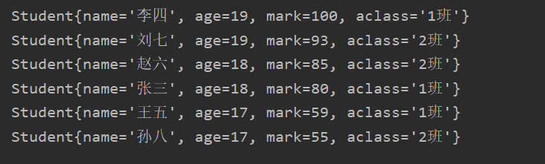

1. 输出不及格的学生信息

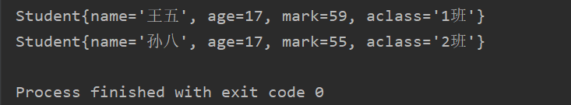

1. 查找张三的信息



1. 从list剔除年龄大于18岁的学生信息

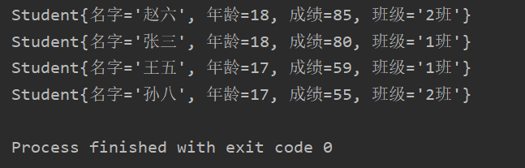

1. 使用Map 完成练习1的习题。

代码：

package Text;  
*/**  
 * 学生的实体类  
 * xukunyuan  
 * 2020/3/4 22：47  
 */*public class Student {  
 */**  
 * 姓名  
 */* private String name;  
 */**  
 * 年龄  
 */* private int age;  
 */**  
 * 成绩  
 */* private int mark;  
 */**  
 * 班级  
 */* private String aclass;  
  
 public Student(String name, int age, int mark, String aclass) {  
 this.name = name;  
 this.age = age;  
 this.mark = mark;  
 this.aclass = aclass;  
 }  
  
 public String getName() {  
 return name;  
 }  
  
 public void setName(String name) {  
 this.name = name;  
 }  
  
 public int getAge() {  
 return age;  
 }  
  
 public void setAge(int age) {  
 this.age = age;  
 }  
  
 public int getMark() {  
 return mark;  
 }  
  
 public void setMark(int mark) {  
 this.mark = mark;  
 }  
  
 public String getAclass() {  
 return aclass;  
 }  
  
 public void setAclass(String aclass) {  
 this.aclass = aclass;  
 }  
  
 @Override  
 public String toString() {  
 return "Student{" +  
 "名字='" + name + '\'' +  
 ", 年龄=" + age +  
 ", 成绩=" + mark +  
 ", 班级='" + aclass + '\'' +  
 '}';  
 }  
}

package Text;  
  
import java.util.*;  
  
public class StudentDemo {  
 public static void main(String[] args) {  
  
 //listWay();  
 *mapWay*();  
 }  
  
  
 */**  
 * list方法  
 */* public static void listWay() {  
 List<Student> list1 = new ArrayList<Student>();  
 list1.add(new Student("张三", 18, 80, "1班"));  
 list1.add(new Student("李四", 19, 100, "1班"));  
 list1.add(new Student("王五", 17, 59, "1班"));  
  
 List<Student> list2 = new ArrayList<Student>();  
 list2.add(new Student("赵六", 18, 85, "2班"));  
 list2.add(new Student("刘七", 19, 93, "2班"));  
 list2.add(new Student("孙八", 17, 55, "2班"));  
  
 list1.addAll(list2);  
 *printfStudent*(list1);//输出合并后学生信息  
 *sortStudent*(list1);//按照分数给出学生信息排名  
 *printfBadstudent*(list1);//输出不合格的学生信息  
 *printfZhangsan*(list1);//输出张三的信息  
 *removeStudent*(list1);//删除年龄大于18的学生信息  
 }  
 */**  
 * Map方法  
 */* public static void mapWay() {  
 Map<Integer, Student> map1 = new HashMap<>();  
 map1.put(0, new Student("张三", 18, 80, "1班"));  
 map1.put(1, new Student("李四", 19, 100, "1班"));  
 map1.put(2, new Student("王五", 17, 59, "1班"));  
  
 Map<Integer, Student> map2 = new HashMap<>();  
 map2.put(3, new Student("赵六", 18, 85, "2班"));  
 map2.put(4, new Student("刘七", 19, 93, "2班"));  
 map2.put(5, new Student("孙八", 17, 55, "2班"));  
  
 map1.putAll(map2);  
 *sortMap*(map1);  
 System.*out*.println("");  
 *printfMapStudent*(map2);  
 System.*out*.println("");  
 }  
 public static void sortMap(Map<Integer, Student> map1) {  
 Map<Integer, Student> map3 = new HashMap<>();//将排序后的map存入其中  
 */**  
 * 排序  
 */* for (int i = 0; i < 6; i++) {  
 int max = 0; //找出最大的成绩的下标  
 for (int j = 1; j < 6; j++) {  
 if (map1.get(j).getMark() > map1.get(max).getMark()) {  
 max = j;  
 }  
 }  
 //System.out.printf(" "+map1.get(max));  
 map3.put(i, map1.get(max));  
 System.*out*.println(map3.get(i));  
 map1.get(max).setMark(-50);  
  
 }  
 }  
  
 */**  
 * Map输出学生信息  
 */* public static void printfMapStudent(Map<Integer,Student> map1){  
 for (int i = 0;i<6;i++){  
 System.*out*.println(map1.get(i));  
 }  
 }  
  
 */**  
 * list方法输出学生信息  
 *  
 \** ***@param*** *list1  
 */* public static void printfStudent (List < Student > list1) {  
 for (int i = 0; i < list1.size(); i++) {  
 System.*out*.println(list1.get(i).toString());  
 }  
 }  
  
 */**  
 * list方法对学生排序  
 *  
 \** ***@param*** *list1  
 */* public static void sortStudent (List < Student > list1) {  
 Collections.*sort*(list1, (Student s1, Student s2) -> {  
 return s2.getMark() - s1.getMark();  
 });  
 System.*out*.println("");  
 *printfStudent*(list1);//输出排序后学生信息  
 }  
  
 */**  
 * list方法输出低于平均分的学生  
 *  
 \** ***@param*** *list1  
 */* public static void printfBadstudent (List < Student > list1) {  
 System.*out*.println("");  
 for (int i = 0; i < list1.size(); i++) {  
 if (list1.get(i).getMark() < 60) {  
 System.*out*.println(list1.get(i).toString());  
 }  
 }  
 }  
  
 */**  
 * list方法输出张三信息  
 *  
 \** ***@param*** *list1  
 */* public static void printfZhangsan (List < Student > list1) {  
 System.*out*.println("");  
 for (int i = 0; i < list1.size(); i++) {  
 if (list1.get(i).getName() == "张三") {  
 System.*out*.println(list1.get(i).toString());  
 }  
 }  
 }  
  
 */**  
 * list方法删除学生信息  
 *  
 \** ***@param*** *list1  
 */* public static void removeStudent (List < Student > list1) {  
 for (int i = 0; i < list1.size(); i++) {  
 for (int j = 0; j < list1.size(); j++) {  
 if (list1.get(j).getAge() > 18) {  
 list1.remove(j);  
 break;  
 }  
 }  
 }  
 System.*out*.println("");  
 *printfStudent*(list1);//输出删除后学生信息  
 }  
}

1. 仿照手机淘宝，设计订单和商品的实体类。
2. package Text;  
     
   */**  
    * 订单和商品的实体类  
    * xukunyuan  
    * 2020/3/5 10:06  
    */*public class OrderForGoods {  
    */**  
    * 商品id  
    */* private String id;  
    */**  
    * 商品名字  
    */* private String goodsName;  
    */**  
    * 商品价格  
    */* private String goodsPrice;  
    */**  
    * 商品订单号  
    */* private String goodsId;  
    */**  
    * 用户id  
    */* private String userID;  
    */**  
    * 用户名字  
    */* private String userName;  
    */**  
    * 用户地址  
    */* private String userAddress;  
    */**  
    * 用户支付时间  
    */* private String payTime;  
    */**  
    * 支付方式  
    */* private String payWay;  
    */**  
    * 创建时间  
    */* private String createTime;  
    */**  
    * 创建人  
    */* private String createName;  
    */**  
    * 修改时间  
    */* private String updateTime;  
    */**  
    * 修改人  
    */* private String updateName;  
     
    public OrderForGoods(String id, String goodsName, String goodsPrice, String goodsId, String userID, String userName, String userAddress, String payTime, String payWay, String createTime, String createName, String updateTime, String updateName) {  
    this.id = id;  
    this.goodsName = goodsName;  
    this.goodsPrice = goodsPrice;  
    this.goodsId = goodsId;  
    this.userID = userID;  
    this.userName = userName;  
    this.userAddress = userAddress;  
    this.payTime = payTime;  
    this.payWay = payWay;  
    this.createTime = createTime;  
    this.createName = createName;  
    this.updateTime = updateTime;  
    this.updateName = updateName;  
    }  
     
    public String getId() {  
    return id;  
    }  
     
    public void setId(String id) {  
    this.id = id;  
    }  
     
    public String getGoodsName() {  
    return goodsName;  
    }  
     
    public void setGoodsName(String goodsName) {  
    this.goodsName = goodsName;  
    }  
     
    public String getGoodsPrice() {  
    return goodsPrice;  
    }  
     
    public void setGoodsPrice(String goodsPrice) {  
    this.goodsPrice = goodsPrice;  
    }  
     
    public String getGoodsId() {  
    return goodsId;  
    }  
     
    public void setGoodsId(String goodsId) {  
    this.goodsId = goodsId;  
    }  
     
    public String getUserID() {  
    return userID;  
    }  
     
    public void setUserID(String userID) {  
    this.userID = userID;  
    }  
     
    public String getUserName() {  
    return userName;  
    }  
     
    public void setUserName(String userName) {  
    this.userName = userName;  
    }  
     
    public String getUserAddress() {  
    return userAddress;  
    }  
     
    public void setUserAddress(String userAddress) {  
    this.userAddress = userAddress;  
    }  
     
    public String getPayTime() {  
    return payTime;  
    }  
     
    public void setPayTime(String payTime) {  
    this.payTime = payTime;  
    }  
     
    public String getPayWay() {  
    return payWay;  
    }  
     
    public void setPayWay(String payWay) {  
    this.payWay = payWay;  
    }  
     
    public String getCreateTime() {  
    return createTime;  
    }  
     
    public void setCreateTime(String createTime) {  
    this.createTime = createTime;  
    }  
     
    public String getCreateName() {  
    return createName;  
    }  
     
    public void setCreateName(String createName) {  
    this.createName = createName;  
    }  
     
    public String getUpdateTime() {  
    return updateTime;  
    }  
     
    public void setUpdateTime(String updateTime) {  
    this.updateTime = updateTime;  
    }  
     
    public String getUpdateName() {  
    return updateName;  
    }  
     
    public void setUpdateName(String updateName) {  
    this.updateName = updateName;  
    }  
   }