Java基础练习3

1. 建立一个实体类Student类，属性：姓名，年龄，成绩，班级

建立一个list1，包含 “张三，18岁，80分，1班”，“李四，19岁，100分，1班”，“王五，17岁，59分，1班”。

建立一个list2，包含 “赵六，18岁，85分，2班”，“刘七，19岁，93分，2班”，“孙八，17岁，55分，2班”。

1. 整合两个list学生信息成一个新的list
2. 按照分数给出学生信息排名
3. 输出不及格的学生信息
4. 查找张三的信息
5. 从list剔除年龄大于18岁的学生信息

import java.util.ArrayList;

import java.util.List;

/\*\*

\* 使用list

\*/

public class Student {

private String name;

/\*\*

\* 姓名

\*/

private int age;

/\*\*

\* 年龄

\*/

private double grade;

/\*\*

\* 成绩

\*/

private String CLASS;

/\*\*

\*

\* 班级

\*/

public String getName() {

return name;

}

public void setName(String name) {

this.name = name;

}

public int getAge() {

return age;

}

public void setAge(int age) {

this.age = age;

}

public double getGrade() {

return grade;

}

public void setGrade(double grade) {

this.grade = grade;

}

public String getCLASS() {

return CLASS;

}

public void setClass(String aClass) {

CLASS = aClass;

}

}

class a {

public static void main(String[] args) {

Student st1 = new Student();

st1.setName("张三");

st1.setAge(18);

st1.setGrade(80);

st1.setClass("1班");

Student st2 = new Student();

st2.setName("李四");

st2.setAge(19);

st2.setGrade(100);

st2.setClass("1班");

Student st3 = new Student();

st3.setName("王五");

st3.setAge(17);

st3.setGrade(59);

st3.setClass("1班");

Student st4 = new Student();

st4.setName("赵六");

st4.setAge(18);

st4.setGrade(85);

st4.setClass("2班");

Student st5 = new Student();

st5.setName("赵六");

st5.setAge(19);

st5.setGrade(93);

st5.setClass("2班");

Student st6 = new Student();

st6.setName("孙八");

st6.setAge(17);

st6.setGrade(55);

st6.setClass("2班");

/\*\*

\*

\* 创建list1

\*/

List<Student> list1 = new ArrayList<>();

list1.add(st1);

list1.add(st2);

list1.add(st3);

/\*\*

\*

\* 创建list2

\*/

List<Student> list2 = new ArrayList<>();

list2.add(st4);

list2.add(st5);

list2.add(st6);

/\*\*

\* 合并两个list学生信息成一个新的list

\*/

list1.addAll(list2);

int MIN;

Student tmp;

/\*\*

\* 按照分数给出学生信息排名

\*/

for (int i = 0; i < list1.size(); i++) {

MIN = i;

for (int j = i; j < list1.size(); j++) {

if (list1.get(j).getGrade() < list1.get(MIN).getGrade()) {

MIN = j;

}

}

tmp = list1.get(i);

list1.set(i, list1.get(MIN));

list1.set(MIN, tmp);

}

int i = list1.size();

System.out.println("排名：");

for (Student s : list1) {

System.out.println("第" + i + "名:" + s.getName() + s.getGrade() + "分" +i+"班");

i--;

}

System.out.println("----------------------------");

System.out.println("不及格:");

/\*\*

\* 输出不及格的学生信息

\*/

for (Student s : list1) {

if (s.getGrade() < 60) {

System.out.println(s.getName() + " " + s.getCLASS() + " " + s.getGrade() + "分");

}

}

System.out.println("---------------------------");

System.out.println("张三信息：");

/\*\*

\* 查找张三的信息

\*/

for (Student s : list1) {

if ("张三".equals(s.getName())) {

System.out.println(s.getName() + " " + s.getCLASS() + " " + s.getAge() + "岁 " + s.getGrade() + "分");

}

}

System.out.println("--------------------------");

/\*\*

\* 从list剔除年龄大于18岁的学生信息

\*/

for (i = 0; i < list1.size(); i++) {

if (list1.get(i).getAge() > 18) {

list1.remove(i);

i--;

}

}

System.out.println("不大于18岁的学生：");

for (Student s : list1) {

System.out.println(s.getName() + ": " + s.getAge());

}

}

}

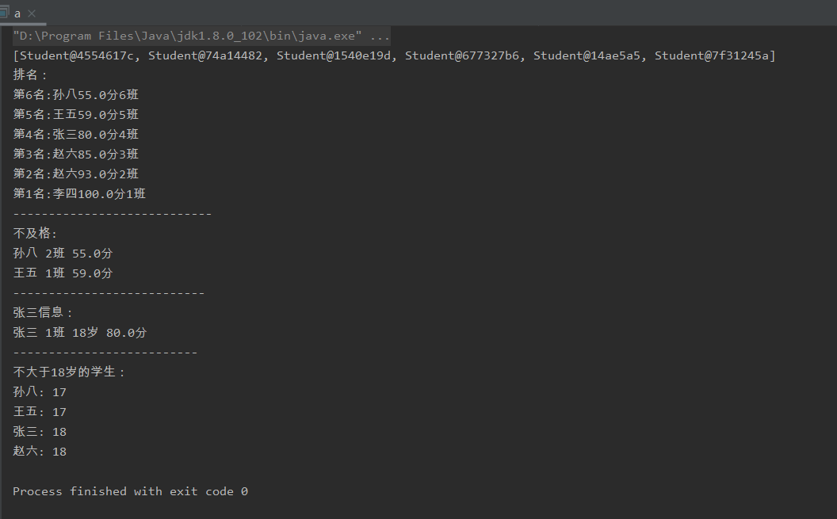

1. 使用Map 完成练习1的习题。

import java.util.ArrayList;

import java.util.HashMap;

import java.util.List;

import java.util.Map;

/\*\*

\* 使用Map

\*/

public class Student2 {

private String name;

/\*\*

\* 姓名

\*/

private int age;

/\*\*

\* 年龄

\*/

private double grade;

/\*\*

\* 成绩

\*/

private String CLASS;

/\*\*

\*

\* 班级

\*/

public String getName() {

return name;

}

public void setName(String name) {

this.name = name;

}

public int getAge() {

return age;

}

public void setAge(int age) {

this.age = age;

}

public double getGrade() {

return grade;

}

public void setGrade(double grade) {

this.grade = grade;

}

public String getCLASS() {

return CLASS;

}

public void setClass(String aClass) {

CLASS = aClass;

}

public static void main(String[] args) {

Student st1 = new Student();

st1.setName("张三");

st1.setAge(18);

st1.setGrade(80);

st1.setClass("1班");

Student st2 = new Student();

st2.setName("李四");

st2.setAge(19);

st2.setGrade(100);

st2.setClass("1班");

Student st3 = new Student();

st3.setName("王五");

st3.setAge(17);

st3.setGrade(59);

st3.setClass("1班");

Student st4 = new Student();

st4.setName("赵六");

st4.setAge(18);

st4.setGrade(85);

st4.setClass("2班");

Student st5 = new Student();

st5.setName("赵六");

st5.setAge(19);

st5.setGrade(93);

st5.setClass("2班");

Student st6 = new Student();

st6.setName("孙八");

st6.setAge(17);

st6.setGrade(55);

st6.setClass("2班");

/\*\*

\* 创建Map1

\*/

Map<Integer, Student> m1 = new HashMap<>();

m1.put(0, st1);

m1.put(1, st2);

m1.put(2, st3);

/\*\*

\* 创建Map2

\*/

Map<Integer, Student> m2 = new HashMap<>();

m2.put(3, st4);

m2.put(4, st5);

m2.put(5, st6);

/\*\*

\* （1）整合两个Map学生信息成一个新的Map

\*/

m1.putAll(m2);

int MIN;

Student tmp;

for (int i = 0; i < m1.size(); i++) {

MIN = i;

for (int j = i; j < m1.size(); j++) {

if (m1.get(j).getGrade() < m1.get(MIN).getGrade()) {

MIN = j;

}

}

tmp = m1.get(i);

m1.put(i, m1.get(MIN));

m1.put(MIN, tmp);

}

int i = m1.size();

System.out.println("排名：");

for (Map.Entry<Integer, Student> entry : m1.entrySet()) {

System.out.println("第" + i + "名:" + entry.getValue().getName() + entry.getValue().getGrade() + "分");

i--;

}

System.out.println("--------------------");

System.out.println("不及格的人:");

/\*\*

\* （3）输出不及格的学生信息

\*/

for (Map.Entry<Integer, Student> entry : m1.entrySet()) {

if (entry.getValue().getGrade() < 60) {

System.out.println(entry.getValue().getName() + " " + entry.getValue().getCLASS() + " " + entry.getValue().getGrade() + "分");

}

}

System.out.println("---------------------------");

System.out.println("张三信息：");

/\*\*

\* （4）查找张三的信息

\*/

for (Map.Entry<Integer, Student> entry : m1.entrySet()) {

if ("张三".equals(entry.getValue().getName())) {

System.out.println(entry.getValue().getName() + " " + entry.getValue().getCLASS() + " " + entry.getValue().getAge() + "岁 " + entry.getValue().getGrade() + "分");

}

}

System.out.println("---------------------------------");

/\*\*

\* （5）从list剔除年龄大于18岁的学生信息

\*/

int size = m1.size();

for (i = 0; i < size; i++) {

if (m1.get(i).getAge() > 18) {

m1.remove(i);

}

}

System.out.println("不大于18岁的学生：");

for (Map.Entry<Integer, Student> entry : m1.entrySet()) {

System.out.println(entry.getValue().getName() + ":" + entry.getValue().getAge());

}

}

}

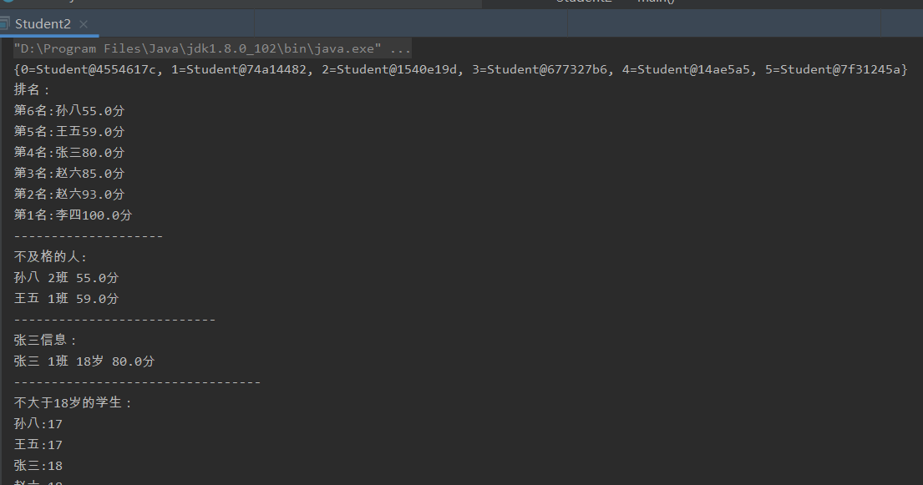

1. 仿照手机淘宝，设计订单和商品的实体类。

public class TaoBao {

/\*\*

\* 订单实体类

\*/

private String babay;

/\*\*

\* 宝贝

\*/

private String Price;

/\*\*

\* 单价

\*/

private String Number;

/\*\*

\* 数量

\*/

private String payment;

/\*\*

\* 付款

\*/

private String Ordernumber;

/\*\*

\* 订单号

\*/

private String shop;

/\*\*

\* 店铺

\*/

public String getbaby() {

return baby;

}

public void setbaby(String baby) {

this.baby = baby;

}

public double getPrice() {

return price;

}

public void setPrice(double price) {

this.price = price;

}

public int getNumber(int Number) {

return Number;

}

public void getNumber(int Number) {

this.Number = Number;

}

public void getpayment(int payment) {

return payment;

}

public void getpayment(int payment) {

this.payment = payment;

}

public String getShop() {

return shop;

}

\* 商品尺寸

\*/

private int size;

public String getName() {

return name;

}

public void se

public void setShop(String shop) {

this.shop = shop;

}

public String Ordernumber() {

return Ordernumber;

}

public void setOrdernumber(String Ordernumber) {

this.Ordernumber = Ordernumber;

}

}

/\*\*

\* 商品实体类

\*/

class commodity{

/\*\*

\* 商品名称

\*/

private String name;

/\*\*

\* 商品价格

\*/

private double price;

/\*\*

\* 店铺名称

\*/

private String shop;

/\*\*

\* 商品编号

\*/

private String id;

/\*\*tName(String name) {

this.name = name;

}

public double getPrice() {

return price;

}

public void setPrice(double price) {

this.price = price;

}

public String getShop() {

return shop;

}

public void setShop(String shop) {

this.shop = shop;

}

public String getId() {

return id;

}

public void setId(String id) {

this.id = id;

}

public int getSize() {

return size;

}

public void setSize(int size) {

this.size = size;

}

}

}