Java基础练习3

1. 建立一个实体类Student类，属性：姓名，年龄，成绩，班级

*/\*\*  
 \* student实体类  
 \* wumaoxing  
 \* 2020-3-4 17:07  
 \*/*public class Student implements Comparable<Student> {  
 */\*\*  
 \* 姓名  
 \*/* private String name;  
 */\*\*  
 \* 年龄  
 \*/* private int age;  
 */\*\*  
 \* 成绩  
 \*/* private int score;  
 */\*\*  
 \* 班级  
 \*/* private String grade;  
  
 public String getName() {  
 return name;  
 }  
  
 public void setName(String name) {  
 this.name = name;  
 }  
  
 public Integer getAge() {  
 return age;  
 }  
  
 public void setAge(Integer age) {  
 this.age = age;  
 }  
  
 public Integer getScore() {  
 return score;  
 }  
  
 public void setScore(Integer score) {  
 this.score = score;  
 }  
  
 public String getGrade() {  
 return grade;  
 }  
  
 public void setGrade(String grade) {  
 this.grade = grade;  
 }  
  
 @Override  
 public String toString() {  
 return "Student{" +  
 "name='" + name + '\'' +  
 ", age=" + age +  
 ", score=" + score +  
 ", grade='" + grade + '\'' +  
 '}';  
 }  
  
 */\*\*  
 \* 重写compareTo方法，按照成绩排序  
 \* wumaoxing  
 \* 2020-3-4 17:52  
 \*/* @Override  
 public int compareTo(Student stu) {  
 return stu.getScore() - this.score;  
 }  
}

建立一个list1，包含 “张三，18岁，80分，1班”，“李四，19岁，100分，1班”，“王五，17岁，59分，1班”。

建立一个list2，包含 “赵六，18岁，85分，2班”，“刘七，19岁，93分，2班”，“孙八，17岁，55分，2班”。

1. 整合两个list学生信息成一个新的list
2. 按照分数给出学生信息排名
3. 输出不及格的学生信息
4. 查找张三的信息
5. 从list剔除年龄大于18岁的学生信息

import java.util.ArrayList;  
import java.util.Collections;  
import java.util.List;  
  
*/\*\*  
 \* 测试类  
 \* wumaoxing  
 \* 2020-3-4 17:14  
 \*/*public class Test {  
 public static void main(String[] args) {  
 List<Student> list1 = new ArrayList<>();  
 Student st1 = new Student();  
 st1.setName("张三");  
 st1.setAge(18);  
 st1.setScore(80);  
 st1.setGrade("1班");  
 list1.add(st1);  
  
 Student st2 = new Student();  
 st2.setName("李四");  
 st2.setAge(19);  
 st2.setScore(100);  
 st2.setGrade("1班");  
 list1.add(st2);  
  
 Student st3 = new Student();  
 st3.setName("王五");  
 st3.setAge(17);  
 st3.setScore(59);  
 st3.setGrade("1班");  
 list1.add(st3);  
  
 List<Student> list2 = new ArrayList<>();  
 Student st4 = new Student();  
 st4.setName("赵六");  
 st4.setAge(18);  
 st4.setScore(85);  
 st4.setGrade("2班");  
 list2.add(st4);  
  
 Student st5 = new Student();  
 st5.setName("刘七");  
 st5.setAge(19);  
 st5.setScore(93);  
 st5.setGrade("2班");  
 list2.add(st5);  
  
 Student st6 = new Student();  
 st6.setName("孙八");  
 st6.setAge(17);  
 st6.setScore(55);  
 st6.setGrade("2班");  
 list2.add(st6);  
  
 //整合两个list学生信息成一个新的list  
 List<Student> list3 = new ArrayList<>();  
 list3.addAll(list1);  
 list3.addAll(list2);  
 System.*out*.println("整合两个list学生信息成一个新的list");  
 for (Student stu : list3) {  
 System.*out*.println(stu);  
 }  
  
 //按照分数给出学生信息排名  
 System.*out*.println("按照分数给出学生信息排名");  
 Collections.*sort*(list3);  
 for (Student stu : list3) {  
 System.*out*.println(stu);  
 }  
  
 //输出不及格的学生信息  
 System.*out*.println("输出不及格的学生信息");  
 for (Student stu : list3) {  
 if (stu.getScore() < 60) {  
 System.*out*.println(stu);  
 }  
 }  
  
 //查找张三的信息  
 System.*out*.println("查找张三的信息");  
 for (Student stu : list3) {  
 if (stu.getName().equals("张三")) {  
 System.*out*.println(stu);  
 break;  
 }  
 }  
  
 //从list剔除年龄大于18岁的学生信息  
 System.*out*.println("从list剔除年龄大于18岁的学生信息");  
 List<Student> deleteList=new ArrayList<>();  
 for (Student stu : list3) {  
 if (stu.getAge()>18) {  
 deleteList.add(stu);  
 }  
 }  
 list3.removeAll(deleteList);  
 for (Student stu : list3) {  
 System.*out*.println(stu);  
 }  
 }  
}

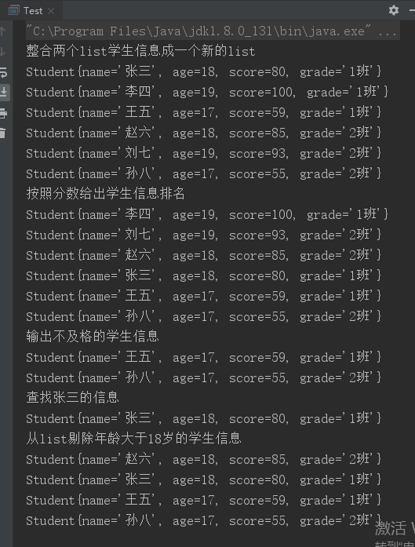

1. 使用Map 完成练习1的习题。

import java.util.\*;  
import java.util.Map.Entry;  
  
*/\*\*  
 \* 测试类  
 \* wumaoxing  
 \* 2020-3-4 17:14  
 \*/*public class Test1 {  
 public static void main(String[] args) {  
 Map<Integer, Student> map1 = new HashMap<>();  
 Student st1 = new Student();  
 st1.setName("张三");  
 st1.setAge(18);  
 st1.setScore(80);  
 st1.setGrade("1班");  
 map1.put(1, st1);  
  
 Student st2 = new Student();  
 st2.setName("李四");  
 st2.setAge(19);  
 st2.setScore(100);  
 st2.setGrade("1班");  
 map1.put(2, st2);  
  
 Student st3 = new Student();  
 st3.setName("王五");  
 st3.setAge(17);  
 st3.setScore(59);  
 st3.setGrade("1班");  
 map1.put(3, st3);  
  
 Map<Integer, Student> map2 = new HashMap<>();  
 Student st4 = new Student();  
 st4.setName("赵六");  
 st4.setAge(18);  
 st4.setScore(85);  
 st4.setGrade("2班");  
 map2.put(4, st4);  
  
 Student st5 = new Student();  
 st5.setName("刘七");  
 st5.setAge(19);  
 st5.setScore(93);  
 st5.setGrade("2班");  
 map2.put(5, st5);  
  
 Student st6 = new Student();  
 st6.setName("孙八");  
 st6.setAge(17);  
 st6.setScore(55);  
 st6.setGrade("2班");  
 map2.put(6, st6);  
  
 //整合两个map学生信息成一个新的map  
 Map<Integer, Student> map3 = new HashMap<>();  
 map3.putAll(map1);  
 map3.putAll(map2);  
 System.*out*.println("整合两个map学生信息成一个新的map");  
 for (Map.Entry<Integer, Student> entry : map3.entrySet()) {  
 System.*out*.println(entry.getKey() + "->" + entry.getValue());  
 }  
  
 //按照分数给出学生信息排名  
 System.*out*.println("按照分数给出学生信息排名");  
 List<Map.Entry<Integer, Student>> list = new ArrayList<>(map3.entrySet());  
 Collections.*sort*(list, new Comparator<Entry<Integer, Student>>() {  
 @Override  
 public int compare(Entry<Integer, Student> o1, Entry<Integer, Student> o2) {  
 return o2.getValue().getScore().compareTo(o1.getValue().getScore());  
 }  
 });  
 for (Map.Entry<Integer, Student> entry : list) {  
 System.*out*.println(entry.getValue());  
 }  
  
 //输出不及格的学生信息  
 System.*out*.println("输出不及格的学生信息");  
 for (Map.Entry<Integer, Student> entry : map3.entrySet()) {  
 if (entry.getValue().getScore() < 60) {  
 System.*out*.println(entry.getValue());  
 }  
 }  
  
 //查找张三的信息  
 System.*out*.println("查找张三的信息");  
 for (Map.Entry<Integer, Student> entry : map3.entrySet()) {  
 if (entry.getValue().getName().equals("张三")) {  
 System.*out*.println(entry.getValue());  
 break;  
 }  
 }  
  
 //从list剔除年龄大于18岁的学生信息  
 System.*out*.println("从map剔除年龄大于18岁的学生信息");  
 for (Iterator<Map.Entry<Integer, Student>> it = map3.entrySet().iterator(); it.hasNext(); ) {  
 Map.Entry<Integer, Student> entry = it.next();  
 if (entry.getValue().getAge() > 18) {  
 it.remove();  
 }  
 }  
 for (Map.Entry<Integer, Student> entry : map3.entrySet()) {  
 System.*out*.println(entry.getValue());  
 }  
 }  
}

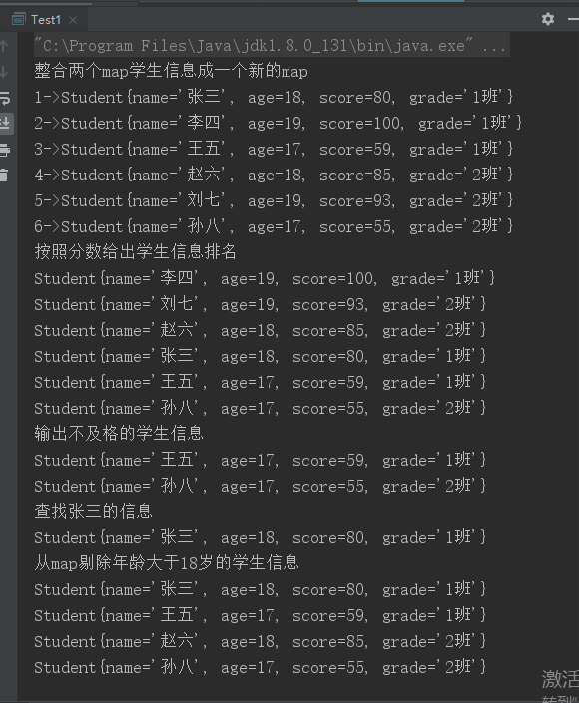

1. 仿照手机淘宝，设计订单和商品的实体类。

订单类

*/\*\*  
 \* 订单实体类  
 \* wumaoxing  
 \* 2020-3-4 20:34  
 \*/*public class Order {  
 */\*\*  
 \* 订单id  
 \*/* private Integer orderId;  
 */\*\*  
 \* 订单状态  
 \*/* private String orderState;  
 */\*\*  
 \* 物流信息  
 \*/* private String logisticsDetails;  
 */\*\*  
 \* 物流id  
 \*/* private String logisticsId;  
 */\*\*  
 \* 买家姓名  
 \*/* private String buysName;  
 */\*\*  
 \* 买家手机  
 \*/* private String buysPhono;  
 */\*\*  
 \* 买家地址  
 \*/* private String buysAddress;  
 */\*\*  
 \* 店家id  
 \*/* private String bossId;  
 */\*\*  
 \* 商品id  
 \*/* private String goodsId;  
 */\*\*  
 \* 商品图片  
 \*/* private String goodsPhoto;  
 */\*\*  
 \* 商品信息  
 \*/* private String goodsDetails;  
 */\*\*  
 \* 商品总价  
 \*/* private String goodsTotalMoney;  
 */\*\*  
 \* 运费  
 \*/* private String orderCarriage;  
 */\*\*  
 \* 订单总价  
 \*/* private String orderTotalMoney;  
 */\*\*  
 \* 实付款  
 \*/* private String actualPayMoney;  
 */\*\*  
 \* 订单创建时间  
 \*/* private String orderCreateTime;  
 */\*\*  
 \* 订单付款时间  
 \*/* private String orderPayTime;  
 */\*\*  
 \* 订单发货时间  
 \*/* private String orderSendTime;  
  
 public Integer getOrderId() {  
 return orderId;  
 }  
  
 public void setOrderId(Integer orderId) {  
 this.orderId = orderId;  
 }  
  
 public String getOrderState() {  
 return orderState;  
 }  
  
 public void setOrderState(String orderState) {  
 this.orderState = orderState;  
 }  
  
 public String getLogisticsDetails() {  
 return logisticsDetails;  
 }  
  
 public void setLogisticsDetails(String logisticsDetails) {  
 this.logisticsDetails = logisticsDetails;  
 }  
  
 public String getLogisticsId() {  
 return logisticsId;  
 }  
  
 public void setLogisticsId(String logisticsId) {  
 this.logisticsId = logisticsId;  
 }  
  
 public String getBuysName() {  
 return buysName;  
 }  
  
 public void setBuysName(String buysName) {  
 this.buysName = buysName;  
 }  
  
 public String getBuysPhono() {  
 return buysPhono;  
 }  
  
 public void setBuysPhono(String buysPhono) {  
 this.buysPhono = buysPhono;  
 }  
  
 public String getBuysAddress() {  
 return buysAddress;  
 }  
  
 public void setBuysAddress(String buysAddress) {  
 this.buysAddress = buysAddress;  
 }  
  
 public String getBossId() {  
 return bossId;  
 }  
  
 public void setBossId(String bossId) {  
 this.bossId = bossId;  
 }  
  
 public String getGoodsId() {  
 return goodsId;  
 }  
  
 public void setGoodsId(String goodsId) {  
 this.goodsId = goodsId;  
 }  
  
 public String getGoodsPhoto() {  
 return goodsPhoto;  
 }  
  
 public void setGoodsPhoto(String goodsPhoto) {  
 this.goodsPhoto = goodsPhoto;  
 }  
  
 public String getGoodsDetails() {  
 return goodsDetails;  
 }  
  
 public void setGoodsDetails(String goodsDetails) {  
 this.goodsDetails = goodsDetails;  
 }  
  
 public String getGoodsTotalMoney() {  
 return goodsTotalMoney;  
 }  
  
 public void setGoodsTotalMoney(String goodsTotalMoney) {  
 this.goodsTotalMoney = goodsTotalMoney;  
 }  
  
 public String getOrderCarriage() {  
 return orderCarriage;  
 }  
  
 public void setOrderCarriage(String orderCarriage) {  
 this.orderCarriage = orderCarriage;  
 }  
  
 public String getOrderTotalMoney() {  
 return orderTotalMoney;  
 }  
  
 public void setOrderTotalMoney(String orderTotalMoney) {  
 this.orderTotalMoney = orderTotalMoney;  
 }  
  
 public String getActualPayMoney() {  
 return actualPayMoney;  
 }  
  
 public void setActualPayMoney(String actualPayMoney) {  
 this.actualPayMoney = actualPayMoney;  
 }  
  
 public String getOrderCreateTime() {  
 return orderCreateTime;  
 }  
  
 public void setOrderCreateTime(String orderCreateTime) {  
 this.orderCreateTime = orderCreateTime;  
 }  
  
 public String getOrderPayTime() {  
 return orderPayTime;  
 }  
  
 public void setOrderPayTime(String orderPayTime) {  
 this.orderPayTime = orderPayTime;  
 }  
  
 public String getOrderSendTime() {  
 return orderSendTime;  
 }  
  
 public void setOrderSendTime(String orderSendTime) {  
 this.orderSendTime = orderSendTime;  
 }  
}

商品类

*/\*\*  
 \* 商品类  
 \* wumaoxing  
 \* 2020-3-4 21:13  
 \*/*public class Goods {  
 */\*\*  
 \* 商品id  
 \*/* private Integer goodsId;  
 */\*\*  
 \* 商品名称  
 \*/* private String goodsName;  
 */\*\*  
 \* 商品图片  
 \*/* private String goodsPhoto;  
 */\*\*  
 \* 商品价格  
 \*/* private String goodsMoney;  
 */\*\*  
 \* 商品发货地  
 \*/* private String goodsSendAddress;  
 */\*\*  
 \* 商品活动  
 \*/* private String goodsActivity;  
 */\*\*  
 \* 商品参数信息  
 \*/* private String goodsParameterDetails;  
 */\*\*  
 \* 商品库存  
 \*/* private String goodsRepertory;  
 */\*\*  
 \* 商品颜色  
 \*/* private String goodsColor;  
 */\*\*  
 \* 商品尺寸  
 \*/* private String goodsSize;  
 */\*\*  
 \* 商品评价  
 \*/* private String goodsEvaluate;  
 */\*\*  
 \* 店家id  
 \*/* private String sellsId;  
 */\*\*  
 \* 店家信息  
 \*/* private String sellsDetails;  
  
 public Integer getGoodsId() {  
 return goodsId;  
 }  
  
 public void setGoodsId(Integer goodsId) {  
 this.goodsId = goodsId;  
 }  
  
 public String getGoodsName() {  
 return goodsName;  
 }  
  
 public void setGoodsName(String goodsName) {  
 this.goodsName = goodsName;  
 }  
  
 public String getGoodsPhoto() {  
 return goodsPhoto;  
 }  
  
 public void setGoodsPhoto(String goodsPhoto) {  
 this.goodsPhoto = goodsPhoto;  
 }  
  
 public String getGoodsMoney() {  
 return goodsMoney;  
 }  
  
 public void setGoodsMoney(String goodsMoney) {  
 this.goodsMoney = goodsMoney;  
 }  
  
 public String getGoodsSendAddress() {  
 return goodsSendAddress;  
 }  
  
 public void setGoodsSendAddress(String goodsSendAddress) {  
 this.goodsSendAddress = goodsSendAddress;  
 }  
  
 public String getGoodsActivity() {  
 return goodsActivity;  
 }  
  
 public void setGoodsActivity(String goodsActivity) {  
 this.goodsActivity = goodsActivity;  
 }  
  
 public String getGoodsParameterDetails() {  
 return goodsParameterDetails;  
 }  
  
 public void setGoodsParameterDetails(String goodsParameterDetails) {  
 this.goodsParameterDetails = goodsParameterDetails;  
 }  
  
 public String getGoodsRepertory() {  
 return goodsRepertory;  
 }  
  
 public void setGoodsRepertory(String goodsRepertory) {  
 this.goodsRepertory = goodsRepertory;  
 }  
  
 public String getGoodsColor() {  
 return goodsColor;  
 }  
  
 public void setGoodsColor(String goodsColor) {  
 this.goodsColor = goodsColor;  
 }  
  
 public String getGoodsSize() {  
 return goodsSize;  
 }  
  
 public void setGoodsSize(String goodsSize) {  
 this.goodsSize = goodsSize;  
 }  
  
 public String getGoodsEvaluate() {  
 return goodsEvaluate;  
 }  
  
 public void setGoodsEvaluate(String goodsEvaluate) {  
 this.goodsEvaluate = goodsEvaluate;  
 }  
  
 public String getSellsId() {  
 return sellsId;  
 }  
  
 public void setSellsId(String sellsId) {  
 this.sellsId = sellsId;  
 }  
  
 public String getSellsDetails() {  
 return sellsDetails;  
 }  
  
 public void setSellsDetails(String sellsDetails) {  
 this.sellsDetails = sellsDetails;  
 }  
}