使用List运行结果截图：

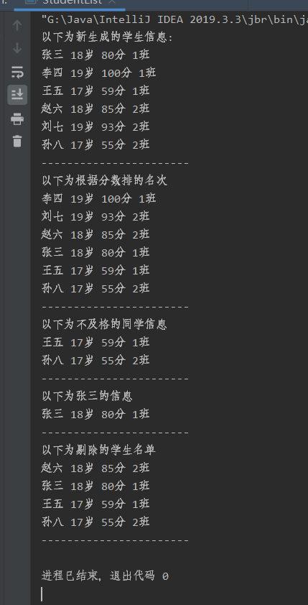

使用Map运行的结果截图：

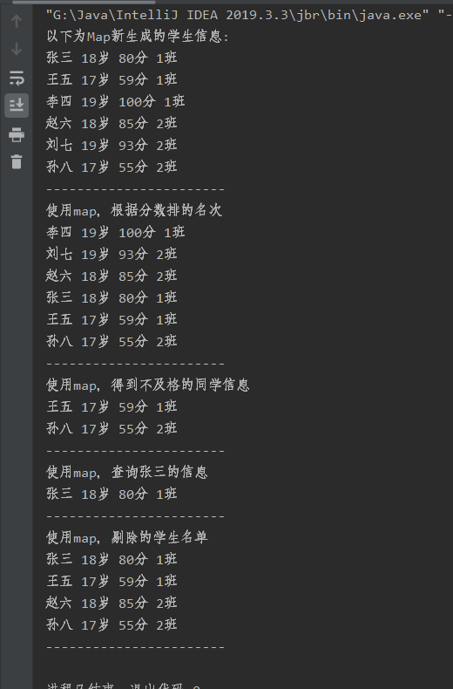

**List代码**

package Basics;  
import java.util.ArrayList;  
import java.util.Comparator;  
import java.util.List;  
*/**  
 \** ***@author*** *张鑫  
 * 2020-3-4  
 * 学生信息类List  
 */*public class StudentList {  
 public static void main(String[] args) {  
 List<Student> list1 = new ArrayList<>();  
 list1.add(new Student("张三",18,80,"1班"));  
 list1.add(new Student("李四",19,100,"1班"));  
 list1.add(new Student("王五",17,59,"1班"));  
 List<Student> list2 = new ArrayList<>();  
 list2.add(new Student("赵六",18,85,"2班"));  
 list2.add(new Student("刘七",19,93,"2班"));  
 list2.add(new Student("孙八",17,55,"2班"));  
 List<Student> list3 = new ArrayList<>();  
 list3.addAll(list1);  
 list3.addAll(list2);  
 System.*out*.println("以下为新生成的学生信息:");  
 *Newstulist*(list3);  
 System.*out*.println("-----------------------");  
 System.*out*.println("以下为根据分数排的名次");  
 *StudentRank*(list3);  
 System.*out*.println("-----------------------");  
 System.*out*.println("以下为不及格的同学信息");  
 *BadStudent*(list3);  
 System.*out*.println("-----------------------");  
 System.*out*.println("以下为张三的信息");  
 *SearchStu*(list3);  
 System.*out*.println("-----------------------");  
 System.*out*.println("以下为剔除的学生名单");  
 *RemoveStu*(list3);  
 System.*out*.println("-----------------------");  
  
 }  
 */**  
 * 新生成的学生信息  
 */* public static void Newstulist(List<Student> stu){  
 for (Student v : stu){  
 System.*out*.println(v.getName() + " " + v.getAge() + "岁" + " " +  
 v.getGrade() + "分" + " " + v.getClassnumber());  
 }  
 }  
 */**  
 * 按照分数给出学生排名  
 */* public static void StudentRank(List<Student> stu){  
 //sort排名  
 stu.sort(new Comparator<Student>() {  
 @Override  
 public int compare(Student t1, Student t2) {  
 return -Double.*compare*(t1.getGrade(),t2.getGrade());  
 }  
 });  
 for (int i = 0; i < stu.size(); i++){  
 Student v = stu.get(i);  
 System.*out*.println(v.getName() + " " + v.getAge() + "岁" + " " +  
 v.getGrade() + "分" + " " + v.getClassnumber());  
 }  
 }  
 */**  
 * 输出不及格的学生信息  
 */* public static void BadStudent(List<Student> stu){  
 for (int i = 0; i < stu.size(); i++){  
 Student v = stu.get(i);  
 int grade = v.getGrade();  
 if(grade < 60 ){  
 System.*out*.println(v.getName() + " " + v.getAge() + "岁" + " " +  
 v.getGrade() + "分" + " " + v.getClassnumber());  
 }  
 }  
 }  
 */**  
 * 查找张三的信息  
 */* public static void SearchStu(List<Student> stu){  
 for (int i = 0; i < stu.size(); i++){  
 Student v = stu.get(i);  
 String name = v.getName();  
 if(name == "张三" ){  
 System.*out*.println(v.getName() + " " + v.getAge() + "岁" + " " +  
 v.getGrade() + "分" + " " + v.getClassnumber());  
 }  
 }  
 }  
 */**  
 * 剔除大于18岁的学生信息  
 */* public static void RemoveStu(List<Student> stu){  
 for (int i = 0; i < stu.size(); i++){  
 Student v = stu.get(i);  
 int age = v.getAge();  
 if(age > 18 ){  
 stu.remove(i);  
 }  
 }  
 for (int i = 0; i < stu.size(); i++){  
 Student v = stu.get(i);  
 int age = v.getAge();  
 if(age > 18 ){  
 stu.remove(i);  
 }  
 }  
 //这里为什么一次过不完。。。。  
 for (int i = 0; i < stu.size(); i++){  
 Student v = stu.get(i);  
 System.*out*.println(v.getName() + " " + v.getAge() + "岁" + " " +  
 v.getGrade() + "分" + " " + v.getClassnumber());  
 }  
 }  
  
}

**Map代码**

package Basics;  
import java.util.*;  
  
*/**  
 \** ***@author*** *张鑫  
 * 2020-3-4  
 * 学生信息类Map  
 */*public class StudentMap {  
 public static void main(String[] args) {  
 Map<Integer,Student> map1 = new HashMap<Integer, Student>();  
 map1.put(80,new Student("张三",18,80,"1班"));  
 map1.put(100,new Student("李四",19,100,"1班"));  
 map1.put(59,new Student("王五",17,59,"1班"));  
 Map<Integer,Student> map2 = new HashMap<Integer, Student>();  
 map2.put(85,new Student("赵六",18,85,"2班"));  
 map2.put(93,new Student("刘七",19,93,"2班"));  
 map2.put(55,new Student("孙八",17,55,"2班"));  
 Map<Integer,Student> map3 = new HashMap<Integer, Student>();  
 map3.putAll(map1);  
 map3.putAll(map2);  
 System.*out*.println("以下为Map新生成的学生信息:");  
 *Newstulist*(map3);  
 System.*out*.println("-----------------------");  
 System.*out*.println("使用map，根据分数排的名次");  
 *StudentRank*(map3);  
 System.*out*.println("-----------------------");  
 System.*out*.println("使用map，得到不及格的同学信息");  
 *BadStudent*(map3);  
 System.*out*.println("-----------------------");  
 System.*out*.println("使用map，查询张三的信息");  
 *SearchStu*(map3);  
 System.*out*.println("-----------------------");  
 System.*out*.println("使用map，剔除的学生名单");  
 *RemoveStu*(map3);  
 System.*out*.println("-----------------------");  
  
 }  
 */**  
 * 新生成的学生信息  
 */* public static void Newstulist(Map<Integer,Student> map){  
 for (Student v : map.values()){  
 System.*out*.println(v.getName() + " " + v.getAge() + "岁" + " " +  
 v.getGrade() + "分" + " " + v.getClassnumber());  
 }  
  
 }  
 */**  
 * 按照分数给出学生排名  
 */* public static void StudentRank(Map<Integer,Student> map){  
 List<Map.Entry<Integer,Student>> list =  
 new ArrayList<Map.Entry<Integer, Student>>(map.entrySet());  
 Collections.*sort*(list, new Comparator<Map.Entry<Integer, Student>>() {  
 @Override  
 public int compare(Map.Entry<Integer, Student> t1, Map.Entry<Integer, Student> t2) {  
 return t2.getKey().compareTo(t1.getKey());  
 }  
 });  
 for(int i = 0; i < list.size(); i++){  
 Student v = list.get(i).getValue();  
 System.*out*.println(v.getName() + " " + v.getAge() + "岁" + " " +  
 v.getGrade() + "分" + " " + v.getClassnumber());  
 }  
 }  
 */**1  
 * 输出不及格的学生信息  
 */* public static void BadStudent(Map<Integer,Student> map){  
 for (Student v : map.values()){  
 if (v.getGrade() < 60){  
 System.*out*.println(v.getName() + " " + v.getAge() + "岁" + " " +  
 v.getGrade() + "分" + " " + v.getClassnumber());  
 }  
 }  
 }  
 */**  
 * 查找张三的信息  
 */* public static void SearchStu(Map<Integer,Student> map){  
 for (Student v : map.values()){  
 String name = v.getName();  
 if(name == "张三"){  
 System.*out*.println(v.getName() + " " + v.getAge() + "岁" + " " +  
 v.getGrade() + "分" + " " + v.getClassnumber());  
 }  
 }  
 }  
 */**  
 * 剔除大于18岁的学生信息  
 */* public static void RemoveStu(Map<Integer,Student> map) {  
 for (Student v : map.values()) {  
 if (v.getAge() <= 18){  
 System.*out*.println(v.getName() + " " + v.getAge() + "岁" + " " +  
 v.getGrade() + "分" + " " + v.getClassnumber());  
 }  
 }  
 }  
  
}

**商品类(避免太长就不弄get，set了)**

package Basics;  
  
*/**  
 \** ***@author*** *张鑫  
 * 2020-3-4  
 * 商品常量  
 */*public class Goods {  
 */**  
 * 商品编号  
 */* private String goodsNumber;  
 */**  
 * 商品信息描述，出产商，生产日期这些  
 */* private String goodsInfromation;  
 */**  
 * 商品价格  
 */* private int goodsPrice;  
 */**  
 * 商品优惠价  
 */* private String goodsVipPrice;  
 */**  
 * 商品销量  
 */* private int goodsSales;  
 */**  
 * 商品活动  
 */* private String goodsActivi;  
 */**  
 * 商品保险  
 */* private String goodsInsurance;  
 */**  
 * 商品评价  
 */* private String goodsEvaluate;  
 */**  
 * 商品客服  
 */* private String goodsSevice;  
 */**  
 * 商品的原店铺  
 */* private String goodsStore;  
 */**  
 * 商品的同类  
 */* private String goodsSameKind;  
 */**  
 * 商品的颜色  
 */* private String goodsColor;  
 */**  
 * 商品的可购买数量  
 */* private int goodsNum;  
}

**订单类**

package Basics;  
  
*/**  
 \** ***@author*** *张鑫  
 * 2020-3-4  
 * 订单常量  
 */*public class Order {  
 */**  
 * 订单代码  
 */* private int orderNumber;  
 */**  
 * 建立订单的时间  
 */* private String orderTime;  
 */**  
 * 支付订单的时间  
 */* private String orderPayTime;  
 */**  
 * 订单价钱  
 */* private String orderPrice;  
 */**  
 * 订单数量  
 */* private int orderCount;  
 */**  
 * 下订单的用户昵称  
 */* private String orderPerson;  
 */**  
 * 订单中的商品名称  
 */* private String orderName;  
 */**  
 * 订单的地址  
 */* private String orderAddress;  
 */**  
 * 订单的用户联系方式  
 */* private String orderContact;  
 */**  
 * 订单的原商家  
 */* private String orderMerchant;  
 */**  
 * 订单预计到达的时间  
 */* private String orderArriveTime;  
 */**  
 * 订单优惠的价钱  
 */* private String orderVipPrice;  
 */**  
 * 订单可使用的优惠券  
 */* private String orderCoupon;  
 */**  
 * 订单发货的时间  
 */* private String orderDeliverTime;  
 */**  
 * 订单的实时物流信息  
 */* private String orderRealTimeInformation;  
 */**  
 * 订单的运费  
 */* private String orderTransportationPrice;  
 */**  
 * 订单的运费险  
 */* private String orderInsurance;  
}