**Java基础练习3**

# 1-2大题

## 1.使用List

题目和答案

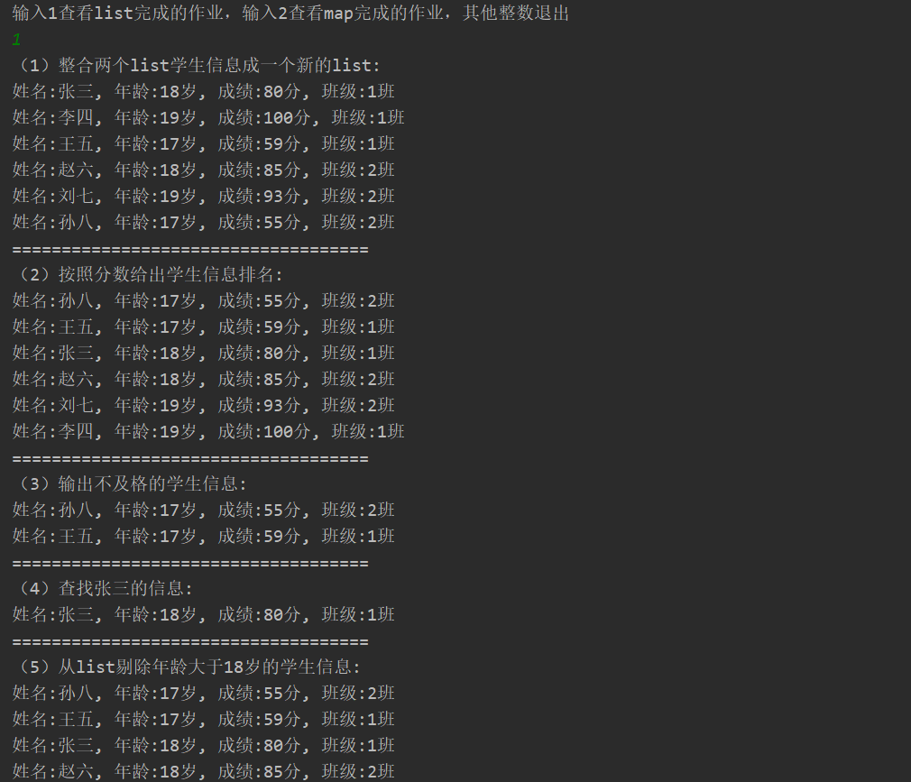

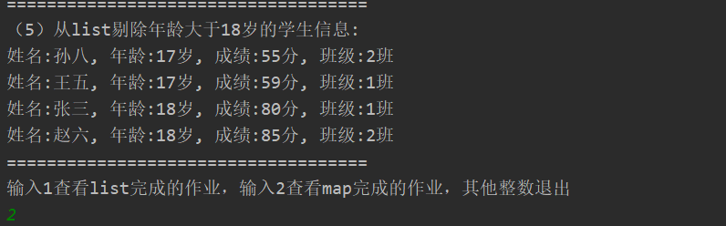

## 2.使用map完成

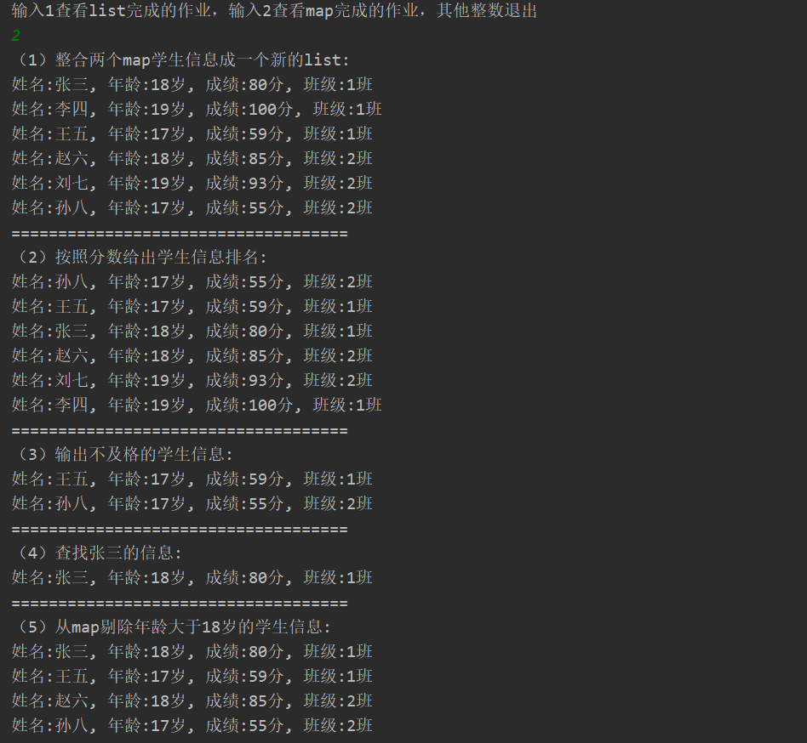

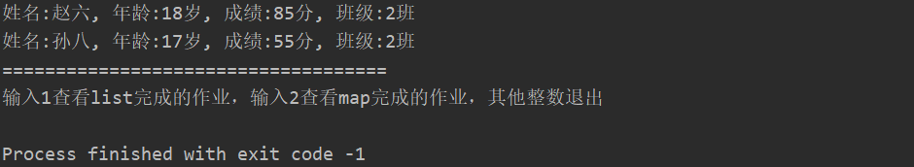

## 代码

### Main类：

import java.util.Scanner;

/**

* 主类

* ywq

* 2020-03-04 20:00

*/

public class Main {

/**

* 主方法

* @param args

* ywq

* 2020-03-04 20:01

*/

public static void main(String[] args) {

DoHomework doHomework = new DoHomework();

Scanner scanner = new Scanner( System.in );

System.out.println("输入1查看list完成的作业，输入2查看map完成的作业，其他整数退出");

int num = scanner.nextInt();

while ( num == 1 || num == 2 ) {

if (num == 1){

doHomework.useListDo();

}else {

doHomework.useMapDo();

}

System.out.println("输入1查看list完成的作业，输入2查看map完成的作业，其他整数退出");

num = scanner.nextInt();

}

}

}

### Student类：

/**

* 学生实体

* ywq

* 2020-03-04 20:05

*/

public class Student {

/**

* 学生的姓名

*/

private String name;

/**

* 学生的年龄

*/

private int age;

/**

* 学生的成绩

*/

private int grade;

/**

* 学生的班级

*/

private int theClass;

public String getName() {

return name;

}

public void setName(String name) {

this.name = name;

}

public int getAge() {

return age;

}

public void setAge(int age) {

this.age = age;

}

public int getGrade() {

return grade;

}

public void setGrade(int grade) {

this.grade = grade;

}

public int getTheClass() {

return theClass;

}

public void setTheClass(int theClass) {

this.theClass = theClass;

}

}

### DoHomework类：

import java.util.*;

/**

* 完成list和map的练习

* ywq

* 2020-03-04 20:08

*/

public class DoHomework {

/**

* 用list完成五道练习

* ywq

* 2020-03-04 20:45

*/

public void useListDo(){

List<Student> list1 = new ArrayList<>();

list1.add( getStudent("张三", 18, 80, 1 ) );

list1.add( getStudent("李四", 19, 100, 1 ) );

list1.add( getStudent("王五", 17, 59, 1 ) );

List<Student> list2 = new ArrayList<>();

list2.add( getStudent("赵六", 18, 85, 2 ) );

list2.add( getStudent("刘七", 19, 93, 2 ) );

list2.add( getStudent("孙八", 17, 55, 2 ) );

System.out.println("（1）整合两个list学生信息成一个新的list: ");

list1.addAll(list2);

list1.forEach( student ->{

outputStudent(student);

} );

System.out.println("====================================");

System.out.println("（2）按照分数给出学生信息排名: ");

//list1的排序

list1.sort(new Comparator<Student>() {

//规定排序的规则

@Override

public int compare(Student o1, Student o2) {

Integer grade1 = o1.getGrade();

Integer grade2 = o2.getGrade();

return grade1.compareTo(grade2);

}

});

list1.forEach( student ->{

outputStudent(student);

});

//student相当于是定义一个list1定义的类的变量

System.out.println("====================================");

System.out.println("（3）输出不及格的学生信息: ");

for ( int i = 0 ; i < list1.size() ; i++ ){

Student student = list1.get(i);

if (student.getGrade() < 60){

outputStudent(student);

}else {

break;

}

}

System.out.println("====================================");

System.out.println("（4）查找张三的信息: ");

for ( int i = 0 ; i < list1.size() ; i++ ){

Student student = list1.get(i);

if ("张三".equals(student.getName()) ){

outputStudent( student );

}

}

System.out.println("====================================");

System.out.println("（5）从list剔除年龄大于18岁的学生信息: ");

for (int i = 0 ; i < list1.size() ; i++ ){

Student student = list1.get(i);

if (student.getAge() > 18){

list1.remove(i--);

}

}

list1.forEach( student -> {

outputStudent(student);

} );

System.out.println("====================================");

}

/**

* 使用Map完成五道练习题

* ywq

* 2020-03-04 21:40

*/

public void useMapDo(){

int count = 1;

Map<Integer, Student> map1 = new HashMap<>();

map1.put( count++, getStudent("张三", 18, 80, 1 ) );

map1.put( count++, getStudent("李四", 19, 100, 1 ) );

map1.put( count++, getStudent("王五", 17, 59, 1 ) );

Map<Integer, Student> map2 = new HashMap<>();

map2.put( count++, getStudent("赵六", 18, 85, 2 ) );

map2.put( count++, getStudent("刘七", 19, 93, 2 ) );

map2.put( count++, getStudent("孙八", 17, 55, 2 ) );

System.out.println("（1）整合两个map学生信息成一个新的list: ");

map1.putAll(map2);

map1.forEach( (key,student) ->{

outputStudent(student);

});

//key对应的是键，student对应的是值

System.out.println("====================================");

System.out.println("（2）按照分数给出学生信息排名: ");

//将map转成list后排序

List< Map.Entry<Integer, Student> > list = new ArrayList<>(map1.entrySet());

//这里可以直接用list.sort也可以如下方式排序list

Collections.sort(list, new Comparator<Map.Entry<Integer, Student>>() {

//规定排排序的规则

@Override

public int compare(Map.Entry<Integer, Student> o1, Map.Entry<Integer, Student> o2) {

Integer x = o1.getValue().getGrade();

Integer y = o2.getValue().getGrade();

return x.compareTo(y);

}

});

list.forEach( mapToList ->{

outputStudent(mapToList.getValue() );

} );

System.out.println("====================================");

System.out.println("（3）输出不及格的学生信息: ");

map1.forEach( (key, student) ->{

if(student.getGrade() < 60 ){

outputStudent(student);

}

} );

System.out.println("====================================");

System.out.println("（4）查找张三的信息: ");

for( Student student : map1.values() ) {

if ( "张三".equals(student.getName()) ){

outputStudent(student);

break;

}

}

System.out.println("====================================");

System.out.println("（5）从map剔除年龄大于18岁的学生信息: ");

List<Integer> integerList = new ArrayList<>();

//暂存大于18岁学生的key值

map1.forEach( (key, student) ->{

if(student.getAge() > 18 ){

integerList.add(key);

}

} );

integerList.forEach( key ->{

map1.remove(key);

} );

map1.forEach( (key, student) ->{

outputStudent(student);

} );

System.out.println("====================================");

}

/**

* 对学生对象赋值

* @param name

* @param age

* @param grade

* @param theClass

* @return

* ywq

* 2020-03-04 20:12

*/

public static Student getStudent(String name,int age,int grade,int theClass){

Student student = new Student();

student.setName(name);

student.setAge(age);

student.setGrade(grade);

student.setTheClass(theClass);

return student;

}

/**

* 输出学生对象的所有信息

* @param student

* ywq

* 2020-03-04 20:15

*/

public static void outputStudent(Student student){

System.out.print("姓名:" + student.getName() );

System.out.print(", 年龄:" + student.getAge() + "岁");

System.out.print(", 成绩:" + student.getGrade() + "分");

System.out.println(", 班级:" + student.getTheClass() + "班");

}

}

# 3.仿照手机淘宝，设计订单和商品的实体类。

## 订单类(TheOrder):

import java.io.File;

import java.util.Date;

/**

* 订单实体

* ywq

* 2020-03-04 22:30

*/

public class TheOrder {

/**

* 订单编号

*/

private String orderNum;

/**

* 订单的创建时间

*/

private Date createOrderTime;

/**

* 订单的付款时间

*/

private Date paymentTime;

/**

* 订单的成交时间

*/

private Date finishBargainTime;

/**

* 订单的发货时间

*/

private Date deliverGoodsTime;

/**

* 订单的交易金额

*/

private float orderAmount;

/**

* 订单的货物名称

*/

private String goodsName;

/**

* 货物的数量

*/

private int goodsNumber;

/**

* 货物的总价

*/

private float goodsPrice;

/**

* 货物的具体款式

*/

private String goodsSpecificStyle;

/**

* 货物的图片

*/

private File goodsPicture;

/**

* 优惠金额

*/

private float preferential;

/**

* 运费

*/

private float freight;

/**

* 快递的单号（通过这个查询到快递的状态）

*/

private String deliveryNum;

/**

* 交易的状态

*/

private String transactionStatus;

/**

* 订单状态

*/

private String orderStatus;

/**

* 收件人名称

*/

private String recipientName;

/**

* 收件人电话

*/

private String recipientPhone;

/**

* 收件地址

*/

private String recipientAddress;

/**

* 收件方式

*/

private String receiptWay;

/**

* 此订单信息的创建时间

*/

private String createTime;

/**

* 此订单信息的创建的人

*/

private String createUser;

/**

* 此订单信息的修改时间

*/

private String updateTime;

/**

* 此订单信息的修改的人

*/

private String updateUser;

public String getOrderNum() {

return orderNum;

}

public void setOrderNum(String orderNum) {

this.orderNum = orderNum;

}

public Date getCreateOrderTime() {

return createOrderTime;

}

public void setCreateOrderTime(Date createOrderTime) {

this.createOrderTime = createOrderTime;

}

public Date getPaymentTime() {

return paymentTime;

}

public void setPaymentTime(Date paymentTime) {

this.paymentTime = paymentTime;

}

public Date getFinishBargainTime() {

return finishBargainTime;

}

public void setFinishBargainTime(Date finishBargainTime) {

this.finishBargainTime = finishBargainTime;

}

public Date getDeliverGoodsTime() {

return deliverGoodsTime;

}

public void setDeliverGoodsTime(Date deliverGoodsTime) {

this.deliverGoodsTime = deliverGoodsTime;

}

public float getOrderAmount() {

return orderAmount;

}

public void setOrderAmount(float orderAmount) {

this.orderAmount = orderAmount;

}

public String getGoodsName() {

return goodsName;

}

public void setGoodsName(String goodsName) {

this.goodsName = goodsName;

}

public int getGoodsNumber() {

return goodsNumber;

}

public void setGoodsNumber(int goodsNumber) {

this.goodsNumber = goodsNumber;

}

public float getGoodsPrice() {

return goodsPrice;

}

public void setGoodsPrice(float goodsPrice) {

this.goodsPrice = goodsPrice;

}

public String getGoodsSpecificStyle() {

return goodsSpecificStyle;

}

public void setGoodsSpecificStyle(String goodsSpecificStyle) {

this.goodsSpecificStyle = goodsSpecificStyle;

}

public File getGoodsPicture() {

return goodsPicture;

}

public void setGoodsPicture(File goodsPicture) {

this.goodsPicture = goodsPicture;

}

public float getPreferential() {

return preferential;

}

public void setPreferential(float preferential) {

this.preferential = preferential;

}

public float getFreight() {

return freight;

}

public void setFreight(float freight) {

this.freight = freight;

}

public String getDeliveryNum() {

return deliveryNum;

}

public void setDeliveryNum(String deliveryNum) {

this.deliveryNum = deliveryNum;

}

public String getTransactionStatus() {

return transactionStatus;

}

public void setTransactionStatus(String transactionStatus) {

this.transactionStatus = transactionStatus;

}

public String getOrderStatus() {

return orderStatus;

}

public void setOrderStatus(String orderStatus) {

this.orderStatus = orderStatus;

}

public String getRecipientName() {

return recipientName;

}

public void setRecipientName(String recipientName) {

this.recipientName = recipientName;

}

public String getRecipientPhone() {

return recipientPhone;

}

public void setRecipientPhone(String recipientPhone) {

this.recipientPhone = recipientPhone;

}

public String getRecipientAddress() {

return recipientAddress;

}

public void setRecipientAddress(String recipientAddress) {

this.recipientAddress = recipientAddress;

}

public String getReceiptWay() {

return receiptWay;

}

public void setReceiptWay(String receiptWay) {

this.receiptWay = receiptWay;

}

public String getCreateTime() {

return createTime;

}

public void setCreateTime(String createTime) {

this.createTime = createTime;

}

public String getCreateUser() {

return createUser;

}

public void setCreateUser(String createUser) {

this.createUser = createUser;

}

public String getUpdateTime() {

return updateTime;

}

public void setUpdateTime(String updateTime) {

this.updateTime = updateTime;

}

public String getUpdateUser() {

return updateUser;

}

public void setUpdateUser(String updateUser) {

this.updateUser = updateUser;

}

}

## 商品类(Goods):

package OnlineShop;

import java.io.File;

import java.util.Date;

public class Goods {

/**

* 商品编号(条形码的码号)

*/

private String goodsBarCode;

/**

* 商品名称

*/

private String goodsName;

/**

* 商品功能

*/

private String goodsFunction;

/**

* 商品图片

*/

private File goodsPicture;

/**

* 品牌

*/

private String brand;

/**

* 商品的分类编号

*/

private String goodsClassificationNum;

/**

* 卖家号

*/

private String sellerId;

/**

* 生产地

*/

private String goodsProducer;

/**

* 制成商品材料

*/

private String goodsMaterial;

/**

* 商品价格

*/

private float goodsPrice;

/**

* 优惠

*/

private float goodsPreferential;

/**

* 货存

*/

private int inventoryGoods;

/**

* 月销数量

*/

private int thisMonthSalesAmount;

/**

* 每个人限购数量

*/

private int individualPurchaseLimit;

/**

* 商品评分

*/

private String productGrade;

/**

* 上架时间

*/

private Date goodsShelfTime;

/**

* 下架时间

*/

private Date goodsUnderTime;

/*

同类商品的其他款式，可以根据商品的分类直接搜索出来

评价商品的用户的id,应该有一个专门存评价的表

可以找出全部评价这个商品的信息，所以不写

商品涉及的活动也是同上的理由不写*/

/**

* 此商品信息的创建时间

*/

private String createTime;

/**

* 此商品信息的创建的人

*/

private String createUser;

/**

* 此商品信息的修改时间

*/

private String updateTime;

/**

* 此商品信息的修改的人

*/

private String updateUser;

public String getGoodsBarCode() {

return goodsBarCode;

}

public void setGoodsBarCode(String goodsBarCode) {

this.goodsBarCode = goodsBarCode;

}

public String getGoodsName() {

return goodsName;

}

public void setGoodsName(String goodsName) {

this.goodsName = goodsName;

}

public String getGoodsFunction() {

return goodsFunction;

}

public void setGoodsFunction(String goodsFunction) {

this.goodsFunction = goodsFunction;

}

public File getGoodsPicture() {

return goodsPicture;

}

public void setGoodsPicture(File goodsPicture) {

this.goodsPicture = goodsPicture;

}

public String getBrand() {

return brand;

}

public void setBrand(String brand) {

this.brand = brand;

}

public String getGoodsClassificationNum() {

return goodsClassificationNum;

}

public void setGoodsClassificationNum(String goodsClassificationNum) {

this.goodsClassificationNum = goodsClassificationNum;

}

public String getSellerId() {

return sellerId;

}

public void setSellerId(String sellerId) {

this.sellerId = sellerId;

}

public String getGoodsProducer() {

return goodsProducer;

}

public void setGoodsProducer(String goodsProducer) {

this.goodsProducer = goodsProducer;

}

public String getGoodsMaterial() {

return goodsMaterial;

}

public void setGoodsMaterial(String goodsMaterial) {

this.goodsMaterial = goodsMaterial;

}

public float getGoodsPrice() {

return goodsPrice;

}

public void setGoodsPrice(float goodsPrice) {

this.goodsPrice = goodsPrice;

}

public float getGoodsPreferential() {

return goodsPreferential;

}

public void setGoodsPreferential(float goodsPreferential) {

this.goodsPreferential = goodsPreferential;

}

public int getInventoryGoods() {

return inventoryGoods;

}

public void setInventoryGoods(int inventoryGoods) {

this.inventoryGoods = inventoryGoods;

}

public int getThisMonthSalesAmount() {

return thisMonthSalesAmount;

}

public void setThisMonthSalesAmount(int thisMonthSalesAmount) {

this.thisMonthSalesAmount = thisMonthSalesAmount;

}

public int getIndividualPurchaseLimit() {

return individualPurchaseLimit;

}

public void setIndividualPurchaseLimit(int individualPurchaseLimit) {

this.individualPurchaseLimit = individualPurchaseLimit;

}

public String getProductGrade() {

return productGrade;

}

public void setProductGrade(String productGrade) {

this.productGrade = productGrade;

}

public Date getGoodsShelfTime() {

return goodsShelfTime;

}

public void setGoodsShelfTime(Date goodsShelfTime) {

this.goodsShelfTime = goodsShelfTime;

}

public Date getGoodsUnderTime() {

return goodsUnderTime;

}

public void setGoodsUnderTime(Date goodsUnderTime) {

this.goodsUnderTime = goodsUnderTime;

}

public String getCreateTime() {

return createTime;

}

public void setCreateTime(String createTime) {

this.createTime = createTime;

}

public String getCreateUser() {

return createUser;

}

public void setCreateUser(String createUser) {

this.createUser = createUser;

}

public String getUpdateTime() {

return updateTime;

}

public void setUpdateTime(String updateTime) {

this.updateTime = updateTime;

}

public String getUpdateUser() {

return updateUser;

}

public void setUpdateUser(String updateUser) {

this.updateUser = updateUser;

}

}