Student实体类：

package Test;

/\*\*

\* 学生实体类

\* yangmingzhen

\* 2020/3/4

\*/

public class Student {

/\*\*

\* 学生姓名

\*/

private String name;

/\*\*

\* 学生年龄

\*/

private int age;

/\*\*

\* 学生成绩

\*/

private int grade;

/\*\*

\* 学生班级

\*/

private String classnum;

public String getName() {

return name;

}

public void setName(String name) {

this.name = name;

}

public int getAge() {

return age;

}

public void setAge(int age) {

this.age = age;

}

public int getGrade() {

return grade;

}

public void setGrade(int grade) {

this.grade = grade;

}

public String getClassnum() {

return classnum;

}

public void setClassnum(String classnum) {

this.classnum = classnum;

}

}

List练习

package Test;

import java.util.ArrayList;

import java.util.List;

/\*\*

\* List练习

\* yangmingzhen

\* 2020/3/4

\*/

public class StudentList {

public static void main(String[] args) {

Student student1 = new Student();

student1.setName("张三");

student1.setAge(18);

student1.setGrade(80);

student1.setClassnum("1班");

Student student2 = new Student();

student2.setName("李四");

student2.setAge(19);

student2.setGrade(100);

student2.setClassnum("1班");

Student student3 = new Student();

student3.setName("王五");

student3.setAge(17);

student3.setGrade(59);

student3.setClassnum("1班");

Student student4 = new Student();

student4.setName("赵六");

student4.setAge(18);

student4.setGrade(85);

student4.setClassnum("2班");

Student student5 = new Student();

student5.setName("刘七");

student5.setAge(19);

student5.setGrade(93);

student5.setClassnum("2班");

Student student6 = new Student();

student6.setName("孙八");

student6.setAge(17);

student6.setGrade(55);

student6.setClassnum("2班");

List<Student> list1 = new ArrayList<Student>();

List<Student> list2 = new ArrayList<Student>();

list1.add(student1);

list1.add(student2);

list1.add(student3);

list2.add(student4);

list2.add(student5);

list2.add(student6);

/\*\*

\* 合并两个List

\*/

List<Student> list3 = new ArrayList<Student>();

list3.addAll(list1);

list3.addAll(list2);

/\*\*

\* （1）整合两个list学生信息成一个新的list

\*/

System.out.println("-----------第一题------------");

for (Student s : list3) {

System.out.println(s.getClassnum() + s.getAge() + "岁的" + s.getName() + "同学分数为：" + s.getGrade() +"分");

}

/\*\*

\* （2）按照分数给出学生信息排名

\*/

int minGrade;

Student temp;

for (int i = 0; i < list3.size(); i++){

minGrade = i;

for (int j = i; j < list3.size(); j++){

if (list3.get(j).getGrade() < list3.get(minGrade).getGrade()){

minGrade = j;

}

}

temp = list3.get(i);

list3.set(i, list3.get(minGrade));

list3.set(minGrade, temp);

}

System.out.println("-----------第二题------------");

System.out.println("按照分数由低到高给出学生信息：");

for (Student s : list3) {

System.out.println(s.getClassnum() + s.getAge() + "岁的" + s.getName() + "同学分数为：" + s.getGrade() +"分");

}

/\*\*

\* （3）输出不及格的学生信息

\*/

System.out.println("-----------第三题------------");

System.out.println("分数不合格的学生信息：");

for (Student s : list3) {

if (s.getGrade() < 60) {

System.out.println(s.getClassnum() + s.getAge() + "岁的" + s.getName() + "同学分数为：" + s.getGrade() + "分");

}

}

/\*\*

\* （4）查找张三的信息

\*/

System.out.println("-----------第四题------------");

System.out.println("名叫张三的学生信息：");

for (Student zs: list3) {

if (zs.getName() == "张三") {

System.out.println(zs.getClassnum() + zs.getAge() + "岁的" + zs.getName() + "同学分数为：" + zs.getGrade() + "分");

}

}

/\*\*

\* （5）从list剔除年龄大于18岁的学生信息

\*/

System.out.println("-----------第五题------------");

System.out.println("剔除年龄大于18的学生信息：");

for (int i = 0; i < list3.size();){

if (list3.get(i).getAge() > 18){

list3.remove(i);

}

else{

i++;

}

}

for (Student zs: list3) {

System.out.println(zs.getClassnum() + zs.getAge() + "岁的" + zs.getName() + "同学分数为：" + zs.getGrade() + "分");

}

}

}

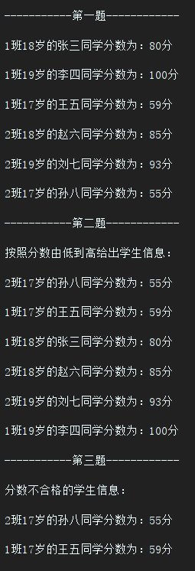 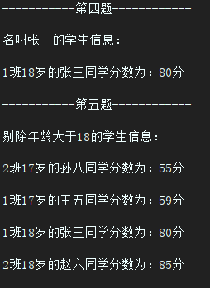

Map练习：

package Test;

import java.util.Map;

import java.util.HashMap;

/\*\*

\* map练习

\* yangmingzhen

\* 2020/3/4

\*/

public class StudentMap {

public static void main(String[] args) {

Map<Integer,Student> stuMap1 = new HashMap<>();

Map<Integer,Student> stuMap2 = new HashMap<>();

Student student1 = new Student();

student1.setName("张三");

student1.setAge(18);

student1.setGrade(80);

student1.setClassnum("1班");

Student student2 = new Student();

student2.setName("李四");

student2.setAge(19);

student2.setGrade(100);

student2.setClassnum("1班");

Student student3 = new Student();

student3.setName("王五");

student3.setAge(17);

student3.setGrade(59);

student3.setClassnum("1班");

Student student4 = new Student();

student4.setName("赵六");

student4.setAge(18);

student4.setGrade(85);

student4.setClassnum("2班");

Student student5 = new Student();

student5.setName("刘七");

student5.setAge(19);

student5.setGrade(93);

student5.setClassnum("2班");

Student student6 = new Student();

student6.setName("孙八");

student6.setAge(17);

student6.setGrade(55);

student6.setClassnum("2班");

stuMap1.put(1,student1);

stuMap1.put(2,student2);

stuMap1.put(3,student3);

stuMap2.put(4,student4);

stuMap2.put(5,student5);

stuMap2.put(6,student6);

Map<Integer,Student> stuMap3 = new HashMap<>();

/\*\*

\* 合并两个map

\*/

stuMap3.putAll(stuMap1);

stuMap3.putAll(stuMap2);

/\*\*

\* （1）整合两个list学生信息成一个新的list

\*/

System.out.println("-----------第一题------------");

for (Map.Entry<Integer, Student> entry : stuMap3.entrySet()) {

System.out.println(entry.getValue().getClassnum() + entry.getValue().getAge() + "岁的" + entry.getValue().getName() + "同学分数为："

+ entry.getValue().getGrade());

}

/\*\*

\* （2）按照分数给出学生信息排名

\*/

System.out.println("-----------第二题------------");

System.out.println("按照分数由低到高给出学生信息：");

int minGrade;

Student temp;

for (int i = 1; i < stuMap3.size(); i++){

minGrade = i;

for (int j = i; j <= stuMap3.size(); j++){

if (stuMap3.get(j).getGrade() < stuMap3.get(minGrade).getGrade()){

minGrade = j;

}

}

temp = stuMap3.get(i);

stuMap3.put(i, stuMap3.get(minGrade));

stuMap3.put(minGrade, temp);

}

for (Map.Entry<Integer, Student> entry : stuMap3.entrySet()) {

System.out.println(entry.getValue().getClassnum() + entry.getValue().getAge() + "岁的" + entry.getValue().getName() + "同学分数为："

+ entry.getValue().getGrade());

}

/\*\*

\* （3）输出不及格的学生信息

\*/

System.out.println("-----------第三题------------");

System.out.println("分数不合格的学生信息：");

for (Map.Entry<Integer, Student> entry : stuMap3.entrySet()) {

if (entry.getValue().getGrade() < 60){

System.out.println(entry.getValue().getClassnum() + entry.getValue().getAge() + "岁的" + entry.getValue().getName() + "同学分数为："

+ entry.getValue().getGrade());

}

}

/\*\*

\* （4）查找张三的信息

\*/

System.out.println("-----------第四题------------");

System.out.println("名叫张三的学生信息：");

for (Map.Entry<Integer, Student> entry : stuMap3.entrySet()) {

if (entry.getValue().getName() == "张三"){

System.out.println(entry.getValue().getClassnum() + entry.getValue().getAge() + "岁的" + entry.getValue().getName() + "同学分数为："

+ entry.getValue().getGrade());

}

}

/\*\*

\* （5）从list剔除年龄大于18岁的学生信息

\*/

System.out.println("-----------第五题------------");

System.out.println("剔除年龄大于18的学生信息：");

for (int i = 1; i <= stuMap3.size()+1; i++) {

if (stuMap3.get(i).getAge() > 18) {

stuMap3.remove(i);

}

}

for (Map.Entry<Integer, Student> entry : stuMap3.entrySet()) {

System.out.println(entry.getValue().getClassnum() + entry.getValue().getAge() + "岁的" + entry.getValue().getName() + "同学分数为："

+ entry.getValue().getGrade());

}

}

}

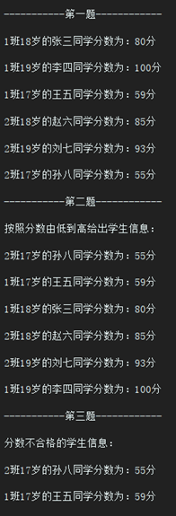 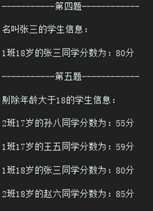

订单实体类：

package Test;

/\*\*

\* 订单实体类

\* yangmingzhen

\* 2020/3/4

\*/

public class OrderForm {

/\*\*

\* 商品编号

\*/

private String goodsid;

/\*\*

\* 商品总价

\*/

private float price;

/\*\*

\* 商品名称

\*/

private String goodsname;

/\*\*

\* 商家名称

\*/

private String merchants;

/\*\*

\* 买家

\*/

private String buyer;

/\*\*

\* 收货地址

\*/

private String address;

/\*\*

\* 运费

\*/

private float freight;

/\*\*

\* 交易账号

\*/

private String trannumber;

/\*\*

\* 订单创建时间

\*/

private String creattime;

/\*\*

\* 支付时间

\*/

private String paytime;

/\*\*

\* 发货时间

\*/

private String deliverytime;

/\*\*

\* 成交时间

\*/

private String clinchtime;

public String getGoodsid() {

return goodsid;

}

public void setGoodsid(String goodsid) {

this.goodsid = goodsid;

}

public float getPrice() {

return price;

}

public void setPrice(float price) {

this.price = price;

}

public String getGoodsname() {

return goodsname;

}

public void setGoodsname(String goodsname) {

this.goodsname = goodsname;

}

public String getMerchants() {

return merchants;

}

public void setMerchants(String merchants) {

this.merchants = merchants;

}

public String getBuyer() {

return buyer;

}

public void setBuyer(String buyer) {

this.buyer = buyer;

}

public String getAddress() {

return address;

}

public void setAddress(String address) {

this.address = address;

}

public float getFreight() {

return freight;

}

public void setFreight(float freight) {

this.freight = freight;

}

public String getTrannumber() {

return trannumber;

}

public void setTrannumber(String trannumber) {

this.trannumber = trannumber;

}

public String getCreattime() {

return creattime;

}

public void setCreattime(String creattime) {

this.creattime = creattime;

}

public String getPaytime() {

return paytime;

}

public void setPaytime(String paytime) {

this.paytime = paytime;

}

public String getDeliverytime() {

return deliverytime;

}

public void setDeliverytime(String deliverytime) {

this.deliverytime = deliverytime;

}

public String getClinchtime() {

return clinchtime;

}

public void setClinchtime(String clinchtime) {

this.clinchtime = clinchtime;

}

}

商品实体类：

package Test;

/\*\*

\* 商品实体类

\* yangmingzhen

\* 2020/3/4

\*/

public class Goods {

/\*\*

\* 商品编号

\*/

private String goodsid;

/\*\*

\* 商品名称

\*/

private String goodsname;

/\*\*

\* 上架时间

\*/

private String helftime;

/\*\*

\* 重量

\*/

private String weight;

/\*\*

\* 颜色

\*/

private String color;

/\*\*

\* 单价

\*/

private float price;

/\*\*

\* 材质

\*/

private String materia;

/\*\*

\* 功能

\*/

private String function;

/\*\*

\* 产地

\*/

private String origin;

/\*\*

\* 运费

\*/

private float freight;

public String getGoodsid() {

return goodsid;

}

public void setGoodsid(String goodsid) {

this.goodsid = goodsid;

}

public String getGoodsname() {

return goodsname;

}

public void setGoodsname(String goodsname) {

this.goodsname = goodsname;

}

public String getHelftime() {

return helftime;

}

public void setHelftime(String helftime) {

this.helftime = helftime;

}

public String getWeight() {

return weight;

}

public void setWeight(String weight) {

this.weight = weight;

}

public String getColor() {

return color;

}

public void setColor(String color) {

this.color = color;

}

public float getPrice() {

return price;

}

public void setPrice(float price) {

this.price = price;

}

public String getMateria() {

return materia;

}

public void setMateria(String materia) {

this.materia = materia;

}

public String getFunction() {

return function;

}

public void setFunction(String function) {

this.function = function;

}

public String getOrigin() {

return origin;

}

public void setOrigin(String origin) {

this.origin = origin;

}

public float getFreight() {

return freight;

}

public void setFreight(float freight) {

this.freight = freight;

}

}