Java基础练习3

1. 建立一个实体类Student类，属性：姓名，年龄，成绩，班级

建立一个list1，包含 “张三，18岁，80分，1班”，“李四，19岁，100分，1班”，“王五，17岁，59分，1班”。

建立一个list2，包含 “赵六，18岁，85分，2班”，“刘七，19岁，93分，2班”，“孙八，17岁，55分，2班”。

1. 整合两个list学生信息成一个新的list
2. 按照分数给出学生信息排名
3. 输出不及格的学生信息
4. 查找张三的信息
5. 从list剔除年龄大于18岁的学生信息
6. 使用Map 完成练习1的习题。

3.仿照手机淘宝，设计订单和商品的实体类。

答：

1. 代码源码如下：

**package** homework_3;  
  
**import** java.util.ArrayList;  
**import** java.util.List;  
  
*/**  
 * Student实体类  
 * linxianghang  
 * 2020-03-04 19：42  
 */***public class** Student {  
 */**  
 * 姓名  
 */* **private** String **name**;  
 */**  
 * 年龄  
 */* **private int age**;  
 */**  
 * 成绩  
 */* **private int grade**;  
 */**  
 * 班级  
 */* **private** String **studentclass**;  
  
 **public** String getName() {  
 **return name**;  
 }  
  
 **public void** setName(String name) {  
 **this**.**name** = name;  
 }  
  
 **public int** getAge() {  
 **return age**;  
 }  
  
 **public void** setAge(**int** age) {  
 **this**.**age** = age;  
 }  
  
 **public int** getGrade() {  
 **return grade**;  
 }  
  
 **public void** setGrade(**int** grade) {  
 **this**.**grade** = grade;  
 }  
  
 **public** String getStudentclass() {  
 **return studentclass**;  
 }  
  
 **public void** setStudentclass(String studentclass) {  
 **this**.**studentclass** = studentclass;  
 }  
  
 **public** Student(String name, **int** age, **int** grade, String studentclass){  
 **this**.**age** = age;  
 **this**.**name** = name;  
 **this**.**grade** = grade;  
 **this**.**studentclass** = studentclass;  
 }  
  
 **public static void** main(String[] args) {  
 List<Student> list1 = **new** ArrayList<>();  
 Student student1 = **new** Student(**"张三"**, 18, 80, **"1班"**);  
 Student student2 = **new** Student(**"李四"**, 19, 100, **"1班"**);  
 Student student3 = **new** Student(**"王五"**, 17, 59, **"1班"**);  
 list1.add(student1);  
 list1.add(student2);  
 list1.add(student3);  
  
 List<Student> list2 = **new** ArrayList<>();  
 Student student4 = **new** Student(**"赵六"**, 18, 85, **"2班"**);  
 Student student5 = **new** Student(**"刘七"**, 19, 93, **"2班"**);  
 Student student6 = **new** Student(**"孙八"**, 17, 55, **"2班"**);  
 list1.add(student4);  
 list1.add(student5);  
 list1.add(student6);  
  
 List<Student> list3 = **new** ArrayList<>();  
 list3.addAll(list1);  
 list3.addAll(list2);  
  
 System.***out***.println(**"按分数排名学生信息如下："**);  
 **for** (**int** i = 0; i < list3.size(); i++) {  
 **for** (**int** j = i + 1; j < list3.size(); j++) {  
 **if** (list3.get(i).getGrade() > list3.get(j).getGrade()) {  
 Student temp = list3.get(j);  
 list3.set(j, list3.get(i));  
 list3.set(i, temp);  
 }  
 }  
 }  
 **for** (Student student : list3) {  
 System.***out***.println(**"The student name is "** + student.getName() + **" age is "** + student.getAge()  
 + **" grade is "** + student.getGrade() + **" studentclass is "** + student.getStudentclass());  
 }  
  
 System.***out***.println(**"-------------"**);  
 System.***out***.println(**"不及格学生信息如下："**);  
 **for** (**int** i = 0; i < list3.size(); i++) {  
 **if** (list3.get(i).getGrade() < 60) {  
 System.***out***.println(**"The student name is "** + list3.get(i).getName() + **" age is "** + list3.get(i).getAge() +  
 **" grade is "** + list3.get(i).getGrade() + **" studentclass is "** + list3.get(i).getStudentclass());  
 }  
 }  
  
 System.***out***.println(**"-------------"**);  
 System.***out***.println(**"查找张三信息如下："**);  
 **for** (**int** i = 0; i < list3.size(); i++) {  
 **if** (**"张三"**.equals(list3.get(i).getName())) {  
 System.***out***.println(**"The student name is "** + list3.get(i).getName() + **" age is "** + list3.get(i).getAge() +  
 **" grade is "** + list3.get(i).getGrade() + **" studentclass is "** + list3.get(i).getStudentclass());  
 }  
 }  
  
 System.***out***.println(**"-------------"**);  
 System.***out***.println(**"剔除年龄大于18岁后信息如下："**);  
 **for**(**int** i=0; i<list3.size(); i++){  
 **if**(list3.get(i).getAge() > 18){  
 list3.remove(i);  
 i--;  
 }  
 }  
 **for** (Student student : list3) {  
 System.***out***.println(**"The student name is "** + student.getName() + **" age is "** + student.getAge()  
 + **" grade is "** + student.getGrade() + **" studentclass is "** + student.getStudentclass());  
 }  
  
  
  
  
 }  
 }  
  
  
  
运行结果如下图：

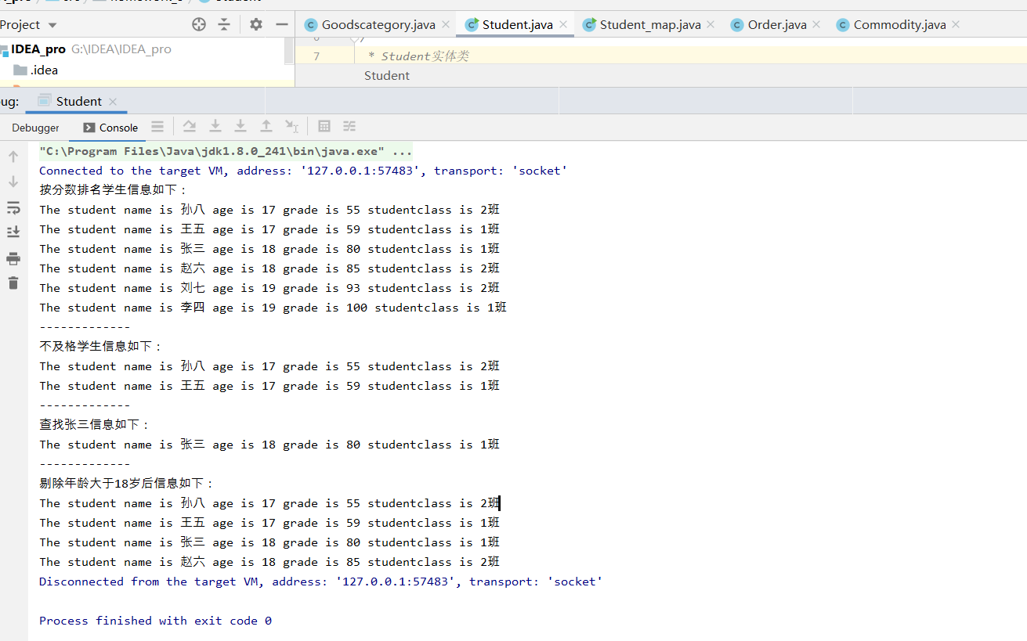

2.

**代码源码如下：**

**package** homework_3;  
  
**import** java.util.Arrays;  
**import** java.util.HashMap;  
**import** java.util.Map;  
  
*/**  
 * 用map实现练习1  
 * linxianghang  
 * 2020-03-04 20：00  
 */***public class** Student_map {  
 */**  
 * 姓名  
 */* **private** String **name**;  
 */**  
 * 年龄  
 */* **private int age**;  
 */**  
 * 成绩  
 */* **private int grade**;  
 */**  
 * 班级  
 */* **private** String **studentclass**;  
  
 **public** String getName() {  
 **return name**;  
 }  
  
 **public void** setName(String name) {  
 **this**.**name** = name;  
 }  
  
 **public int** getAge() {  
 **return age**;  
 }  
  
 **public void** setAge(**int** age) {  
 **this**.**age** = age;  
 }  
  
 **public int** getGrade() {  
 **return grade**;  
 }  
  
 **public void** setGrade(**int** grade) {  
 **this**.**grade** = grade;  
 }  
  
 **public** String getStudentclass() {  
 **return studentclass**;  
 }  
  
 **public void** setStudentclass(String studentclass) {  
 **this**.**studentclass** = studentclass;  
 }  
  
 **public** Student_map(String name, **int** age, **int** grade, String studentclass){  
 **this**.**age** = age;  
 **this**.**name** = name;  
 **this**.**grade** = grade;  
 **this**.**studentclass** = studentclass;  
 }  
  
  
  
  
  
 **public static void** main(String[] args) {  
 Map<Integer,Student_map> map1 = **new** HashMap<>();  
 Student_map student1 = **new** Student_map(**"张三"**, 18, 80, **"1班"**);  
 Student_map student2 = **new** Student_map(**"李四"**, 19, 100, **"1班"**);  
 Student_map student3 = **new** Student_map(**"王五"**, 17, 59, **"1班"**);  
 map1.put(80,student1);  
 map1.put(100,student2);  
 map1.put(59,student3);  
  
 Map<Integer,Student_map> map2 = **new** HashMap<>();  
 Student_map student4 = **new** Student_map(**"赵六"**, 18, 85, **"2班"**);  
 Student_map student5 = **new** Student_map(**"刘七"**, 19, 93, **"2班"**);  
 Student_map student6 = **new** Student_map(**"孙八"**, 17, 55, **"2班"**);  
 map1.put(85,student4);  
 map1.put(93,student5);  
 map1.put(55,student6);  
  
 Map<Integer,Student_map> map3 = **new** HashMap<>();  
 map3.putAll(map1);  
 map3.putAll(map2);  
  
 System.***out***.println(**"按成绩排序后的学生信息如下："**);  
 Object[] objects = map3.keySet().toArray();  
 Arrays.*sort*(objects);  
 **for** (**int** i = 0; i < objects.**length**; i++) {  
 System.***out***.println(**"The student name is "** + map3.get(objects[i]).getName() + **" age is "** + map3.get(objects[i]).getAge() +  
 **" grade is "** + map3.get(objects[i]).getGrade() + **" studentclass is "** + map3.get(objects[i]).getStudentclass());  
 }  
  
 System.***out***.println(**"----------------"**);  
 System.***out***.println(**"输出不及格的学生信息: "**);  
 **for** (Map.Entry<Integer, Student_map> entry : map3.entrySet()) {  
 **if**(entry.getKey()<60)  
 {  
 System.***out***.println(**"The student name is "** + entry.getValue().getName() + **" age is "** + entry.getValue().getAge() +  
 **" grade is "** + entry.getValue().getGrade() + **" studentclass is "** + entry.getValue().getStudentclass());  
 }  
 }  
  
 System.***out***.println(**"----------------"**);  
 System.***out***.println(**"查找张三的信息: "**);  
 **for** (Map.Entry<Integer, Student_map> entry : map3.entrySet()) {  
 **if**(**"张三"**.equals(entry.getValue().getName()))  
 {  
 System.***out***.println(**"The student name is "** + entry.getValue().getName() + **" age is "** + entry.getValue().getAge() +  
 **" grade is "** + entry.getValue().getGrade() + **" studentclass is "** + entry.getValue().getStudentclass());  
 }  
 }  
  
 System.***out***.println(**"----------------"**);  
 System.***out***.println(**"从list剔除年龄大于18岁的学生信息:"**);  
 **for** (**int** i = 0; i < objects.**length**; i++) {  
 **if**(map3.get(objects[i]).getAge() > 18)  
 {  
 map3.remove(objects[i]);  
 }  
 }  
 **for** (Map.Entry<Integer, Student_map> entry : map3.entrySet()) {  
 System.***out***.println(**"The student name is "** + entry.getValue().getName() + **" age is "** + entry.getValue().getAge() +  
 **" grade is "** + entry.getValue().getGrade() + **" studentclass is "** + entry.getValue().getStudentclass());  
 }  
  
  
  
  
  
  
  
 }  
}

运行输出结果如下图：

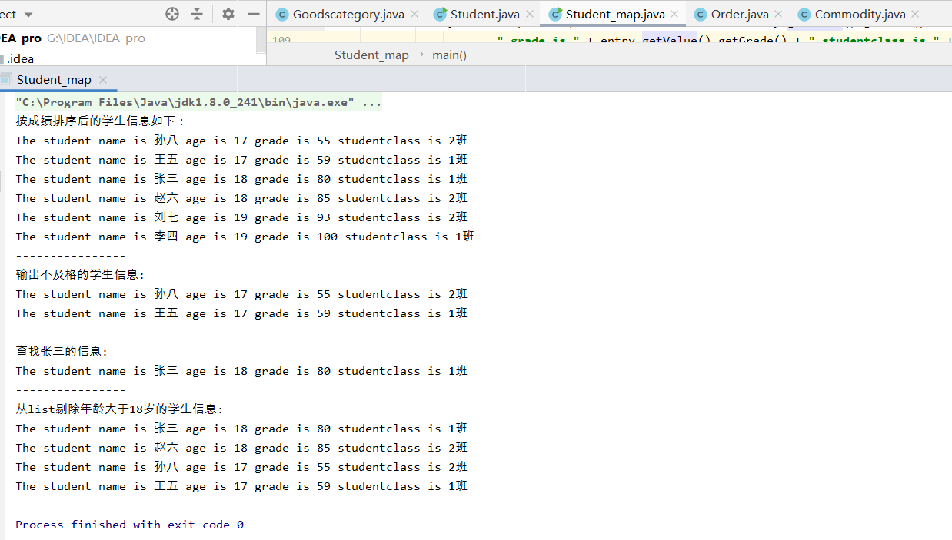

3.

*/**  
 * 订单实体类  
 * linxianghang  
 * 2020-03-04 21：00  
 */***public class** Order {  
 */**  
 * 订单号  
 */* **private** String **ordernumber**;  
 */**  
 * 原价  
 */* **private int originalprice**;  
 */**  
 * 订单状态  
 */* **private** String **orderstatus**;  
 */**  
 * 商品数量  
 */* **private int quantity**;  
 */**  
 * 订单信息  
 */* **private** String **information**;  
 */**  
 * 优惠  
 */* **private int discount**;  
 */**  
 * 实付款  
 */* **private int actualpayment**;  
 */**  
 * 商家名称  
 */* **private** String **vendorname**;  
 */**  
 * 商家评价  
 */* **private int Merchantsevaluation**;  
 */**  
 * 运费  
 */* **private int transportationexpense**;  
 */**  
 * 关联商品编码  
 */* **private int commoditycode**;  
 */**  
 * 创建时间  
 */* **private** String **createTime**;  
 */**  
 * 创建人  
 */* **private** String **createUser**;  
 */**  
 *修改时间  
 */* **private** String **updateTime**;  
 */**  
 *修改用户  
 */* **private** String **updateUser**;  
}

*/**  
 * 商品分类实体类  
 * linxianghang  
 * 2020-03-04 20：50  
 */***public class** Commodity {  
 */**  
 * 商品名称  
 */* **private** String **CommodityName**;  
 */**  
 * 商品尺码  
 */* **private int CommoditySize**;  
 */**  
 * 商品现价  
 */* **private int CommodityCurrentPirce**;  
 */**  
 * 商品原价  
 */* **private int CommodityOriginalPrice**;  
 */**  
 * 商品优惠  
 */* **private int CommodityDiscount**;  
 */**  
 * 月销量  
 */* **private int monthlySales**;  
 */**  
 * 存货数量  
 */* **private int CommodityQuantity**;  
 */**  
 * 累计评价数  
 */* **private int EvaluationNumber**;  
 */**  
 * 商品参数  
 */* **private** String **CommodityParameter**;  
 */**  
 * 创建时间  
 */* **private** String **createTime**;  
 */**  
 * 创建人  
 */* **private** String **createUser**;  
 */**  
 *修改时间  
 */* **private** String **updateTime**;  
 */**  
 *修改用户  
 */* **private** String **updateUser**;  
}