第一题list

1. 建立一个实体类Student类

package day03;  
  
*/**  
 *  
 * 学生类  
 \** ***@liangzijie*** *\** ***@2020.3.4*** *\*/*public class Student implements Comparable<Student>{  
 //姓名  
 private String studentName;  
 //年龄  
 private int studentAge;  
 //成绩  
 private int studentGrades;  
 //班级  
 private String studentClass;  
  
 public String getStudentName() {  
 return studentName;  
 }  
  
 public void setStudentName(String studentName) {  
 this.studentName = studentName;  
 }  
  
 public int getStudentAge() {  
 return studentAge;  
 }  
  
 public void setStudentAge(int studentAge) {  
 this.studentAge = studentAge;  
 }  
  
 public int getStudentGrades() {  
 return studentGrades;  
 }  
  
 public void setStudentGrades(int studentGrades) {  
 this.studentGrades = studentGrades;  
 }  
  
 public String getStudentClass() {  
 return studentClass;  
 }  
  
 public void setStudentClass(String studentClass) {  
 this.studentClass = studentClass;  
 }  
  
 @Override  
 public String toString() {  
 return this.studentName+" "+this.studentGrades+" "+this.studentAge+" "+this.studentClass;  
 }  
  
  
 @Override  
 public int compareTo(Student o) {  
 if(this.studentGrades>=o.getStudentGrades()) {  
 return 1;  
 }  
 return -1;  
 }  
}

1.2测试

（1）整合两个list学生信息成一个新的list

（2）按照分数给出学生信息排名

（3）输出不及格的学生信息

（4）查找张三的信息

（5）从list剔除年龄大于18岁的学生信息

package day03;  
  
import org.junit.Test;  
  
import java.util.ArrayList;  
import java.util.Collection;  
import java.util.Comparator;  
import java.util.List;  
  
public class StudentList {  
 @Test  
 public void testStudent(){  
 //调用第一个学生集合方法  
 List<Student> list1 = firstList();  
 //调用第二学生集合方法  
 List<Student> list2 = secondList();  
 //调用整合两个list学生信息成一个新的list  
 list1.addAll(list2);  
 System.*out*.println(list1);  
 //调用按照学生分数给出学生信息排名  
 sortGrades(list1);  
  
 //调用输出不及格学生信息  
 flunkStudent(list1);  
  
 //找出张三信息  
 findStudent(list1);  
  
 //剔除年龄大于18学生  
 studentAgeBig18(list1);  
  
 }  
 //创建第一个学生类集合  
 public List<Student> firstList(){  
 //创建第一个学生集合list  
 List<Student> list1=new ArrayList<Student>();  
 //创建学生对象  
 Student student1=new Student();  
 Student student2=new Student();  
 Student student3=new Student();  
 //封装学生数据  
 student1.setStudentName("张三");  
 student1.setStudentAge(18);  
 student1.setStudentGrades(80);  
 student1.setStudentClass("1班");  
 student2.setStudentName("李四");  
 student2.setStudentAge(19);  
 student2.setStudentGrades(100);  
 student2.setStudentClass("1班");  
 student3.setStudentName("王五");  
 student3.setStudentAge(17);  
 student3.setStudentGrades(59);  
 student3.setStudentClass("1班");  
 //把学生数据添加到list1  
 list1.add(student1);  
 list1.add(student2);  
 list1.add(student3);  
 return list1;  
 }  
 public List<Student> secondList(){  
 //创建第一个学生集合list  
 List<Student> list2=new ArrayList<Student>();  
 //创建学生对象  
 Student student1=new Student();  
 Student student2=new Student();  
 Student student3=new Student();  
 //封装学生数据  
 student1.setStudentName("赵六");  
 student1.setStudentAge(18);  
 student1.setStudentGrades(85);  
 student1.setStudentClass("2班");  
 student2.setStudentName("刘七");  
 student2.setStudentAge(19);  
 student2.setStudentGrades(93);  
 student2.setStudentClass("2班");  
 student3.setStudentName("孙八");  
 student3.setStudentAge(17);  
 student3.setStudentGrades(55);  
 student3.setStudentClass("2班");  
 //把学生数据添加到list1  
 list2.add(student1);  
 list2.add(student2);  
 list2.add(student3);  
 return list2;  
 }  
 //按照学生分数给出学生信息排名  
 public void sortGrades(List<Student> list3){  
 list3.sort(Comparator.*naturalOrder*());  
 System.*out*.println("根据分数从小到大排序："+list3);  
 }  
 //输出不及格学生信息  
 public void flunkStudent(List<Student> list3){  
 System.*out*.println("输出不及格学生信息:");  
 for(int i=0;i<list3.size();i++){  
 if(list3.get(i).getStudentGrades()<60){  
 System.*out*.println(list3.get(i));  
 }  
 }  
 }  
 //找出张三信息  
 public void findStudent(List<Student> list3){  
 System.*out*.println("张三信息为：");  
 for (int i=0;i<list3.size();i++){  
 if ("张三" == list3.get(i).getStudentName()){  
 System.*out*.println(list3.get(i));  
 }  
 }  
 }  
 //剔除年龄大于18的学生  
 public void studentAgeBig18(List<Student> list3){  
 for (int i=0;i<list3.size();i++){  
 if (list3.get(i).getStudentAge()>18){  
 list3.remove(i);  
 }  
 }  
 System.*out*.println(list3);  
 }  
}

结果

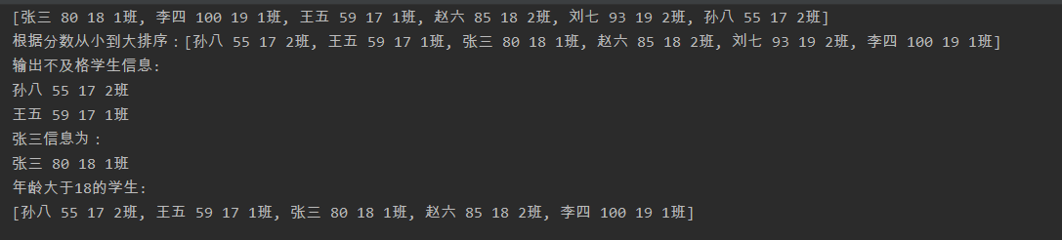

第二题Map，在做list以上功能

package day03;  
  
  
import org.junit.Test;  
  
import java.util.HashMap;  
import java.util.Map;  
  
public class StudentMap {  
 @Test  
 public void testStudent(){  
 //调用第一个学生集合方法  
 Map<Integer,Student> Map1=Map1();  
 //调用第一个学生集合方法  
 Map<Integer,Student> Map2=Map2();  
 //调用整合两个map学生信息成一个新的map  
 Map1.putAll(Map2);  
 System.*out*.println(Map1);  
 //调用按照学生分数给出学生信息排名  
 sortGrades(Map1);  
 //调用输出不及格学生信息  
 flunkStudent(Map1);  
 //找出张三信息  
 findStudent(Map1);  
 //剔除年龄大于18学生  
 studentAgeBig18(Map1);  
 }  
 public Map<Integer,Student> Map1(){  
 //创建第一个学生集合list  
 Map<Integer,Student> Map1=new HashMap<Integer, Student>();  
 //创建学生对象  
 Student student1=new Student();  
 Student student2=new Student();  
 Student student3=new Student();  
 //封装学生数据  
 student1.setStudentName("张三");  
 student1.setStudentAge(18);  
 student1.setStudentGrades(80);  
 student1.setStudentClass("1班");  
 student2.setStudentName("李四");  
 student2.setStudentAge(19);  
 student2.setStudentGrades(100);  
 student2.setStudentClass("1班");  
 student3.setStudentName("王五");  
 student3.setStudentAge(17);  
 student3.setStudentGrades(59);  
 student3.setStudentClass("1班");  
 //把学生数据添加到list1  
 Map1.put(1,student1);  
 Map1.put(2,student2);  
 Map1.put(3,student3);  
 return Map1;  
 }  
 public Map<Integer,Student> Map2(){  
 //创建第一个学生集合list  
 Map<Integer,Student> Map2=new HashMap<Integer, Student>();  
 //创建学生对象  
 Student student1=new Student();  
 Student student2=new Student();  
 Student student3=new Student();  
 //封装学生数据  
 student1.setStudentName("赵六");  
 student1.setStudentAge(18);  
 student1.setStudentGrades(85);  
 student1.setStudentClass("2班");  
 student2.setStudentName("刘七");  
 student2.setStudentAge(19);  
 student2.setStudentGrades(93);  
 student2.setStudentClass("2班");  
 student3.setStudentName("孙八");  
 student3.setStudentAge(17);  
 student3.setStudentGrades(55);  
 student3.setStudentClass("2班");  
 //把学生数据添加到list1  
 Map2.put(4,student1);  
 Map2.put(5,student2);  
 Map2.put(6,student3);  
 return Map2;  
 }  
 //输出不及格学生信息方法  
 public void flunkStudent(Map<Integer,Student> Map3){  
 System.*out*.println("不及格学生信息：");  
 for (Map.Entry<Integer,Student> entry:Map3.entrySet()){  
 if(entry.getValue().getStudentGrades()<60){  
 System.*out*.println(entry);  
 }  
 }  
 }  
 //找出张三信息  
 public void findStudent(Map<Integer,Student> Map3){  
 System.*out*.println("张三学生信息：");  
 for (Map.Entry<Integer,Student> entry:Map3.entrySet()){  
 if("张三" == entry.getValue().getStudentName()){  
 System.*out*.println(entry);  
 }  
 }  
 }  
 //剔除年龄大于18学生  
 public void studentAgeBig18(Map<Integer,Student> Map3){  
 System.*out*.println("//剔除年龄大于18学生后：");  
 for (Map.Entry<Integer,Student> entry:Map3.entrySet()){  
 if(entry.getValue().getStudentAge()>18){  
 System.*out*.println(entry);  
 }  
 }  
 }  
//学生分数给出学生信息排名  
 public void sortGrades(Map<Integer,Student> Map3){  
 System.*out*.println("学生分数给出学生信息排名："+"这个不会，网上上不懂");  
  
 }  
}

结果

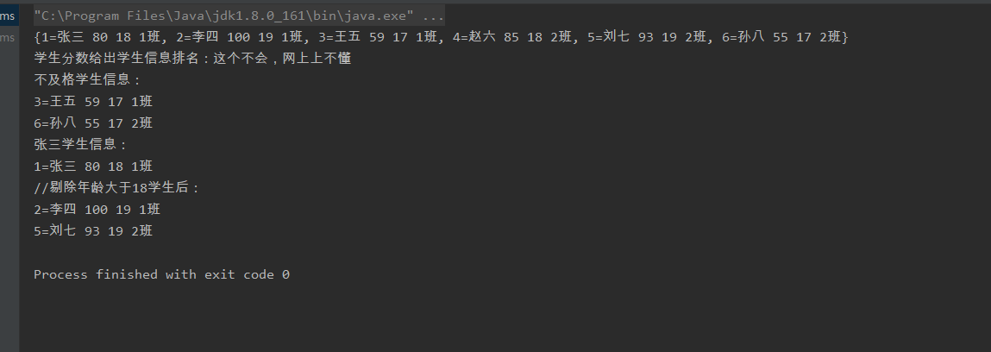

第三题

仿照手机淘宝，设计订单和商品的实体类。

商品类

*/**  
 * 商品类  
 * liangzijie  
 \** ***@2020.3.4*** *\*/*public class Product {  
 //商品名字  
 private String productName;  
 //商品编号  
 private String productCode;  
 //商品价格  
 private String productprice;  
 //商品等级  
 private String productRank;  
 //商品创建时间  
 private String productCreateTime;  
 //商品创建者  
 private String productCreatePerson;  
  
 public String getProductName() {  
 return productName;  
 }  
  
 public void setProductName(String productName) {  
 this.productName = productName;  
 }  
  
 public String getProductCode() {  
 return productCode;  
 }  
  
 public void setProductCode(String productCode) {  
 this.productCode = productCode;  
 }  
  
 public String getProductprice() {  
 return productprice;  
 }  
  
 public void setProductprice(String productprice) {  
 this.productprice = productprice;  
 }  
  
 public String getProductRank() {  
 return productRank;  
 }  
  
 public void setProductRank(String productRank) {  
 this.productRank = productRank;  
 }  
  
 public String getProductCreateTime() {  
 return productCreateTime;  
 }  
  
 public void setProductCreateTime(String productCreateTime) {  
 this.productCreateTime = productCreateTime;  
 }  
  
 public String getProductCreatePerson() {  
 return productCreatePerson;  
 }  
  
 public void setProductCreatePerson(String productCreatePerson) {  
 this.productCreatePerson = productCreatePerson;  
 }  
}

订单类

*\*\*  
 * 订单类  
 * liangzijie  
 \** ***@2020.3.4*** *\*/*public class Order {  
 //订单创建时间  
 private String orderCreateTime;  
 //订单创建者  
 private String orderCreatePerson;  
 //订单取消时间  
 private String orderCancelsTime;  
 //订单编号  
 private String orderCode;  
 //订单商品编号  
 private String orderProductCode;  
  
 public String getOrderCreateTime() {  
 return orderCreateTime;  
 }  
  
 public void setOrderCreateTime(String orderCreateTime) {  
 this.orderCreateTime = orderCreateTime;  
 }  
  
 public String getOrderCreatePerson() {  
 return orderCreatePerson;  
 }  
  
 public void setOrderCreatePerson(String orderCreatePerson) {  
 this.orderCreatePerson = orderCreatePerson;  
 }  
  
 public String getOrderCancelsTime() {  
 return orderCancelsTime;  
 }  
  
 public void setOrderCancelsTime(String orderCancelsTime) {  
 this.orderCancelsTime = orderCancelsTime;  
 }  
  
 public String getOrderCode() {  
 return orderCode;  
 }  
  
 public void setOrderCode(String orderCode) {  
 this.orderCode = orderCode;  
 }  
  
 public String getOrderProductCode() {  
 return orderProductCode;  
 }  
  
 public void setOrderProductCode(String orderProductCode) {  
 this.orderProductCode = orderProductCode;  
 }  
}