Student类

package text;  
  
class Student {  
 private String name;  
 private int age;  
 private int score;  
 private String grade;  
  
 public Student(String name,int age,int score,String grade){  
 this.name = name;  
 this.age = age;  
 this.score = score;  
 this.grade = grade;  
 }  
  
 public String getName() {  
 return name;  
 }  
  
 public void setName(String name) {  
 this.name = name;  
 }  
  
 public int getAge() {  
 return age;  
 }  
  
 public void setAge(int age) {  
 this.age = age;  
 }  
  
 public int getScore() {  
 return score;  
 }  
  
 public void setScore(int score) {  
 this.score = score;  
 }  
  
 public String getGrade() {  
 return grade;  
 }  
  
 public void setGrade(String grade) {  
 this.grade = grade;  
 }  
}

List：

import java.util.ArrayList;  
import java.util.Collections;  
import java.util.List;  
  
public class text {  
 public static void main(String[] args) {  
 List<Student> list1 = new ArrayList<>();  
 List<Student> list2 = new ArrayList<>();  
 List<Student> list3 = new ArrayList<>();  
 Student s1 = new Student("张三",18,80,"1班");  
 Student s2 = new Student("李四",19,100,"1班");  
 Student s3 = new Student("王五",17,59,"1班");  
 Student s4 = new Student("赵六",18,85,"1班");  
 Student s5 = new Student("刘七",19,93,"1班");  
 Student s6 = new Student("孙八",17,55,"1班");  
  
 list1.add(s1);  
 list1.add(s2);  
 list1.add(s3);  
  
 list2.add(s4);  
 list2.add(s5);  
 list2.add(s6);  
  
 list3.addAll(list1);  
 list3.addAll(list2);  
  
 */\*\*  
 \* 打印合并后的学生列表  
 \*/* System.*out*.println("打印合并后的学生列表");  
 for(int i = 0 ; i < list3.size() ; i++){  
 Student list = (Student)list3.get(i);  
 System.*out*.println(list.getName() + " "+list.getAge() + " "+list.getScore() + " "+list.getGrade());  
 }  
  
 */\*\*  
 \* 按成绩排序  
 \*/* System.*out*.println("按成绩排序");  
 Collections.*sort*(list3,(c1,c2)->c2.getScore()-c1.getScore());  
  
 for(int i = 0 ; i < list3.size() ; i++){  
 Student list = (Student)list3.get(i);  
 System.*out*.println(list.getName() + " "+list.getAge() + " "+list.getScore() + " "+list.getGrade());  
 }  
  
 */\*\*  
 \* 输出不及格的学生信息  
 \*/* System.*out*.println("输出不及格的学生信息");  
 for(int i = 0 ; i < list3.size() ; i++){  
 if(list3.get(i).getScore() < 60){  
 Student list = (Student)list3.get(i);  
 System.*out*.println(list.getName() + " "+list.getAge() + " "+list.getScore() + " "+list.getGrade());  
 }  
 }  
  
 */\*\*  
 \* 查找张三信息  
 \*/* System.*out*.println("查找张三信息");  
 for(int i = 0 ; i < list3.size() ; i++){  
 if(list3.get(i).getName() == "张三"){  
 Student list = (Student)list3.get(i);  
 System.*out*.println(list.getName() + " "+list.getAge() + " "+list.getScore() + " "+list.getGrade());  
 }  
 }  
  
 */\*\*  
 \* 从list剔除年龄大于18岁的学生信息  
 \*/* System.*out*.println("从list剔除年龄大于18岁的学生信息");  
 for(int i = 0 ; i < list3.size() ; i++){  
 if(list3.get(i).getAge() > 18){  
 list3.remove(i);  
 Student list = (Student)list3.get(i);  
 System.*out*.println(list.getName() + " "+list.getAge() + " "+list.getScore() + " "+list.getGrade());  
 }  
 }  
  
 }  
}

运行结果：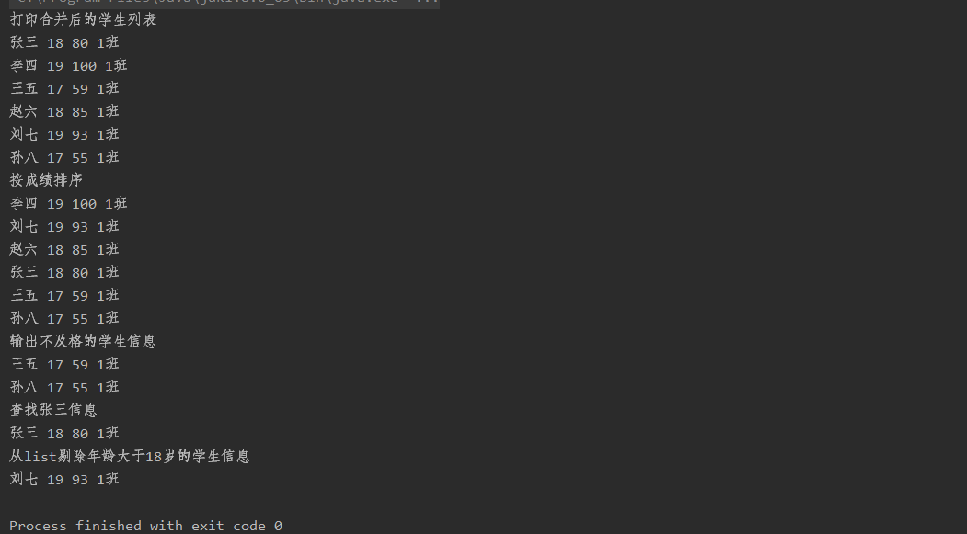

Map：

import java.util.HashMap;  
import java.util.Map;  
  
public class test {  
 public static void main(String[] args) {  
 Map<Integer,Student> map1 = new HashMap<>();  
 Map<Integer,Student> map2 = new HashMap<>();  
 Map<Integer,Student> map3 = new HashMap<>();  
  
 Student s1 = new Student("张三",18,80,"1班");  
 Student s2 = new Student("李四",19,100,"1班");  
 Student s3 = new Student("王五",17,59,"1班");  
 Student s4 = new Student("赵六",18,85,"1班");  
 Student s5 = new Student("刘七",19,93,"1班");  
 Student s6 = new Student("孙八",17,55,"1班");  
  
 map1.put(1,s1);  
 map1.put(2,s2);  
 map1.put(3,s3);  
 map2.put(4,s4);  
 map2.put(5,s5);  
 map2.put(6,s6);  
  
 map3.putAll(map1);  
 map3.putAll(map2);  
 System.*out*.println("合并两个map");  
 for(Map.Entry<Integer,Student> entry : map3.entrySet()){  
 Student student = entry.getValue();  
 System.*out*.println(student.getName() + " "+student.getAge() + " "+student.getScore() + " "+student.getGrade());  
 }  
  
 */\*\*  
 \* 输出不及格的学生信息  
 \*/* System.*out*.println("输出不及格的学生信息");  
 for(Map.Entry<Integer,Student> entry : map3.entrySet()){  
 Student student = entry.getValue();  
 if(student.getScore() < 60 ){  
 System.*out*.println(student.getName() + " "+student.getAge() + " "+student.getScore() + " "+student.getGrade());  
 }  
 }  
  
 */\*\*  
 \* 查找张三信息  
 \*/* System.*out*.println("查找张三信息");  
 for(Map.Entry<Integer,Student> entry : map3.entrySet()){  
 Student student = entry.getValue();  
 if(student.getName() == "张三" ){  
 System.*out*.println(student.getName() + " "+student.getAge() + " "+student.getScore() + " "+student.getGrade());  
 }  
 }  
  
 */\*\*  
 \* 从list剔除年龄大于18岁的学生信息  
 \*/* System.*out*.println("从list剔除年龄大于18岁的学生信息");  
 for(Map.Entry<Integer,Student> entry : map3.entrySet()){  
 Student student = entry.getValue();  
 if(student.getAge() <= 18 ){  
 System.*out*.println(student.getName() + " "+student.getAge() + " "+student.getScore() + " "+student.getGrade());  
 }  
 }  
  
 }  
}

运行结果：

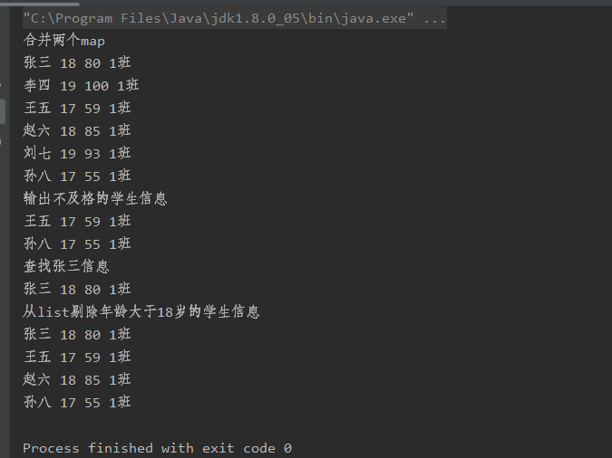

1. 淘宝目录：

public class Order {  
 */\*\*  
 \* 订单编号  
 \*/* private String orderCode;  
 */\*\*  
 \* 商品id  
 \*/* private String orderId;  
 */\*\*  
 \* 商品名称  
 \*/* private String goodsName;  
 */\*\*  
 \*创建时间  
 \*/* private String createTime;  
 */\*\*  
 \* 付款时间  
 \*/* private String payTime;  
 */\*\*  
 \* 付款方式  
 \*/* private String payStyle;  
 */\*\*  
 \* 发货时间  
 \*/* private String deliveryTime;  
 */\*\*  
 \* 成交时间  
 \*/* private String dealTime;  
 */\*\*  
 \* 发货地址  
 \*/* private String deliveryAddress;  
 */\*\*  
 \* 收获地址  
 \*/* private String getAddress;  
 */\*\*  
 \* 卖家  
 \*/* private String seller;  
 */\*\*  
 \* 买家  
 \*/* private String buyers;  
 */\*\*  
 \* 订单总价  
 \*/* private String orderPrice;  
 */\*\*  
 \* 运险费  
 \*/* private String transportInsurance;  
 */\*\*  
 \* 运费  
 \*/* private String transportMoney;  
 */\*\*  
 \* 商品总价  
 \*/* private String goodsPrice;  
}

*/\*\*  
 \* 商品实体类  
 \*/*public class Product {  
 */\*\*  
 \* 商品编号  
 \*/* private int productId;  
 */\*\*  
 \* 商品名称  
 \*/* private String productName;  
 */\*\*  
 \* 商品类型编号  
 \*/* private int classifyId;  
 */\*\*  
 \* 商品品牌编号  
 \*/* private int brandId;  
 */\*\*  
 \* 商品型号  
 \*/* private String modelId;  
 */\*\*  
 \* 商品介绍  
 \*/* private String introduce;  
 */\*\*  
 \* 商品描述  
 \*/* private String describe;  
 */\*\*  
 \* 商品小图  
 \*/* private String smallPicture;  
 */\*\*  
 \* 商品大图  
 \*/* private String bigPicture;  
 */\*\*  
 \* 商品价格  
 \*/* private double productPrice;  
 */\*\*  
 \* 商品库存  
 \*/* private int inventoryNumber;  
 */\*\*  
 \* 商品上传时间  
 \*/* private String uploadTime;  
 */\*\*  
 \* 商品上架与下架  
 \*/* private String productCondition;  
}