Java基础练习3

1. 建立一个实体类Student类，属性：姓名，年龄，成绩，班级

建立一个list1，包含 “张三，18岁，80分，1班”，“李四，19岁，100分，1班”，“王五，17岁，59分，1班”。

建立一个list2，包含 “赵六，18岁，85分，2班”，“刘七，19岁，93分，2班”，“孙八，17岁，55分，2班”。

1. 整合两个list学生信息成一个新的list
2. 按照分数给出学生信息排名
3. 输出不及格的学生信息
4. 查找张三的信息
5. 从list剔除年龄大于18岁的学生信息

*实体类:*

*public class* Student {  
 */**  
 * 学生姓名  
 */  
 private* String name;  
 */**  
 * 学生年龄  
 */  
 private int* age;  
 */**  
 * 学生成绩  
 */  
 private int* grade;  
 */**  
 * 学生班级  
 */  
 private* String classes;  
  
 *public* Student(){}  
  
 *public* Student(String name,*int* age,*int* grade,String classes){  
 *this*.name = name;  
 *this*.age = age;  
 *this*.grade = grade;  
 *this*.classes = classes;  
 }  
  
 *public* String getName() {  
 *return* name;  
 }  
  
 *public void* setName(String name) {  
 *this*.name = name;  
 }  
  
 *public int* getAge() {  
 *return* age;  
 }  
  
 *public void* setAge(*int* age) {  
 *this*.age = age;  
 }  
  
 *public int* getGrade() {  
 *return* grade;  
 }  
  
 *public void* setGrade(*int* grade) {  
 *this*.grade = grade;  
 }  
  
 *public* String getClasses() {  
 *return* classes;  
 }  
  
 *public void* setClasses(String classes) {  
 *this*.classes = classes;  
 }  
}

***Lisi的:***

*package* com.xiekai.homework;  
*import* java.util.ArrayList;  
*import* java.util.List;  
  
*public class* ListTest {  
  
 *public static void* main(String[] args) {  
 *//创建列表* List<Student> list1 = *new* ArrayList<>();  
 List<Student> list2 = *new* ArrayList<>();  
 *//实例化对象并插入list1* Student stu1 = *new* Student("张三", 18, 80, "1班");  
 Student stu2 = *new* Student("李四", 19, 100, "1班");  
 Student stu3 = *new* Student("王五", 17, 59, "1班");  
 list1.add(stu1);  
 list1.add(stu2);  
 list1.add(stu3);  
 *//实例化对象并插入list2* Student stu4 = *new* Student("赵六", 18, 85, "2班");  
 Student stu5 = *new* Student("刘七", 19, 93, "2班");  
 Student stu6 = *new* Student("孙八", 17, 55, "2班");  
 list2.add(stu4);  
 list2.add(stu5);  
 list2.add(stu6);  
 *//1）整合两个list学生信息成一个新的list* List<Student> list3 = *new* ArrayList<>();  
 list3.addAll(list1);  
 list3.addAll(list2);  
 *for* (Student li : list3) {  
 System.out.println(li.getClasses() + "的年龄为" + li.getAge() + "的" + li.getName() + "考了" + li.getGrade());  
 }  
 *//（2）按照分数给出学生信息排名* System.out.println("------------------------");  
 *int* MIN;  
 Student temp;  
 *for*(*int* i = 0;i < list3.size();i++) {  
 MIN = i;  
 *for* (*int* j = i; j < list3.size(); j++) {  
 *if* (list3.get(j).getGrade() < list3.get(MIN).getGrade()) {  
 MIN = j;  
 }  
 }  
 temp = list3.get(i);  
 list3.set(i, list3.get(MIN));  
 list3.set(MIN, temp);  
 }  
 *int* i = list3.size();  
 *for*(Student s:list3){  
 System.out.println(("第" + i +"名:" + s.getName() + s.getGrade() + "分"));  
 i--;  
 }  
  
  
 *//（3）输出不及格的学生信息* System.out.println("------------------------");  
 *for*(Student s:list3){  
 *if*(s.getGrade()<60){  
 System.out.println(s.getName() + "不及格,分数为:" +s.getGrade() );  
 }  
 }  
 *//（4）查找张三的信息* System.out.println("------------------------");  
 *for*(Student s:list3){  
 *if*(s.getName() == "张三"){  
 System.out.println(s.getName() + " " +s.getAge() + " " +s.getGrade() + " " +s.getClasses());  
 }  
 }  
  
 *//（5）从list剔除年龄大于18岁的学生信息* System.out.println("------------------------");  
 *for*(*int* j = 0;j < list3.size();) {*//清除大于18的!  
 if*(list3.get(j).getAge() > 18) {  
 list3.remove(j);  
 }*else* {  
 j++;  
 }  
 }  
 *for*(Student s:list3){  
 System.out.println(s.getName() + " " +s.getAge() + " " +s.getGrade() + " " +s.getClasses());  
 }  
  
 }  
}

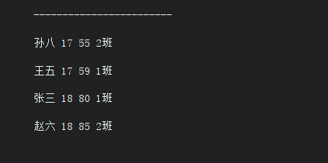

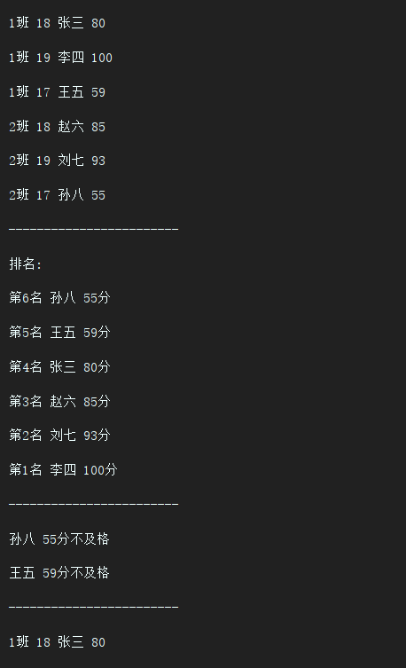

1. 使用Map 完成练习1的习题。
2. *Map的:*

*package* com.xiekai.homework;  
  
*import* com.sun.deploy.net.proxy.RemoveCommentReader;  
  
*import* java.util.HashMap;  
*import* java.util.Map;  
  
*public class* MapTest {  
 *public static void* main(String[] args) {  
 *//创建三个Map* Map<Integer, Student> stuMap1 = *new* HashMap<Integer, Student>();  
 Map<Integer, Student> stuMap2 = *new* HashMap<Integer, Student>();  
 Map<Integer, Student> stuMap3 = *new* HashMap<Integer, Student>();  
 *//创建三个对象并插入Map1* Student stu1 = *new* Student("张三", 18, 80, "1班");  
 Student stu2 = *new* Student("李四", 19, 100, "1班");  
 Student stu3 = *new* Student("王五", 17, 59, "1班");  
 stuMap1.put(1, stu1);  
 stuMap1.put(2, stu2);  
 stuMap1.put(3, stu3);  
 *//创建三个对象并插入Map2* Student stu4 = *new* Student("赵六", 18, 85, "2班");  
 Student stu5 = *new* Student("刘七", 19, 93, "2班");  
 Student stu6 = *new* Student("孙八", 17, 55, "2班");  
 stuMap2.put(4, stu4);  
 stuMap2.put(5, stu5);  
 stuMap2.put(6, stu6);  
 *//把map1和map2插入map3* stuMap3.putAll(stuMap1);  
 stuMap3.putAll(stuMap2);  
  
 *//（1）整合两个map学生信息成一个新的map  
 //遍历map3  
 for* (Map.Entry<Integer, Student> e : stuMap3.entrySet()) {  
 System.out.println(e.getValue().getClasses() + " " + e.getValue().getAge() +  
 " " + e.getValue().getName() + " " + e.getValue().getGrade());  
 }  
  
 *//（2）按照分数给出学生信息排名* System.out.println("------------------------");  
 *int* MIN;  
 Student temp;  
 *for* (*int* i = 1; i < stuMap3.size(); i++) {  
 MIN = i;  
 *for* (*int* j = i; j <= stuMap3.size(); j++) {  
 *if* (stuMap3.get(j).getGrade() < stuMap3.get(MIN).getGrade()) {  
 MIN = j;  
 }  
 }  
 temp = stuMap3.get(i);  
 stuMap3.put(i, stuMap3.get(MIN));  
 stuMap3.put(MIN, temp);  
 }  
 *int* i = stuMap3.size();  
 System.out.println("排名:");  
 *for* (Map.Entry<Integer, Student> entry : stuMap3.entrySet()) {  
 System.out.println("第" + i + "名 " + entry.getValue().getName() +  
 " " + entry.getValue().getGrade() + "分");  
 i--;  
 }  
 *//（3）输出不及格的学生信息* System.out.println("------------------------");  
 *for* (Map.Entry<Integer, Student> entry : stuMap3.entrySet()) {  
 *if* (entry.getValue().getGrade() < 60) {  
 System.out.println(entry.getValue().getName() + " " +  
 entry.getValue().getGrade() + "分不及格");  
  
 }  
 }  
 *//（4）查找张三的信息* System.out.println("------------------------");  
 *for* (Map.Entry<Integer, Student> e : stuMap3.entrySet()) {  
 *if* (e.getValue().getName() == "张三") {  
 System.out.println(e.getValue().getClasses() + " " + e.getValue().getAge() +  
 " " + e.getValue().getName() + " " + e.getValue().getGrade());  
  
 }  
 }  
 *//（5）从map剔除年龄大于18岁的学生信息* System.out.println("------------------------");  
System.out.println("------------------------");  
*for* (*int* j = 1; j <= stuMap3.size()+1;j++) {  
 *if* (stuMap3.get(j).getAge() > 18) {  
 stuMap3.remove(j);  
 }  
}

*//System.out.println(stuMap3.size());  
 for* (Map.Entry<Integer, Student> e : stuMap3.entrySet()) {  
 System.out.println(e.getValue().getClasses() + " " + e.getValue().getAge() +  
 " " + e.getValue().getName() + " " + e.getValue().getGrade());  
 }  
 }  
}

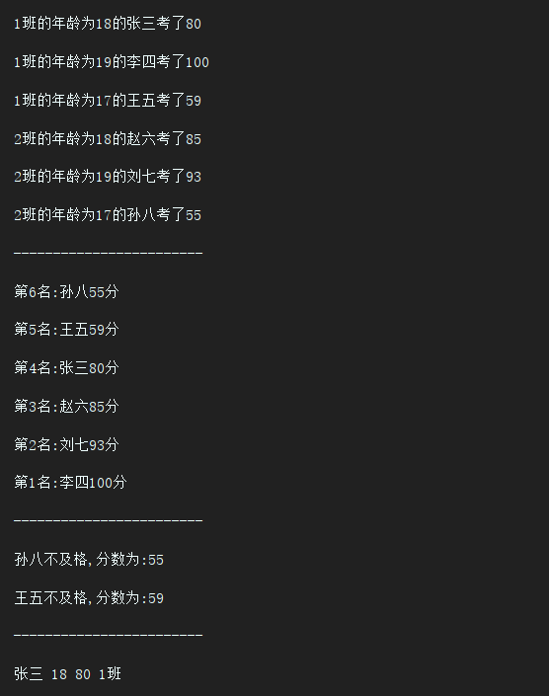

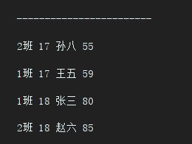

3.仿照手机淘宝，设计订单和商品的实体类。

商品类:

*/**  
 * 原价  
 */  
 private int* originalPrice;  
 */**  
 * 现价  
 */  
 private int* currentPrice;  
 */**  
 * 库存  
 */  
 private int* inventory;  
 */**  
 * 具体商品属性  
 */  
 private* String commodityAttribute;  
 */**  
 * 评价  
 */  
 private* String evaluation;  
 */**  
 * 月销  
 */  
 private int* monthlySales;  
 */**  
 * 所在地  
 */  
 private* String location;  
 */**  
 * 所在店铺  
 */  
 private* String Store;  
 */**  
 * 星级  
 */  
 private double* level;  
 */**  
 * 创建时间  
 */  
 private* String creationTime;  
 */**  
 * 修改时间  
 */  
 private* String modificationTime;  
 */**  
 * 创建人  
 */  
 private* String creationUser;  
}

订单类:

*/\*\**

*\* 店铺名字  
 */  
private* String shopName;  
*/**  
 * 交易状态  
 */  
private* String transactionStatus;  
*/**  
 * 物流状况  
 */  
private* String logisticsSituation;  
*/**  
 * 收货地址  
 */  
private* String shippingAddress;  
*/**  
 * 商品名字  
 */  
private* String commodityName;  
*/**  
 * 商品总价  
 */  
private* String totalPriceOfGoods;  
*/**  
 * 实付款  
 */  
private* String shiFukuan;  
*/**  
 * 订单编号  
 */  
private int* orderNumber;  
*/**  
 * 支付宝交易号  
 */  
private int* transactionNumber;  
*/**  
 * 创建时间  
 */  
private* String creationTime;  
*/**  
 * 付款时间  
 */  
private* String paymentTime;  
*/**  
 * 发货时间  
 */  
private* String deliveryTime;  
*/**  
 * 成交时间  
 */  
private* String closingTime;