**Student类省略**

**1、用list实现操作**

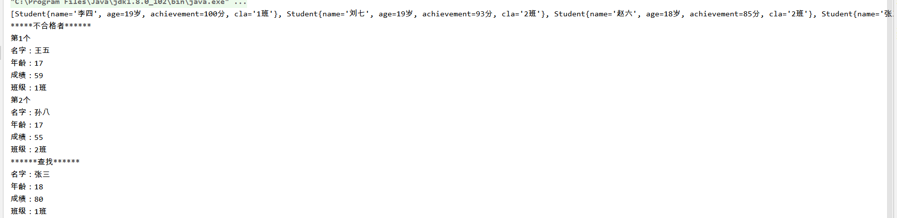

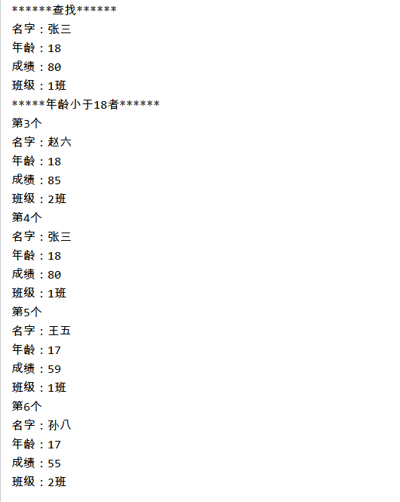

**public class** Demo {  
 **public static void** main(String[] args) {  
 List<Student> list1 = **new** ArrayList<>();  
 list1.add(**new** Student(**"张三"**,18,80,**"1班"**));  
 list1.add(**new** Student(**"李四"**,19,100,**"1班"**));  
 list1.add(**new** Student(**"王五"**,17,59,**"1班"**));  
  
 List<Student> list2 = **new** ArrayList<>();  
 list2.add(**new** Student(**"赵六"**,18,85,**"2班"**));  
 list2.add(**new** Student(**"刘七"**,19,93,**"2班"**));  
 list2.add(**new** Student(**"孙八"**,17,55,**"2班"**));  
 //合并  
 List<Student> list3 = **new** ArrayList<>();  
 list3.addAll(list1);  
 list3.addAll(list2);

//按照成绩排序  
 Collections.*sort*(list3,(v1,v2)->v2.getAchievement()-v1.getAchievement());  
 System.***out***.println(list3.toString());  
  
 System.***out***.println(**"*****不合格者******"**);  
 List<Student> list4 = *filter*(list3,(str)->{**return** str.getAchievement()<60;});  
 **int** count = 1;  
 **for**(Student student:list4){  
 System.***out***.println(**"第"**+ count++ +**"个"**);  
 System.***out***.println(**"名字："**+ student.getName());  
 System.***out***.println(**"年龄："**+ student.getAge());  
 System.***out***.println(**"成绩："**+ student.getAchievement());  
 System.***out***.println(**"班级："**+ student.getCla());  
 }  
 System.***out***.println(**"******查找******"**);  
 **for**(Student student:list3){  
 **if** (**"张三"**.equals(student.getName())){  
 System.***out***.println(**"名字："**+ student.getName());  
 System.***out***.println(**"年龄："**+ student.getAge());  
 System.***out***.println(**"成绩："**+ student.getAchievement());  
 System.***out***.println(**"班级："**+ student.getCla());  
 **break**;  
 }  
 }  
 System.***out***.println(**"*****年龄小于18者******"**);  
 List<Student> list5 = *filter*(list3,(str)->{**return** str.getAge()<=18;});  
 **int** count2 = 1;  
 **for**(Student student:list5){  
 System.***out***.println(**"第"**+ count++ +**"个"**);  
 System.***out***.println(**"名字："**+ student.getName());  
 System.***out***.println(**"年龄："**+ student.getAge());  
 System.***out***.println(**"成绩："**+ student.getAchievement());  
 System.***out***.println(**"班级："**+ student.getCla());  
 }  
 }  
 **private static** List<Student> filter(List<Student> list, Predicate<Student> pre){  
 List<Student> results = **new** ArrayList<>();  
 **for**(Student r:list){  
 **if**(pre.test(r)) *//测试是否符合要求* {  
 results.add(r);  
 }  
 }  
 **return** results;  
 }  
}

1. 用Map实现操作

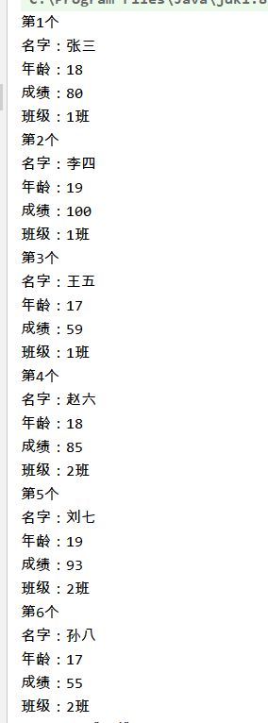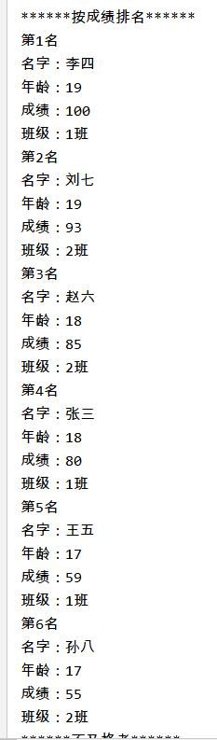

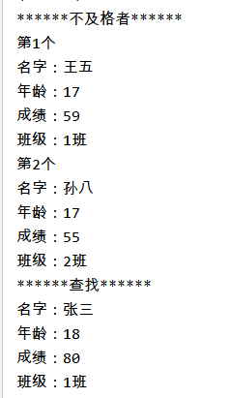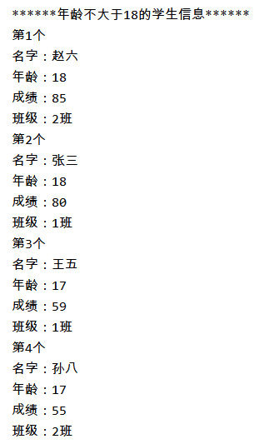

**public class** Demo2 {  
 **public static void** main(String[] args) {  
 Map<Integer , Student> map = **new** HashMap<>();  
 **int** i = 0;  
 map.put(i++,**new** Student(**"张三"**,18,80,**"1班"**));  
 map.put(i++,**new** Student(**"李四"**,19,100,**"1班"**));  
 map.put(i++,**new** Student(**"王五"**,17,59,**"1班"**));  
  
 Map<Integer , Student> map2 = **new** HashMap<>();  
 map2.put(i++,**new** Student(**"赵六"**,18,85,**"2班"**));  
 map2.put(i++,**new** Student(**"刘七"**,19,93,**"2班"**));  
 map2.put(i++,**new** Student(**"孙八"**,17,55,**"2班"**));  
  
 Map<Integer,Student> map3 = **new** HashMap<>();  
 map3.putAll(map);  
 map3.putAll(map2);  
 Set<Entry<Integer,Student>> entrySet = map3.entrySet();  
 **int** count = 1;  
 **for** (Entry<Integer,Student> entry:entrySet){  
 Student student = entry.getValue();  
 System.***out***.println(**"第"**+ count++ +**"个"**);  
 System.***out***.println(**"名字："**+ student.getName());  
 System.***out***.println(**"年龄："**+ student.getAge());  
 System.***out***.println(**"成绩："**+ student.getAchievement());  
 System.***out***.println(**"班级："**+ student.getCla());  
 }  
  
  
 System.***out***.println(**"******按成绩排名******"**);  
 *//将map3变成按照成绩高低顺序排列的map* count=1;  
 **for** ( i = 0; i < map3.size(); i++) {  
 Student student;  
 **for** (**int** j = i + 1 ; j < map3.size() ; j++){  
 **if** (map3.get(i).getAchievement()<map3.get(j).getAchievement()){  
 student = map3.get(i);  
 map3.replace(i,map3.get(j));  
 map3.replace(j,student);  
 }  
 }  
 student = map3.get(i);  
 System.***out***.println(**"第"**+ count++ +**"名"**);  
 System.***out***.println(**"名字："**+ student.getName());  
 System.***out***.println(**"年龄："**+ student.getAge());  
 System.***out***.println(**"成绩："**+ student.getAchievement());  
 System.***out***.println(**"班级："**+ student.getCla());  
 }  
  
  
 System.***out***.println(**"******不及格者******"**);  
 **int** count2 = 1;  
 Student findStu = **null**;  
  
 *//年龄不大于18岁的学生信息map* Map<Integer,Student> map4 = **new** HashMap<>();  
 **for** (Entry<Integer,Student> entry:entrySet){  
 Student student = entry.getValue();  
 **if** (student.getAchievement()<60){  
 System.***out***.println(**"第"**+ count2++ +**"个"**);  
 System.***out***.println(**"名字："**+ student.getName());  
 System.***out***.println(**"年龄："**+ student.getAge());  
 System.***out***.println(**"成绩："**+ student.getAchievement());  
 System.***out***.println(**"班级："**+ student.getCla());  
 }  
 **if** (**"张三"**.equals(student.getName())){ *//查找张三的信息* findStu = student;  
 }  
 **if** (student.getAge()<=18){ *//将年龄小于等于18的学生信息加入map4* map4.put(count++,student);  
 }  
 }  
  
  
 System.***out***.println(**"******查找******"**);  
 **if** (findStu!=**null**){  
 System.***out***.println(**"名字："**+ findStu.getName());  
 System.***out***.println(**"年龄："**+ findStu.getAge());  
 System.***out***.println(**"成绩："**+ findStu.getAchievement());  
 System.***out***.println(**"班级："**+ findStu.getCla());  
 }  
  
  
 System.***out***.println(**"******年龄不大于18的学生信息******"**);  
 Set<Entry<Integer,Student>> entrySet2 = map4.entrySet();  
 **int** count3 = 1;  
 **for** (Entry<Integer,Student> entry:entrySet2){  
 Student student = entry.getValue();  
 System.***out***.println(**"第"**+ count3++ +**"个"**);  
 System.***out***.println(**"名字："**+ student.getName());  
 System.***out***.println(**"年龄："**+ student.getAge());  
 System.***out***.println(**"成绩："**+ student.getAchievement());  
 System.***out***.println(**"班级："**+ student.getCla());  
 }  
 }  
}