Java基础练习3

1. 建立一个实体类Student类，属性：姓名，年龄，成绩，班级

建立一个list1，包含

“张三，18岁，80分，1班”，

“李四，19岁，100分，1班”，

“王五，17岁，59分，1班”。

建立一个list2，

包含

“赵六，18岁，85分，2班”，

“刘七，19岁，93分，2班”，

“孙八，17岁，55分，2班”。

1. 整合两个list学生信息成一个新的list
2. 按照分数给出学生信息排名
3. 输出不及格的学生信息
4. 查找张三的信息
5. 从list剔除年龄大于18岁的学生信息

运行截图:

2.使用Map完成练习1的习题

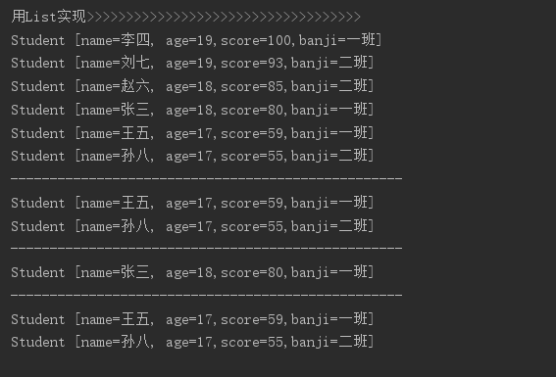

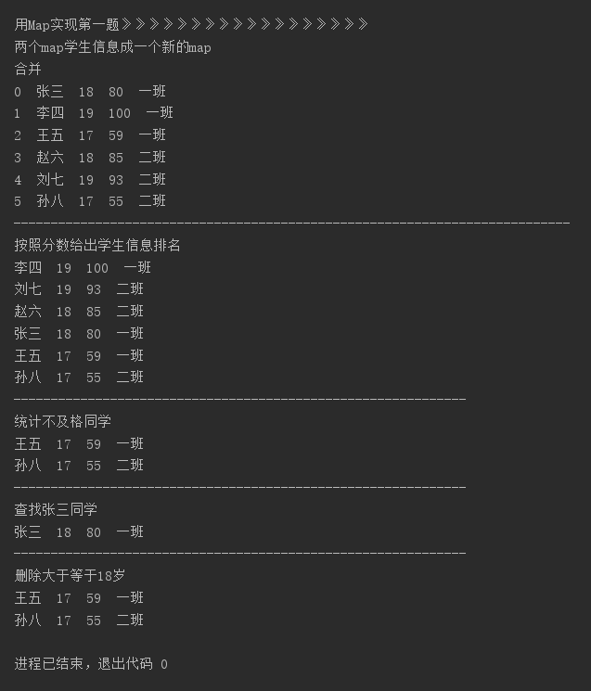

运行代码：

package Study1;

import java.util.ArrayList;

import java.util.Comparator;

import java.util.List;

import java.util.Collections;

import java.util.Map;

import java.util.HashMap;

/**

* 2020年3月4日作业

*chenjinglun

* 2020年3月4日20:52:58

*/

public class Test5 {

public static void main(String[] args) {

List<Student> list = new ArrayList<>();

Student S01 = new Student("张三", 18, 80, "一班");

Student S02 = new Student("李四", 19, 100, "一班");

Student S03 = new Student("王五", 17, 59, "一班");

list.add(S01);

list.add(S02);

list.add(S03);

List<Student> list1 = new ArrayList<>();

Student S04 = new Student("赵六", 18, 85, "二班");

Student S05 = new Student("刘七", 19, 93, "二班");

Student S06 = new Student("孙八", 17, 55, "二班");

list1.add(S04);

list1.add(S05);

list1.add(S06);

System.out.println("用List实现>>>>>>>>>>>>>>>>>>>>>>>>>>>>>>>>>>>");

list.addAll(list1);

Collections.sort(list, new Comparator<Student>() {

@Override

public int compare(Student stu1, Student stu2) {

return stu2.getScore()-stu1.getScore();

}

});

for(int i=0;i<list.size();i++){

System.out.println(list.get(i));

}

System.out.println("--------------------------------------------------");

for(int i=0;i<list.size();i++){

if(list.get(i).score < 60){

System.out.println(list.get(i));

}

}

System.out.println("--------------------------------------------------");

for(int i=0;i<list.size();i++){

if(list.get(i).name.equals("张三")){

System.out.println(list.get(i));

}

}

System.out.println("--------------------------------------------------");

List<Integer>cont = new ArrayList<>();

int count = 0;

for(int i = 0; i<list.size(); i++){

if (list.get(i).getAge() >= 18){

list.get(i).setAge(-1);

count++;

}

}

while(count>0){

for(int i = 0;i<list.size();i++){

if(list.get(i).getAge() == -1){

list.remove(i);

count--;

break;

}

}

}

for(int i = 0;i<list.size();i++){

System.out.println(list.get(i).toString());

}

System.out.println();

System.out.println("用Map实现第一题》》》》》》》》》》》》》》》》》》");

String []name = new String[]{"张三","李四","王五","赵六","刘七","孙八"}; //名字

int []age = new int[]{18,19,17,18,19,17}; //年龄

int []grade = new int []{80,100,59,85,93,55}; //成绩

String []class_ = new String []{"一班","一班","一班","二班","二班","二班"}; //成班级

//创建Map

Map<Integer,Student>map1 = new HashMap<Integer,Student>();

Map<Integer,Student>map2 = new HashMap<Integer,Student>();

for(int i = 0;i<name.length;i++){

Student temp = new Student();

temp.setAge(age[i]);

temp.setBanji(class_[i]);

temp.setName(name[i]);

temp.setScore(grade[i]);

if(i <name.length/2){

map1.put(i,temp);

}

else{

map2.put(i,temp);

}

}

System.out.println("两个map学生信息成一个新的map");

Map<Integer,Student>map_combine = new HashMap<>();

map_combine.putAll(map1);

map_combine.putAll(map2);

System.out.println("合并");

for(Map.Entry<Integer,Student>entry :map_combine.entrySet()){

System.out.print(entry.getKey()+" ");

System.out.println(entry.getValue().getName()+" "+entry.getValue().getAge()+" "+entry.getValue().getScore()+" "+entry.getValue().getBanji());

}

System.out.println("---------------------------------------------------------------------------");

System.out.println("按照分数给出学生信息排名");

int temp = 0;

double min = -1;

List<Integer>count1 = new ArrayList<>();

boolean control = false;

for(int i = 0;i < map_combine.size();i++){

temp = 0;

for(int j = 0;j < map_combine.size();j++){

control = false;

//先判断是否已经处理过

for(int k = 0;k < count1.size();k++){

if(j == count1.get(k)){

control = true;

break;

}

}

if(map_combine.get(j).getScore() > min && !control){

temp = j;

min = map_combine.get(j).getScore();

}

}

System.out.println(map_combine.get(temp).getName()+" "+map_combine.get(temp).getAge()+" "+map_combine.get(temp).getScore()+" "+map_combine.get(temp).getBanji());

//处理标记

count1.add(temp);

min = -1;

}

System.out.println("-------------------------------------------------------------");

System.out.println("统计不及格同学");

for(int i = 0;i< map_combine.size();i++){

if(map_combine.get(i).getScore()<60){

System.out.println(map_combine.get(i).getName()+" "+map_combine.get(i).getAge()+" "+map_combine.get(i).getScore()+" "+map_combine.get(i).getBanji());

}

}

System.out.println("-------------------------------------------------------------");

System.out.println("查找张三同学");

String name1 = "张三";

for(int i = 0;i< map_combine.size();i++){

if(map_combine.get(i).getName().equals(name1)){

System.out.println(map_combine.get(i).getName()+" "+map_combine.get(i).getAge()+" "+map_combine.get(i).getScore()+" "+map_combine.get(i).getBanji());

}

}

System.out.println("-------------------------------------------------------------");

System.out.println("删除大于等于18岁");

for(int i = 0;i< map_combine.size();i++){

if(map_combine.get(i).getAge() < 18){

System.out.println(map_combine.get(i).getName()+" "+map_combine.get(i).getAge()+" "+map_combine.get(i).getScore()+" "+map_combine.get(i).getBanji());

}

}

}

}

class Student{

/**

* 姓名

*/

protected String name;

/**

* 年龄

*/

protected int age;

/**

* 成绩

*/

protected int score;

/**

* 班级

*/

protected String banji;

public Student(String name, int age, int score, String banji){

this.name = name;

this.age = age;

this.score = score;

this.banji = banji;

}

public Student(){

}

public String getName(){

return name;

}

public void setName(String name){

this.name = name;

}

public int getAge(){

return age;

}

public void setAge(int age){

this.age = age;

}

public int getScore(){

return score;

}

public void setScore(int score){

this.score = score;

}

public String getBanji() {

return banji;

}

public void setBanji(String banji) {

this.banji = banji;

}

public String toString() {

return "Student [name=" + name + ", age=" + age + ",score=" + score +",banji=" + banji +"]";

}

}

3.仿照手机淘宝，设计订单和商品的实体类

有点思路，不是很会

class Tbao {

private String goodNumber;{

//商品名单

}

private String yonghumingzi;{

}//用户昵称

private String []photo{

//商品图片

}

private String descrption{

//商品描述

}

private int buyertotal{

//付款人数

}

private int counter{

//折扣

}

private String saleTime{

//卖出时间

}

private int saleNu{

//卖出数量

}

private double price{

//价格

}

private int kucun{

//库存

}

}