Mysql练习题2

1. 从student表中查询每个院系有多少人

**原表：**

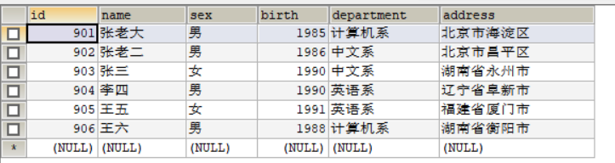

**SELECT department, COUNT(*) AS '人数' FROM student GROUP BY department;**

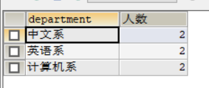

1. 从score表中查询每个科目的最高分

**原表：**

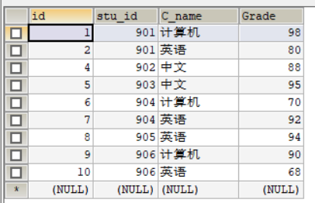

**SELECT C_name,MAX(Grade) FROM score GROUP BY C_name;**

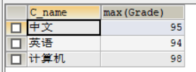

1. 查询李四的考试科目（c_name）和考试成绩（grade）

**SELECT NAME,C_name,Grade**

**FROM student s,score sc**

**WHERE s.id=sc.stu_id AND NAME='李四';**

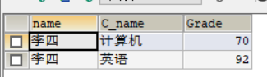

1. 计算每个学生的总成绩

**SELECT NAME,SUM(Grade)**

**FROM student s,score sc**

**WHERE s.id=sc.stu_id**

**GROUP BY NAME;**

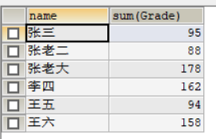

1. 计算每个考试科目的平均成绩

**SELECT s.department,AVG(sc.Grade) AS '平均分'**

**FROM student s,score sc**

**WHERE s.id=sc.stu_id**

**GROUP BY s.department**

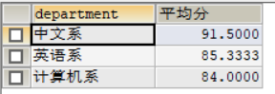

1. 查询计算机成绩低于95的学生信息

**SELECT s.name,s.sex,s.birth,s.department,s.address,sc.Grade**

**FROM student s,score sc**

**WHERE s.id=sc.stu_id AND sc.C_name='计算机' AND sc.Grade<95;**

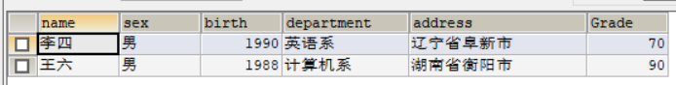

1. 查询同时参加计算机和英语考试的学生的信息

**SELECT s.name,s.sex,s.birth,s.department,s.address,sc.C_name,sc.Grade**

**FROM student s,score sc**

**WHERE s.id=sc.stu_id AND C_name IN('计算机','英语')**

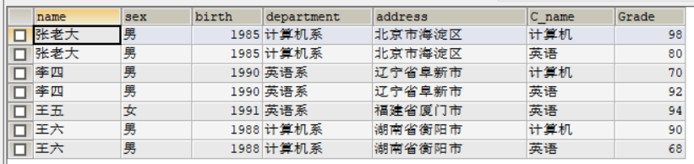

1. 将计算机考试成绩按从高到低进行排序

**select * from score where C_name='计算机' order by Grade desc；**

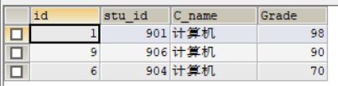

1. 查询姓张或者姓王的同学的姓名、院系和考试科目及成绩

**SELECT s.name,s.department,sc.C_name,sc.Grade**

**FROM student s,score sc**

**WHERE s.id=sc.stu_id AND s.name LIKE '张%' OR '王%'**；

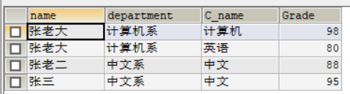

1. 查询都是湖南的学生的姓名、年龄、院系和考试科目及成绩

**SELECT s.name,2020-s.birth AS '年龄',s.department,sc.C_name,sc.Grade**

**FROM student s,score sc**

**WHERE s.id=sc.stu_id AND s.address LIKE '湖南%'**

