Mysql练习题2

1. 从student表中查询每个院系有多少人

SELECT COUNT(Department) AS '人数',Department AS '院系'

FROM student

GROUP BY Department

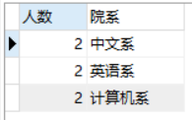

1. 从score表中查询每个科目的最高分

SELECT MAX(Grade) AS '最高分',C_name AS '科目'

FROM score

GROUP BY C_name

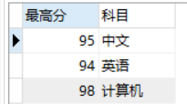

1. 查询李四的考试科目（c_name）和考试成绩（grade）

SELECT sc.C_name,sc.Grade

FROM student

AS st,score AS sc

WHERE st.Id=sc.Stu_id

AND st.Name='李四'

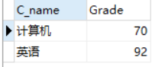

1. 计算每个学生的总成绩

SELECT SUM(Grade)AS '总成绩',

st.Name AS '姓名'

FROM score as sc,student AS st

WHERE st.Id=sc.Stu_id

GROUP BY st.Name

ORDER BY 总成绩 DESC

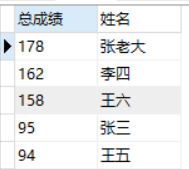

1. 计算每个考试科目的平均成绩

SELECT AVG(Grade)AS '平均成绩',

C_name AS '科目'

FROM score

GROUP BY score.C_name

ORDER BY 平均成绩 DESC

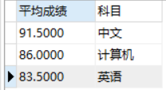

1. 查询计算机成绩低于95的学生信息

SELECT *

FROM student st,score sc

WHERE Grade<95

AND st.Id=sc.Stu_id

AND C_name='计算机'



1. 查询同时参加计算机和英语考试的学生的信息

SELECT a.*

FROM student a ,score b ,score c

WHERE a.id=b.stu_id

AND b.c_name='计算机'

AND a.id=c.stu_id

AND c.c_name='英语';

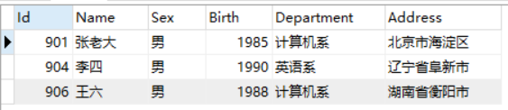

1. 将计算机考试成绩按从高到低进行排序

SELECT Stu_id as '学号',

C_name as '课程',

Grade AS'成绩'

FROM score

WHERE C_name='计算机'

ORDER BY Grade DESC

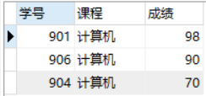

1. 查询姓张或者姓王的同学的姓名、院系和考试科目及成绩

SELECT st.`Name` '姓名',

st.Department '院系',

sc.C_name '考试科目',

sc.Grade '成绩'

from score as sc INNER JOIN student as st

ON sc.Stu_id=St.Id

where

st.`Name` like '张%' or st.name like '王%'

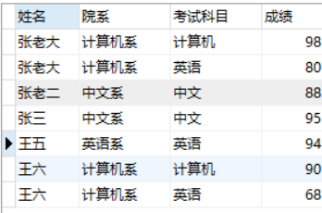

1. 查询都是湖南的学生的姓名、年龄、院系和考试科目及成绩

SELECT st.Name AS'姓名',

(2020-st.Birth) AS'年龄',

st.Department AS'院系',

sc.C_name AS'考试科目',

sc.Grade AS '成绩'

from score sc,student st

where sc.Stu_id=St.Id

AND st.Address LIKE'湖南%'

GROUP BY st.Id

