**Mysql练习题2**

#1.从 student 表中查询每个系有多少人

SELECT Department '系别', COUNT(Department) '人数'

FROM Student

GROUP BY Department;



#2.从 score 表中查询每个科目的最高分

SELECT C_name '科目', MAX(Grade) '最高分'

FROM Score

GROUP BY C_name;

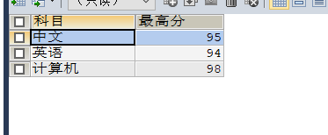

#3.查询李四的考试科目（C_name）和考试成绩（grade）

SELECT Stu.name '名字', C_name '科目', Grade '成绩'

FROM Student Stu, Score Sco

WHERE Stu.name = '李四'

AND Stu.id = Sco.Stu_id;

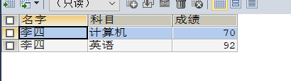

#4.计算每个学生的总成绩

SELECT Stu.name '名字', SUM(Sco.Grade) '总成绩'

FROM Student Stu, Score Sco

WHERE Stu.id = Sco.Stu_id

GROUP BY Stu.name;



#5.计算每个考试科目的平均成绩

SELECT C_name '科目', AVG(Grade) '平均成绩'

FROM Score

GROUP BY C_name;

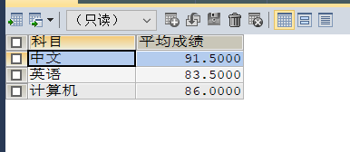

#6.查询计算机成绩低于 95 的学生信息

SELECT Stu.id '学号', NAME '姓名', Sex '性别', Birth '出生日期',

Department '系别', C_name '科目', Grade '成绩', Address '地址'

FROM Student Stu, Score Sco

WHERE Stu.id = Sco.Stu_id

AND Grade < 95

AND C_name = '计算机';

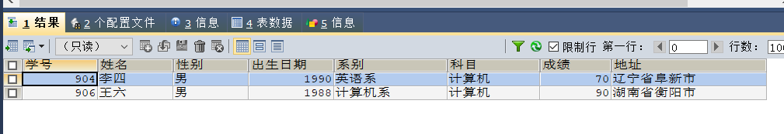

#7.查询同时参加计算机和英语考试的学生的信息

SELECT Stu.id '学号', NAME '姓名', Sex '性别', Birth '出生日期', Address '地址'

FROM Student Stu, Score Sco1, Score Sco2

WHERE Stu.id = Sco1.Stu_id

AND stu.id = Sco2.Stu_id

AND Sco1.C_name = '计算机'

AND Sco2.C_name = '英语';



#8.将计算机考试成绩按从高到低进行排序

SELECT Stu.id '学号', Stu.name '姓名', Grade '成绩', C_name '科目'

FROM Student Stu, Score Sco

WHERE Stu.id = Sco.Stu_id

AND C_name = '计算机'

ORDER BY Grade DESC;



#9.查询姓张或者姓王的同学的姓名、院系、考试科目及成绩

SELECT NAME '姓名', Department '院系', C_name '考试科目', Grade '成绩'

FROM Student Stu, Score Sco

WHERE Stu.id = Sco.Stu_id

AND (NAME LIKE '张%'

OR NAME LIKE '王%');

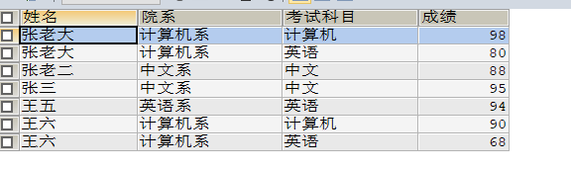

#10.查询都是湖南的学生的姓名、年龄、院系和考试科目及成绩

SELECT NAME '姓名', (YEAR(NOW())-Birth) '年龄', Department '院系',

C_name '考试科目', Grade '成绩'

FROM Student Stu, Score Sco

WHERE Stu.id = Sco.Stu_id

AND Address LIKE '湖南省%';

