Mysql练习题2

**Student表的数据**

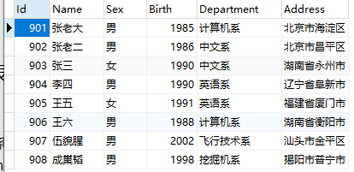

**Score表的数据**

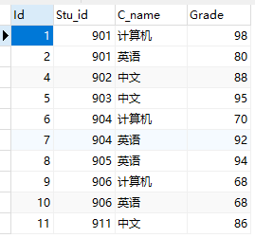

## 1.从student表中查询每个院系有多少人

SELECT

Department '院系',

COUNT(Department) '总人数'

FROM

student

GROUP BY

Department;



## 2.从score表中查询每个科目的最高分

SELECT

C_name '院系',

MAX(Grade) '最高分'

FROM

score

GROUP BY

Grade;

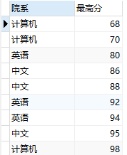

## 3.查询李四的考试科目（c_name）和考试成绩（grade）

SELECT

stu.`Name` '姓名',

sc.C_name '科目',

sc.Grade '成绩'

FROM

student stu

INNER JOIN score sc ON stu.Id = sc.Stu_id

AND stu.`Name` = '李四';

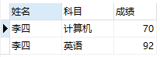

## 4.计算每个学生的总成绩

SELECT

stu.`Name` '姓名',

stu.Department '院系',

SUM(sc.Grade) '总成绩'

FROM

score sc

INNER JOIN

student stu ON stu.Id = sc.Stu_id

GROUP BY

sc.Grade;

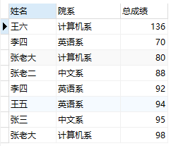

## 5.计算每个考试科目的平均成绩

SELECT

C_name '科目',

AVG(Grade) '平均成绩'

FROM

score

GROUP BY

C_name;

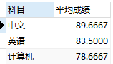

## 6.查询计算机成绩低于95的学生信息

SELECT

stu.Id '学号',

stu.`Name` '姓名',

stu.Sex '性别',

stu.Birth '出生年',

stu.Department '院系',

stu.Address '家庭住址',

sc.C_name '科目',

sc.Grade '成绩'

FROM

score sc,

student stu

WHERE

sc.Grade < 95

AND sc.C_name = '计算机'

AND stu.Id = sc.Stu_id;

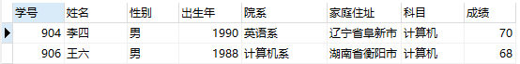

## 7.查询同时参加计算机和英语考试的学生的信息

SELECT

stu.Id '学号',

stu.`Name` '姓名',

stu.Sex '性别',

stu.Birth '出生年',

stu.Department '院系',

stu.Address '家庭住址',

a.Grade '计算机成绩',

b.Grade '英语成绩'

FROM

score a,

score b,

student stu

WHERE

a.C_name = '计算机'

AND b.C_name = '英语'

AND a.Stu_id = b.Stu_id

AND stu.Id = a.Stu_id;

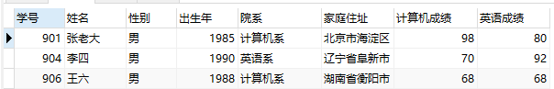

## 8.将计算机考试成绩按从高到低进行排序

SELECT

C_name '科目',

Grade '计算机成绩排名'

FROM

score

WHERE

C_name = '计算机'

ORDER BY

Grade DESC;

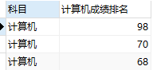

## 9.查询姓张或者姓王的同学的姓名、院系和考试科目及成绩

#方法1

SELECT

stu.`姓名`,

stu.`院系`,

sc.C_name '科目',

sc.Grade '成绩'

FROM

( SELECT Id, `Name` '姓名', Department '院系' FROM student WHERE `Name` LIKE '张%' OR `Name` LIKE '王%' ) stu

LEFT JOIN score sc ON sc.Stu_id = stu.Id;

#方法2

SELECT

stu.`Name` '姓名',

stu.Department '院系',

sc.C_name '科目',

sc.Grade '成绩'

FROM

student stu

INNER JOIN score sc ON sc.Stu_id = stu.Id

AND (stu.`Name` LIKE '张%' OR stu.`Name` LIKE '王%');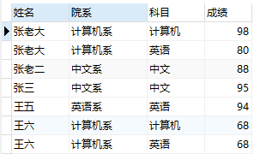

## 10.查询都是湖南的学生的姓名、年龄、院系和考试科目及成绩

#方法1

SELECT

stu.`姓名`,

stu.`院系`,

stu.`家庭住址`,

sc.C_name '科目',

sc.Grade '成绩'

FROM

( SELECT Id, `Name` '姓名', Department '院系', Address '家庭住址' FROM student WHERE `Address` LIKE '湖南省%' ) stu

LEFT JOIN score sc ON sc.Stu_id = stu.Id;

#方法2

SELECT

stu.`Name` '姓名',

stu.Department '院系',

stu.Address '家庭住址',

sc.C_name '科目',

sc.Grade '成绩'

FROM

student stu

INNER JOIN score sc ON sc.Stu_id = stu.Id

AND stu.Address LIKE '湖南省%';