Mysql练习题2

1. 从student表中查询每个院系有多少人

select department '院系',count(*) '人数' from student group by department;

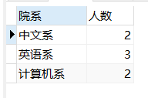

1. 从score表中查询每个科目的最高分

select C_name '科目',max(Grade) '最高分' from score group by C_name;

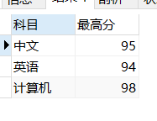

1. 查询李四的考试科目（c_name）和考试成绩（grade）

Select

stu.name '姓名',

sc.C_name '科目',

sc.Grade '成绩'

from

student stu,score sc

where

stu.id = sc.stu_id

and

stu.name = '李四'

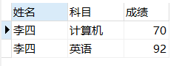

1. 计算每个学生的总成绩

select

name '姓名',

sum(Grade) '总成绩'

from

student stu,score sc

where

stu.id = sc.stu_id

Group by

stu.name

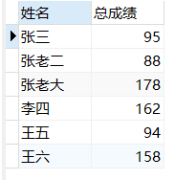

1. 计算每个考试科目的平均成绩

select

sc.C_name '科目',

avg(Grade) '总成绩'

from

student stu,score sc

where

stu.id = sc.stu_id

Group by

sc.C_name

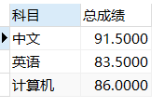

1. 查询计算机成绩低于95的学生信息

select

stu.name '姓名',

sc.stu_id '学号',

stu.sex '性别',

stu.Birth '生日',

stu.department '院系'

from

student stu,score sc

where

stu.id = sc.stu_id

and

sc.Grade < 95

and

sc.C_name = '计算机'

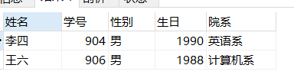

1. 查询同时参加计算机和英语考试的学生的信息

select DISTINCT

stu.name '姓名',

sc.stu_id '学号',

stu.sex '性别',

stu.Birth '生日',

stu.department '院系'

from

student stu,score sc

where

stu.id = sc.stu_id

and

sc.C_name in('计算机','英语')

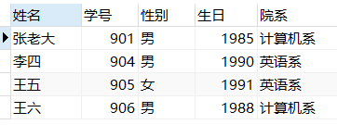

1. 将计算机考试成绩按从高到低进行排序

select DISTINCT

stu.name '姓名',

sc.C_name'科目',

sc.Grade '成绩'

from

student stu,score sc

where

stu.id = sc.stu_id

and

sc.C_name = '计算机'

order by Grade desc

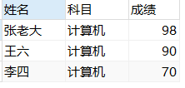

1. 查询姓张或者姓王的同学的姓名、院系和考试科目及成绩

select DISTINCT

stu.name '姓名',

stu.department '院系',

sc.C_name'科目',

sc.Grade '成绩'

from

student stu,score sc

where

stu.id = sc.stu_id

and

(stu.name like'张%' or stu.name like '李%')

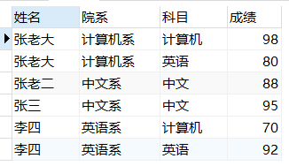

1. 查询都是湖南的学生的姓名、年龄、院系和考试科目及成绩

select DISTINCT

stu.name '姓名',

year(now())-stu.Birth '年龄',

stu.department '院系',

sc.C_name'科目',

sc.Grade '成绩'

from

student stu,score sc

where

stu.id = sc.stu_id

and

stu.address like '湖南%'

