Mysql练习题2

1. 从student表中查询每个院系有多少人

SELECT

Department,

COUNT(*) '人数'

FROM

student

GROUP BY

Department;

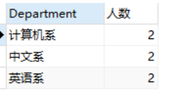

1. 从score表中查询每个科目的最高分

SELECT

C_name,

MAX(Grade) '最高分'

FROM

score

GROUP BY

C_name

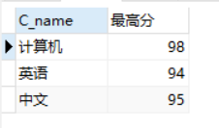

1. 查询李四的考试科目（c_name）和考试成绩（grade）

SELECT

NAME,

C_name,

Grade

FROM

student st,

score sc

WHERE

st.Id = sc.Stu_id

AND st. NAME = '李四'

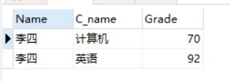

1. 计算每个学生的总成绩

SELECT

NAME,

SUM(Grade) '总成绩'

FROM

student st,

score sc

WHERE

st.Id = sc.Stu_id

GROUP BY

st.name

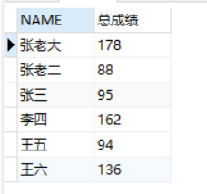

1. 计算每个考试科目的平均成绩

SELECT

C_name,

AVG(Grade) '平均成绩'

FROM

score

GROUP BY

C_name

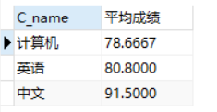

1. 查询计算机成绩低于95的学生信息

SELECT

*

FROM

student st,

score sc

WHERE

st.Id = sc.Stu_id

AND

sc.Grade<95

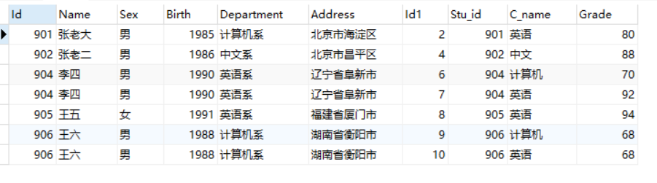

1. 查询同时参加计算机和英语考试的学生的信息

SELECT

*

FROM

student st,

score sc

WHERE

st.Id = sc.Stu_id

AND

Name

in

(SELECT

Name

FROM

student st,

score sc

WHERE

st.Id = sc.Stu_id

AND

C_name='计算机')

AND

Name

in

(SELECT

Name

FROM

student st,

score sc

WHERE

st.Id = sc.Stu_id

AND

C_name='英语')

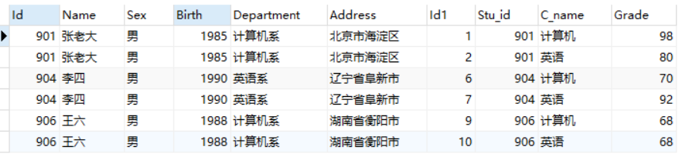

1. 将计算机考试成绩按从高到低进行排序

SELECT

C_name,Grade

FROM

score

WHERE

C_name='计算机'

ORDER BY

Grade DESC

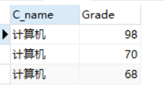

1. 查询姓张或者姓王的同学的姓名、院系和考试科目及成绩

SELECT

name,

Department,

C_name,

Grade

FROM

student st,

score sc

WHERE

st.Id = sc.Stu_id

AND

(Name

LIKE

'张%'

OR

Name

LIKE

'王%')

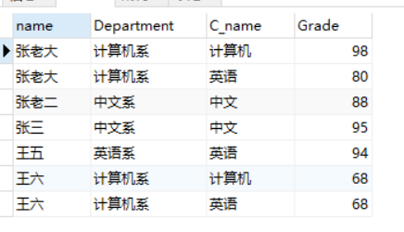

1. 查询都是湖南的学生的姓名、年龄、院系和考试科目及成绩

SELECT

Name,

2020-Birth

AS

'年龄',

Department,

C_name,

Grade

FROM

student st,

score sc

WHERE

st.Id = sc.Stu_id

AND

Address

LIKE

'湖南%'

