-- 1.从student表中查询每个院系有多少人

SELECT

Department AS '院系名称',

COUNT(Department) AS '院系人数'

FROM

student

GROUP BY

Department

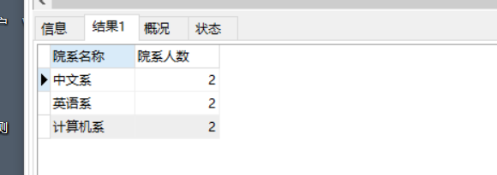

-- 2.从score表中查询每个科目的最高分

SELECT C_name,max(Grade)AS '最高分' FROM score GROUP BY C_name

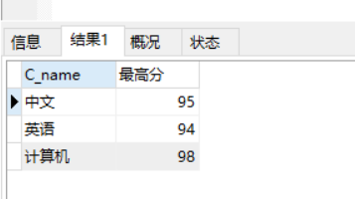

-- 3.查询李四的考试科目（c_name）和考试成绩（grade）

SELECT

student.`Name`,

C_name,

Grade

FROM

student,

score

WHERE

student.id = score.Stu_id

AND student.`Name` = '李四'

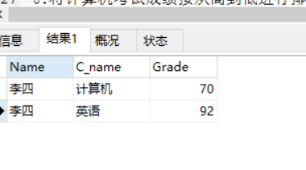

-- 4.计算每个学生的总成绩

SELECT

student.`Name`,

SUM(score.Grade) AS '总分'

FROM

student

LEFT JOIN score ON student.Id = score.Stu_id

GROUP BY

student.`Name`

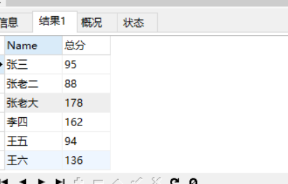

-- 5.计算每个考试科目的平均成绩

SELECT

C_name,

AVG(Grade)AS '平均分'

FROM

score

GROUP BY

C_name

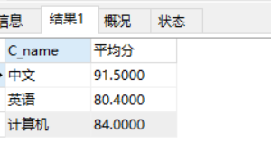

-- 6.查询计算机成绩低于95的学生信息

SELECT

*

FROM

student

LEFT JOIN score ON student.Id = score.Stu_id

WHERE

score.C_name = '计算机'

AND score.Grade < 95

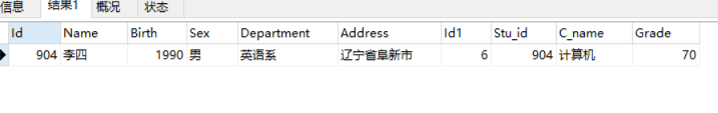

-- 7.查询同时参加计算机和英语考试的学生的信息

SELECT

`Name`

FROM

student,

score,

score sc

WHERE

student.Id = score.Stu_id

AND score.C_name = '计算机'

AND sc.C_name = '英语'

GROUP BY

student.`Name`

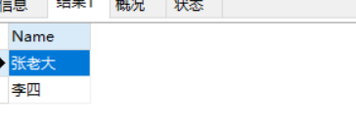

-- 8.将计算机考试成绩按从高到低进行排序

SELECT

*

FROM

score

WHERE

C_name='计算机'

ORDER BY

Grade ASC

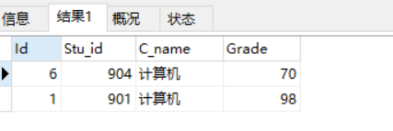

-- 9.查询姓张或者姓王的同学的姓名、院系和考试科目及成绩

SELECT

`Name`,

Department,

C_name,

Grade

FROM

student

LEFT JOIN score ON student.id = score.Stu_id

WHERE

NAME LIKE '张%'

OR '王%'

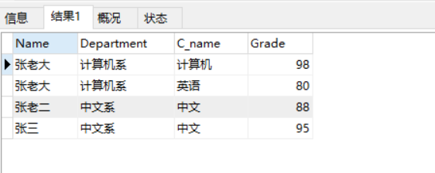

-- 10.查询都是湖南的学生的姓名、年龄、院系和考试科目及成绩

SELECT

`Name`,

Department,

student.Address,

C_name,

Grade

FROM

student

LEFT JOIN score ON student.id = score.Stu_id

WHERE

Address LIKE '湖南%'

