Mysql练习题2

1. 从student表中查询每个院系有多少人

SELECT

department '院系',

COUNT( * ) '人数'

FROM

student

GROUP BY

department

运行结果：

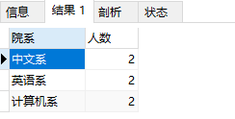

1. 从score表中查询每个科目的最高分

SELECT

c_name '课程名',

max( grade ) '最高分'

FROM

score

GROUP BY

c_name

运行结果：

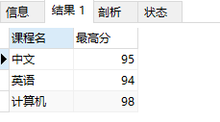

1. 查询李四的考试科目（c_name）和考试成绩（grade）

SELECT NAME

'姓名',

c_name '科目',

grade '成绩'

FROM

student st

INNER JOIN score sc ON st.id = sc.stu_id

WHERE

NAME = '李四'

运行结果：

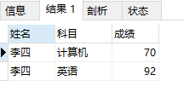

1. 计算每个学生的总成绩

SELECT NAME

'姓名',

sum( grade ) '总成绩'

FROM

student st

LEFT JOIN score sc ON st.id = sc.stu_id

GROUP BY

stu_id

运行结果：

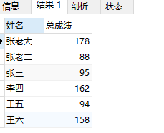

1. 计算每个考试科目的平均成绩

SELECT

c_name '科目',

AVG( grade ) '平均分'

FROM

score

GROUP BY

c_name

运行结果：

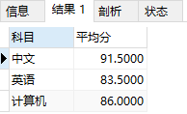

1. 查询计算机成绩低于95的学生信息

SELECT

st.id '学号',

NAME '姓名',

sex '性别',

birth '出生年份',

department '院系',

address '住址',

c_name '考试科目',

grade '成绩'

FROM

student st,

score sc

WHERE

st.id = stu_id

AND sc.c_name = '计算机'

AND sc.grade < 95

运行结果：

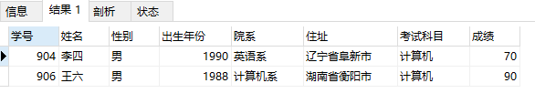

1. 查询同时参加计算机和英语考试的学生的信息

SELECT

st.id '学号',

NAME '姓名',

sex '性别',

birth '出生年份',

department '院系',

address '住址',

sc.c_name '考试科目',

sc.grade '成绩',

sc_e.c_name '考试科目',

sc_e.grade '成绩'

FROM

( SELECT * FROM score WHERE c_name = '计算机' ) sc

LEFT JOIN ( SELECT * FROM score WHERE c_name = '英语' ) sc_e ON sc.stu_id = sc_e.stu_id

LEFT JOIN student st ON st.id = sc.stu_id

运行结果：

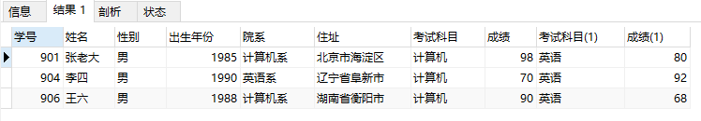

1. 将计算机考试成绩按从高到低进行排序

SELECT

stu_id '学号',

c_name '科目',

grade '成绩'

FROM

score

WHERE

c_name = '计算机'

ORDER BY

grade DESC

运行结果：

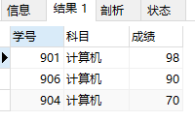

1. 查询姓张或者姓王的同学的姓名、院系和考试科目及成绩

SELECT NAME

'姓名',

department '院系',

c_name '考试科目',

grade '成绩'

FROM

student st

INNER JOIN score sc ON st.id = sc.stu_id

WHERE

NAME LIKE '张%'

OR NAME LIKE '王%'

运行结果：

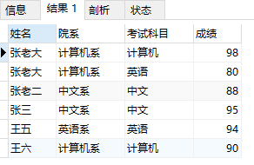

1. 查询都是湖南的学生的姓名、年龄、院系和考试科目及成绩

SELECT

NAME '姓名',

2012-birth '年龄',

department '院系',

address '住址',

c_name '考试科目',

grade '成绩'

FROM

student st

INNER JOIN score sc ON st.id = sc.stu_id

WHERE

address LIKE '湖南%'

运行结果：

