Mysql练习题2

1. 从student表中查询每个院系有多少人

SELECT

count( * ) '人数',

Department '院系'

FROM

student

GROUP BY

Department

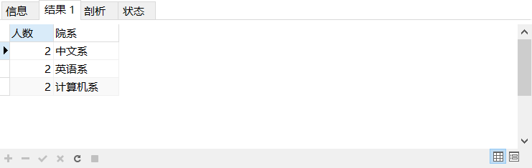

1. 从score表中查询每个科目的最高分

SELECT

max(grade) '最高分',

Cname '科目'

FROM

score

GROUP BY

cname

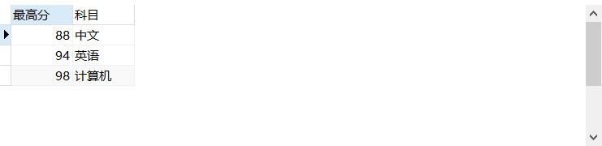

1. 查询李四的考试科目（c_name）和考试成绩（grade）

SELECT

name '名字',

Cname '科目' ,

grade '成绩'

FROM

score a,student b

where

stuid = b.id

and b.name = '李四'

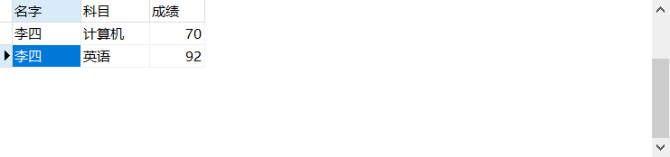

1. 计算每个学生的总成绩

SELECT

name '名字',

sum(grade) '成绩'

FROM

score a,student b

where

stuid = b.id

GROUP BY

name

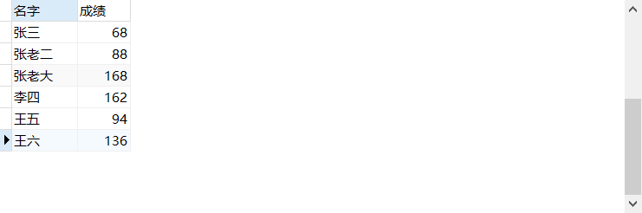

1. 计算每个考试科目的平均成绩

SELECT

Department '科目',

avg(grade) '平均成绩'

FROM

score a,student b

where

stuid = b.id

GROUP BY

Department

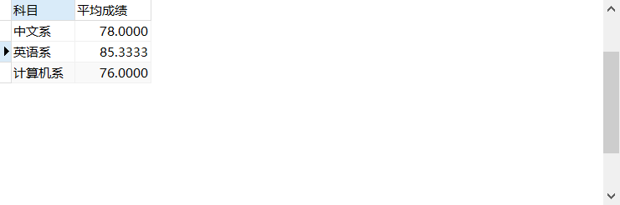

1. 查询计算机成绩低于95的学生信息

SELECT

name '名字',

cname '科目',

grade '成绩'

FROM

score a,student b

where

stuid = b.id

and Cname = '计算机'

and grade < 95

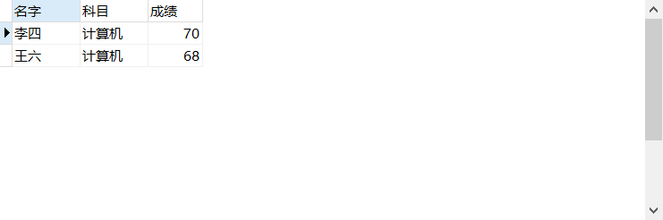

1. 查询同时参加计算机和英语考试的学生的信息

SELECT

a.*

FROM

score s

INNER JOIN ( SELECT st.* FROM student st INNER JOIN score sc ON st.id = sc.stuid WHERE sc.cname = '计算机' ) a ON s.stuid = a.id

WHERE

s.cname = '英语';

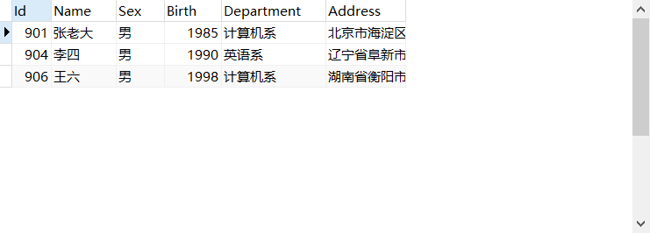

1. 将计算机考试成绩按从高到低进行排序

SELECT

name '名字',

cname '科目',

grade '成绩'

FROM

score a,student b

where

stuid = b.id

and Cname = '计算机'

ORDER BY grade desc

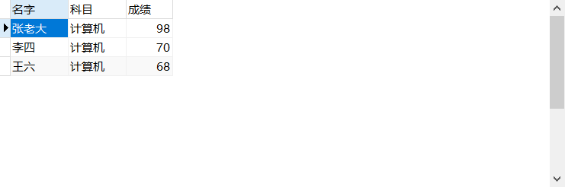

1. 查询姓张或者姓王的同学的姓名、院系和考试科目及成绩

SELECT NAME

'名字',

Department '院系',

cname '科目',

grade '成绩'

FROM

score a,

student b

WHERE

stuid = b.id

AND NAME LIKE '张%'

OR NAME LIKE '王%'

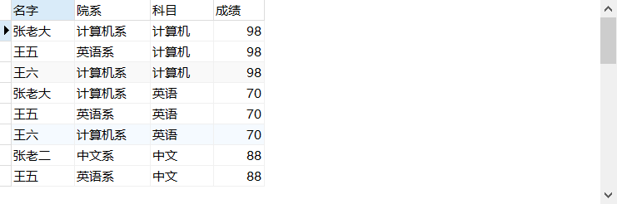

1. 查询都是湖南的学生的姓名、年龄、院系和考试科目及成绩

SELECT

NAME '名字',

YEAR ( CurDate( ) ) - birth '年龄',

Department '院系',

cname '科目',

grade '成绩'

FROM

student a

JOIN score b ON a.Id = Stuid

WHERE

Address LIKE '湖南%'

