Mysql练习题2

1. 从student表中查询每个院系有多少人

SELECT

Department,

COUNT(id) '人数'

FROM

student

GROUP BY Department ;

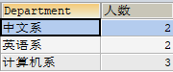

1. 从score表中查询每个科目的最高分

SELECT

C_name '科目',

MAX(grade) '最高分'

FROM

score

GROUP BY C_name ;

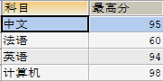

1. 查询李四的考试科目（c_name）和考试成绩（grade）

SELECT

stu.`NAME`,

sc.`C_name`,

sc.`Grade`

FROM

score sc,

student stu

WHERE

sc.`Stu_id` = stu.`id`

AND stu.`NAME` = '李四';



1. 计算每个学生的总成绩

SELECT

stu.`NAME` '姓名',

SUM(sc.`Grade`) '总分'

FROM

score sc,

student stu

WHERE

sc.`Stu_id` = stu.`id`

GROUP BY stu.`NAME`;

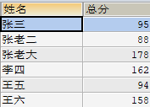

1. 计算每个考试科目的平均成绩

SELECT

C_name '科目',

AVG(Grade) '平均成绩'

FROM

score

GROUP BY C_name;

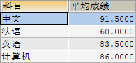

1. 查询计算机成绩低于95的学生信息

SELECT

stu.`NAME`,

sc.`C_name`,

sc.`Grade`

FROM

score sc,

student stu

WHERE

sc.`Stu_id` = stu.`id`

AND sc.`Grade` < 95

AND sc.`C_name` = '计算机';



1. 查询同时参加计算机和英语考试的学生的信息

SELECT

a.*

FROM

(SELECT

stu.`NAME`,

stu.`id`,

stu.`Sex`,

stu.`Address`,

stu.`birth`,

stu.`Department`,

sc.`C_name`

FROM

score sc,

student stu

WHERE sc.`Stu_id` = stu.`id`

AND sc.`C_name` IN ('计算机', '英语')) a

WHERE a.name IN ('张老大', '李四', '王六') ;

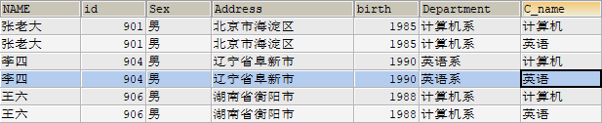

1. 将计算机考试成绩按从高到低进行排序

SELECT

stu.`NAME`,

stu.`id`,

stu.`Sex`,

stu.`Address`,

stu.`birth`,

stu.`Department`,

sc.`C_name`,

sc.grade '计算机成绩'

FROM

student stu ,

(SELECT Stu_id,C_name,grade FROM score WHERE C_name = '计算机') sc

WHERE

sc.`Stu_id` = stu.`id`

ORDER BY sc.grade DESC;

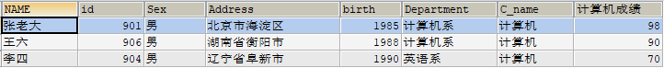

1. 查询姓张或者姓王的同学的姓名、院系和考试科目及成绩

SELECT

stu.`NAME` '姓名',

stu.`Department` '院系',

sc.`C_name` '考试科目',

sc.`Grade` '成绩'

FROM

score sc,

student stu

WHERE

sc.`Stu_id` = stu.`id`

AND (stu.`NAME` LIKE '张%'

OR stu.`NAME` LIKE '王%');

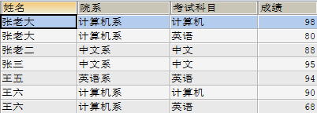

10.查询都是湖南的学生的姓名、年龄、院系和考试科目及成绩

SELECT

stu.Address '地址',

stu.`NAME` '姓名',

2020 - stu.`birth` '年龄',

stu.`Department` '院系',

sc.`C_name` '考试科目',

sc.`Grade` '成绩'

FROM

score sc,

student stu

WHERE

sc.`Stu_id` = stu.`id`

AND stu.`Address` LIKE '%湖南%';

