Mysql练习题2

1. 从student表中查询每个院系有多少人

select Department as '院系', count(Department) as '人数' from student group by Department;

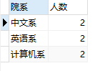

1. 从score表中查询每个科目的最高分

select Stu_id as '学号', C_name as '科目', max(Grade) as '分数' from score group by C_name;

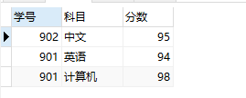

1. 查询李四的考试科目（c_name）和考试成绩（grade）

select sc.C_name, sc.Grade from student stu, score sc where stu.Id = sc.Stu_id and stu.Name = '李四';

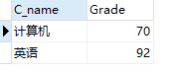

1. 计算每个学生的总成绩

select stu.Name '姓名', sum(sc.Grade) '总分' from student stu, score sc where stu.Id = sc.Stu_id group by stu.Name;

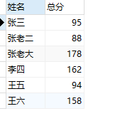

1. 计算每个考试科目的平均成绩

select sc.C_name '科目', avg(sc.Grade) '平均分' from student stu, score sc where stu.Id = sc.Stu_id group by sc.C_name;

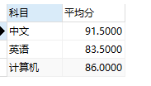

1. 查询计算机成绩低于95的学生信息

select stu.Id, stu.Name, stu.Sex, stu.Brith, stu.Department, stu.Address, stu.Age, sc.C_name, sc.Grade from student stu, score sc where stu.Id = sc.Stu_id and sc.C_name = '计算机' and sc.Grade < 95;

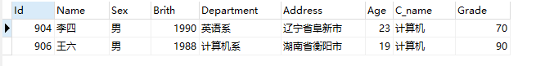

1. 查询同时参加计算机和英语考试的学生的信息

select stu.Name, stu.Sex, stu.Brith, stu.Department, stu.Address, stu.Age from (select * from score where C_name = '计算机') as sc1 inner join (select * from score where C_name= '英语') as sc2 on sc1.Stu_id = sc2.Stu_id inner join student as stu on stu.Id = sc1.Stu_id;

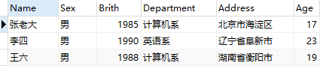

1. 将计算机考试成绩按从高到低进行排序

select C_name, Grade from score where C_name = '计算机' order by Grade desc;

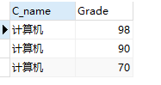

1. 查询姓张或者姓王的同学的姓名、院系和考试科目及成绩

select stu.Name, stu.Department, sc.C_name, sc.Grade from student stu inner join score sc on stu.Id = sc.Stu_id where stu.Name like '张%' or stu.Name like '王%';

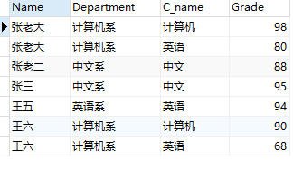

1. 查询都是湖南的学生的姓名、年龄、院系和考试科目及成绩

select stu.Name, stu.Age, stu.Department, sc.C_name, sc.Grade from student stu, score sc where stu.Id = sc.Stu_id and stu.Address like '湖南%';

