Mysql练习题2

数据:

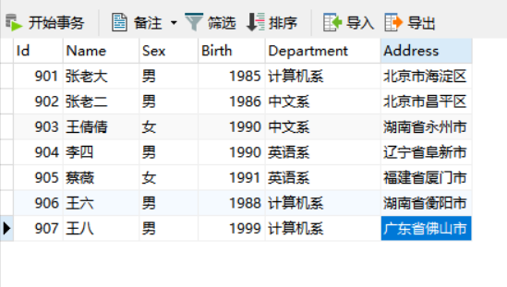

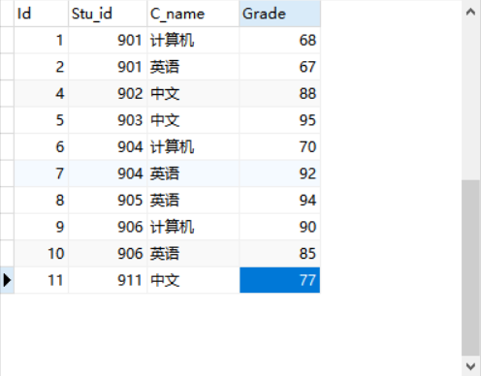

1. 从student表中查询每个院系有多少人

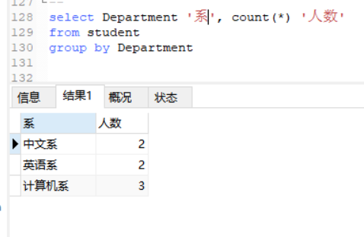

1. 从score表中查询每个科目的最高分

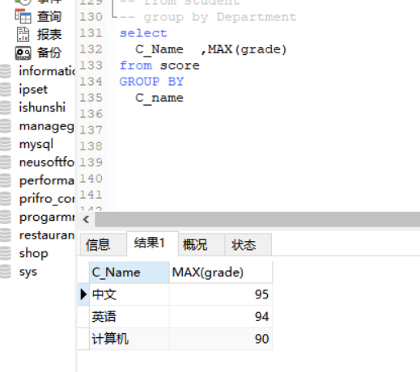

1. 查询李四的考试科目（c_name）和考试成绩（grade）

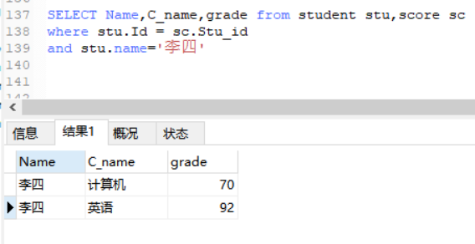

1. 计算每个学生的总成绩

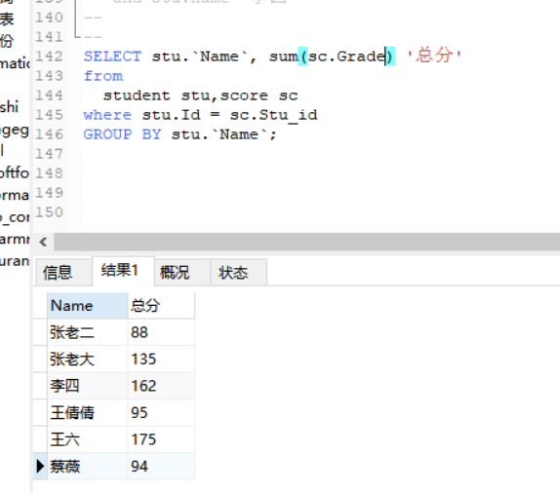

1. 计算每个考试科目的平均成绩

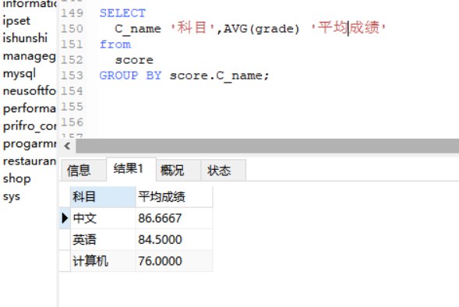

1. 查询计算机成绩低于95的学生信息

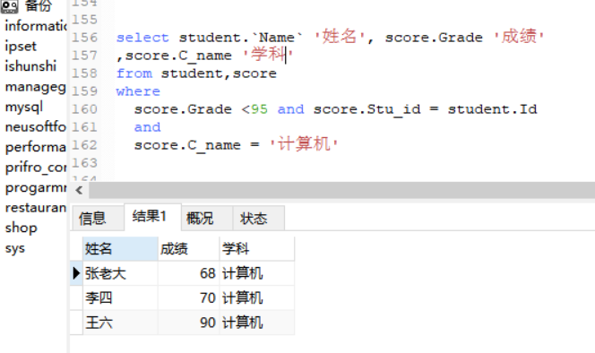

1. 查询同时参加计算机和英语考试的学生的信息

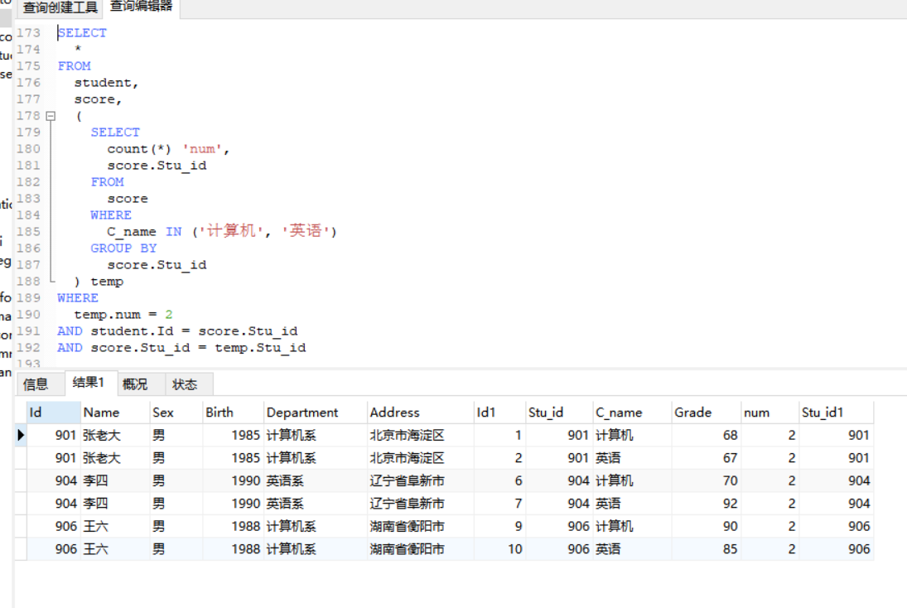

1. 将计算机考试成绩按从高到低进行排序

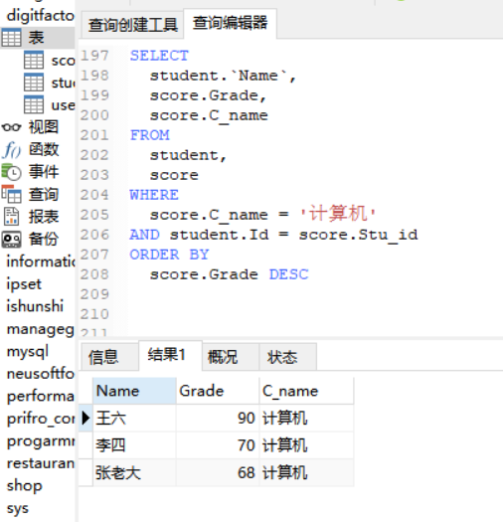

1. 查询姓张或者姓王的同学的姓名、院系和考试科目及成绩

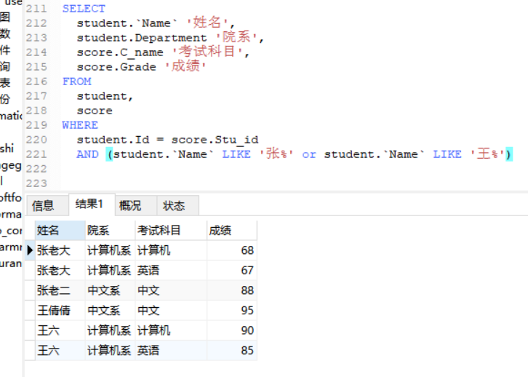

1. 查询都是湖南的学生的姓名、年龄、院系和考试科目及成绩

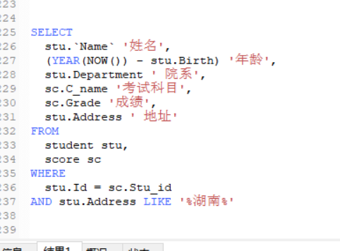



代码:

select

st.`Name`,st.Sex,st.Department,sc.C_name,sc.Grade

from

student st

RIGHT JOIN

score sc

ON

st.Id = sc.Stu_id

select Department '系', count(*) '人数'

from student

group by Department

select

C_Name ,MAX(grade)

from score

GROUP BY

C_name

SELECT Name,C_name,grade from student stu,score sc

where stu.Id = sc.Stu_id

and stu.name='李四'

SELECT stu.`Name`, sum(sc.Grade) '总分'

from

student stu,score sc

where stu.Id = sc.Stu_id

GROUP BY stu.`Name`;

SELECT

C_name '科目',AVG(grade) '平均成绩'

from

score

GROUP BY score.C_name;

select student.`Name` '姓名', score.Grade '成绩'

,score.C_name '学科'

from student,score

where

score.Grade <95 and score.Stu_id = student.Id

and

score.C_name = '计算机'

SELECT

*

FROM

student,

score,

(

SELECT

count(*) 'num',

score.Stu_id

FROM

score

WHERE

C_name IN ('计算机', '英语')

GROUP BY

score.Stu_id

) temp

WHERE

temp.num = 2

AND student.Id = score.Stu_id

AND score.Stu_id = temp.Stu_id

SELECT

student.`Name`,

score.Grade,

score.C_name

FROM

student,

score

WHERE

score.C_name = '计算机'

AND student.Id = score.Stu_id

ORDER BY

score.Grade DESC

SELECT

student.`Name` '姓名',

student.Department '院系',

score.C_name '考试科目',

score.Grade '成绩'

FROM

student,

score

WHERE

student.Id = score.Stu_id

AND (student.`Name` LIKE '张%' or student.`Name` LIKE '王%')

SELECT

stu.`Name` '姓名',

(YEAR(NOW()) - stu.Birth) '年龄',

stu.Department ' 院系',

sc.C_name '考试科目',

sc.Grade '成绩',

stu.Address ' 地址'

FROM

student stu,

score sc

WHERE

stu.Id = sc.Stu_id

AND stu.Address LIKE '%湖南%'