Mysql练习题2

1. 从student表中查询每个院系有多少人
2. 从score表中查询每个科目的最高分
3. 查询李四的考试科目（c_name）和考试成绩（grade）
4. 计算每个学生的总成绩
5. 计算每个考试科目的平均成绩
6. 查询计算机成绩低于95的学生信息
7. 查询同时参加计算机和英语考试的学生的信息
8. 将计算机考试成绩按从高到低进行排序
9. 查询姓张或者姓王的同学的姓名、院系和考试科目及成绩
10. 查询都是湖南的学生的姓名、年龄、院系和考试科目及成绩
11. SELECT Department '院系',count(*) '人数' from student GROUP BY Department;

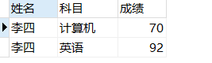

1. SELECT C_name '科目' ,max(Grade) '最高分' from score GROUP BY C_name;

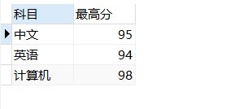

1. SELECT stu.`Name` '姓名',sc.C_name '科目',sc.Grade '成绩'

from student stu,score sc

WHERE stu.Id=sc.Stu_id

and stu.`Name`='李四';

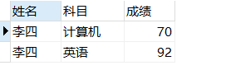

1. SELECT stu.`Name` '姓名',sum(sc.Grade) '总成绩'

from student stu,score sc

WHERE stu.Id=sc.Stu_id

GROUP BY stu.`Name`

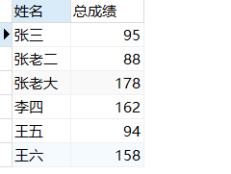

1. SELECT sc.C_name '科目',AVG(sc.Grade) '平均成绩'

from student stu,score sc

WHERE stu.Id=sc.Stu_id

GROUP BY sc.C_name

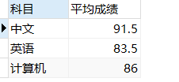

1. SELECT stu.*,sc.C_name '科目',sc.Grade '成绩'

from student stu, score sc

where stu.Id=sc.Stu_id

and sc.C_name ='计算机'

and sc.Grade<95

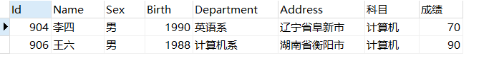

1. SELECT stu.*

from student stu, score sc ,score scc

where stu.Id=sc.Stu_id

and sc.C_name='英语'

and stu.Id=scc.Stu_id

and scc.C_name='计算机'



1. SELECT stu.*,sc.C_name '科目',sc.Grade '成绩'

from student stu, score sc

where stu.Id=sc.Stu_id

and sc.C_name ='计算机'

ORDER BY sc.Grade desc

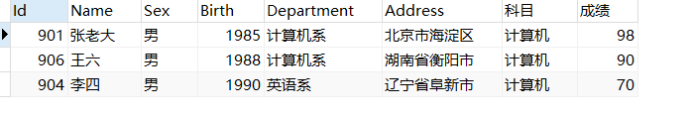

1. SELECT stu.`Name` '姓名',stu.Department '院系',sc.C_name '科目',sc.Grade '成绩'

from student stu, score sc

where stu.Id=sc.Stu_id

and stu.`Name` like '张%'

or stu.`Name` like '王%'

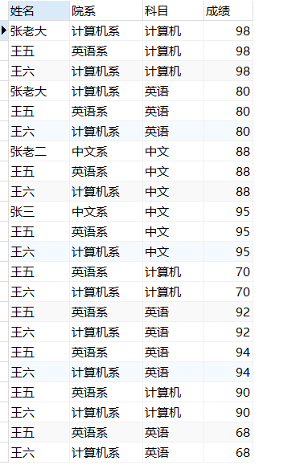

1. SELECT stu.`Name` '姓名',stu.Birth '年龄',stu.Department '院系',sc.C_name '科目',sc.Grade '成绩'

from student stu, score sc

where stu.Id=sc.Stu_id

and stu.Address LIKE '湖南%'

