Mysql练习题2

1. 从student表中查询每个院系有多少人
2. 从score表中查询每个科目的最高分
3. 查询李四的考试科目（c_name）和考试成绩（grade）
4. 计算每个学生的总成绩
5. 计算每个考试科目的平均成绩
6. 查询计算机成绩低于95的学生信息
7. 查询同时参加计算机和英语考试的学生的信息
8. 将计算机考试成绩按从高到低进行排序
9. 查询姓张或者姓王的同学的姓名、院系和考试科目及成绩
10. 查询都是湖南的学生的姓名、年龄、院系和考试科目及成绩

答案：

1. 从student表中查询每个院系有多少人

|  |
| --- |
| select department, count(*) as '人数' from student group by department |

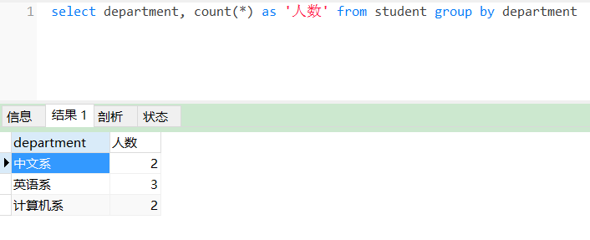

2. 从score表中查询每个科目的最高分

|  |
| --- |
| select c_name, max(grade) as '最高分' from score group by c_name |

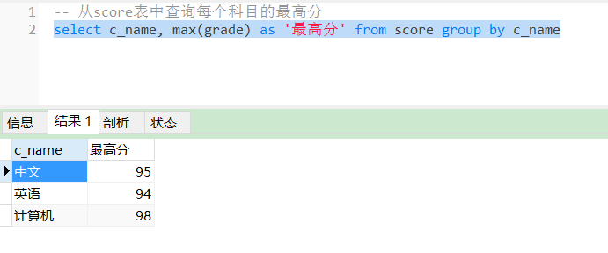

3. 查询李四的考试科目（c_name）和考试成绩（grade）

|  |
| --- |
| select name, c_name, grade from student, score where name = '李四' and student.id = stu_id |

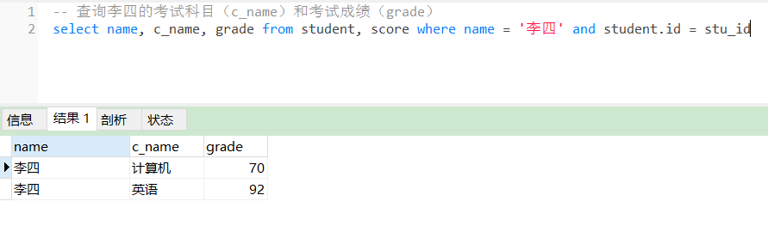

4. 计算每个学生的总成绩

|  |
| --- |
| select name, count(c_name) as '课程数', sum(grade) as '总分数' from student left join score on student.id = stu_id group by name |

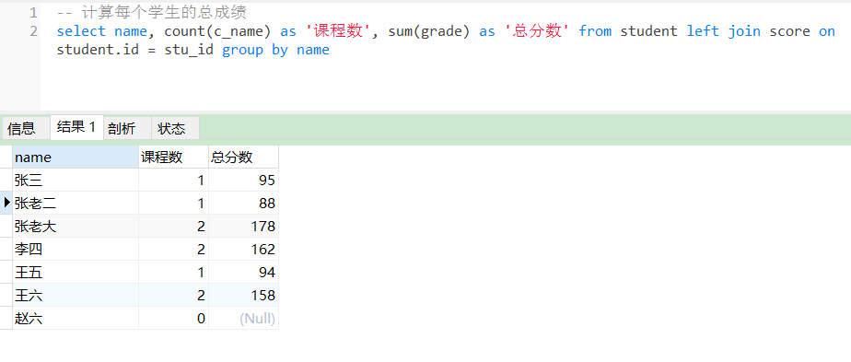

5. 计算每个考试科目的平均成绩

|  |
| --- |
| select c_name, avg(grade) as '平均成绩' from score group by c_name |

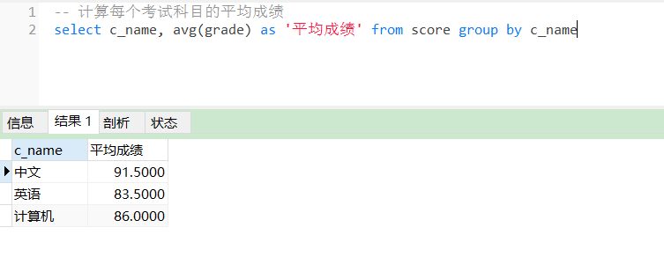

6. 查询计算机成绩低于95的学生信息

|  |
| --- |
| select student.*, grade from student, score where student.id = stu_id and c_name = '计算机' and grade < 95 |

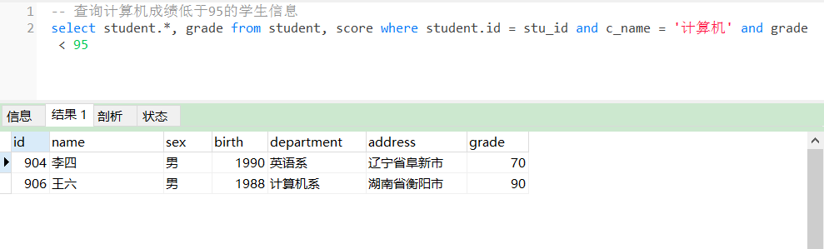

7. 查询同时参加计算机和英语考试的学生的信息

|  |
| --- |
| select student.*, c_name from student, score where student.id = stu_id and c_name in ('计算机', '英语') |

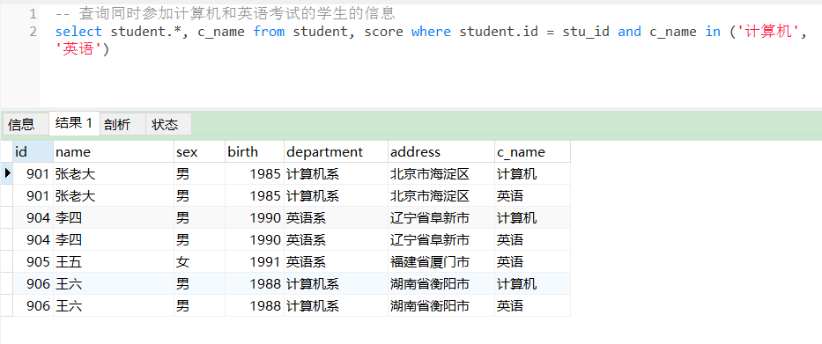

8. 将计算机考试成绩按从高到低进行排序

|  |
| --- |
| select c_name, grade from score where c_name = '计算机' order by grade desc |

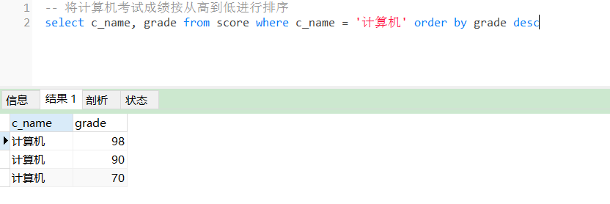

9. 查询姓张或者姓王的同学的姓名、院系和考试科目及成绩

|  |
| --- |
| select name, department, c_name, grade from student, score where student.id = stu_id and (name like '张%' or name like '王%') |

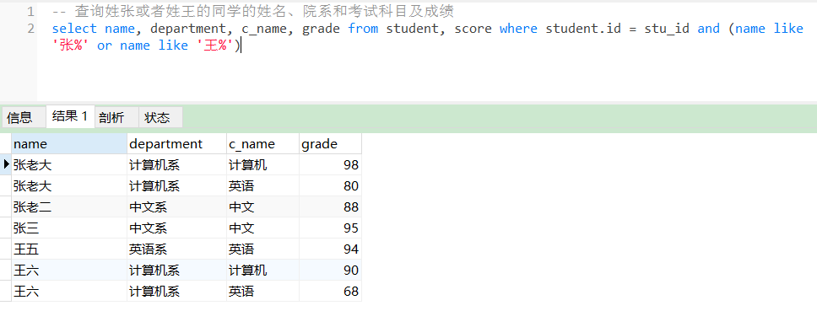

10. 查询都是湖南的学生的姓名、年龄、院系和考试科目及成绩

|  |
| --- |
| select name, 2020-birth as 'age', department, c_name, grade, address from student, score where student.id = stu_id and address like '湖南%' |

