Mysql练习题

**Class表的定义**

|  |  |  |  |  |  |  |  |
| --- | --- | --- | --- | --- | --- | --- | --- |
| **字段名** | **字段描述** | **数据类型** | **主键** | **外键** | **非空** | **唯一** | **自增** |
| class_id | 编号 | INT(10) | 是 | 否 | 是 | 是 | 是 |
| class_name | 班级名称 | VARCHAR(64) | 否 | 否 | 是 | 否 | 否 |

INSERT INTO `class` VALUES ('1', '三年二班'), ('2', '三年三班'), ('3', '一年二班'), ('4', '二年九班');

**Subject表的定义**

|  |  |  |  |  |  |  |  |
| --- | --- | --- | --- | --- | --- | --- | --- |
| **字段名** | **字段描述** | **数据类型** | **主键** | **外键** | **非空** | **唯一** | **自增** |
| subject_id | 编号 | INT(10) | 是 | 否 | 是 | 是 | 是 |
| subject_name | 课程名称 | VARCHAR(64) | 否 | 否 | 是 | 否 | 否 |
| teacher_id | 教师id | INT(10) | 否 | 否 | 否 | 否 | 否 |

INSERT INTO `course` VALUES ('1', '生物', '1'), ('2', '物理', '2'), ('3', '体育', '3'), ('4', '美术', '2');

**Score表的定义**

|  |  |  |  |  |  |  |  |
| --- | --- | --- | --- | --- | --- | --- | --- |
| **字段名** | **字段描述** | **数据类型** | **主键** | **外键** | **非空** | **唯一** | **自增** |
| score_id | 编号 | INT(10) | 是 | 否 | 是 | 是 | 是 |
| subject_id | 课程id | INT(10) | 否 | 否 | 是 | 否 | 否 |
| student_id | 学生id | INT(10) | 否 | 否 | 否 | 否 | 否 |
| score | 分数 | INT(10) | 否 | 否 | 否 | 否 | 否 |

INSERT INTO `score` (score_id,student_id,subject_id,score)VALUES ('1', '1', '1', '10'), ('2', '1', '2', '9'), ('5', '1', '4', '66'), ('6', '2', '1', '8'), ('8', '2', '3', '68'), ('9', '2', '4', '99'), ('10', '3', '1', '77'), ('11', '3', '2', '66'), ('12', '3', '3', '87'), ('13', '3', '4', '99'), ('14', '4', '1', '79'), ('15', '4', '2', '11'), ('16', '4', '3', '67'), ('17', '4', '4', '100'), ('18', '5', '1', '79'), ('19', '5', '2', '11'), ('20', '5', '3', '67'), ('21', '5', '4', '100'), ('22', '6', '1', '9'), ('23', '6', '2', '100'), ('24', '6', '3', '67'), ('25', '6', '4', '100'), ('26', '7', '1', '9'), ('27', '7', '2', '100'), ('28', '7', '3', '67'), ('29', '7', '4', '88'), ('30', '8', '1', '9'), ('31', '8', '2', '100'), ('32', '8', '3', '67'), ('33', '8', '4', '88'), ('34', '9', '1', '91'), ('35', '9', '2', '88'), ('36', '9', '3', '67'), ('37', '9', '4', '22'), ('38', '10', '1', '90'), ('39', '10', '2', '77'), ('40', '10', '3', '43'), ('41', '10', '4', '87'), ('42', '11', '1', '90'), ('43', '11', '2', '77'), ('44', '11', '3', '43'), ('45', '11', '4', '87'), ('46', '12', '1', '90'), ('47', '12', '2', '77'), ('48', '12', '3', '43'), ('49', '12', '4', '87'), ('52', '13', '3', '87');

**Student表的定义**

|  |  |  |  |  |  |  |  |
| --- | --- | --- | --- | --- | --- | --- | --- |
| **字段名** | **字段描述** | **数据类型** | **主键** | **外键** | **非空** | **唯一** | **自增** |
| student_id | 编号 | INT(10) | 是 | 否 | 是 | 是 | 是 |
| sex | 性别 | VARCHAR(64) | 否 | 否 | 是 | 否 | 否 |
| class_id | 班级id | INT(10) | 否 | 否 | 否 | 否 | 否 |
| student_name | 学生姓名 | VARCHAR(64) | 否 | 否 | 否 | 否 | 否 |

INSERT INTO `student` VALUES ('1', '男', '1', '理解'), ('2', '女', '1', '钢蛋'), ('3', '男', '1', '张三'), ('4', '男', '1', '张一'), ('5', '女', '1', '张二'), ('6', '男', '1', '张四'), ('7', '女', '2', '铁锤'), ('8', '男', '2', '李三'), ('9', '男', '2', '李一'), ('10', '女', '2', '李二'), ('11', '男', '2', '李四'), ('12', '女', '3', '如花'), ('13', '男', '3', '刘三'), ('14', '男', '3', '刘一'), ('15', '女', '3', '刘二'), ('16', '男', '3', '刘四');

**Teacher表的定义**

|  |  |  |  |  |  |  |  |
| --- | --- | --- | --- | --- | --- | --- | --- |
| **字段名** | **字段描述** | **数据类型** | **主键** | **外键** | **非空** | **唯一** | **自增** |
| teacher_id | 编号 | INT(10) | 是 | 否 | 是 | 是 | 是 |
| teacher_name | 姓名 | VARCHAR(64) | 否 | 否 | 是 | 否 | 否 |

INSERT INTO `teacher` VALUES ('1', '张磊老师'), ('2', '李平老师'), ('3', '刘海燕老师'), ('4', '朱云海老师'), ('5', '李杰老师');

1. 查询男生、女生的人数；

select

count(*) as '人数'

from

student

GROUP BY

sex;

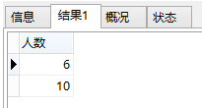

1. 查询姓“张”的学生名单；

select

student_id as '编号',sex as '性别',

class_id as '班级id',student_name as '学生姓名'

from

student

where

student_name like '张%';

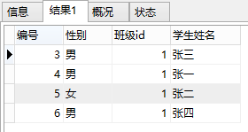

1. 课程平均分从高到低显示

select

subject_id as '课程id',avg(score) as '平均分'

from

score

GROUP BY

subject_id

ORDER BY 平均分 desc;

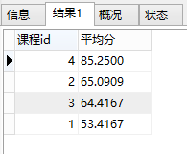

1. 查询有课程成绩小于60分的同学的学号、姓名；

select DISTINCT

stu.student_id as '学号',student_name as '姓名'

from

student stu,score sc

where

score<60 and stu.student_id=sc.student_id;

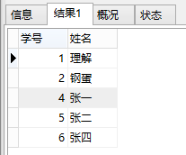

1. 查询至少有一门课与学号为1的同学所学课程相同的同学的学号和姓名；

select DISTINCT

student_name as '姓名',stu.student_id as '学号'

from

student stu,score sc

where

subject_id in

(select

subject_id

from

score

where

student_id=1);

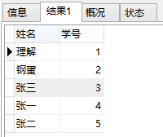

1. 查询出只选修了一门课程的全部学生的学号和姓名；

select

stu.student_id as '学号',student_name as '姓名'

from

student stu,score sc

where

stu.student_id=sc.student_id and stu.student_id=

(select

student_id

from

(select

student_id,count(*) as '选修课程数目'

from

score

GROUP BY

student_id) a

where

a.选修课程数目=1);

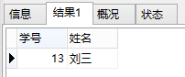

1. 查询各科成绩最高和最低的分：以如下形式显示：课程ID，最高分，最低分；

select

subject_id as '课程ID',max(score) as '最高分',

min(score) as '最低分'

from

score

GROUP BY

subject_id;

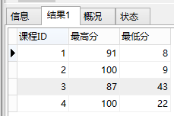

1. 查询课程编号“2”的成绩比课程编号“1”课程低的所有同学的学号、姓名；

select DISTINCT

stu.student_id as '学号',student_name as '姓名'

from

student stu,score sc

where

stu.student_id=sc.student_id and stu.student_id in

(select

a.student_id

from

(select

student_id,score

from

score

where

subject_id=1) a,

(select

student_id,score

from

score

where

subject_id=2) b

where

a.score>b.score and a.student_id=b.student_id);

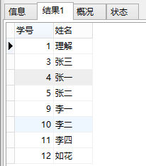

1. 查询“生物”课程比“物理”课程成绩高的所有学生的学号；

select

a.student_id as '学号'

from

(select

student_id,score

from

subject sub,score sc

where

sub.subject_name='生物' and sub.subject_id=sc.subject_id) a,

(select

student_id,score

from

subject sub,score sc

where

sub.subject_name='物理' and sub.subject_id=sc.subject_id) b

where

a.score>b.score and a.student_id=b.student_id;

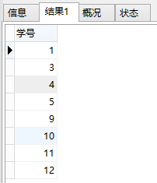

1. 查询平均成绩大于60分的同学的学号和平均成绩;

select

student_id as '学号',a.avg as '平均成绩'

from

(select

student_id,avg(score) as 'avg'

from

score

GROUP BY

student_id) a

where

a.avg>60;

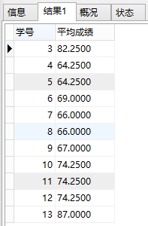

1. 查询所有同学的学号、姓名、选课数、总成绩；

select

stu.student_id as '学号',student_name as '姓名',

count(*) as '选课数',sum(score) as '总成绩'

from

student stu,score sc

where

stu.student_id=sc.student_id

GROUP BY

stu.student_id;

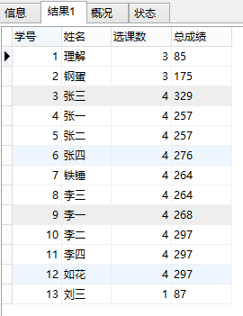

1. 查询姓“李”的老师的个数；

select

count(*) as '姓“李”的老师的个数'

from

teacher

where

teacher_name like '李%';

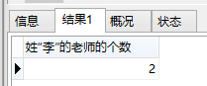

1. 查询没学过“张磊老师”课的同学的学号、姓名；

select

stu.student_id as '学号',student_name as '姓名'

from

student stu,score sc

where

stu.student_id=sc.student_id and stu.student_id not in

(select

stu.student_id

from

student stu,score sc

where

stu.student_id=sc.student_id and sc.subject_id in

(select

subject_id

from

subject sub,teacher tea

where

sub.teacher_id=tea.teacher_id and tea.teacher_name='张磊老师'));

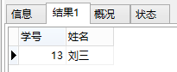

1. 查询学过“1”并且也学过编号“2”课程的同学的学号、姓名；

select DISTINCT

stu.student_id as '学号',student_name as '姓名'

from

student stu,score sc

where

stu.student_id=sc.student_id and stu.student_id in

(select

a.student_id

from

(select

student_id

from

score

where

subject_id=1) a,

(select

student_id

from

score

where

subject_id=2) b

where

a.student_id=b.student_id);

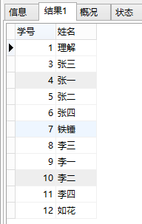

1. 查询学过“李平老师”所教的所有课的同学的学号、姓名；

select DISTINCT

stu.student_id as '学号',student_name as '姓名'

from

student stu,score sc

where

stu.student_id=sc.student_id and stu.student_id in

(select

student_id

from

(select

student_id,count(*)

from

score

where

subject_id in

(select

subject_id

from

subject sub,teacher tea

where

sub.teacher_id=tea.teacher_id and tea.teacher_name='李平老师')

GROUP BY

student_id) a

where

a.student_id!=(select

count(*)

from

subject sub,teacher tea

where

sub.teacher_id=tea.teacher_id and tea.teacher_name='李平老师'));

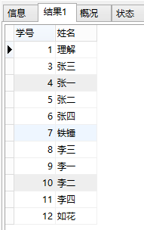

1. 查询没有学全所有课的同学的学号、姓名；

select DISTINCT

stu.student_id as '学号',student_name as '姓名'

from

student stu,score sc

where

stu.student_id=sc.student_id and stu.student_id in

(select student_id from

(select

student_id,count(*) as 'cnt'

from

score

GROUP BY

student_id) a

where a.cnt!=

(select

count(*)

from

subject));

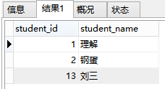

1. 查询和“002”号的同学学习的课程完全相同的其他同学学号和姓名；

select

stu.student_id as '学号',student_name as '姓名'

from

student stu,score sc

where

stu.student_id=sc.student_id and sc.student_id!=2 and sc.student_id not in

(select

student_id

from

score

where

subject_id not in(select

subject_id

from

score

where

student_id=2))

GROUP BY

sc.student_id

HAVING count(*)=

(select

count(*)

from

score

where

student_id=2);

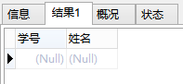

1. 删除学习“叶平”老师课的SC表记录；

delete from score where subject_id in

(select

subject_id

from

subject

where teacher_id=

(select

teacher_id

from

teacher

where

teacher_name='叶平老师'));

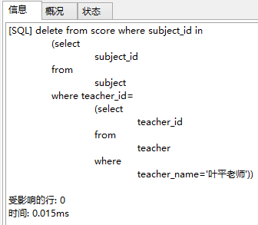

1. 向SC表中插入一些记录，这些记录要求符合以下条件：①没有上过编号“002”课程的同学学号；②插入“002”号课程的平均成绩；

-- 2 13

select DISTINCT

student_id

from

score

where

student_id not in

(select DISTINCT

student_id

from

score

where

subject_id=2)

-- 65.0909

(select

avg(score)

from

score

where

subject_id=2

GROUP BY

subject_id)

-- 添加数据

insert into

score(

subject_id,student_id,score

)VALUES(

2,2,65.0909

),(

2,13,65.0909

);

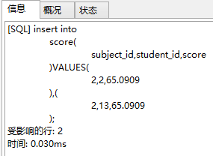

20.按平均成绩从低到高显示所有学生的“语文”、“数学”、“英语”三门的课程成绩，按如下形式显示： 学生ID,语文,数学,英语,有效课程数,有效平均分；

select DISTINCT

sc.student_id as '学生ID',a.生物,b.物理,c.体育,d.美术,e.有效课程数,e.有效平均分

from

score sc LEFT JOIN(select

student_id,score as '生物'

from

score

where

subject_id=(select

subject_id

from

subject

where

subject_name = '生物')) a

on sc.student_id=a.student_id LEFT JOIN

(select

student_id,score as '物理'

from

score

where

subject_id=(select

subject_id

from

subject

where

subject_name = '物理')) b

on sc.student_id=b.student_id LEFT JOIN

(select

student_id,score as '体育'

from

score

where

subject_id=(select

subject_id

from

subject

where

subject_name = '体育')) c

on sc.student_id=c.student_id LEFT JOIN

(select

student_id,score as '美术'

from

score

where

subject_id=(select

subject_id

from

subject

where

subject_name = '美术')) d

on sc.student_id=d.student_id LEFT JOIN

(select

student_id,count(score) as '有效课程数',avg(score) as '有效平均分'

from

score

GROUP BY

student_id) e

on sc.student_id=e.student_id;

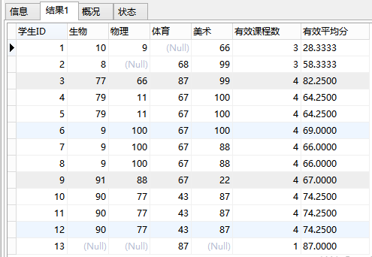

21.查询各科成绩最高和最低的分：以如下形式显示：课程ID，最高分，最低分；

select

subject_id as '课程ID',max(score) as '最高分',

min(score) as '最低分'

from

score

GROUP BY

subject_id;

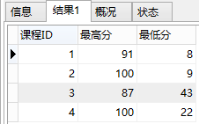

22.按各科平均成绩从低到高和及格率的百分数从高到低顺序；

select

sub.subject_name as '课程名称',c.平均成绩,d.及格率

from

subject sub,

(select

subject_id,avg(score) '平均成绩'

from

score

GROUP BY

subject_id) c,

(select

a.subject_id,a.及格数/b.总数 as '及格率'

from

(select

subject_id,count(score) as '及格数'

from

score

where

score>=60

GROUP BY

subject_id) a,

(select

subject_id,count(score) as '总数'

from

score

GROUP BY

subject_id) b

where

a.subject_id=b.subject_id) d

where

c.subject_id=d.subject_id and sub.subject_id=c.subject_id

ORDER BY

平均成绩,及格率 desc;

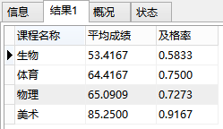

23.查询各科成绩前三名的记录:(不考虑成绩并列情况)

SELECT student_id, subject_id, score

FROM score t1

WHERE (

SELECT count(*) FROM score t2

WHERE t1.subject_id = t2.subject_id

AND t1.score< t2.score

) < 3

ORDER BY subject_id, score DESC;

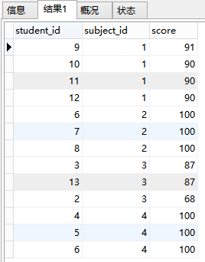

24.查询每门课程被选修的学生数；

select

sub.subject_name as '课程名称',count(*) as '选修的学生数'

from

score sc,subject sub

where

sc.subject_id=sub.subject_id

GROUP BY

sub.subject_id;

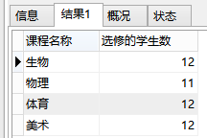

25.查询同名同姓学生名单，并统计同名人数；

select

student_name as '姓名',count(*) as '人数'

from

student

GROUP BY

student_name;

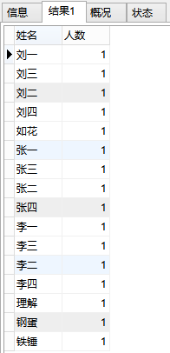

1. 查询每门课程的平均成绩，结果按平均成绩升序排列，平均成绩相同时，按课程号降序排列；

select

subject_id as '课程ID',avg(score) as '平均成绩'

from

score

GROUP BY

subject_id

ORDER BY

平均成绩,subject_id desc;

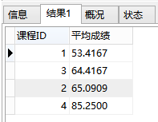

27.查询平均成绩大于85的所有学生的学号. 姓名和平均成绩；

select

stu.student_id as '学号',student_name as '姓名',a.平均成绩

from

student stu,

(select

student_id,avg(score) as '平均成绩'

from

score

GROUP BY

student_id

HAVING

平均成绩>85) a

where

stu.student_id=a.student_id;

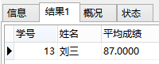

28.查询课程名称为“生物”，且分数低于60的学生姓名和分数；

select

student_name as '学生姓名',score as '分数'

from

score sc,student stu

where

sc.student_id=stu.student_id and score<60 and subject_id=(select

subject_id

from

subject

where

subject_name = '生物');

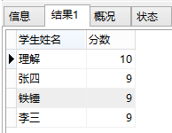

29.查询课程编号为003且课程成绩在80分以上的学生的学号和姓名；

select

student_id as '学号',score as '分数'

from

score sc

where

score>80 and subject_id=3;

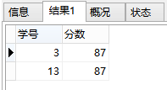

30.求选了课程的学生人数

select

count(a.aa) as '选了课程的学生人数'

from

(select

count(*) as aa

from

score

GROUP BY

student_id) a;

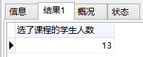

31.查询选修“李平”老师所授课程的学生中，成绩最高的学生姓名及其成绩；

select DISTINCT

student_name as '姓名',score as '成绩'

from

score sc,student stu

where

stu.student_id=sc.student_id

and subject_id in

(select

subject_id

from

subject

where

teacher_id=

(select

teacher_id

from

teacher

where

teacher_name='李平老师'))

and score=(select max(score) from score WHERE

subject_id in(select subject_id from subject

where teacher_id=(select teacher_id from teacher

where teacher_name='李平老师')));

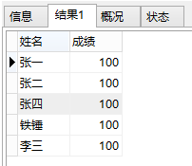

32.查询各个课程及相应的选修人数；

select

sub.subject_name as '课程名称',count(*) as '选修人数'

from

score sc,subject sub

where

sc.subject_id=sub.subject_id

GROUP BY

sub.subject_id;

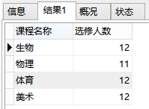

33.查询不同课程但成绩相同的学生的学号、课程号、学生成绩；

select

a.student_id as '学生一',a.subject_id as '课程号一',a.score as '成绩',

b.student_id as '学生二',b.subject_id as '课程号二'

from

score a

LEFT JOIN

score b

on

a.score=b.score

and a.subject_id!=b.subject_id;

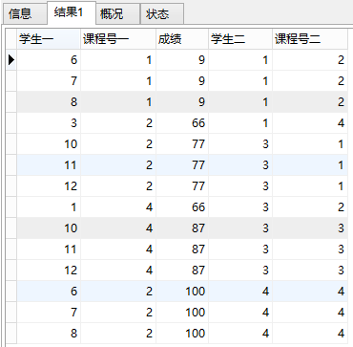

等70条记录。

34.查询每门课程成绩最好的前两名；

SELECT student_id, subject_id, score

FROM score t1

WHERE (

SELECT count(*) FROM score t2

WHERE t1.subject_id = t2.subject_id

AND t1.score< t2.score

) < 2

ORDER BY subject_id, score DESC;

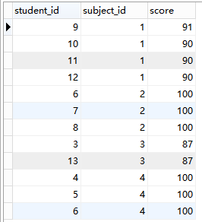

35.检索至少选修两门课程的学生学号；

select

student_id as '学号',count(*) as '选修课程数'

from

score

GROUP BY

student_id

HAVING

选修课程数>=2;

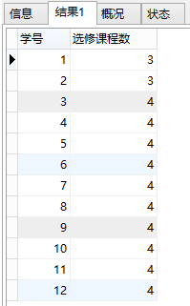

36.查询全部学生都选修的课程的课程号和课程名；

select

sc.subject_id as '课程号',subject_name as '课程名'

from

score sc,subject sub

where

sc.subject_id=sub.subject_id

group by

sc.subject_id

having

count(student_id)=(select count(student_id) from student);

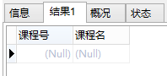

37.查询没学过“李平”老师讲授的任一门课程的学生姓名；

select

student_name as '姓名'

from

score sc,student stu

where

sc.student_id=stu.student_id and sc.student_id not in(select

student_id

from

score

where

subject_id in (select

subject_id

from

subject sub,teacher tea

where

sub.teacher_id=tea.teacher_id and tea.teacher_name='李平老师'));

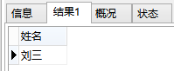

38.查询两门以上不及格课程的同学的学号及其平均成绩；

select

student_id as '学号',count(a.student_id)

as '不及格课程的数量',avg(a.score) as '平均成绩'

from

(select

student_id,score

from

score

where

score<60) a

GROUP BY

student_id

HAVING

不及格课程的数量>2;

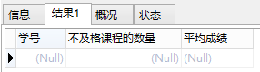

39.检索“004”课程分数小于60，按分数降序排列的同学学号；

select

student_id as '学号'

from

score

where

score<60

ORDER BY

score desc;

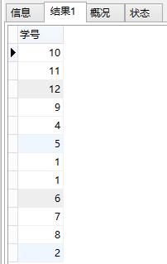

40.删除“002”同学的“001”课程的成绩；

delete

from

score

where

student_id=2 and subject_id=1;

